Targeting RECQL4 in Hepatocellular Carcinoma: From Prognosis to Therapeutic Potential."(Submission ID: c446cc7d-8106-4029-865b-b270cd68007f)
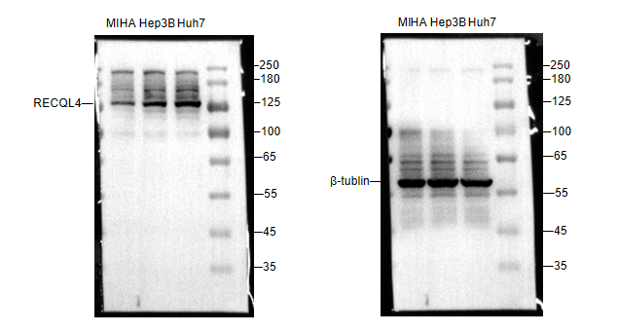
Fig. 5a Differential expression of RECQL4 at the protein level in liver tumor cell lines Hep3B and Huh7 compared to the normal hepatocyte cell line MIHA.

Fig. 5b Validation of RECQL4 knockdown at the protein level in Hep3B and Huh7 cell lines.
