Table S1: Main characteristics of the included studies
Study settings (Region) | Study period | Source of sample | Definition of MDR Adopted | Microorganism studied | No. of Isolate | MDR | No. of MDR | AST Method | Breakpoint Used for MIC | Genes Identification Methods | Genes involved | AMR class | Reference
North Central | May 2016- May 2017 | Human (fecal, urine samples) | - | Klebsiella pneumoniae and Pseudomonas aeruginosa | 235 | - | - | Kirby-Bauer method | CLSI | DNA and PCR | bla_{CTX-M-1}, bla_{CTX-M-9}, bla_{SHV} | ESBL resistant | Daam et al. 2023 [1]
North Central | 2016- 2018 | Human (blood, urine, wound biopsy/swab,  cerebrospinal fluid (CSF), sputum, aspirates, ear, and  eye swabs) | - | E. coli | 400 | E. coli | 121 | VITEK 2 system | CLSI | DNA and PCR | bla_{TEM-1}, bla_{CTX-M}, bla_{SHV} | ESBL resistant, gentamicin resistant, chloramphenicol resistant. | Enyinnaya et al. 2021 [2]
North Central | June 2015-June 2018 | Human (blood) | - | Salmonella enterica | 83 | Salmonella enterica | 39 | Kirby-Bauer method | CLSI | DNA and PCR | bla_{TEM,} qnrA, tetA, tetB and tetG | ESBL resistant, quinolones resistant, tetracycline resistant | Uzairue et al. 2023 [3]
North Central | 2017 | Human (urine) | - | E. coli | 45 | - | - | Kirby-Bauer method | - | DNA and PCR | bla_{TEM}, bla_{CTX-M}, bla_{SHV} | ESBL resistant | Bassey et al. 2018 [4]
North Central | 2019 | Human (urine) | Resistance to 3 class of antibiotics an above | E. coli | 8 | E. coli | 8 | - | - | DNA and PCR | qnrB and qnrS | Quinolone resistant | Eghieye et al. 2020 [5]
North Central | March 2020-April 2021 | Human (fecal) | - | Salmonella species. | 60 | Salmonella species. | 2 | Kirby-Bauer method | CLSI | DNA, PCR, and genome sequencing (Sanger) | bla_{SHV}, bla_{OXA-1}, bla_{CTX-M-4}, bla_{CTX-M-9}, and bla_{TEM} | ESBL resistant | Orole et al. 2023 [6]
North Central | April 2016 | Human (blood) | - | Klebsiella quasipneumoniae | 7 | Klebsiella quasipneumoniae | 5 | - | CLSI | Genome sequencing (MLST) | Bla_{NDM-5,} bla_{CTX-M-15}, bla_{TEM} and bla_{OXA-1} | ESBL resistant and carbapenem- resistant | Brinkac et al. 2019 [7]
North Central | May- Jul  2013 | Human (stool), Animal (poultry faeces) and Environment (waste water) | - | E. coli | 115 | - | - | Broth micro-dilution method | CLSI | DNA, PCR and whole-genome sequencing (MLST) | bla_{CTX-M-15}, bla_{TEM-1}, aadA1, aadA2, aadA5, aac(3)-IIa, qnrB1, qnrB19, qnrS1, qnrS2, | ESBL resistant, aminoglycoside resistant and Quinolone resistant | Aworh et al. 2020 [8]
North Central | June-July 2019 | Animal (poultry claecal) | - | E. coli | 37 | - | - | - | CLSI | DNA, PCR, and genome sequencing | bla_{CTX-M-15,} bla_{OXA-1,} aac(3)-IId, ant(2'')-Ia,  aadA1, aph(3')-Ia, aph(3'')-Ib | ESBL resistant and Aminoglycoside resistant | Al-Mustapha et al. 2023 [9]
North Central | May-December 2020 | Human (stool), Animal (cattle, poultry faeces, claecal) and Environment (abattoir waste water) | - | E. coli | 97 | - | - | Kirby-Bauer method | CLSI | DNA, PCR, and whole genome sequencing (MLST) | bla_{CTX-M-15}, bla_{CTXM-14}, blaCTX_{-M-55} and bla_{TEM-1} | ESBL resistant and Quinolone resistant | Aworh et al. 2022 [10]
North Central | December 2020 | Animal (poultry claecal) | - | E. coli | 73 | - | - | Kirby-Bauer method | EUCAST | DNA, PCR, and Whole genome sequencing | bla_{CTXM-14}, blaCTX_{-M-55,} bla_{TEM-1,} tetM, sul2 and qnrS | ESBL resistant, Fluoroquinolone resistant, sulfonamide resistance, tetracycline resistance | Al-Mustapha et al. 2022 [11]
North Central | - | Environment (water samples) | - | E. coli | 84 | - | - | Kirby-Bauer method | CLSI | DNA and PCR | blaSHV, blaTEM and blaCTX-M | ESBL resistant, Beta-lactamase resistant | Olatunji et al. 2016 [12]
North Central | Feb., 2018 | Environment (door handle samples) | - | E. coli | 34 | E. coli | 14 | Kirby-Bauer method | CLSI | DNA, and PCR | blaTEM, blaSHV, and blaCTX-M | Beta-lactamase resistant | Tsaku et al. 2019 [13]
South East | Dec., 2016- Nov., 2017 | Human (urine, HVS, wound swabs) |  | K. pneumoniae and E. coli | 276 | - | - | Kirby-Bauer method | CLSI | DNA, PCR, and genome sequencing (Sanger) | blaTEM, blaSHV, blaCTX-M, blaCTX-M-14, blaCTX-M-15 | ESBL resistant, Beta-lactamase resistant | Ugbo et al. 2020 [14]
South East | -. | Human (fecal sample) and Animal (pig, Chicken) | Resistance to at least one agent in three or more classes of antimicrobials | Salmonella enterica | 56 | - | - | Kirby-Bauer method | CLSI | DNA, and PCR | blaOXA, blaTEM, blaSHV, and blaCTX-M, QnrA, QnrB and QnrS | Beta-lactamase resistant and Fluoroquinolone resistant | Nwosu et al. 2023 [15]
South East | - | Animal (Fecal swab of cattle, chicken, goat, pig, and sheep). | Resistance to at least one agent in three or more classes of antimicrobials | E. coli | 196 | - | - | Kirby-Bauer method | CLSI | DNA, PCR and genome sequencing (WGS) | blaCTX-M-15, blaCTX-M-55, blaCTX-M-64, and blaCTX-M-65, blaTEM-1b, blaOXA-1, blaACT-25, blaSHV-28, qnrS1, tet(A) and tet(D) | ESBL resistant, carbapenem-resistant, beta-lactamase resistant, tetracycline resistant, Fluoroquinolone resistant | Olorunleke et al. 2022 [16]
South East | September 2021 - June 2022 | Environment (water samples) | - | Salmonella spp. | 7 | - | - | Kirby-Bauer method | CLSI | DNA, and PCR | QnrA, QnrSM, ParC, and GyrA | Fluoroquinolones resistant | Okorie et al. 2024 [17]
South East | - | Environment | - | E. coli | 272 | - | - | - | CLSI | DNA, PCR, and genome sequencing | blaTEM-1, blaCTX-M-15 and tet(A) | ESBL resistant, tetracycline resistant | Nwaiwu and Onyeaka 2021 [18]
North East | - | Human (urine, stool, wound swab, high vaginal swab, endocervical swab, sputum, blood, cerebrospinal fluid, semen and pleural fluid) | - | E. coli, K. pneumoniae, K. oxytoca, Proteus spp., Salmonella spp., Enterobacter spp., Shigella spp., S. marcescens, Providencia spp., Citrobacter spp., Y. enterocolitica and M. moganii | 420 | - | - | Kirby-Bauer method | CLSI | DNA and PCR | bla_{TEM,} blaCTX-M and blaSHV | ESBL resistant | Saleh et al. 2024 [19]
North East | Jan- June, 2014 | Human (wound swabs, wound biopsies, aspirates, urine, cerebrospinal fluid, blood culture, sputum, ear swabs and eye swabs) | - | Escherichia coli, Klebsiella pneumoniae, Klebsiella oxytoca, Klebsiella terrigena, Klebsiella ozaenae and Klebsiella planticola | 439 | - | - | Kirby-Bauer method | CLSI | DNA and PCR | bla_{CTX-M}, bla_{SHV}, and bla_{TEM} | ESBL resistant | Mohammad et al. 2016 [20]
North East | June- Dec. 2014 | Human (blood, urine, cerebrospinal fluid and  stool) |  | Klebsiella pneumoniae, Escherichia coli, Proteus mirabilis, Klebsiella oxytoca,  Morganella morganii, Citrobacter freundii, Serratia marcescens, Enterobacter  aerogenes, Klebsiella ozaenae, Hafnia alvei and Citrobacter  sedlakii. | 225 | - | - | Kirby-Bauer method | CLSI | DNA, and PCR | blaKPC, blaNDM-1 and blaVIM | Carbapenem- resistant | Yahaya et al. 2015 [21]
North East | Nov. 2017- Jan. 2022 | Human (Blood, Ear, Endocervical, Eye, Stool, Vaginal, Sputum, Urethral Swab, Urine, Wound) | Resistance to three or more classes of antimicrobial agents | E. coli, K. pneumoniae, and P. aeruginosa | 52 | E. coli | 8 | Kirby-Bauer method | CLSI | DNA, PCR, and genome sequencing (MLST) | blaCTX-M-15, blaNDM-1, blaTEM-1, blaVIM, blaGES-9, blaOXA-21-like, blaOXA-50,  blaPDC-1, aac(60)Ib-cr oqxA, oqxB  qnrA1, qnrB1 | Carbapenem- resistant, ESBL resistant and Fluoroquinolone resistant | Kawa et al. 2023 [22]
North East | - | Environment (water) | Resistance to at least 3 antibiotic classes | Klebsiella oxytoca, Klebsiella variicola, Enterobacter aerogenes, Enterobacter hormaechei, Enterobacter asburiae, Citrobacter freundii, and Morganella morganii | 300 | - | - | Kirby-Bauer method | CLSI | DNA and PCR | blaNDM-1, | Carbapenem resistant | Tula et al. 2023 [23]
South West | Sept 2018- Feb 2019. | Human (Urine, Aspirate, Sputum, Stool and Blood) | - | K. pneumoniae, E. coli, Acinetobacter spp., Citrobacter spp., | 180 | K. pneumoniae, E. coli, Acinetobacter spp., Citrobacter spp., | 76 | Kirby-Bauer method | EUCAST | DNA, and PCR | blaSHV, blaTEM,  and blaCTX-M | Beta-lactamase resistant, aminoglycoside resistant, sulfonamide resistant, chloramphenicol resistant | Ajimuda et al. 2022 [24]
South West | Feb 2018- July 2019 | Human (urine, blood, sputum, wound  swabs, high vaginal swabs (HVS), pus, stool, tracheal aspirate, and semen) | - | K. pneumoniae | 128 | - | - | Kirby-Bauer method | CLSI | DNA, PCR and genome sequencing (MLST) | bla_{TEM}, bla_{CTX-M}, and bla_{SHV}, blaCTX-M-15, blaCTX-M-2, and blaCTX-M-9, blaVIM, blaOXA-48, blaIMP, blaFOX | ESBL resistant, Carbapenem resistant | Odewale et al. 2023 [25]
South West | July 2020-April 2021 | Human (throat swab) | - | Enterococcus faecalis, Stapylococcus saprophytics, Staphylococcus lentus, Pseudomonas aeruginosa, Staphylococcus aureus, Enterobacter cloacae and Klebsiella pneumoniae | 240 | Pseudomonas aeruginosa, Staphylococcus aureus and Klebsiella pneumoniae | 38 | VITEK 2.0 | CLSI | DNA, and PCR | mefA, ermB | Macrolide resistance | Bamigbola et al. 2023 [26]
South West | Feb-Mar. 2024) | Human (urine, blood, sputum, pus, tracheal aspirate, and ascitic fluid) | - | K. pneumoniae | 50 | - | - | Kirby-Bauer method | - | DNA, and PCR | blaOXA-48 and blaNDM-1 | Carbapenem resistant | Onyeji et al. 2024 [27]
South West | 2015 | Human (blood) | - | S. Typhi | 27 | - | - | Kirby-Bauer method | CLSI | DNA, and PCR | blaSHV, blaTEM,  and blaCTX-M | Beta-lactamase resistant | Akinyemi et al. 2022 [28]
South West | 2016- 2018 | Human (blood, cerebrospinal fluid, and urine) | - | K. pneumoniae | 134 | - | - | Kirby–Bauer method | - | DNA, PCR and genome sequencing (WGS) | blaCTX_M-15, dfrA14, tetD, qnrS, and oqxAB | ESBL resistant, fluoroquinolones resistant, and tetracycline resistant | Ayorinde et al. 2021 [29]
South West | Dec., 2010- July, 2011 | Environment (water) | Resistance to at least 3 antibiotic classes | Aeromonas, Alcaligenes, Bacillus, Klebsiella, Leucobacter, Morganella, Proteus | 105 | Aeromonas, Alcaligenes, Bacillus, Klebsiella, | 84 | - | CLSI | DNA and PCR | tet(A), tet(M), tet(E) | Tetracycline resistant | Adesoji et al. 2015 [30]
South West | April 2021- August 2021 | Human (blood) | - | Salmonella species | 24 | - | - | Kirby–Bauer method | CLSI | DNA and PCR | blaCTX-M-9, blaCTX-M-15 and qnrB19 | ESBL resistant, fluoroquinolones resistant. | Fakorede et al. 2023 [31]
South West | 2012 | Human (clinical site) | - | Escherichia coli, Klebsiella pneumoniae  and Pseudomonas aeruginosa | 27 | - | - | Kirby-Bauer method | CLSI | DNA and PCR | blaCTX-M-15 | ESBL resistant | Ogbolu and Webber et al. 2017 [32]
South West | Oct. 2011 | Human (urine, wound, blood, stool) | Resistance to 3 or more class of antimicrobial agents | E. coli, K. pneumoniae, Proteus spp., M. morganii and C. freundii. | 38 | E. coli, K. pneumoniae, and C. freundii | 38 | VITEK-2/VITEK MS Systems | CLSI | DNA, PCR and genome sequencing | blaTEM, blaCTX-M and blaCTX-M-15 | ESBL resistant | Raji et al. 2015 [33]
South West | May-August 2023 | Human (urine) | - | K. pneumoniae | 41 | - | - | Kirby-Bauer method | CLSI | DNA and PCR | blaTEM, blaSHV, and blaCTX-M | ESBL resistant | Nzube et al. 2024 [34]
South West | Aug. 2015-Jan. 2016 | Human (sputum, blood, urine, wound swabs and tracheal aspirates) | Resistance to 3 or more class of antimicrobial agents | K. pneumoniae | 50 | K. pneumoniae | 34 | Kirby-Bauer method | CLSI | DNA and PCR | blaKPC and blaNDM | Carbapenem and Metallo-β-lactamase resistance | Okunlola et al. 2019 [35]
South West | March 2018-Sept  2019 | Human (blood, sputum, urine,  wound biopsy, swabs, cerebrospinal fluid and/or  aspirates) | - | Escherichia coli, Klebsiella pneumoniae, Serratia liquefaciens, Enterobacter sakazakii, Enterobacter cloacae, Acinetobacter lwoffii, Acinetobacter haemolyticus, Klebsiella oxytoca, Acinetobacter baumanii, Klebsiella ozaenae, Enterobacter gergoviae, serratia marcescens, pseudomonas | 165 | - | - | Kirby-Bauer method | EUCAST | DNA and PCR | blaTEM, blaSHV, | ESBL resistant | Ajani et al. 2022 [36]
South West | Sept 2018- June 2019 | Human (urine/ catheter tips, diabetic foot, wounds, ear, sputum and vaginal swab) | - | P. aeruginosa | 123 | - | - | VITEK-2 | CLSI | DNA, PCR and genome sequencing (MLST) | blaVIM-2, blaVIM-5, and blaNDM-1 | Carbapenem- resistant | Adasola et al. 2023 [37]
South West | Jan- July, 2016 | Animal (faecal of whistling ducks, egrets and cattle) | Resistance to 3 or more class of antimicrobial agents | E. coli | 149 | E. coli | 145 | Kirby-Bauer method | CLSI | DNA, PCR and genome sequencing (WGS) | blaCTX-M1/15, blaCTX-M9, armA, tetG,  ermB, arr, dfrA19, gepA  and floR, strB and sul2, aac6, aac6Ib and aadA4 | ESBL resistant, Tetracycline resistance, Aminoglycoside resistance,  Macrolide/streptogramin, rifampicin resistance, Ttrimethoprimresistance,  Fluoroquinolone, and chloramphenicol | Fashae et al. 2021 [38]
South West | Aug 2015- May 2016 | Animal (abattoir, poultry, cafeteria,  hostel sewage, and cow ranch) | - | Serratia spp, Enterobacter spp, Klebsiella spp, E. coli, Proteus spp, Salmonella spp, Shigella spp Citrobacter spp, and Yersinia spp | 52 | - | - | Kirby–Bauer method | CLSI | DNA and PCR | bla_{CTX} | Beta- lactamase resistant | Adeleke and Owoseni, 2020 [39]
South West | 1st - 31st Nov, 2019 | Animal (ready-to-eat roasted beef (Suya) | - | Staphylococcus aureus, Pseudomonas spp., Klebsiella spp. and Bacillus spp. | 38 | Staphylococcus aureus, Pseudomonas spp., Klebsiella spp. | 26 | - | CLSI | DNA and PCR | MecA, blaTEM and blaSHV | Methicillin-resistant and beta- lactamase resistant | Alabi et al. 2021 [40]
South West | Oct. 2014- Jan 2015 | Environment (Sediment samples) | - | E. coli, E. cloacae and C. freundii | 40 |  | - | Kirby–Bauer method | CLSI | DNA, PCR and genome sequencing (WGS) | aac(3)-IIa, aac(6’)-lb-cr, aph(3”)-Ib, aadA1, aph(6”)-Ib, blaCMH-3 (ampC), blaCTX-M-15, blaOXA-1,  blaTEM-1B, catA1, catB4, dfrA14, fosA, oqxA, oqxB, sul2, tetA | Aminoglycosides, fluoroquinolones, fosfomycin,  phenicols, sulfamethoxazole, tetracycline, and trimethoprim resistance, ESBL resistance | Adelowo et al. 2020 [41]
South West | 2019 | Environment (wastewater) | - | Acinetobacter spp., Bacillus methylotrophicus, Escherichia coli, Enterobacter sp., Staphylococcus saprophyticus | 60 | - | - | Kirby–Bauer method | CLSI | DNA, PCR and genome sequencing (WGS) | catA1, sulI, tet(E),  aac(3)-IV, ermC, blaTEM, blaCTX-M, blaNDM-1 | Chloramphenicol, sulfonamides, tetracycline, aminoglycoside, macrolide-lincosamide-streptogramin  and Beta-lactams and Carbapenem- resistant | Obayiuwana and Ibekwe, 2020 [42]
South West | Mar. 2021-Feb. 2022. | Environment (hospital wastewater) | - | Acinetobacter baumannii | 82 | - | - | VITEK2 | CLSI | DNA, PCR and genome sequencing (WGS) | blaNDM-1, blaOXA, gyrA and parC | Carbapenems resistant, Quinolones resistant | Odih et al. 2023 [43]
South-South | Oct. 2018-  Mar. 2019 | Human (urine, wound, stool, HVS, Endo cervical swab) | - | E. coli | 206 | - | - | Kirby–Bauer method | EUCAST | DNA, PCR and genome sequencng (Sanger) | qnrS, qnrA and qnrB | fluoroquinolone-resistant | Nsofor et al. 2021 [44]
South-South | Mar-  May 2015 | Human (clinical specimen) | Resistant to ≥1 agent in ≥3 antimicrobial categories | E. coli, K.pneumoniae, Enterobacter asburiae, Enterobacter cloacae, Enterobacter  hormaechei, Atlantibacter hermannii, Citrobacter werkmanii and Proteus mirabilis | 217 | E. coli, K.pneumoniae, Enterobacter | 148 | Kirby–Bauer method | EUCAST | DNA, PCR and genome sequencing (MLST) | blaCTX-M-15, blaCTX-M-55, blaSHV, blaOXA-48, blaOXA-181, blaNDM1 | ESBL resistant, Carbapenems resistant | Jesumirhewe et al. 2020 [45]
South-South | 2016 | Human (wound, endocervical, high vaginal, eye, ear, urethral, seminal fluid, blood, urine, aspirates and catheter tips) | Resistance to 3 or more class of antimicrobial agents | S. aureus | 91 | - | - | Kirby–Bauer method | CLSI | DNA, and PCR | mecA | Methicillin resistance | Ibadin et al. 2017 [46]
South-South | - | Human (stool), Animal (poultry droplet) and Environment (fish pond water) | - | Escherichia coli, Salmonella spp., Shigella spp., Klebsiella spp. and Aeromonas spp. | 1964 | - | - | - | CLSI | DNA, and PCR | aac(6’)-Ib,  qnrA, qnrB, and qnrS | fluoroquinolone-resistant | Ayobola et al. 2021 [47]
South-South | - | Human (food vendors) | - | Escherichia coli | 18 | - | - | Kirby–Bauer method | CLSI | DNA, and PCR | tetA | Tetracycline resistant | Aihiokhai et al. 2023 [48]
South-South | June 2018-April 2019 | Animal (chicken carcass) | - | S. aureus | 110 | - | - | - | CLSI | DNA, and PCR | mecA, dfrG, dfrK, ant (4´)-Ia, aac (6´)-Ie-aph(2´´)-Ia, aph(3´)-IIIa, cat::pC221,ermA, ermB, ermC, tetM, tetL, tetK | Methicillin resistance, trimethoprim, aminoglycosides, chloramphenicol, erythromycins, tetracycline resistance | Igbinosa et al. 2023 [49]
South-South | Mar. 2015- Feb. 2017 | Animal (shall fish) (clams, oysters, periwinkles) | Resistance to 3 or more class of antimicrobial agents | Pseudomonas spp., Alcaligenes spp., Providencia spp., Vibrio sp., Paenalcaligenes sp. | 135 | Pseudomonas spp. | 53 | Kirby–Bauer method | CLSI | DNA, and PCR | blaTEM, blaSHV, blaVIM, qnrA, qnrB and qnrS | ESBL resistant, Carbapenems resistant, fluoroquinolone-resistant | Udoekong et al. 2021 [50]
South-South | June and Dec. 2019 | Environment (water) | - | Enterococcus species | 63 | - | - | Kirby–Bauer method | CLSI | DNA, and PCR | blaNDM-1 | Carbapenems resistant (Metallo-beta-lactamase) | Igere et al. 2022 [51]
South-South | Dec. 2018-Nov. 2019 | Environment (water) | Resistance to 5 antimicrobials (3 classes) to 10 antimicrobials (6 classes) | E. coli | 21 | E. coli | 14 | Kirby–Bauer method | CLSI | DNA, and PCR | blaTEM, blaCTX−M−15, and blaCTX−M−1, tetB, tetA, tetM, sul3, sul2, sul1, aacC(3)-1, ant(4')-Ia, qnrB, qnrA, qnrS, qnrC, and cat3, cat2, cat1 | ESBL resistant, Tetracycline, sulfonamides, aminoglycoside, quinolones and chloramphenicol resistance | Beshiru et al. 2024 [52]
North West | Jan- June 2019 | Human (urine, stool, sputum) | Resistance to 3 or more class of antimicrobial agents | Citrobacter freundii, Enterobacter cloacae,  Escherichia coli, Klebsiella pneumoniae, Morganella  morganii, Proteus mirabilis, Providencia  rettgeri and Providencia stuartii | 129 | E. coli | 7 | Kirby–Bauer method | CLSI | DNA, and PCR | blaSHV, blaTEM, blaCTX-M, blaNDM-5, blaOXA-48 and blaOXA-181 | ESBL resistant, Carbapenems resistant | Olowo-Okere et al. 2020 [53]
North West | 2016 | Human (blood, urine, catheter) | - | Escherichia coli, Klebsiella  pneumoniae, Proteus mirabilis, Proteus vulgaris,  Pseudomonas aeruginosa, Salmonella typhi and  Salmonella paratyphi | 500 | - | - | Kirby–Bauer method | CLSI | DNA, PCR and genome sequencing (Sanger) | blaNDM-1 | Carbapenems resistant | Abdullahi et al. 2017 [54]
North West | 2023 | Human (nasal swab) | - | Coagulase-negative Staphylococci | 60 | - | - | Kirby–Bauer method | EUCAST | DNA, and PCR | mecA and ermB | Methicillin-resistant and macrolide resistant | Atolagbe et al. 2024 [55]
North West | March - June 2021  Longitudinal study | Environment (walls, floors, toilet seat and door handles swabs) | - | E. coli, K. pneumoniae, P. aeruginosa and A. baumannii | 191 | - | - | Kirby–Bauer method | CLSI | DNA, PCR and genome sequencing (Sanger) | blaNDM-1, blaNDM-5, blaIMP, blaKPC and blaCMY- 2, | Methicillin-resistant, Carbapenems resistant | Yusuf et al. 2023 [56]

Table S2. Risk of bias in individual studies using the Newcastle-Ottawa Scale (NOS) for assessing non-randomized studies
 | Selection |  |  |  | Comparability | Outcome
Reference | Representativeness of the Exposed Cohort | Selection of the Non-Exposed Cohort | Ascertainment of Exposure | Demonstration that Outcome of Interest Was Not Present at Start of Study | Comparability of Cohorts on the Basis of the Design or Analysis | Assessment of Outcome | Was Follow-Up Long Enough for Outcomes to Occur | Adequacy of Follow-Up of Cohorts | Total Score | Quality
Daam et al. 2023 [1] | * | * | * | * | * | * | * | * | 8 | good
Enyinnaya et al. 2021 [2] | * | * | * | * | * | * | * | * | 8 | good
Uzairue et al. 2023 [3] | * | * | * | * | * | * | * | * | 8 | good
Bassey et al. 2018 [4] | * | * | * | * | - | * | - | * | 6 | good
Eghieye et al. 2020 [5] | * | - | * | * | - | * | - | * | 5 | fair
Orole et al. 2023. [6] | * | * | * | * | * | * | * | * | 8 | good
Brinkac et al. 2019 [7] | * | - | * | * | - | * | - | * | 5 | fair
Aworh et al. 2020 [8] | * | * | * | * | * | * | - | * | 7 | good
Al-Mustapha et al. 2023 [9] | * | * | * | * | * | * | - | * | 7 | good
Aworh et al. 2022 [10] | * | * | * | * | * | * | * | * | 8 | good
Al-Mustapha et al. 2022 [11] | * | * | * | * | * | * | - | * | 7 | good
Olatunji et al. 2016 [12] | * | - | * | * | * | * | - | * | 6 | good
Tsaku et al. 2019 [13] | * | - | * | * | * | * | - | * | 6 | good
Ugbo et al. 2020 [14] | * | * | * | * | * | * | * | * | 8 | good
Nwosu et al. 2023 [15] | * | * | * | * | * | * | - | * | 7 | good
Olorunleke et al. 2022 [16] | * | * | * | * | * | * | - | * | 7 | good
Okorie et al. 2024 [17] | * | - | * | * | - | * | - | * | 5 | fair
Nwankwo et al. 2021 [18] | * | * | * | * | * | * | - | * | 7 | good
Saleh et al. 2024 [19] | * | * | * | - | * | * | - | * | 6 | good
Mohammad et al. 2016 [20] | * | * | * | * | * | * | * | * | 8 | good
Yahaya et al. 2015 [21] | * | * | * | * | * | * | * | * | 8 | good
Kawa et al. 2023 [22] | * | * | * | * | * | * | * | * | 8 | good
Tula et al. 2023 [23] | * | * | * | * | * | * | - | * | 7 | good
Ajimuda et al. 2022 [24] | * | * | * | * | * | * | * | * | 8 | good
Odewale et al. 2023 [25] | * | * | * | * | * | * | * | * | 8 | good
Bamigbola et al. 2023 [26] | * | * | * | * | * | * | * | * | 8 | good
Onyeji et al. 2024 [27] | * | * | * | * | - | * | - | * | 6 | good
Akinyemi et al. 2022 [28] | * | - | * | * | - | * | - | * | 5 | fair
Ayorinde et al. 2021 [29] | * | * | * | * | * | * | * | * | 8 | good
Adesoji et al. 2015 [30] | * | * | * | * | * | * | * | * | 8 | good
Fakorede et al. 2023 [31] | * | - | * | * | * | * | - | * | 6 | good
Ogbolu and Webber et al. 2017 [32] | * | - | * | * | - | * | - | * | 5 | fair
Raji et al. 2015 [33] | * | - | * | * | - | * | - | * | 5 | fair
Nzube et al. 2024 [34] | * | - | * | * | * | * | - | * | 6 | good
Okunlola et al. 2019 [35] | * | * | * | * | * | * | * | * | 8 | good
Ajani et al. 2022 [36] | * | * | * | * | * | * | * | * | 8 | good
Adasola et al. 2023 [37] | * | * | * | * | * | * | * | * | 8 | good
Fashae et al. 2021 [38] | * | * | * | * | * | * | * | * | 8 | good
Adeleke and Owoseni, 2020 [39] | * | * | * | * | * | * | * | * | 8 | good
Alabi et al. 2021 [40] | * | - | * | * | * | * | - | * | 6 | good
Adelowo et al. 2020 [41] | * | - | * | * | * | * | * | * | 7 | good
Obayiuwana and Ibekwe, 2020 [42] | * | * | * | * | * | * | - | * | 7 | good
Odih et al. 2023 [43] | * | * | * | * | * | * | * | * | 8 | good
Nsofor et al. 2021 [44] | * | * | * | * | * | * | * | * | 8 | good
Jesumirhewe et al. 2020 [45] | * | * | * | * | * | * | * | * | 8 | good
Ibadin et al. 2017 [46] | * | * | * | * | * | * | - | * | 7 | good
Ayobola et al. 2021 [47] | * | * | * | * | * | * | * | * | 8 | good
Aihiokhai et al. 2023 [48] | * | - | * | * | * | * | - | * | 6 | good
Igbinosa et al. 2023 [49] | * | * | * | * | * | * | * | * | 8 | good
Udoekong et al. 2021 [50] | * | * | * | * | * | * | * | * | 8 | good
Igere et al. 2022 [51] | * | * | * | * | * | * | - | * | 7 | good
Beshiru et al. 2024 [52] | * | - | * | * | * | * | * | * | 7 | good
Olowo-Okere et al. 2020 [53] | * | * | * | * | * | * | * | * | 8 | good
Abdullahi et al. 2017 [54] | * | * | * | * | * | * | * | * | 8 | good
Atolagbe et al. 2024 [55] | * | * | * | * | * | * | - | * | 7 | good
Yusuf et al. 2023 [56] | * | * | * | * | * | * | * | * | 8 | good
“*” indicate that the article meets the criteria mentioned above; “-” indicate that the article does not meet the criteria mentioned above; Scores of star: “7-8” indicate low risk of bias, “6” indicate moderate risk of bias, “5” indicate high risk of bias.

Table S3. Database and search terms used
Database | Search term | Number of studies
PubMed | (“resistance genes”[Title/Abstract] OR “ESBL”[Title/Abstract] OR “Extended spectrum beta lactamase”[Title/Abstract] OR “CTX-M”[Title/Abstract] OR “TEM”[Title/Abstract] OR “SHV”[Title/Abstract] OR “NDM”[Title/Abstract] OR “New Delhi Metallo-beta-lactamase”[Title/Abstract] OR “KPC”[Title/Abstract] OR “quinolone resistance”[Title/Abstract] OR “fluoroquinolone resistance”[Title/Abstract] OR “aminoglycoside resistance”[Title/Abstract] OR “streptomycin resistance”[Title/Abstract]) and (“Nigeria”). | 141
AJOL | (“Molecular identification of antibiotic resistance”, (“genotypic antibiotic resistance”, “antibiotic resistance genes”, “ESBL genes”, “beta-lactamase genes”, “carbapenemase genes”), (“tetracycline, sulfonamides, fosfomycin, phenicol resistance genes”), (“aminoglycoside resistance genes, macrolide resistance genes and quinolone resistance genes”), (“geo-political zones”) and (“Nigeria”). | 79
Scopus | ( “Resistance genes” OR “ESBL” OR “Extended spectrum beta lactamase” OR “CTX-M” OR “TEM” OR “SHV” OR “NDM” OR “New Delhi Metallo-beta-lactamase” OR “KPC” OR “quinolone resistance” OR “fluoroquinolone resistance” OR “aminoglycoside resistance” OR “streptomycin resistance” ) and ( “Nigeria”). | 223
Web of Science | ( “Resistance genes” OR “ESBL” OR “CTX-M” OR “TEM” OR “SHV” OR “NDM” OR “KPC” OR “quinolone resistance” OR “fluoroquinolone resistance” OR “aminoglycoside resistance” OR “streptomycin resistance” ) and ( “Nigeria”). | 108
Google Search | (“Genotypic antibiotic resistance”, “antibiotic resistance genes”, “ESBL genes”, “beta-lactamase genes”, “carbapenemase genes”), (“tetracycline, sulfonamides, fosfomycin, phenicol resistance genes”), (“aminoglycoside resistance genes, macrolide resistance genes and quinolone resistance genes”), (“geo-political zones”) and (“Nigeria”). | 211

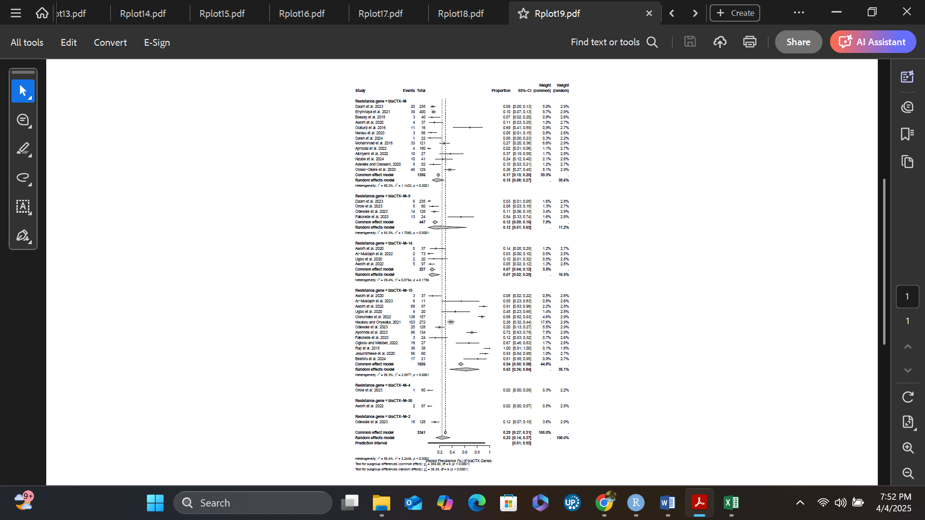
Figure S1. Pooled prevalence of blaCTX-M genes

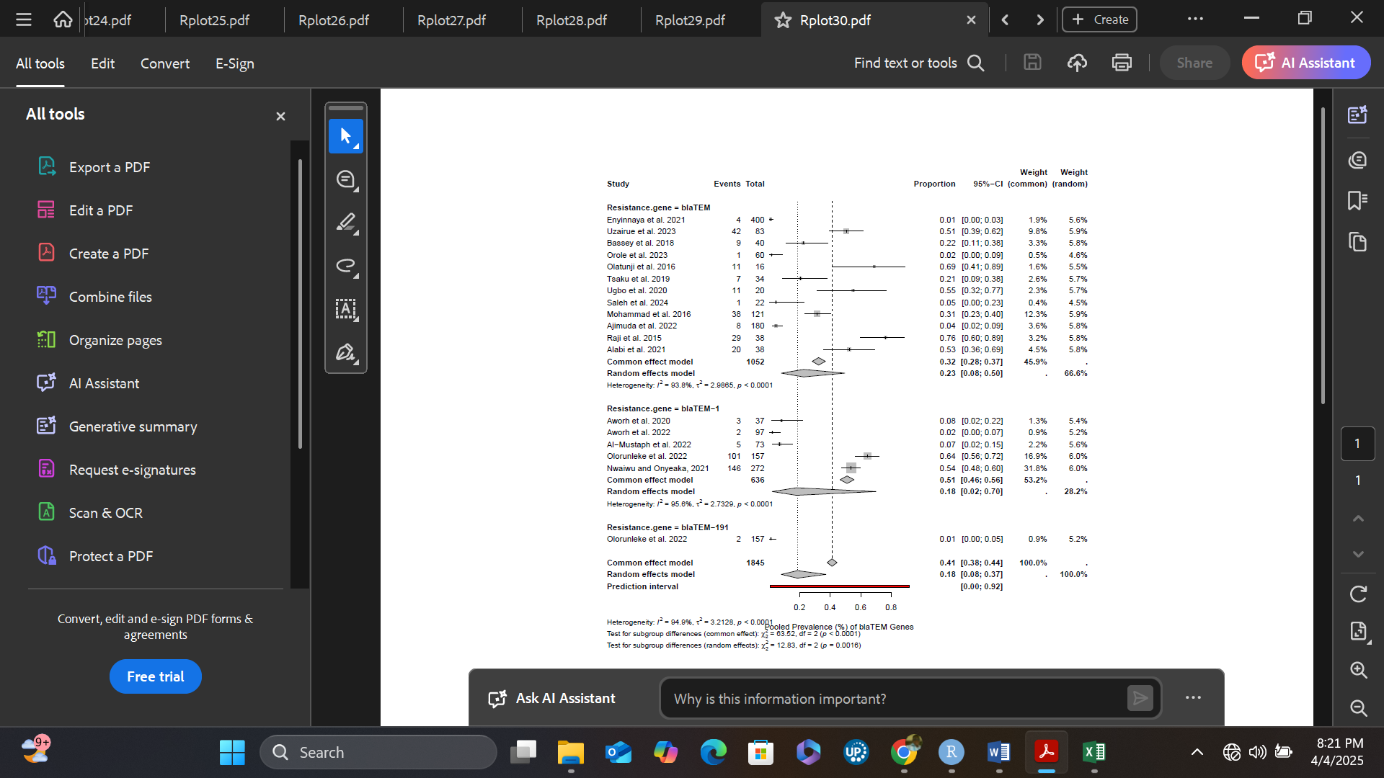

Figure S2. Pooled prevalence of blaTEM genes

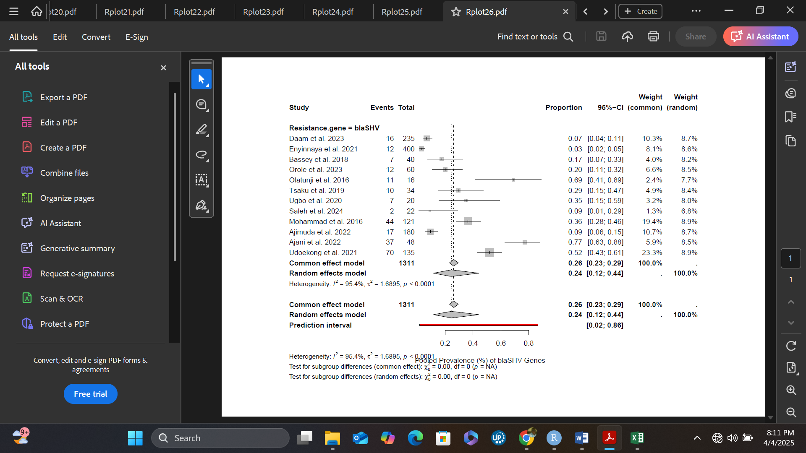

Figure S3. Pooled prevalence of blaSHV genes

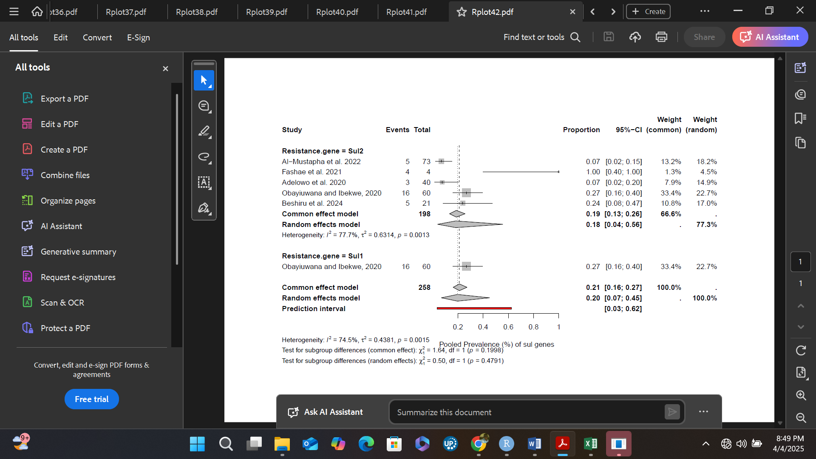

Figure S4. Pooled prevalence of Sul genes

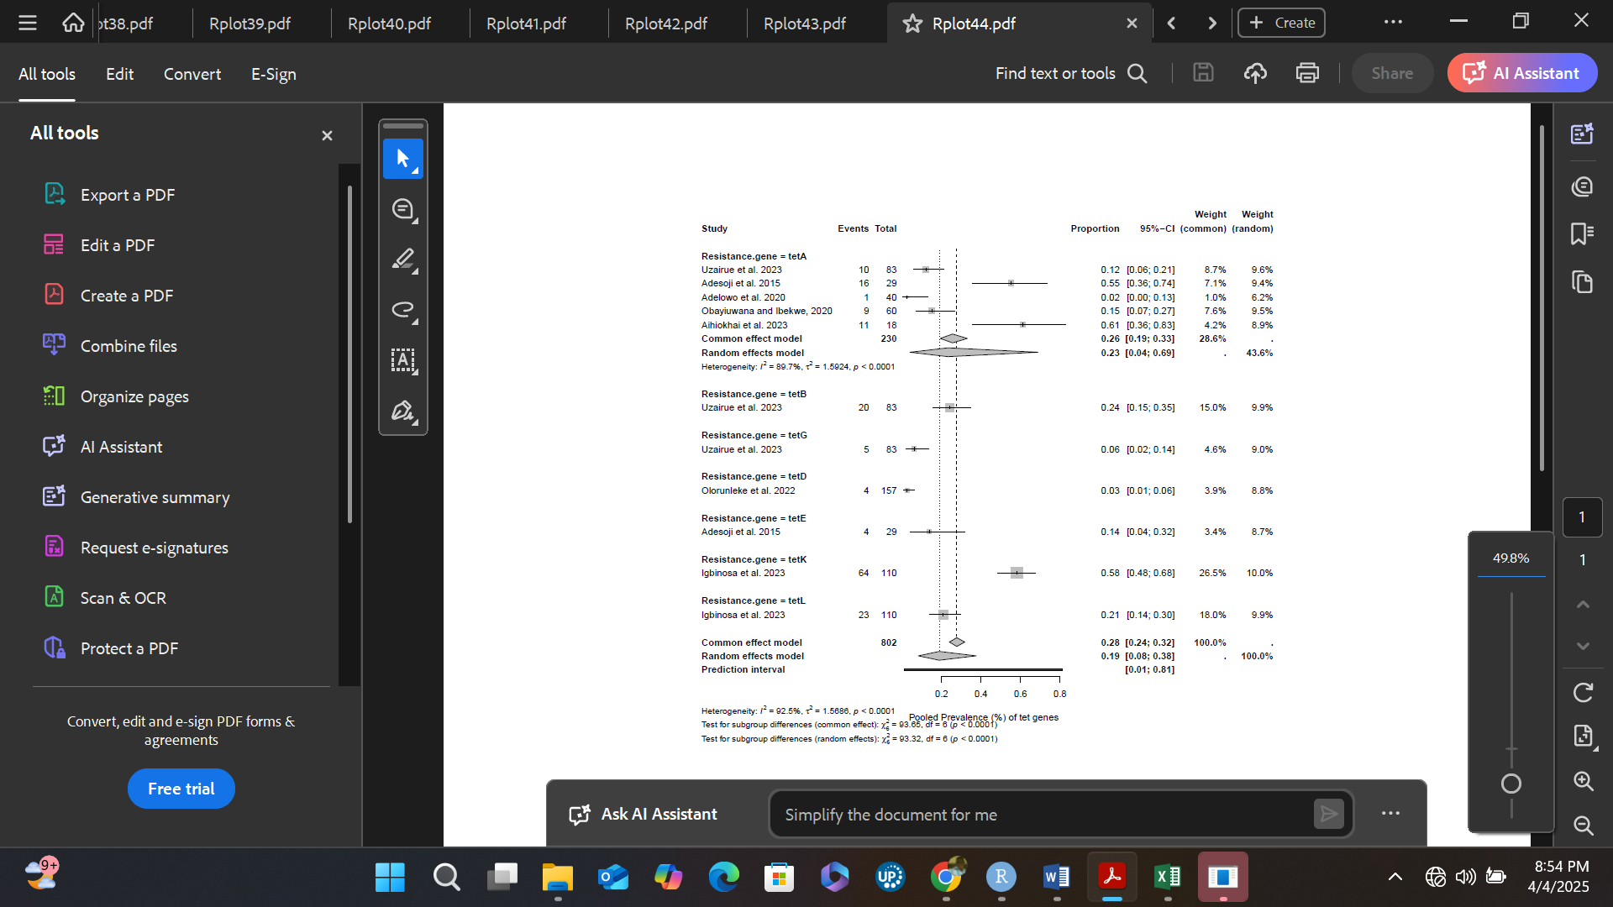

Figure S5. Pooled prevalence of tet genes

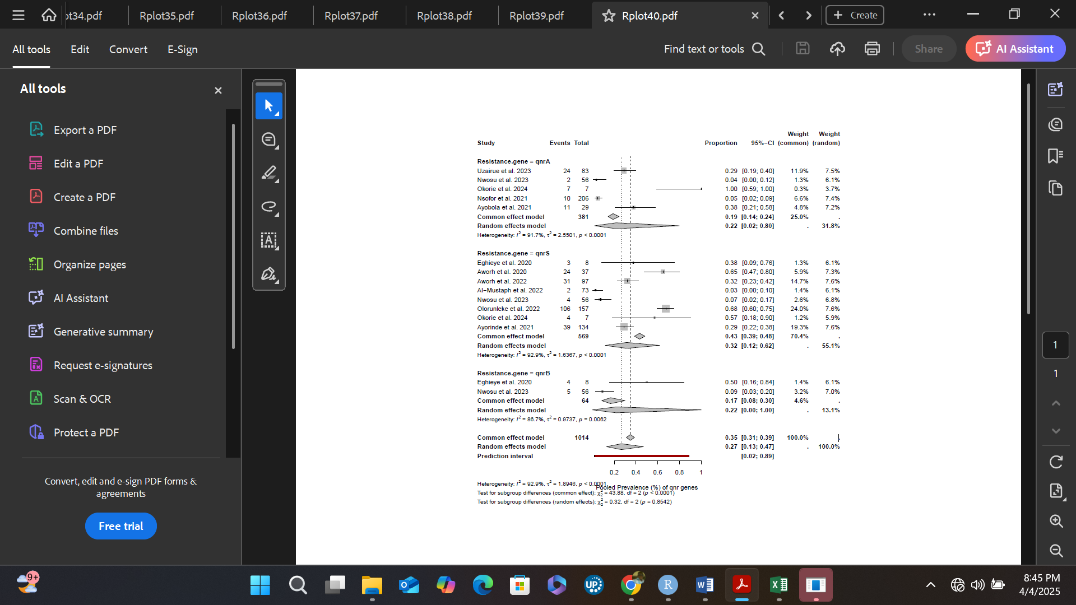

Figure S6. Pooled prevalence of qnr genes

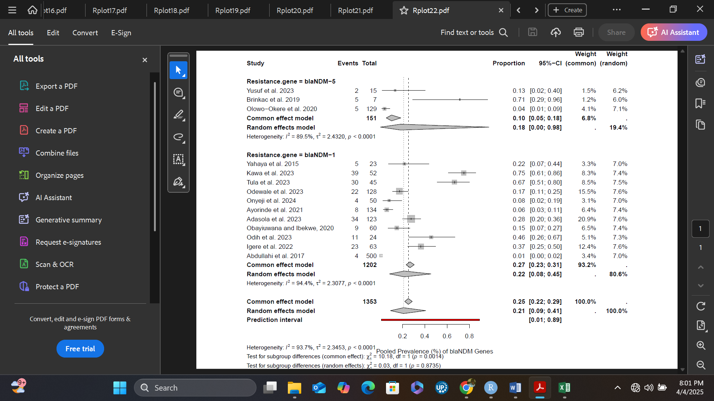
Figure S7. Pooled prevalence of blaNDM genes

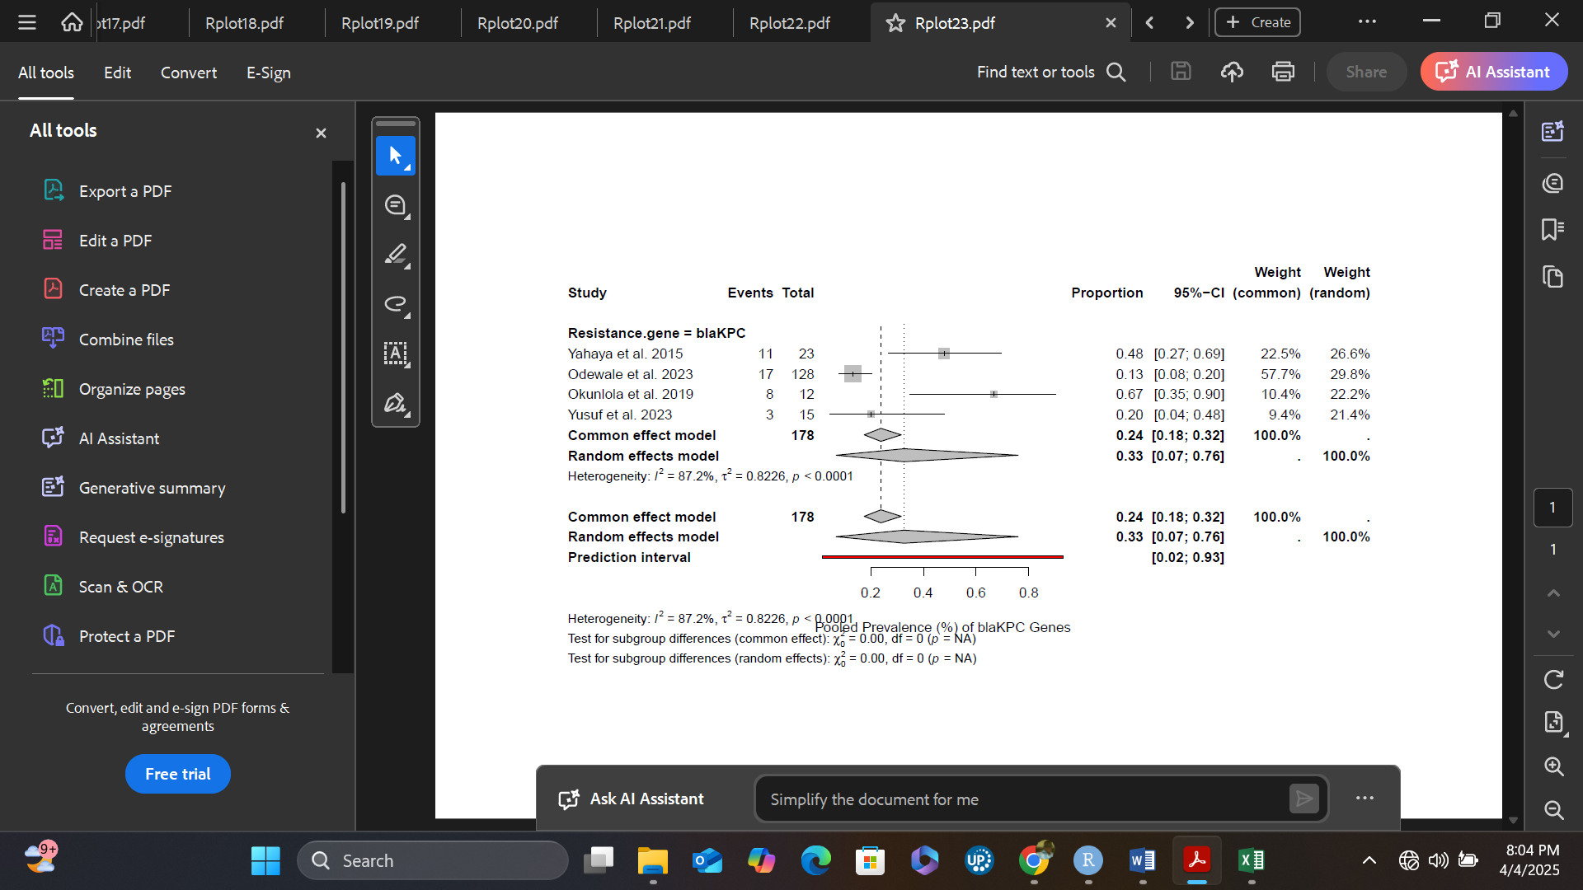
Figure S8. Pooled prevalence of blaKPC genes
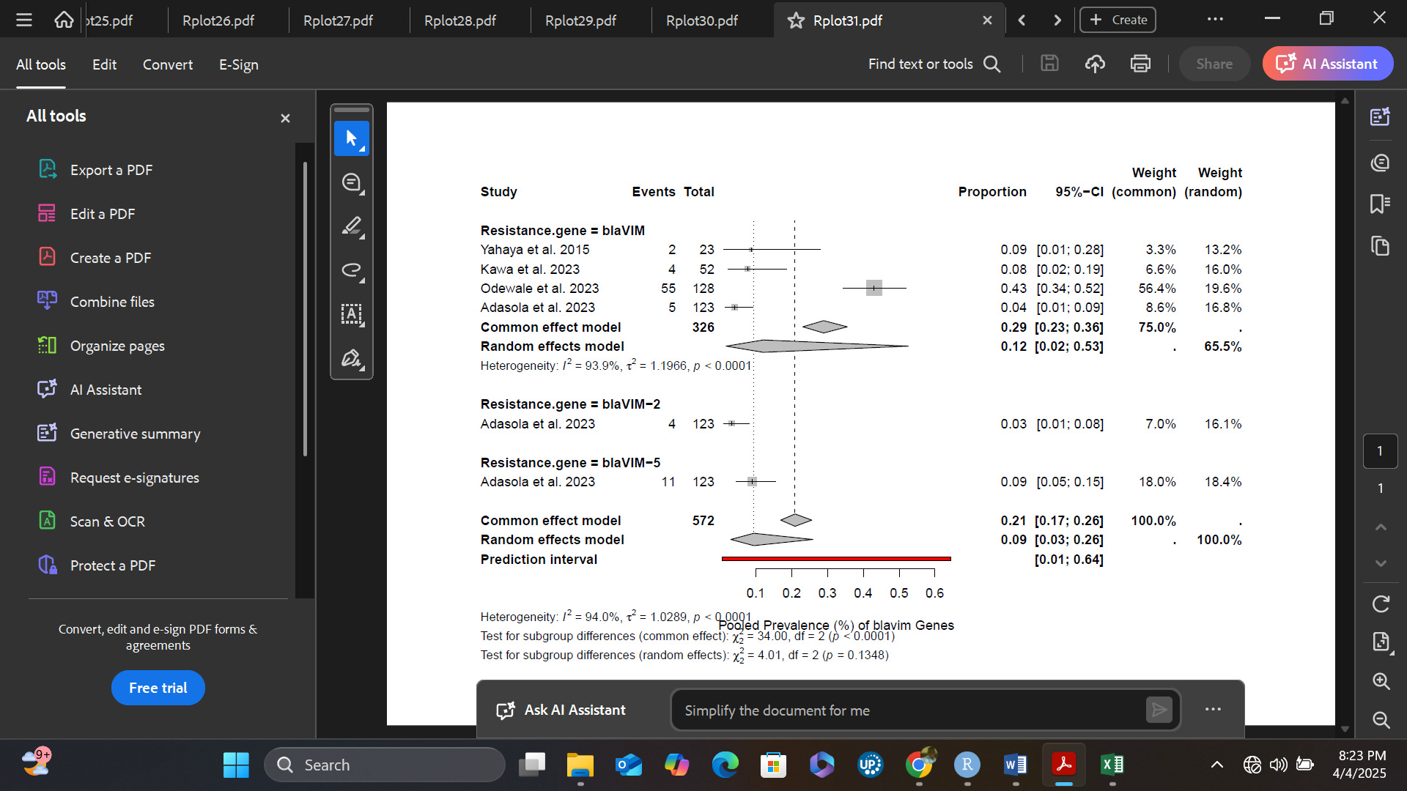
Figure S9. Pooled prevalence of blaVIM genes
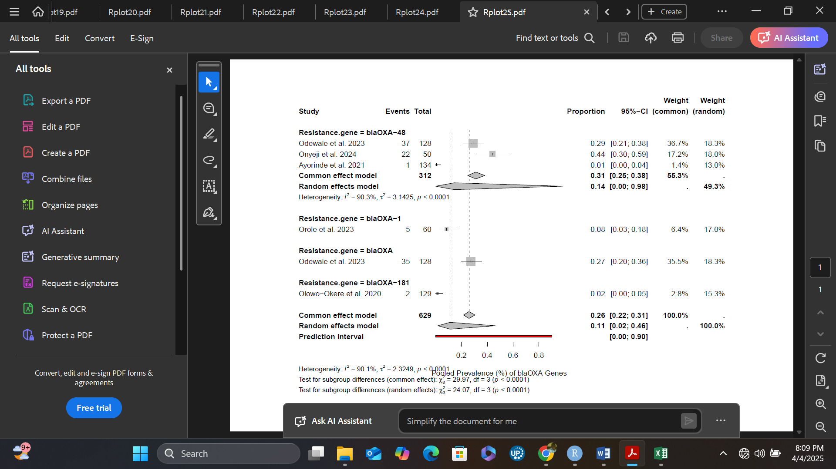
Figure S10. Pooled prevalence of blaOXA genes
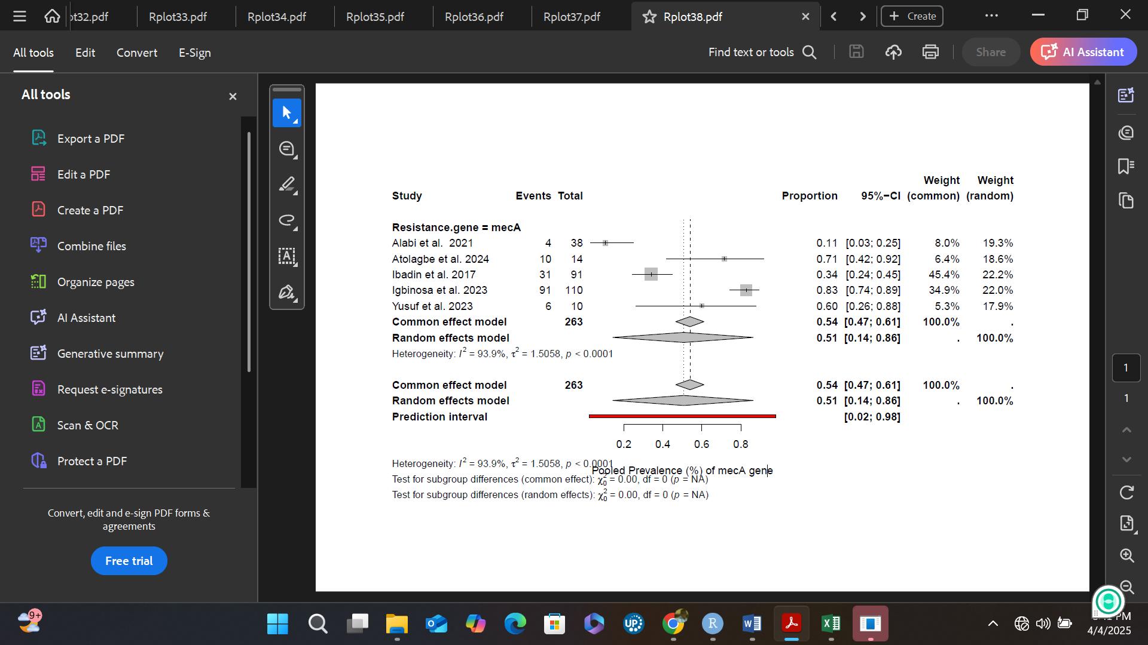
Figure S11. Pooled prevalence of mecA genes
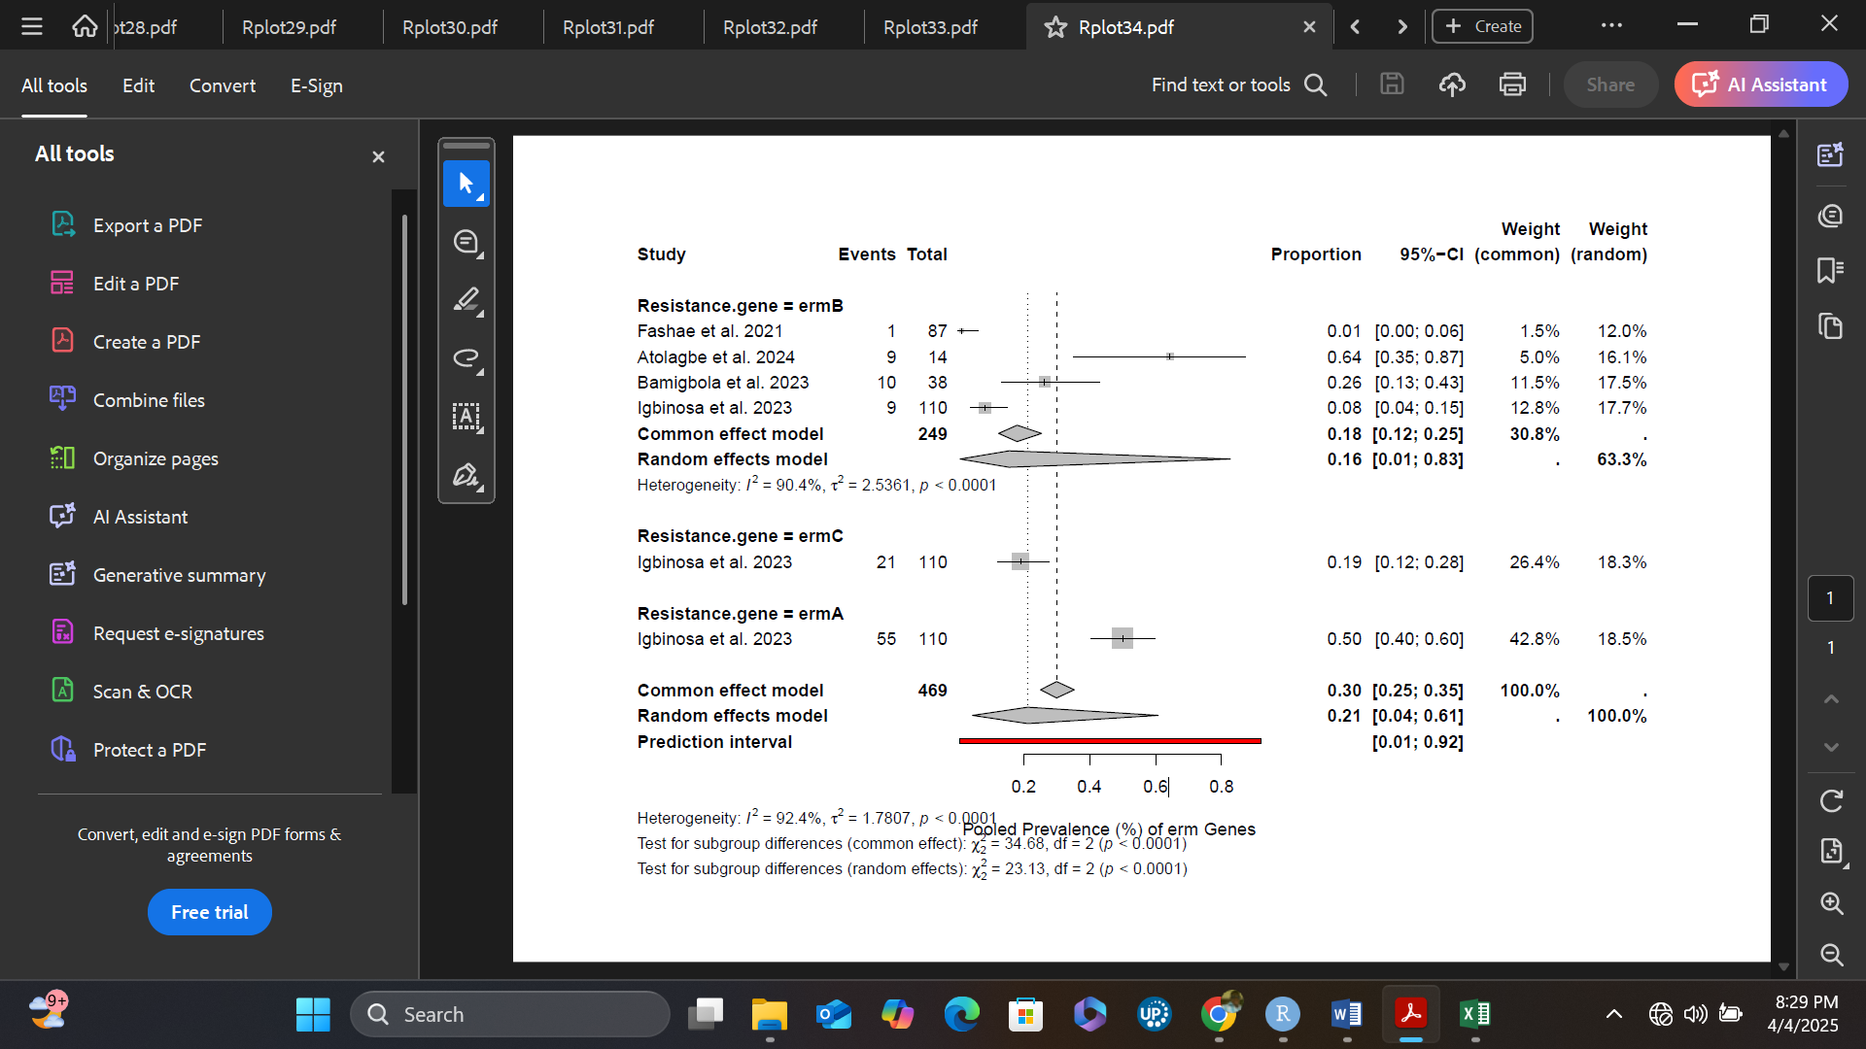
Figure S12. Pooled prevalence of erm genes
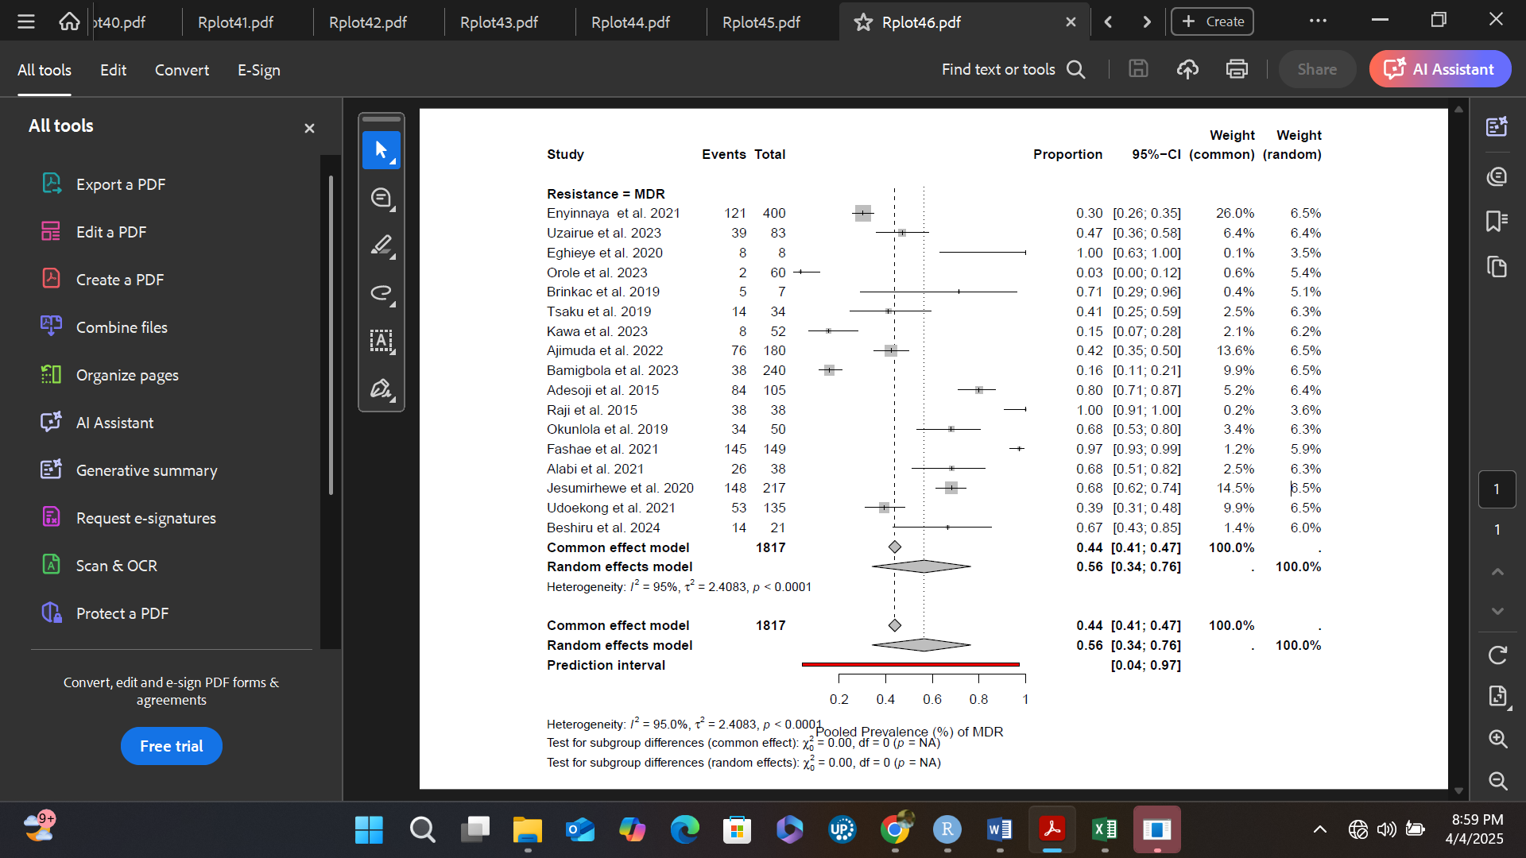
Figure S13. Pooled prevalence of MDR

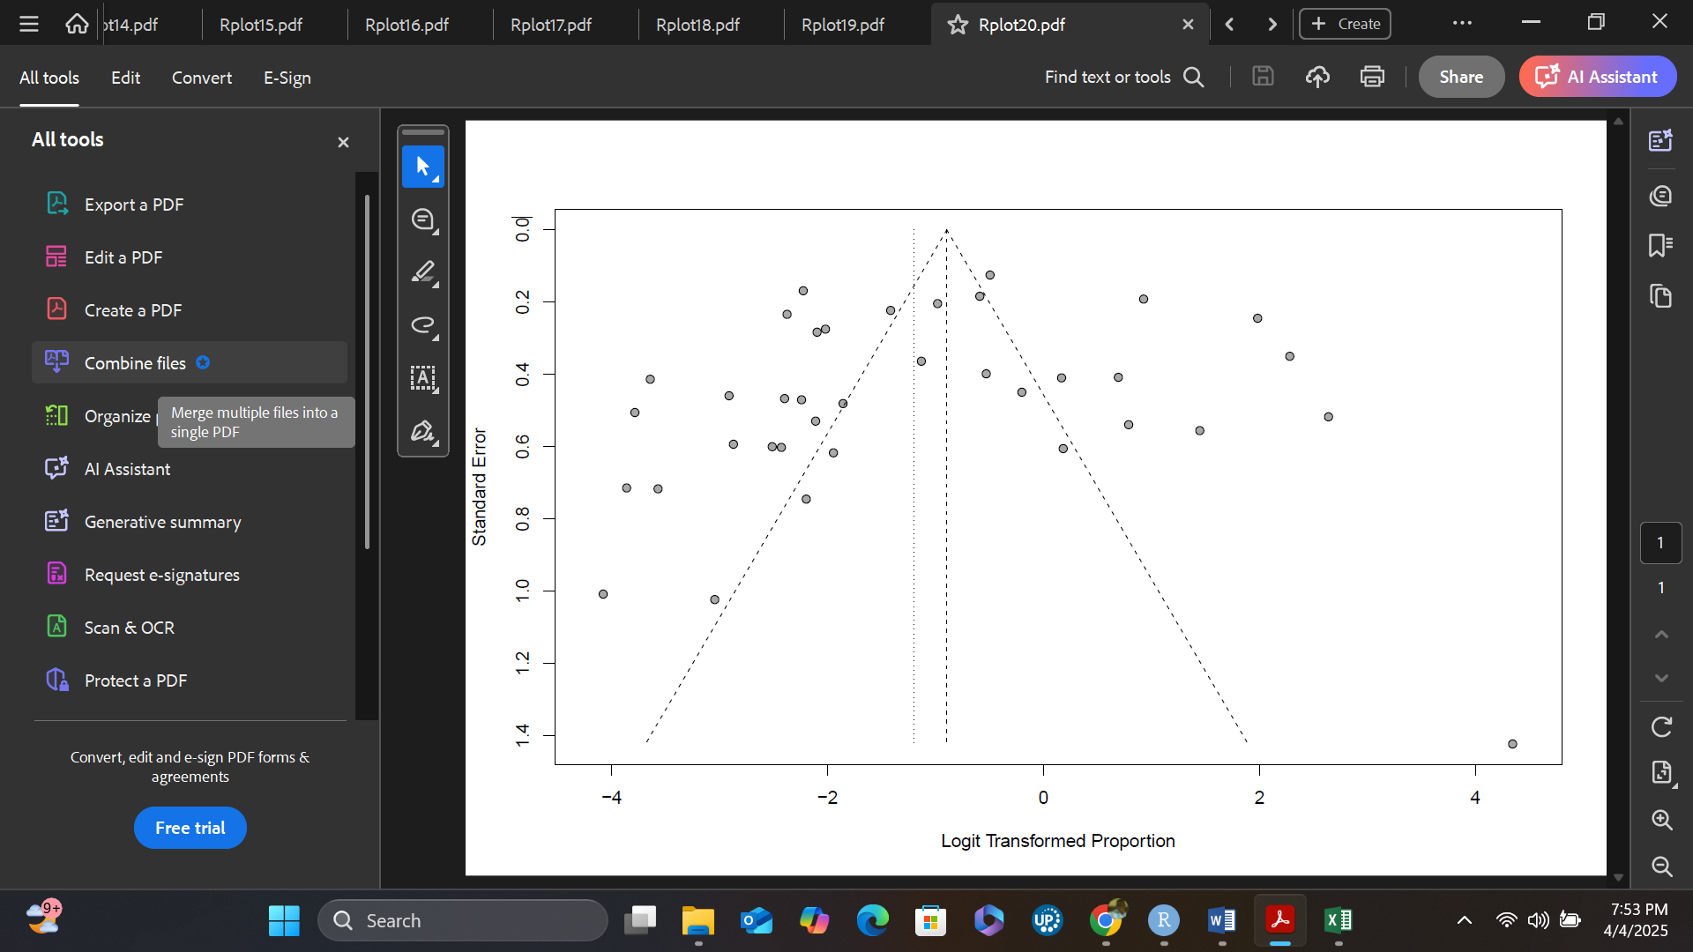
Figure S14. Funnel plot of the studies reporting on the blaCTX-M genes

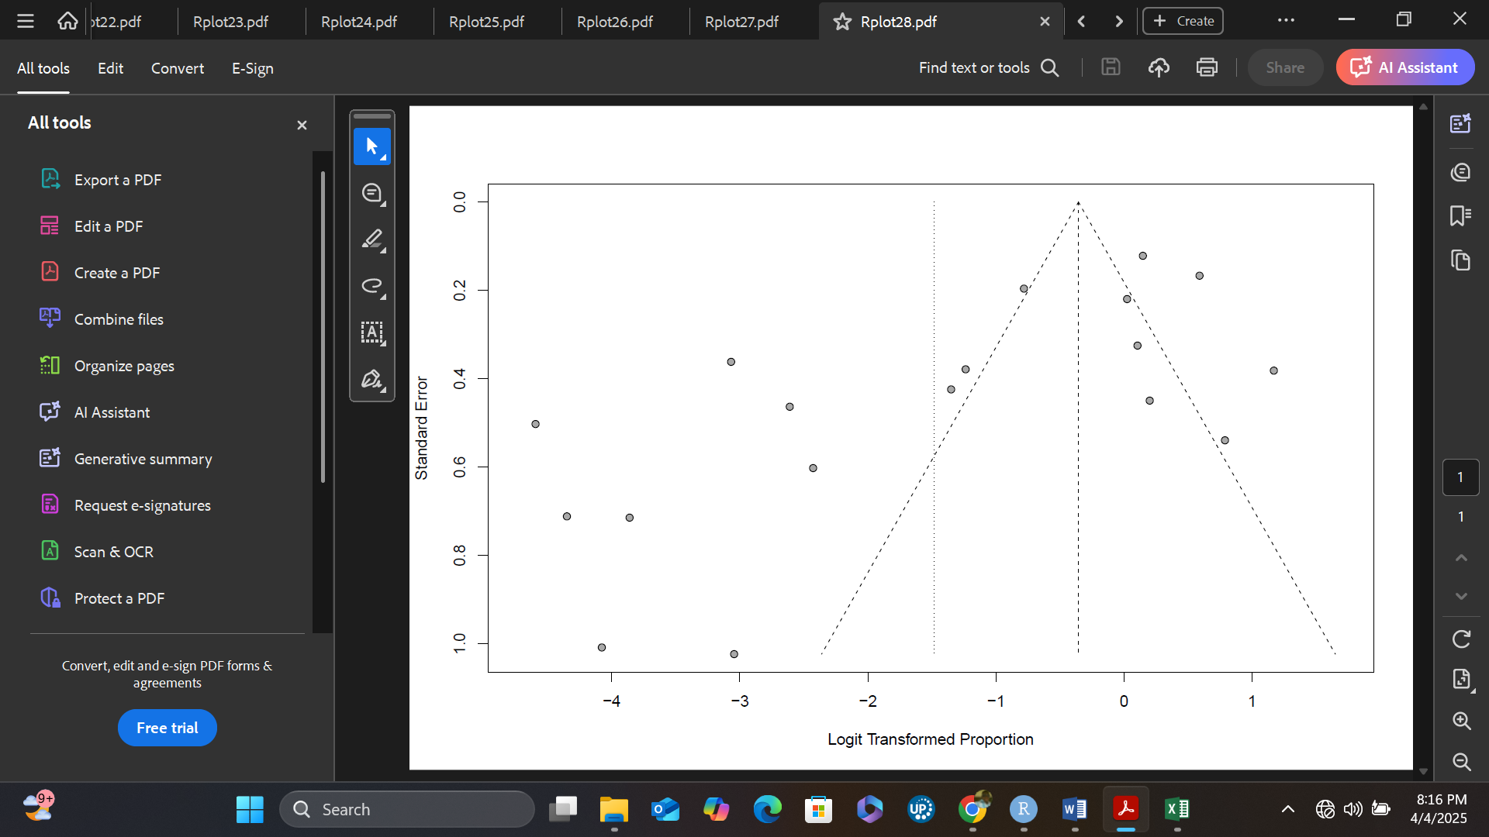
Figure S15. Funnel plot of the studies reporting on the blaTEM genes

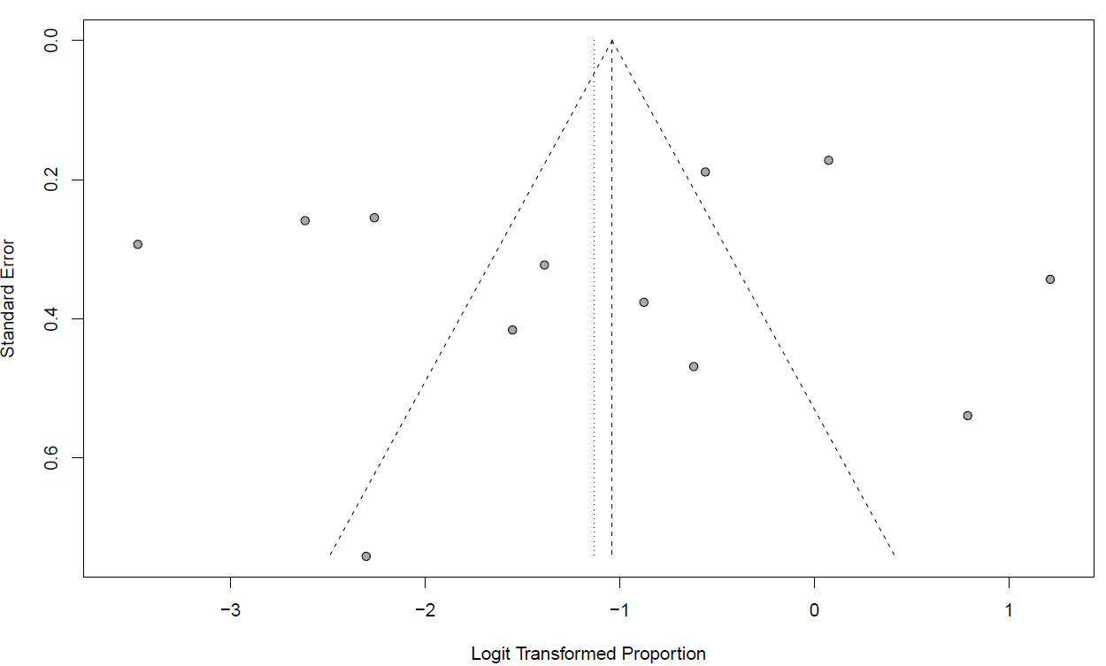
Figure S16. Funnel plot of the studies reporting on the blaSHV genes

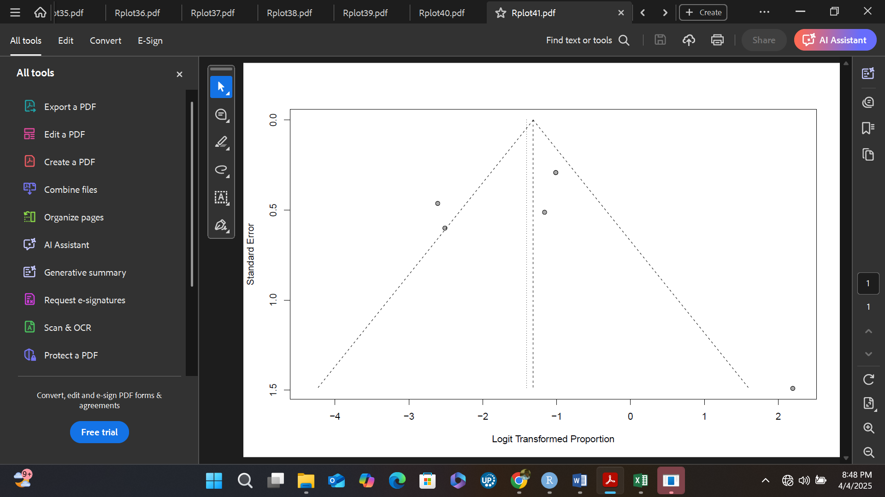
Figure S17. Funnel plot of the studies reporting on the Sul genes

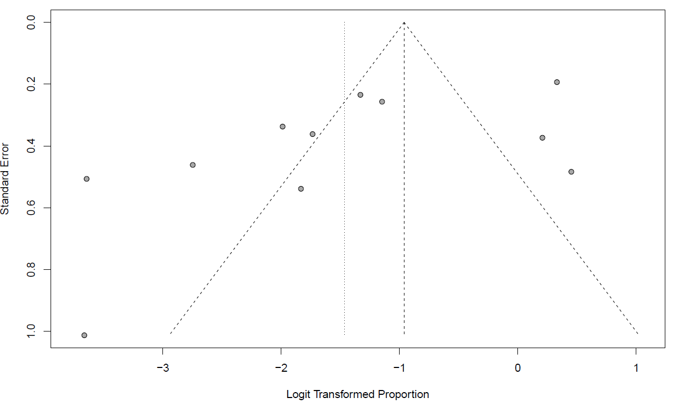
Figure S18. Funnel plot of the studies reporting on the tet genes

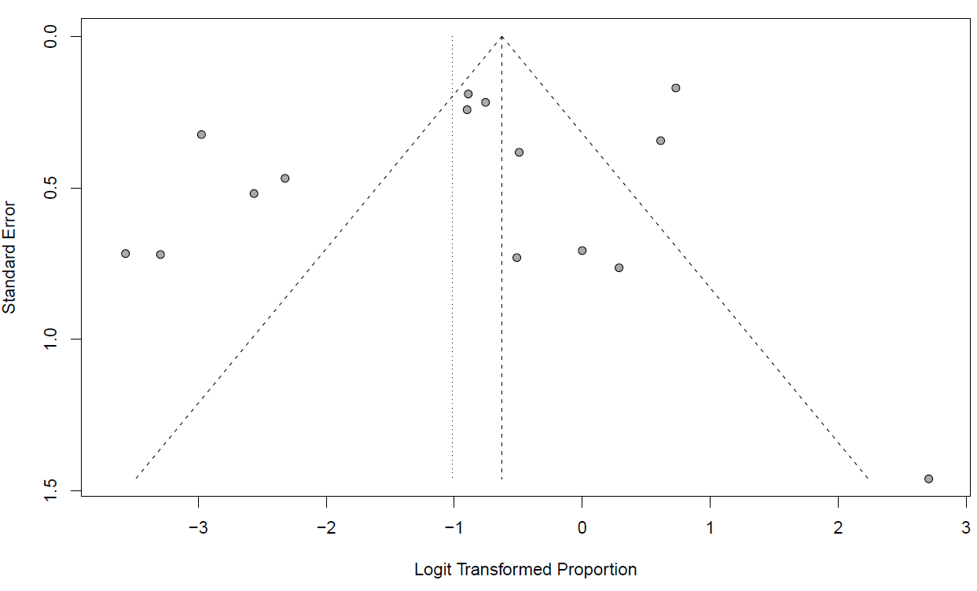
Figure S19. Funnel plot of the studies reporting on the qnr genes

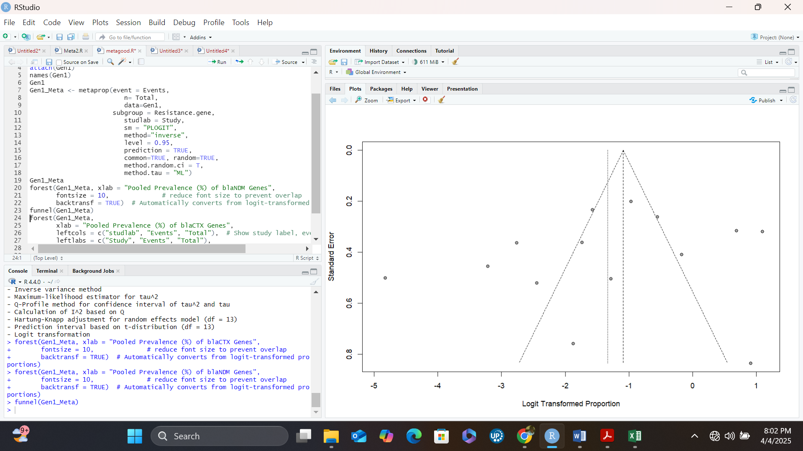
Figure S20. Funnel plot of the studies reporting on the blaNDM genes

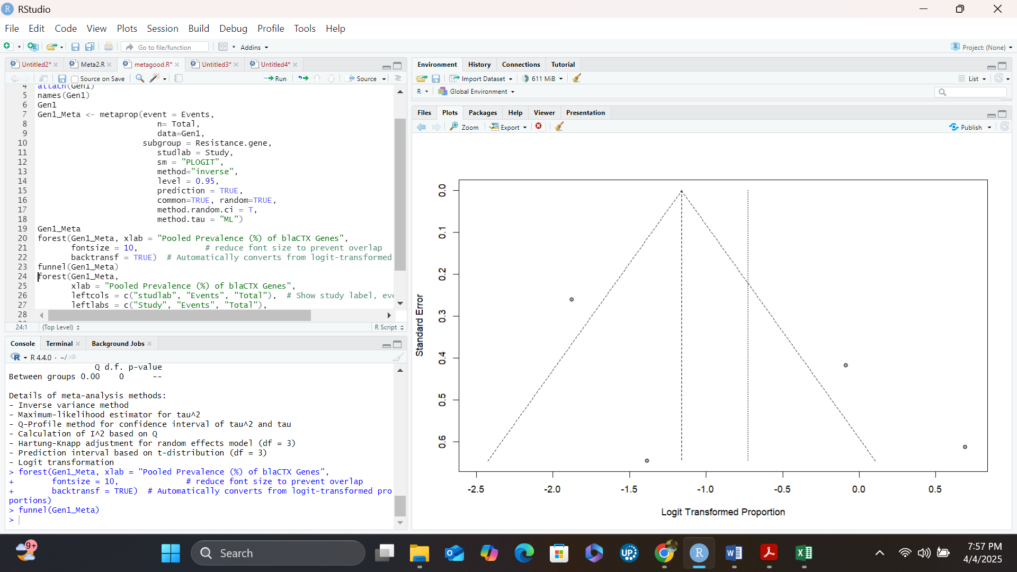
Figure S21. Funnel plot of the studies reporting on the blaKPC genes

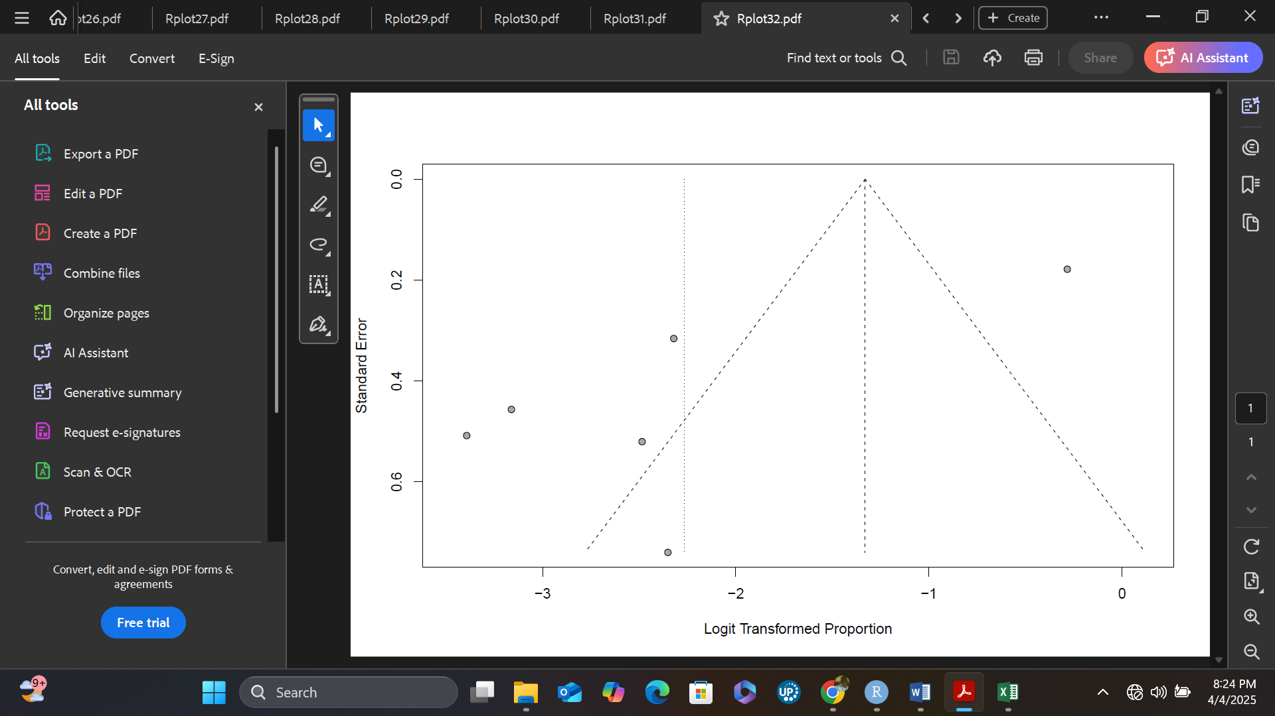
Figure S22. Funnel plot of the studies reporting on the blaVIM genes

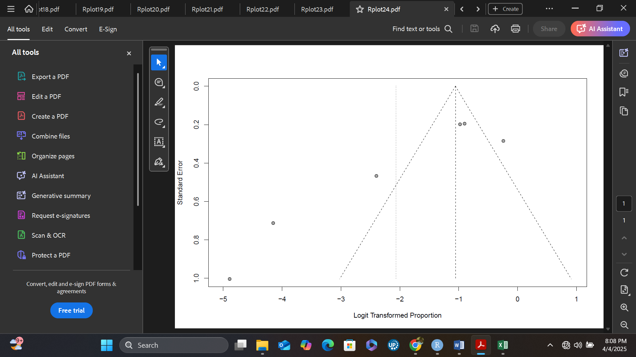
Figure S23. Funnel plot of the studies reporting on the blaOXA genes

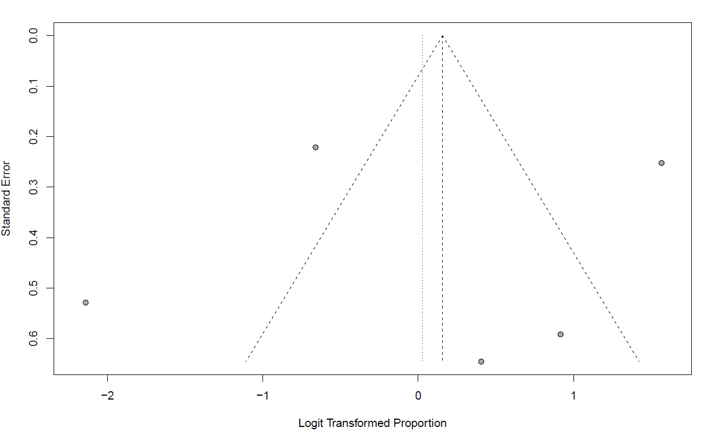
Figure S24. Funnel plot of the studies reporting on the mec genes

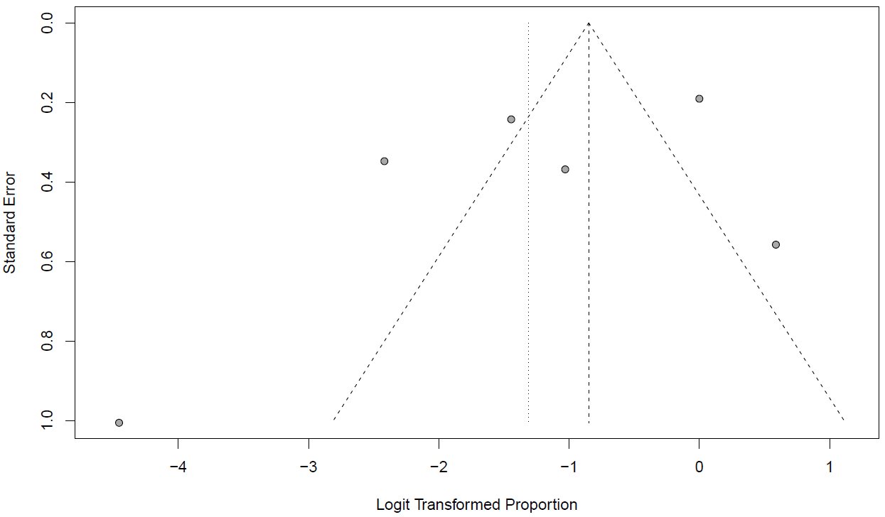
Figure S25. Funnel plot of the studies reporting on the erm genes

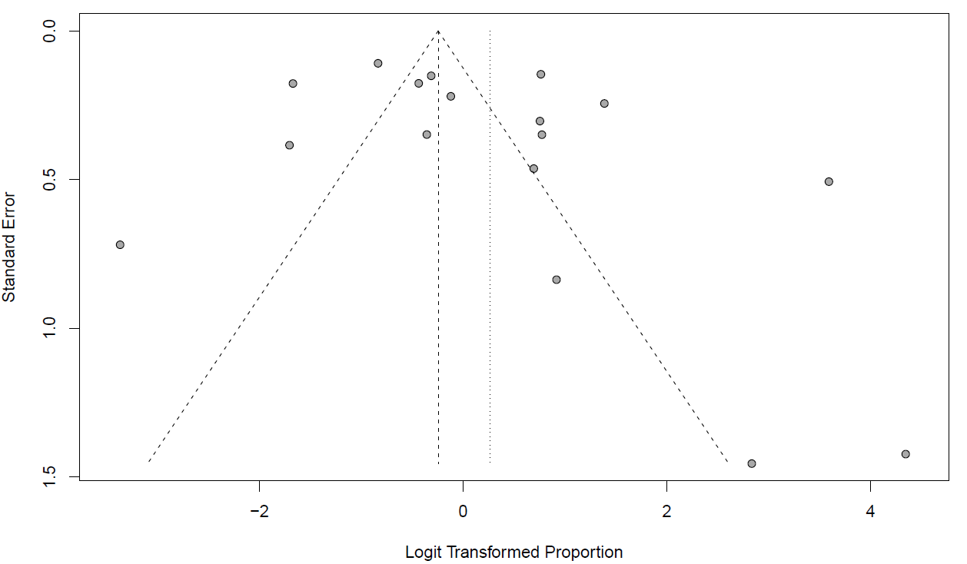
Figure S26. Funnel plot of the studies reporting on the MDR

Table S4. Summary of studies and genes included in the meta-analysis
Study | Total | Events | Resistance gene
Daam et al. 2023 | 235 | 20 | blaCTX-M
Enyinnaya et al. 2021 | 400 | 39 | blaCTX-M
Bassey et al. 2018 | 40 | 3 | blaCTX-M
Aworh et al. 2020 | 37 | 4 | blaCTX-M
Olatunji et al. 2016 | 16 | 11 | blaCTX-M
Nwosu et al. 2023 | 56 | 3 | blaCTX-M
Saleh et al. 2024 | 22 | 1 | blaCTX-M
Mohammad et al. 2016 | 121 | 33 | blaCTX-M
Ajimuda et al. 2022 | 180 | 4 | blaCTX-M
Akinyemi et al. 2022 | 27 | 10 | blaCTX-M
Nzube et al. 2024 | 41 | 10 | blaCTX-M
Adeleke and Owoseni, 2020 | 52 | 5 | blaCTX-M
Olowo-Okere et al. 2020 | 129 | 46 | blaCTX-M
Daam et al. 2023 | 235 | 6 | blaCTX-M-9
Orole et al. 2023 | 60 | 5 | blaCTX-M-9
Odewale et al. 2023 | 128 | 14 | blaCTX-M-9
Fakorede et al. 2023 | 24 | 13 | blaCTX-M-9
Aworh et al. 2020 | 37 | 5 | blaCTX-M-14
Al-Mustaph et al. 2022 | 73 | 2 | blaCTX-M-14
Ugbo et al. 2020 | 20 | 2 | blaCTX-M-14
Aworh et al. 2022 | 97 | 5 | blaCTX-M-14
Aworh et al. 2020 | 37 | 3 | blaCTX-M-15
Al-Mustaph et al. 2023 | 11 | 6 | blaCTX-M-15
Aworh et al. 2022 | 97 | 88 | blaCTX-M-15
Ugbo et al. 2020 | 20 | 9 | blaCTX-M-15
Olorunleke et al. 2022 | 157 | 138 | blaCTX-M-15
Nwaiwu and Onyeaka, 2021 | 272 | 103 | blaCTX-M-15
Odewale et al. 2023 | 128 | 25 | blaCTX-M-15
Ayorinde et al. 2023 | 134 | 96 | blaCTX-M-15
Fakorede et al. 2023 | 24 | 3 | blaCTX-M-15
Ogbolu and Webber, 2022 | 27 | 18 | blaCTX-M-15
Raji et al. 2015 | 38 | 38 | blaCTX-M-15
Jesumirhewe et al. 2020 | 60 | 56 | blaCTX-M-15
Beshiru et al. 2024 | 21 | 17 | blaCTX-M-15
Orole et al. 2023 | 60 | 1 | blaCTX-M-4
Aworh et al. 2022 | 97 | 2 | blaCTX-M-55
Odewale et al. 2023 | 128 | 15 | blaCTX-M-2
Total Summary | 3341 | 859 | blaCTX-M genes
Enyinnaya et al. 2021 | 400 | 4 | blaTEM
Uzairue et al. 2023 | 83 | 42 | blaTEM
Bassey et al. 2018 | 40 | 9 | blaTEM
Orole et al. 2023 | 60 | 1 | blaTEM
Olatunji et al. 2016 | 16 | 11 | blaTEM
Tsaku et al. 2019 | 34 | 7 | blaTEM
Ugbo et al. 2020 | 20 | 11 | blaTEM
Saleh et al. 2024 | 22 | 1 | blaTEM
Mohammad et al. 2016 | 121 | 38 | blaTEM
Ajimuda et al. 2022 | 180 | 8 | blaTEM
Raji et al. 2015 | 38 | 29 | blaTEM
Alabi et al. 2021 | 38 | 20 | blaTEM
Aworh et al. 2020 | 37 | 3 | blaTEM-1
Aworh et al. 2022 | 97 | 2 | blaTEM-1
Al-Mustaph et al. 2022 | 73 | 5 | blaTEM-1
Olorunleke et al. 2022 | 157 | 101 | blaTEM-1
Nwaiwu and Onyeaka, 2021 | 272 | 146 | blaTEM-1
Olorunleke et al. 2022 | 157 | 2 | blaTEM-191
Total Summary | 1845 | 440 | blaTEM genes
Al-Mustapha et al. 2022 | 73 | 5 | Sul2
Fashae et al. 2021 | 4 | 4 | Sul2
Adelowo et al. 2020 | 40 | 3 | Sul2
Obayiuwana and Ibekwe, 2020 | 60 | 16 | Sul2
Beshiru et al. 2024 | 21 | 5 | Sul2
Obayiuwana and Ibekwe, 2020 | 60 | 16 | Sul1
Total Summary | 258 | 33 | Sul genes
Uzairue et al. 2023 | 83 | 10 | tetA
Adesoji et al. 2015 | 29 | 16 | tetA
Adelowo et al. 2020 | 40 | 1 | tetA
Obayiuwana and Ibekwe, 2020 | 60 | 9 | tetA
Aihiokhai et al. 2023 | 18 | 11 | tetA
Uzairue et al. 2023 | 83 | 20 | tetB
Uzairue et al. 2023 | 83 | 5 | tetG
Olorunleke et al. 2022 | 157 | 4 | tetD
Adesoji et al. 2015 | 29 | 4 | tetE
Igbinosa et al. 2023 | 110 | 64 | tetK
Igbinosa et al. 2023 | 110 | 23 | tetL
Total Summary | 802 | 167 | tet genes
Uzairue et al. 2023 | 83 | 24 | qnrA
Nwosu et al. 2023 | 56 | 2 | qnrA
Okorie et al. 2024 | 7 | 7 | qnrA
Nsofor et al. 2021 | 206 | 10 | qnrA
Ayobola et al. 2021 | 29 | 11 | qnrA
Eghieye et al. 2020 | 8 | 3 | qnrS
Aworh et al. 2020 | 37 | 24 | qnrS
Aworh et al. 2022 | 97 | 31 | qnrS
Al-Mustaph et al. 2022 | 73 | 2 | qnrS
Nwosu et al. 2023 | 56 | 4 | qnrS
Olorunleke et al. 2022 | 157 | 106 | qnrS
Okorie et al. 2024 | 7 | 4 | qnrS
Ayorinde et al. 2021 | 134 | 39 | qnrS
Eghieye et al. 2020 | 8 | 4 | qnrB
Nwosu et al. 2023 | 56 | 5 | qnrB
Total Summary | 1014 | 276 | qnr genes
Yusuf et al. 2023 | 15 | 2 | blaNDM-5
Brinkac et al. 2019 | 7 | 5 | blaNDM-5
Olowo-Okere et al. 2020 | 129 | 5 | blaNDM-5
Yahaya et al. 2015 | 23 | 5 | blaNDM-1
Kawa et al. 2023 | 52 | 39 | blaNDM-1
Tula et al. 2023 | 45 | 30 | blaNDM-1
Odewale et al. 2023 | 128 | 22 | blaNDM-1
Onyeji et al. 2024 | 50 | 4 | blaNDM-1
Ayorinde et al. 2021 | 134 | 8 | blaNDM-1
Adasola et al. 2023 | 123 | 34 | blaNDM-1
Obayiuwana and Ibekwe, 2020 | 60 | 9 | blaNDM-1
Odih et al. 2023 | 24 | 11 | blaNDM-1
Igere et al. 2022 | 63 | 23 | blaNDM-1
Abdullahi et al. 2017 | 500 | 4 | blaNDM-1
Total Summary | 1353 | 201 | blaNDM genes
Yahaya et al. 2015 | 23 | 11 | blaKPC
Odewale et al. 2023 | 128 | 17 | blaKPC
Okunlola et al. 2019 | 12 | 8 | blaKPC
Yusuf et al. 2023 | 15 | 3 | blaKPC
Total Summary | 178 | 39 | blaKPC genes
Yahaya et al. 2015 | 23 | 2 | blaVIM
Kawa et al. 2023 | 52 | 4 | blaVIM
Odewale et al. 2023 | 128 | 55 | blaVIM
Adasola et al. 2023 | 123 | 5 | blaVIM
Adasola et al. 2023 | 123 | 4 | blaVIM-2
Adasola et al. 2023 | 123 | 11 | blaVIM-5
Total Summary | 572 | 81 | blaVIM genes
Odewale et al. 2023 | 128 | 37 | blaOXA-48
Onyeji et al. 2024 | 50 | 22 | blaOXA-48
Ayorinde et al. 2021 | 134 | 1 | blaOXA-48
Orole et al. 2023 | 60 | 5 | blaOXA-1
Odewale et al. 2023 | 128 | 35 | blaOXA
Olowo-Okere et al. 2020 | 129 | 2 | blaOXA-181
Total Summary | 629 | 102 | blaOXA genes
Alabi et al. 2021 | 38 | 4 | mecA
Atolagbe et al. 2024 | 14 | 10 | mecA
Ibadin et al. 2017 | 91 | 31 | mecA
Igbinosa et al. 2023 | 110 | 91 | mecA
Yusuf et al. 2023 | 10 | 6 | mecA
Total Summary | 263 | 142 | mec genes
Daam et al. 2023 | 235 | 16 | blaSHV
Enyinnaya et al. 2021 | 400 | 12 | blaSHV
Bassey et al. 2018 | 40 | 7 | blaSHV
Orole et al. 2023 | 60 | 12 | blaSHV
Olatunji et al. 2016 | 16 | 11 | blaSHV
Tsaku et al. 2019 | 34 | 10 | blaSHV
Ugbo et al. 2020 | 20 | 7 | blaSHV
Saleh et al. 2024 | 22 | 2 | blaSHV
Mohammad et al. 2016 | 121 | 44 | blaSHV
Ajimuda et al. 2022 | 180 | 17 | blaSHV
Ajani et al. 2022 | 48 | 37 | blaSHV
Udoekong et al. 2021 | 135 | 70 | blaSHV
Total Summary | 1311 | 245 | blaSHV genes
Fashae et al. 2021 | 87 | 1 | ermB
Atolagbe et al. 2024 | 14 | 9 | ermB
Bamigbola et al. 2023 | 38 | 10 | ermB
Igbinosa et al. 2023 | 110 | 9 | ermB
Igbinosa et al. 2023 | 110 | 21 | ermC
Igbinosa et al. 2023 | 110 | 55 | ermA
Total Summary | 469 | 105 | erm genes
Enyinnaya et al. 2021 | 400 | 121 | MDR
Uzairue et al. 2023 | 83 | 39 | MDR
Eghieye et al. 2020 | 8 | 8 | MDR
Orole et al. 2023 | 60 | 2 | MDR
Brinkac et al. 2019 | 7 | 5 | MDR
Tsaku et al. 2019 | 34 | 14 | MDR
Kawa et al. 2023 | 52 | 8 | MDR
Ajimuda et al. 2022 | 180 | 76 | MDR
Bamigbola et al. 2023 | 240 | 38 | MDR
Adesoji et al. 2015 | 105 | 84 | MDR
Raji et al. 2015 | 38 | 38 | MDR
Okunlola et al. 2019 | 50 | 34 | MDR
Fashae et al. 2021 | 149 | 145 | MDR
Alabi et al. 2021 | 38 | 26 | MDR
Jesumirhewe et al. 2020 | 217 | 148 | MDR
Udoekong et al. 2021 | 135 | 53 | MDR
Beshiru et al. 2024 | 21 | 14 | MDR
Total Summary | 1817 | 853 | MDR

References
- Daam KC, Samuel DA, Nwokoro U, Waziri H, Onyedibe K, Okolo M, Edmund B, Olayinka A, Zanyu ED. Detection of CTX-M and SHV genes in Extended Spectrum Beta-Lactamase producing Klebsiella pneumoniae and Pseudomonas aeruginosa in a Tertiary Hospital in North-central Nigeria. Niger Med J. 2023; 64(2):196-204.

- Enyinnaya SO, Iregbu KC, Jamal WY, Rotimi VO. Antibiotic susceptibility profiles and detection of genes mediating extendedspectrum β-lactamase (Esbl) production in Escherichia coli isolates from National Hospital, Abuja. Niger J Clin Pract. 2022; 25:1216-20. DOI: 10.4103/njcp.njcp_1390_21.

- Uzairue LI, Olufunke BS, Ojo OE, Obuotor TM, Olanipekun G, Ajose T, et al. Antimicrobial resistance and virulence genes of invasive Salmonella enterica from children with bacteremia in north-central Nigeria. SAGE Open Medicine. 2023; 11: 1–13. DOI: 10.1177/20503121231175322.

- Bassey A, Ngwai YB, Bassey BE, Nkene IH, Abimiku RH Parom SK. Phenotypic and Molecular Detection of Extended Spectrum β-Lactamase in Escherichia coli from Patients in Nigerian National Petroleum Corporation Medical Services, Abuja, Nigeria. Annual Research and Review in Biology. 2018; 28(4): 1-7.

- Eghieye MO, Nkene I H, Abimiku RH, Ngwai YB, Yahaya I, Parom SK. Molecular detection of plasmid-mediated Quinolone resistance in ciprofloxacine resistant E. coli from urine of patients attending Garki Hospital Abuja Nigeria. European Journal of Biology and Biotechnology. 2020; 1(4):1-7. DOI: http://dx.doi.org/10.24018/ejbio.2020.1.4.60.

- Orole OO, Jebes NL, Aleruchi C. Phylogenetic Characterization of Resistant Salmonella Strains in Typhoid Fever Patients in Nigeria. Bioinformatics and Biology Insights. 2024; 18: 1–5. DOI: 10.1177/11779322231220194.

- Brinkac LM, White R, D’Souza R, Nguyen K, Obaro SK, Fouts DE. Emergence of New Delhi metallo-β-lactamase (NDM-5) in Klebsiella quasipneumoniae from neonates in a Nigerian hospital. mSphere. 2019; 4: e00685-18. https://doi.org/10.1128/mSphere.00685-18.

- Aworh MK, Kwaga J, Okolocha E, Harden L, Hull D, Hendriksen RS, et al. Extended-spectrum ß-lactamase-producing Escherichia coli among humans, chickens and poultry environments in Abuja, Nigeria. One Health Outlook. 2020; 2:8 :2-11. https://doi.org/10.1186/s42522-020-00014-7.

- Al-Mustapha AI, Raufu IA, Ogundijo OA. Antibiotic resistance genes, mobile elements, virulence genes, and phages in cultivated ESBLproducing Escherichia coli of poultry origin in Kwara State, North Central Nigeria, International Journal of Food Microbiology. 2023; 110086. https://doi.org/10.1016/j.ijfoodmicro.2023.110086

- Aworh MK, Ekeng E, Nilsson P, Egyir B, Owusu-Nyantakyi C, Hendriksen RS. Extended-Spectrum ß-Lactamase- Producing Escherichia coli Among Humans, Beef Cattle, and Abattoir Environments in Nigeria. Front. Cell. Infect. Microbiol. 2022; 12:869314. doi: 10.3389/fcimb.2022.869314.

- Al-Mustapha AI, Shafi AA, Ibrahim AR, Lawal AN, Eskola K, Brouwer MS, et al. Co-occurrence of antibiotic and disinfectant resistance genes in extensively drug-resistant Escherichia coli isolated from broilers in Ilorin, North Central Nigeria. Journal of Global Antimicrobial Resistance. 2022; 31: 337–344. https://doi.org/10.1016/j.jgar.2022.11.002.

- Olatunji MK, Olayemi A, Jimoh F. Distribution Profile of Extended Spectrum Beta Lactamase (ESBL) Producing Escherichia coli Isolates from Asa River (Nigeria). J. Appl. Sci. Environ. Manage. 2016; 20 (4) 973-977. http://dx.doi.org/10.4314/jasem.v20i4.9

- Tsaku PA, Ngwai YB, Pennap GR, Ishaleku D, Ibrahim T, Nkene IH, et al. Extended-Spectrum Beta-Lactamase–production in Escherichia coli isolated from door handles in Nasarawa State University, Keffi, Nigeria. Heliyon. 2019; 5; e02177. https://doi.org/10.1016/j.heliyon.2019.e02177

- Ugbo EN, Anyamene CO, Moses IB, Iroha IR, Babalola OO, Ukpai EG, et al. Prevalence of blaTEM, blaSHV, and blaCTX-M genes among extended spectrum beta-lactamase-producing Escherichia coli and Klebsiella pneumoniae of clinical origin. Gene Reports. 2020; 21: 100909. https://doi.org/10.1016/j.genrep.2020.100909.

- Nwosu UO, Ibiam FA, Amadi-Ibiam CO, Iroha CS, Edemekong CI, Peter IU, et al. Fecal carriage of extended spectrum beta-lactamase and fluoroquinolone resistant gene in non-typhoidal Salmonella enterica isolates from food producing animals and humans, Journal of Drug Delivery and Therapeutics. 2023; 13(9):128-134. DOI: http://dx.doi.org/10.22270/jddt.v13i9.5964

- Olorunleke SO, Kirchner M, Duggett N, AbuOun M, Okorie-Kanu OJ, Stevens K, et al. Molecular characterization of extended spectrum cephalosporin resistant Escherichia coli isolated from livestock and in contact humans in Southeast Nigeria. Front. Microbiol. 2022; 13:937968. doi: 10.3389/fmicb.2022.937968.

- Okorie CN, Emencheta SC, Ezeugwu DN, Iganga JC, Nkereuwem RN, Ozioko CC, et al. Molecular Characterization and Resistance Profiling of Multidrug-Resistance Salmonella species Isolated from Southeast Nigerian River. Trop J Nat Prod Res. 2024; 8(4):7006-7011. https://doi.org/10.26538/tjnpr/v8i4.36

- Nwaiwu O, Onyeaka H. Acquired antimicrobial resistance genes of Escherichia coli obtained from Nigeria: in silico genome analysis. Journal of Food Quality and Hazards Control. 2021; 8: 186-189. DOI: 10.18502/jfqhc.8.4.8260.

- Saleh ZM, Michael G, Adamu MT, Manga MM, Garba L. Molecular Detection of Extended-Spectrum Beta-Lactamase (ESβL)-Encoding Genes among Clinical Isolates of Enterobacteriaceae from Federal Teaching Hospital Gombe State Nigeria. Nig. J. Biotech. 2024; 41(1):175-190. DOI: https://dx.doi.org/10.4314/njb.v41i1.19

- Mohammed Y, Galadima BG, Sambo BZ, Aboderin AO. Characterization of Extended-Spectrum Beta-lactamase from Escherichia coli and Klebsiella species from Nigeria. Journal of Clinical and Diagnostic Research. 2016; 10(2): DC07-DC10. DOI: 10.7860/JCDR/2016/16330.7254

- Yahaya M, Zailani SB, Onipede AO. Characterization of KPC, NDM and VIM Type Carbapenem Resistance Enterobacteriaceae from North Eastern, Nigeria. Journal of Biosciences and Medicines. 2015; 3: 100-107. http://dx.doi.org/10.4236/jbm.2015.311013

- Kawa DE, Tickler IA, Tenover FC, Shettima SA. Characterization of Beta-Lactamase and Fluoroquinolone Resistance Determinants in Escherichia coli, Klebsiella pneumoniae and Pseudomonas aeruginosa Isolates from a Tertiary Hospital in Yola, Nigeria. Trop. Med. Infect. Dis. 2023; 8 (500): 2-13. https://doi.org/10.3390/tropicalmed8110500.

- Tula MY, Enabulele OI, Ophori EA, Okojie RO, Joel F. Emergence of New Delhi metallo-β-lactamase-1 (NDM-1) producing Enterobacterales from water sources: an impending public health challenge in Adamawa-north senatorial zone, Nigeria. Afr. J. Clin. Exper. Microbiol. 2023; 24 (3): 258 – 265. https://dx.doi.org/10.4314/ajcem.v24i3.5

- Ajimuda OE, Sanmi-Kayode I, Adeniyi OO, Alaka OO, Onipede A. Prevalence of extended spectrum Beta-Lactamase producing Klebsiella species from patients’ specimens in a Tertiary Teaching Hospital in Ile-Ife, Southwest Nigeria. Afri Health Sci. 2022; 22(2):146-155. https://dx.doi.org/10.4314/ahs.v22i2.17

- Odewale G, Jibola-Shittu MY, Ojurongbe O, Olowe RA, Olowe OA. Genotypic Determination of Extended Spectrum Beta-Lactamases and Carbapenemase Production in Clinical Isolates of Klebsiella pneumoniae in Southwest Nigeria. Infect. Dis. Rep. 2023; 15: 339–353. https://doi.org/10.3390/idr15030034

- Bamigbola F, Raheem T, Fowora M, Adesina F. Detections of mefA, ermB, and mphA Macrolides Resistant Genes in Bacteria Isolated from Covid-19 Patients from Selected Health Facilities in Ibadan, Nigeria. Advances in Microbiology. 2023; 13, 106-117. https://doi.org/10.4236/aim.2023.132007

- Onyeji CB, Seyi, SE, Olalekan, AK, Igwe AC, Adeniyi AA, Iduh MU et al. Molecular detection of OXA-48 and NDM- 1 carbapenemase genes among clinical isolates of Klebsiella pneumoniae recovered from patients attending a private tertiary hospital in Southwestern Nigeria. BMC Infectious Diseases. 2024; 24:970. https://doi.org/10.1186/s12879-024-09869-x

- Akinyemi KO, Al-Khafaji NSK, Al-Alaq FT, Fakorede OC, Al-Dahmoshi HOM, Iwalokun BA et al. Extended-spectrum Beta-lactamases Encoding Genes among Salmonella Enterica serovar Typhi Isolates in Patients with Typhoid Fever from four Academic Medical Centers in Lagos, Nigeria. Rev Invest Clin. 2022; 74(3):165-71. www.clinicalandtranslationalinvestigation.com.

- Ayorinde OA, Oaikhena OA, Aboderin AO, Olabisi OF, Amupitan AA, Abiri OV, et al. Clones and Clusters of Antimicrobial-Resistant Klebsiella from Southwestern Nigeria. Clinical Infectious Diseases. 2021; 73(S4): S308–15. https://doi.org/10.1093/cid/ciab769

- Adesoji AT, Ogunjobi AA, Olatoye IO, Douglas. R. D. Prevalence of tetracycline resistance genes among multi-drug resistant bacteria from selected water distribution systems in southwestern Nigeria. Annals of Clinical Microbiology and Antimicrobials. 2015: 14:(35):2-8. DOI 10.1186/s12941-015-0093-1.

- Fakorede CO, Amisu KO, Saki M, Akinyemi KO. Co-existence of extended-spectrum β-lactamases blaCTX-M-9 and blaCTX-M-15 genes in Salmonella species isolated from febrile and diarrhoeagenic patients in Lagos, Nigeria: a cross-sectional study. European Journal of Medical Research. 2023; 28:3-15 https://doi.org/10.1186/s40001-022-00960-0.

- Ogbolu DO, Webber MA. Carbapenem Resistance in Gram-negative Bacteria in South-western Nigeria: The Role of Extended-spectrum β-lactamase CTX-M-15. West Indian Med J. 2018; 67 (4): 344- 350. DOI: 10.7727/wimj.2017.122.

- Raji MA, Wafaa J, Omoh Rotimi VO. Sequence analysis of genes mediating extended-spectrum beta-lactamase (ESBL) production in isolates of Enterobacteriaceae in a Lagos Teaching Hospital, Nigeria. BMC Infectious Diseases. 2015; 15:259): 1-5. DOI 10.1186/s12879-015-1005-x.

- Nzube FE, Mgbedo UG, Okoye LC, Agu KC. Prevalence of ESBL genes in Klebsiella pneumoniae from individuals with community acquired urinary tract infections in Lagos state, Nigeria. J RNA Genomics. 2024; 20(2):1-6. https://www.alliedacademies.org/journal-of-rna-and-genomics/

- Okunlola AT, Olugbenga AO, Taiwo SS. Healthcare associated infections caused by plasmid-encoded blaKPC and blaNDM strains of Klebsiella pneumoniae in Ibadan, Nigeria. Pan African Journal of Life Sciences. 2019; 1 (1):1-8.

- Ajani TA, Elikwu CJ, Anaedobe CG, Onwuzo CN, Tayo B, Okangba CC, et al. Evaluation of phenotypic and molecular technique in the detection of extended spectrum beta-lactamase (esbl)- producing Gram negative bacilli in Ogun State, Nigeria. Ann Ibd. Pg. Med. 2022; 20 (2): 160-168.

- Adesola O, Baris KB, Bamidele I, Wolf S, Lalremruata A, Dike A, et al. High incidence of carbapenemase-producing Pseudomonas aeruginosa clinical isolates from Lagos, Nigeria. JAC Antimicrob Resist. 2023; 1-10. https://doi.org/10.1093/jacamr/dlad038.

- Fashae K, Ines E, Stefan M, Braun SD, Ehricht R. Molecular characterization of extended spectrum ß-lactamase producing Escherichia coli in wild birds and cattle, Ibadan, Nigeria. BMC Veterinary Research. 2021; 17:33: 2-12. https://doi.org/10.1186/s12917-020-02734-4.

- Adeleke OA, Owoseni AA. Multiple-Antibiotic Resistance and Presence of CTX-M Genes among Enterobacteriaceae Isolates from Different Sources in Iwo, Osun State, Nigeria. Microbiology Research Journal International. 2020; 30(9): 30-38.

- Alabi OS, Abiola O. O, Bamidele TO. Detection of methicillin-resistant Staphylococcus aureus and extended-spectrum beta-lactamase producers from ready-to-eat roasted beef in Ibadan North, Nigeria. Nigerian Academy of Science. 2021; 14 (1): 33-46.

- Adelowo OO, Ikhimiukor OO, Knecht C, Vollmers J, Bhatia M, Kaster A-K, et al. A survey of extended-spectrum beta-lactamaseproducing Enterobacteriaceae in urban wetlands in southwestern Nigeria as a step towards generating prevalence maps of antimicrobial resistance. PLoS ONE. 2020; 15(3): e0229451:1-19. https://doi.org/10.1371/journal.pone.0229451.

- Obayiuwana Amarachukwu, and Abasiofiok M. Ibekwe (2020). Antibiotic Resistance Genes Occurrence in Wastewaters from Selected Pharmaceutical Facilities in Nigeria. Water 2020, 12, 1897: 1-11. doi:10.3390/w12071897.

- Odih EE, Sunmonu GT, Okeke IN, Anders D. NDM-1- and OXA-23-producing Acinetobacter baumannii in wastewater of a Nigerian hospital. Microbiology Spectrum. 2023; 11 (6): 1-7. DOI:10.1128/spectrum.02381-23.

- Nsofor CM, Mirabeau YT, Nsofor CA. High prevalence of qnrA and qnrB genes among fluoroquinolone-resistant Escherichia coli isolates from a tertiary hospital in Southern Nigeria. Bull Natl Res Cent. 2021; 45:26:1-7. https://doi.org/10.1186/s42269-020-00475-w.

- Jesumirhewe C, Springer B, Allerberger F, Ruppitsch W. Whole genome sequencing of extended-spectrum β-lactamase genes in Enterobacteriaceae isolates from Nigeria. PLoS ONE. 2020; 15(4): e0231146: 1-11. https://doi.org/10.1371/journal.pone.0231146.

- Ibadin EE, Enabulele IO, Muinah F. Prevalence of mecA gene among staphylococci from clinical samples of a tertiary hospital in Benin City, Nigeria. Afri Health Sci. 2017; 17(4): 1000-1010. https://dx.doi.org/10.4314/ahs.v17i4.7.

- Ayobola ED, Whiliki OO, Ejukonemu FE. Occurrence of plasmid mediated fluoroquinolone resistance genes amongst enteric bacteria isolated from human and animal sources in Delta State, Nigeria. AIMS Microbiology. 2021; 7(1): 75–95. DOI: 10.3934/microbiol.2021006.

- Aihiokhai MO, Chika OL, Imoni CA. Prevalence of tetracycline resistance genes in Escherichia coli isolated from food samples in and around Michael and Cecilia Ibru University, Nigeria. Universal Journal of Pharmaceutical Research. 2023; 8(4):78-85. https://doi.org/10.22270/ujpr.v8i4.981

- Igbinosa EO, Beshiru A, Igbinosa IH, Ogofure AG, Ekundayo TC and Okoh AI. Prevalence, multiple antibiotic resistance and virulence profile of methicillin-resistant Staphylococcus aureus (MRSA) in retail poultry meat from Edo, Nigeria. Front. Cell. Infect. Microbiol. 2023; 13:1122059. doi: 10.3389/fcimb.2023.1122059

- Udoekong NS, Bassey EB, Anne EA, Otobong DA, Casmir IC. Multi-Drug Resistance Genes associated with some Gram-Negative Bacteria Isolates from Shellfish in Iko and Douglas River Estuaries, in Nigeria. European Journal of Biology and Biotechnology. 2021; 12(3):19-26. DOI: http://dx.doi.org/10.24018/ejbio.2021.2.3.191.

- Igere BE, Onohuean H, Gxalo O. Occurrence of New Delhi Metallo-Beta-Lactamase Producing Enterococcus Species in Oghara Water Nexus: An Emerging Environmental Implications of Resistance Dynamics. Microbiology Insights. 2022;15: 1–9. DOI: 10.1177/11786361221133731.

- Beshiru A, Isokpehi AN, Igbinosa IH, Akinnibosun O, Ogofure AG, Igbinosa EO. Extended-spectrum beta-lactamase (ESBL)- and non- ESBL producing Escherichia coli surveillance in surface water sources in Edo State, Nigeria: a public health concern. Scientific Reports. 2024; 14:21658. https://doi.org/10.1038/s41598-024-72993-w.

- Olowo-okere A, Ibrahim YKE, Olayinka OB, Ehinmidu OJ, Mohammed Y, Nabti LZ et al. Phenotypic and genotypic characterization of clinical carbapenem resistant Enterobacteriaceae isolates from Sokoto, northwest Nigeria. New Microbe and New Infect. 2020; 37: 100727. https://doi.org/10.1016/j.nmni.2020.100727.

- Abdullahi SA, Arzai AH, Yusuf I, Adamu SM, Adamu S, Koki YA, et alMolecular Detection of New Delhi Metallo Beta Lactamase 1 (NDM-1) Producing Bacterial Isolates in Kano- Northwestern Nigeria. Annual Research & Review in Biology. 2017; 14(4): 1-6

- Atolagbe CT, Babajide A T, Olanrewaju J, Adebola TO, Oyegoke PI, Olayinka BO. Molecular characterization of antimicrobial resistance and virulence factors in coagulase negative staphylococci nasal isolates among adult patients in a tertiary hospital in North- Western Nigeria. JCBR 2024; 4(1): 1492-1505. DOI: https://doi.org/10.54117/jcbr.v4i1.5.

- Yusuf IM, Amin BM, Shuaibu MD, Hamza N, Isah HD, Abdullahi NB, et al. Detection of clinically relevant antibiotic- resistant bacteria in shared fomites, waste water and municipal solid wastes disposed near residential areas of a Nigerian city. Access Microbiology. 2023; 5:000641. v4: 1-17. DOI 10.1099/acmi.0. 000641.v4

