Supplementary Figure
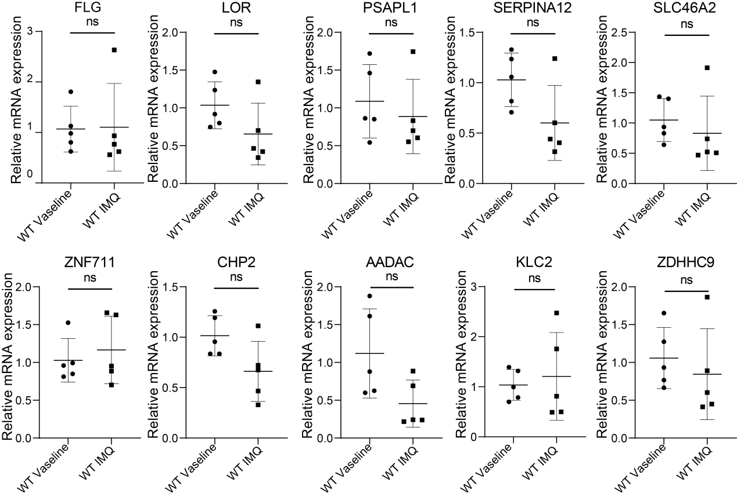
Supplementary Figure 1. qRT-PCR verification of hub genes, n = 5. Data are presented as mean ± SD. ns p > 0.05. qRT-PCR, quantitative reverse transcription polymerase chain reaction.

