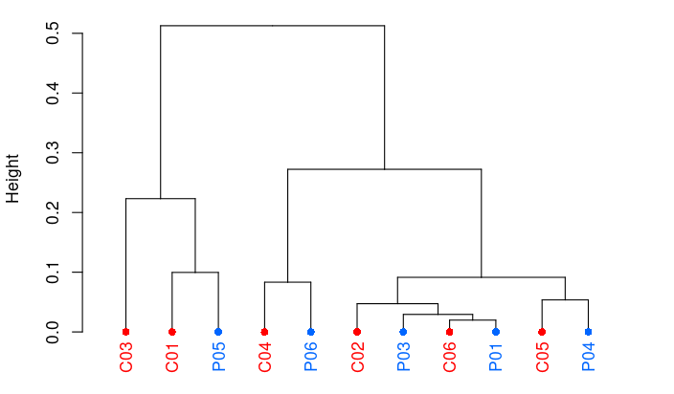
Supplementary Figure S1. Hierarchical clustering of sample methylation profiles using Pearson's correlation distance. Controls are represented in red, and severe preterm samples in blue. In all cases data from the 12 genes analyzed in this study were employed.

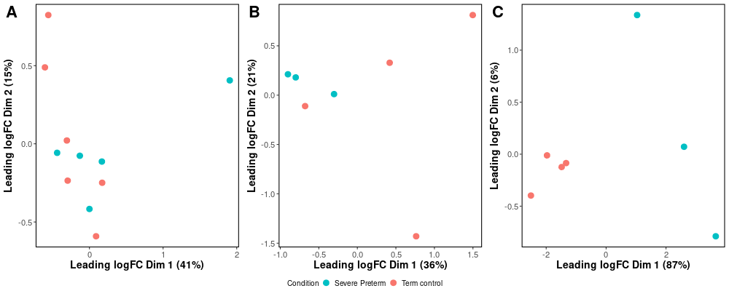
Supplementary Figure S2. Multidimensional scaling (MDS) plot generated based on the matrix of (A) only methylation levels and Euclidean distances for all samples; (B) combined methylation and transcriptome data for 7 samples; and (C) only transcriptome data for 7 samples. In all cases data from the 12 genes analyzed in this study were employed.

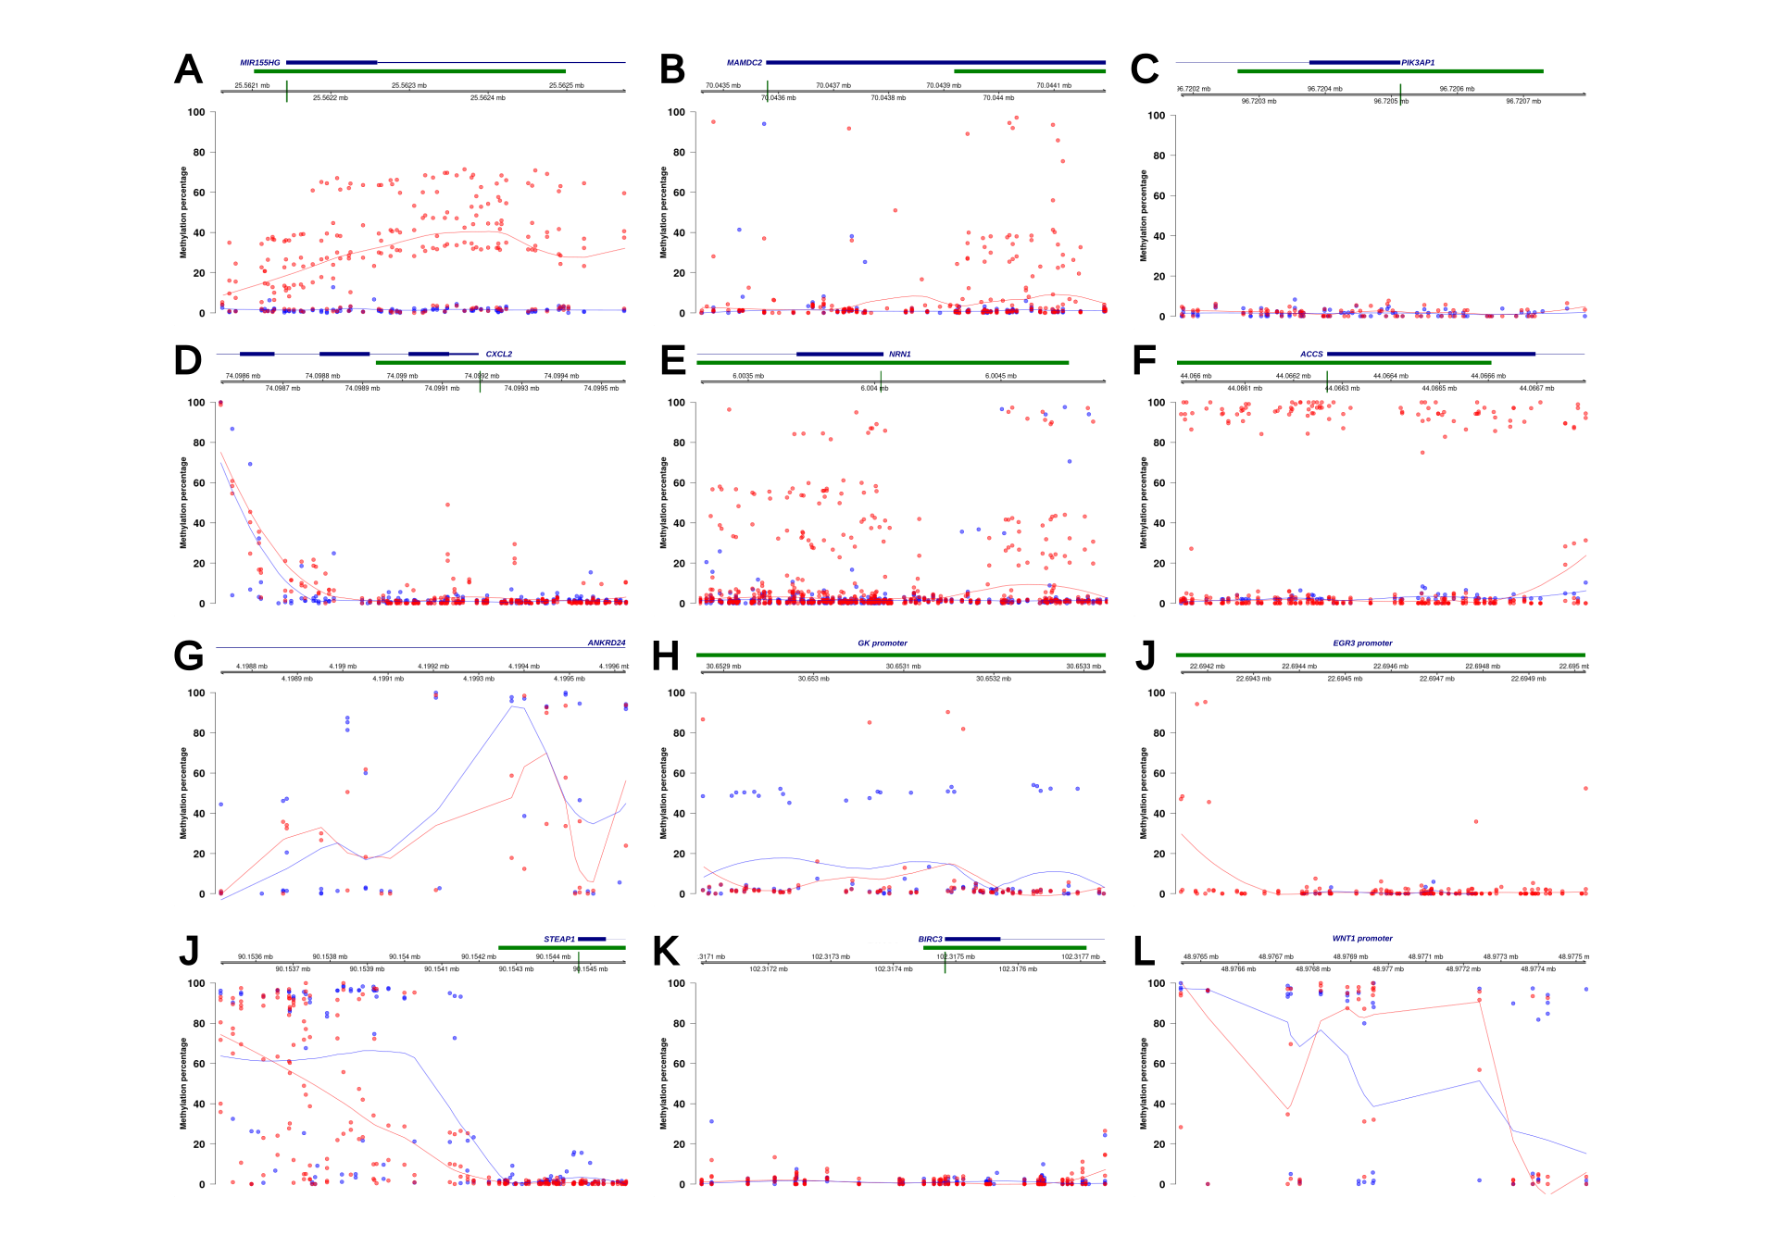Supplementary Figure S3. DNA methylation percentages at CpG sites across the regions of interest for each gene. Methylation percentages (%5mC/5mC+C) are shown for severe preterm newborns (blue) and term controls (red). Blue and red lines represent the smoothed median methylation values for severe preterm and control deliveries, respectively. CpG sites are annotated relative to their genomic positions. Transcription start sites, when present in the region, are highlighted in green on the genome position axis. Gene positions and CpG islands are represented in blue and green, respectively.

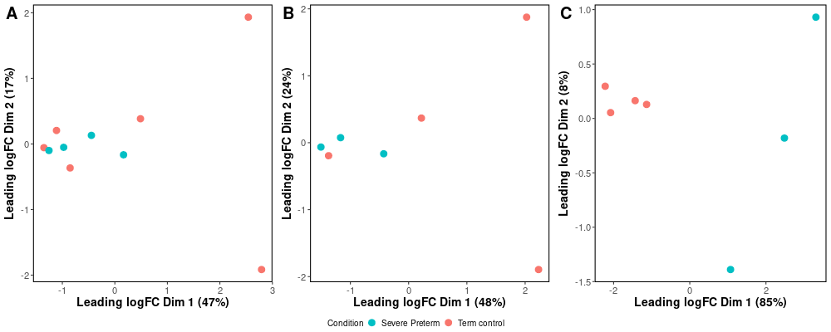
Supplementary Figure S4. Multidimensional scaling (MDS) plot generated based on data only from the 7 genes found with significant methylation. In each case, MDS was performed based on the matrix of (A) only methylation levels and Euclidean distances for all samples; (B) combined methylation and transcriptome data for 7 samples; and (C) only transcriptome data for 7 samples.
Supplementary Table S1. Primer design and details per gene for first and second round PCRs.
Gene Symbol | PCR Round | Forward primer (5'-3') | Reverse primer (5'-3') | Amplicon length (bp) | Tm (°C)
ACCS | 1 | TTAAAAAGTTTTTTGTGTGGG | CTTACCAATTTTCCCAATCC | 1003 | 52
ACCS | 2 | GTTAAGTATATTTTGGTAAG | CAATCCTAATACACAACAC | 963 | 52
BIRC3 | 1 | AAATTGTAAAGGAGAATTGTATG | ATCTAAAACCTACTTTTAAACCC | 871 | 54
BIRC3 | 2 | GATTTTTGTAGTTATAGTAG | CCCTAATATTTAATAACTAC | 712 | 50
CXCL2 | 1 | TTTTGATTTATTTTTTAGGGGG | CAACTCCTTACCAACTCTCC | 660 | 53
CXCL2 | 2 | GTAGACGTTAGTATTTTTG | CCTACTAAACCCCATAAC | 596 | 49
EGR3 | 1 | GGGGGTGTTTTAATTTGTTAG | AATCCCTCCTTTCCTAAAAAC | 997 | 51
EGR3 | 2 | TTTTTTGGTTTAATATTTTAAG | CTAAAAAAAATAAAAAAAAACC | 954 | 55
ANKRD24 | 1 | TAGAGGTTGGGGTAGTTTTTG | ACCTACCCCTAAACACTTAC | 1117 | 55
ANKRD24 | 2 | GGAATGGAAGAGATATTTGG | CAAACAATATCCCCCAAAC | 952 | 52
MAMDC2 | 1 | TTATGGTTTTTTGGAGAGAAG | AATCCAAACCTTACCTTACAAC | 846 | 56
MAMDC2 | 2 | GGAATGTTGAGTATTAGG | CCCCTTAACAACATAATC | 765 | 50
NRN1 | 1 | GATGATGAGTGGTTTGGAG | ATCCCTTCCCCAATACTTC | 882 | 56
NRN1 | 2 | GGATGAGTTTGTTTGGG | CCTACAACAATTTACAAAC | 775 | 49
STEAP1 | 1 | GAAGTTGTATTTAAAAGTTAAG | CCCTCCCAAAACTAAAAAC | 1172 | 50
STEAP1 | 2 | GTTAAGGTAAGGAAGGGAG | CCCAACCTTACAAAAACAC | 1132 | 54
WNT1 | 1 | TTTAAAAGGGAGGTAGAAAGG | AATCACCTTATCACAATCACC | 1245 | 57
WNT1 | 2 | AATTTTGAGAAGGGTTTTTAG | CAATATATCAAAAAAAAAATAAC | 1171 | 52
GK | 1 | GTAAATTTAAGGTTAAGGGAG | CCATAAAACCAACTTCAAATC | 995 | 55
GK | 2 | ATTTTATATGGGGTTAATTTTAG | TACCCCCAAAACTCCAAAAAC | 500 | 54
PIK3AP1 | 1 | GTTAGGTAGGGGTTGAAG | TCCCAAAAACCTAACAACC | 670 | 54
PIK3AP1 | 2 | TATTTTTAGGGTTAGAGGTGG | CAAAAACTTAAAAACAAAACCC | 815 | 54
MIR155HG | 1 | AGGTTGGAGTTTAAGTTTTG | TACCCCTCTAATATATTTTAC | 807 | 53
MIR155HG | 2 | AGGTTGGAGTTTAAGTTTTG | TAACCACTCCAACAAAAAAACTA | 777 | 56

Supplementary Table S2. Detail of performed analyses on each sample: methylation (this study) and transcriptome analysis (Pereyra et al. 2019). Methylation coverage is reported as the number of sequencing reads covering the analyzed CpG sites for each sample.
Sample | Condition | Analysis | Methylation Coverage (reads)
C01 | Term control | Methylation analysis, Transcriptome analysis | 1633708
C02 | Term control | Methylation analysis, Transcriptome analysis | 1892809
C03 | Term control | Methylation analysis, Transcriptome analysis | 864772
C04 | Term control | Methylation analysis, Transcriptome analysis | 1691246
C05 | Term control | Methylation analysis | 1689979
C06 | Term control | Methylation analysis | 3534526
P01 | Severe preterm | Methylation analysis, Transcriptome analysis | 1122805
P03 | Severe preterm | Methylation analysis, Transcriptome analysis | 1690129
P04 | Severe preterm | Methylation analysis, Transcriptome analysis | 1204179
P05 | Severe preterm | Methylation analysis | 1643681
P06 | Severe preterm | Methylation analysis | 783981

Supplementary Table S3. Epidemiological characteristics evaluated in severe preterm patients and term controls. PROM: Premature rupture of membranes.
 | Term control (n= 6) Mean (SD) | Severe preterm (n=5) Mean (SD) | p-value
Gestational Age (weeks) | 39 (1.26) | 29.6 (2.88) | 0.000859
Newborn weight (grams) | 3419.6 (206.6) | 1418 (597.6) | 0.000914
Newborn sex (% Females) | 33.3 % | 40 % | 1
Maternal age (years) | 22.17 (4.96) | 22.4 (4.82) | 0.939
Number of previous gestations | 1 (1.26) | 0.8 (0.84) | 0.761
PROM (% yes) | 33.3 % | 20 % | 1
Passive smoker (%) | 60 % | 20 % | 0.895
Anemia (% yes) | 16.7 % | 20 % | 1

Supplementary Table S4. Descriptive statistics and Wilcoxon test results on grouped CpGs per gene promoter. Methylation percentage levels were estimated as (%5mC/5mC+C).
Gene Symbol | Minimum CpGs per gene per sample | Maximum CpGs per gene per sample | Mean % of methylation | Median % of methylation | p value Wilcoxon test | FDR corrected p value Wilcoxon test
ACCS | 67 | 72 | 22.77 | 1.85 | 0.60 | 0.65
ANKRD24 | 3 | 22 | 39.12 | 31.24 | 0.01 | 0.02
BIRC3 | 31 | 39 | 1.36 | 0.12 | 0.07 | 0.10
CXCL2 | 38 | 79 | 3.70 | 0.76 | <0.01 | <0.01
EGR3 | 24 | 65 | 2.71 | 0.00 | 0.09 | 0.11
GK | 38 | 54 | 9.34 | 1.48 | <0.01 | <0.01
MAMDC2 | 37 | 79 | 6.18 | 0.92 | <0.01 | <0.01
MIR155HG | 55 | 60 | 19.95 | 5.26 | <0.01 | <0.01
NRN1 | 64 | 135 | 07.03 | 1.10 | <0.01 | <0.01
PIK3AP1 | 19 | 65 | 1.63 | 1.55 | 0.08 | 0.10
STEAP1 | 11 | 84 | 27.18 | 1.87 | <0.01 | <0.01
WNT1 | 14 | 17 | 55.29 | 87.78 | 0.88 | 0.88

