SUPPLEMENTARY FIGURES
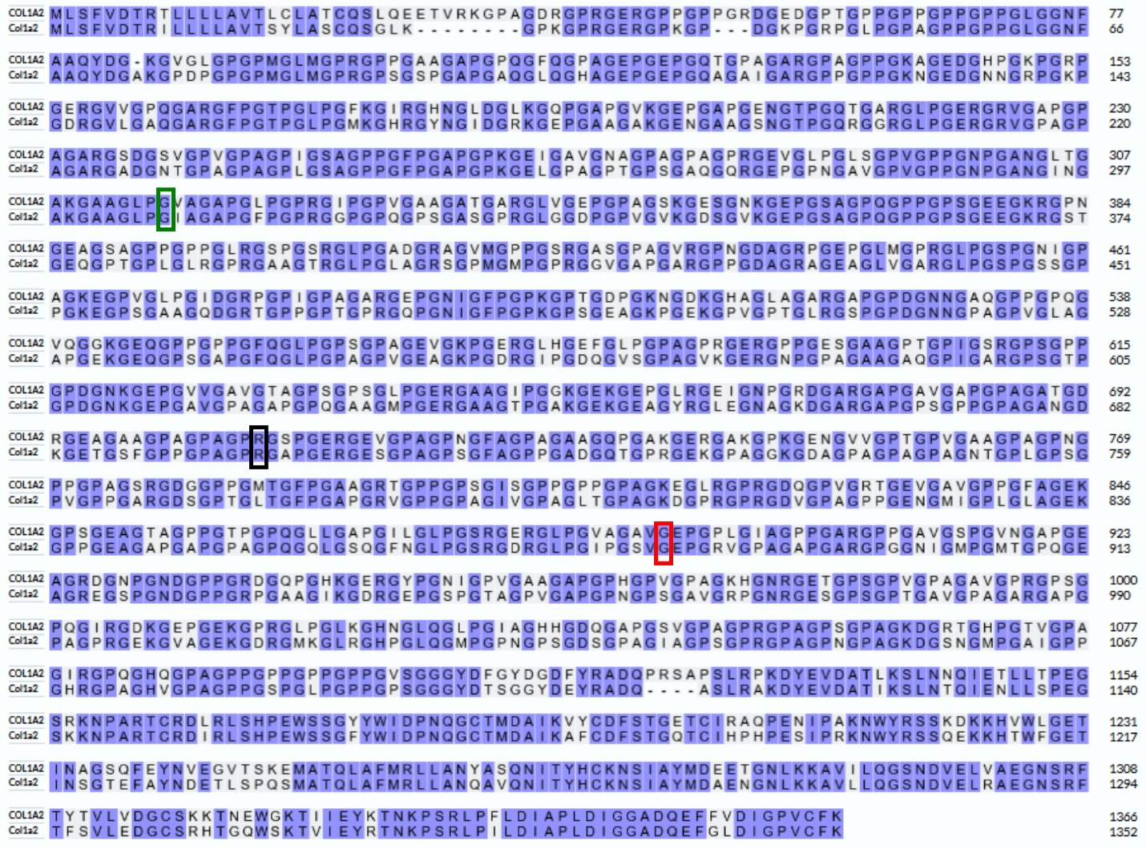

Supplementary Figure 1: Protein alignment of human COL1A2 with zebrafish col1a2. Conserved amino acids are indicated in purple. Conserved variants are indicated in green, black, and red for the negative control, VUS, and positive control, respectively. The following ensemble protein IDs were used for alignment with NCBI protein BLAST: human (ENSP00000297268.6), zebrafish (ENSDARP00000118091.1).

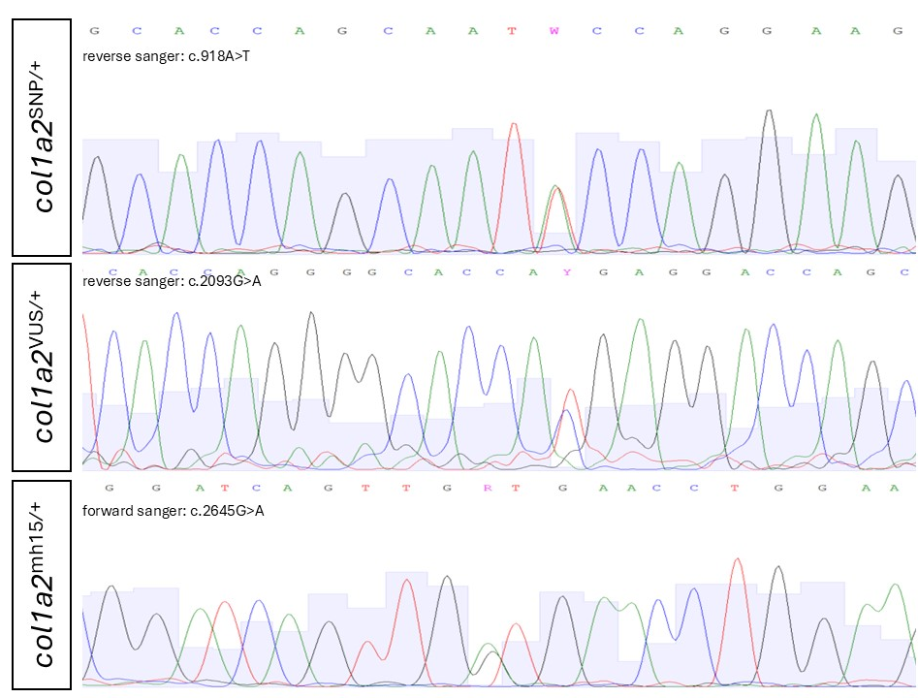
Supplementary Figure 2: Sanger sequences of cDNA of the dorsal fin of all variants. Sanger sequencing of the cDNA of the negative control, VUS, and positive control show the presence of the variant of interest in the genome. For col1a2^{SNP/+}, and col1a2^{VUS/+}, the reverse primers were used for sanger sequencing, while the forward primer was used for col1a2^{mh15/+}

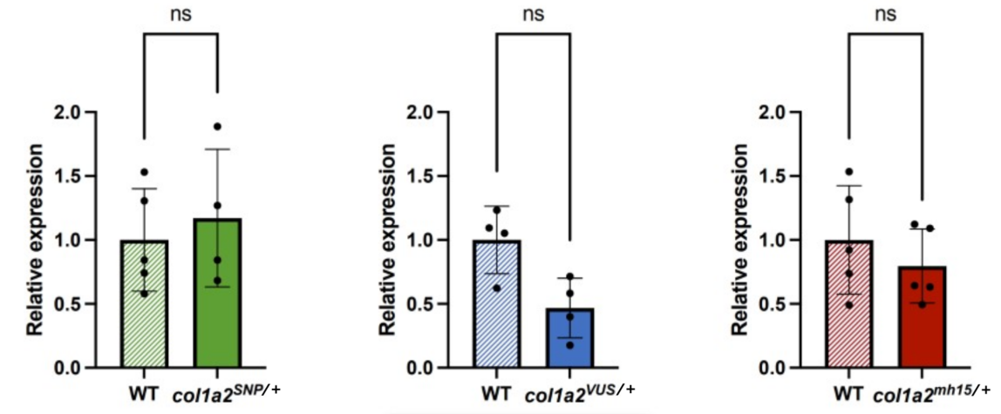
Supplementary Figure 3: qPCR analysis of col1a2 expression in dorsal fin tissue at 10 mpf. Quantitative PCR analysis of the different zebrafish lines at 10 mpf revealed no significant differences in col1a2 expression levels between the variant lines and their corresponding wild-type sibling controls. Expression levels were normalized using the housekeeping genes elfa and bactin2. Sample sizes were as follows: WT for col1a2^{SNP/+} (n = 5), col1a2^{SNP/+} (n = 4), WT for col1a2^{VUS/+} (n = 4), col1a2^{VUS/+} (n = 4), WT for col1a2^{mh15/+} (n = 5), and col1a2^{mh15/+} (n = 5). Data are presented as mean ± standard deviation (SD).

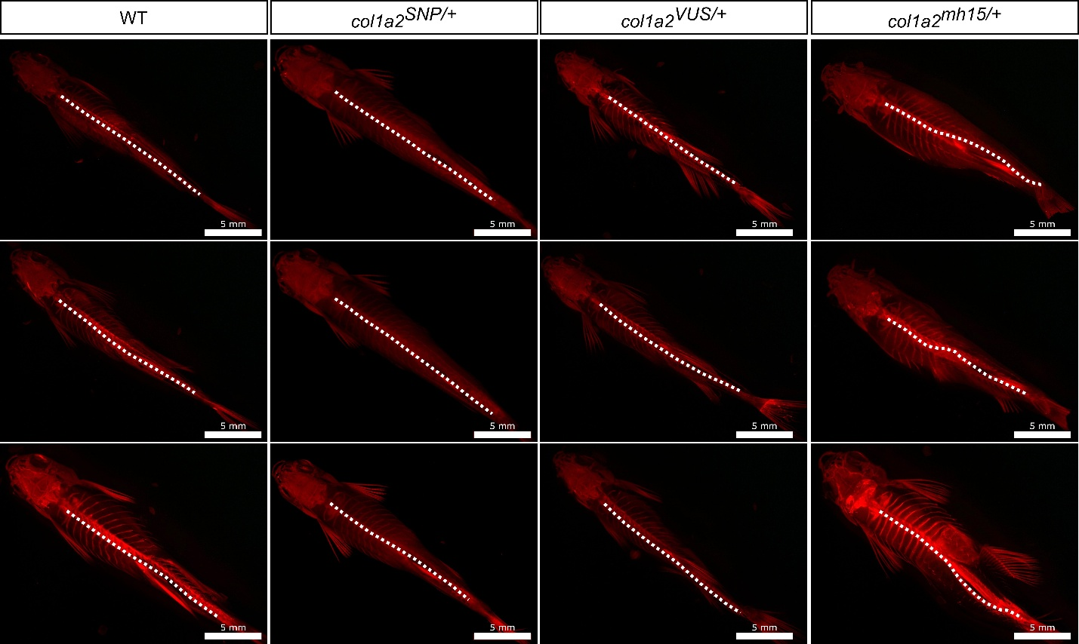
Supplementary Figure 4: Dorsal view of alizarin red-stained zebrafish at 10 mpf. The vertebral column is indicated with a white dotted line to aid visualization of spinal alignment. Only in the col1a2^{mh15/+} line scoliosis is observed. Scalebar = 5 mm.

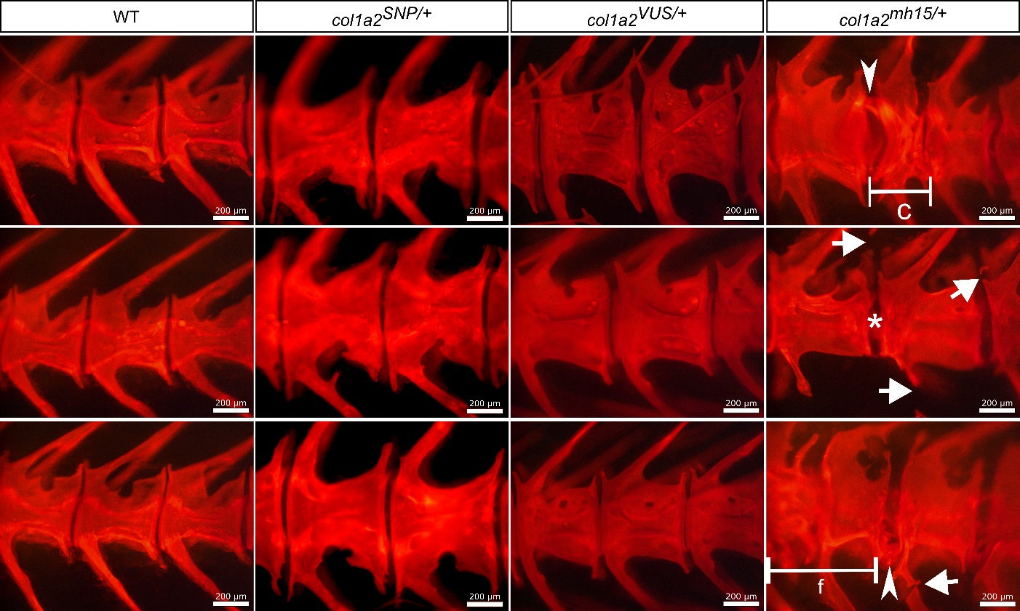
Supplementary Figure 5: Detailed lateral view of the caudal vertebral column of alizarin red-stained zebrafish at 10 mpf. A detailed view of the caudal vertebrae reveals no skeletal abnormalities in the col1a2^{VUS/+} zebrafish while the positive control col1a2^{mh15/+} shows vertebral fusions (f), compressions (c), fractures (arrow), as well as mineralization of the notochord (*) and intervertebral ligament (IVL) (arrowhead). Scalebar = 200 µm.

SUPPLEMENTARY TABLES
Supplementary Table 1: Variant details of human and zebrafish, prime editing guide RNA (pegRNA) sequences, genotyping primers, annealing temperatures of the touchdown (TD) PCR protocols, and cDNA primers utilized for all targets. For pegRNAs, desired edits are colored red, spacer region is underlined, primer binding site (PBS) is bold and reverse transcriptase template (RTT) is blue.

 | TARGET GENE | HUMAN VARIANT | ZEBRAFISH VARIANT | pegRNA | GENOTYPING PRIMERS | TD annealing temperature | cDNA PRIMERs
negative control | COL1A2 | c.948C>T p.Gly316= | c.918A>T p.Gly306= | CCAGGGGCACCAGCAATTCCGTTTTAGAGCT  AGAAATAGCAAGTTAAAATAAGGCTAGTCCG  TTATCAACTTGAAAAAGTGGCACCGAGTCGG  TGCACAGGGTCTTCCTGGTATTGCTGGTG | F: GGCTGTTAATTGTTTTCTTAGGCA  R: ACGTTGTGAATGCAGCAGTTAG | TD60-48 -1°C | F: TCAGGGACAAAGAGGAGAGC  R: AGTCCCAAAGGTCCAGTAGG
VUS | COL1A2 | c.2123G>A p.Arg708Gln | c.2093G>A p.Arg698Gln | AAACTCACAGGGGCACCACGGTTTTAGAGCT  AGAAATAGCAAGTTAAAATAAGGCTAGTCCG  TTATCAACTTGAAAAAGTGGCACCGAGTCGG  TGCTGCTGGTCCTCATGGTGCCCCTG | F: ACTTGCAAGACTCTCAAAAGAACT  R: CATGGACTTACAGGGGGTCC | TD60-48 -1°C | F: AGGACTGGAGGGCAATGC  R: CAGGGAAGCCAGTCAGACC
positive control | COL1A2 | c.2405G>A p.Gly802Asp | c.2645 G>A p.Gly882Asp |  | F: AATAGGGAGCACCTGGACCT  R: ATTCCAGCAGCACCAGGAC | TD62-50 -1°C | F: ACAGGGATTCAATGGTCTTCC  R: GAAGGACCAGATTCACCACG

Supplementary Table 2: Primers for qPCR analysis. Forward and reverse qPCR primers for col1a2, elfa, and bactin2.
 | forward | reverse
col1a2 | GATACCCGGATTCTGTTGCT | TAGGACCCCTCTCACCTCTG
elfa | GGAGACTGGTGTCCTCAA | GGTGCATCTCAACAGACTT
bactin2 | ACGATGGATGGGAAGACA | AAATTGCCGCACTGGTT

Supplementary Table 3: Predictive in silico tool used for variant classification in 2025 with their respective scores. Overview of in silico predictive tools and scores that were consulted to evaluate the PP3 requirement.
prediction tool | score
REVEL | 0.5610
Polyphen | 1.0000
SIFT | 0.0100
CADD | 27.7000
GenoCanyon | 1.0000
DANN | 0.9990
LRT | 0.0000
M-CAP | 0.1760
MetaLR | 0.8840
MetaSVM | 0.9470
MutationAssessor | 0.7250
MutationTaster | 1.0000
FatHMM-MKL | 0.9770
Provean | -3.2800

