Supplementary:

2. Methodology:

Sample grouping in microarray analysis:
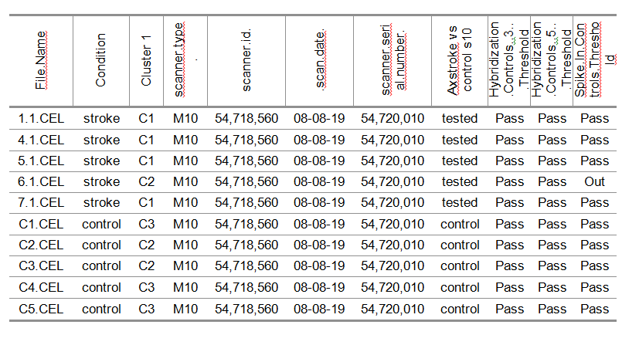
Supplementary figure 1: stroke vs control samples (total 9 samples)

Microarray data normalization and statistical analysis:
- The statistical analysis parameters and methods for microarray data normalization and statistical analysis
TAC: statistical tests
- Expression Analysis Settings:
- Gene-Level Fold Change < -1 > 1
- Gene-Level P-Value < 0.05 with additional FDR correction
- ANOVA Method: ebayes
- A Probeset (Gene/Exon) is considered expressed if Q% samples have DABG values below DABG Threshold.
- DABG < 0.05 * average signal was calculated using Tukey-biweight robust average of this transcript cluster’s expression level for the samples in a given condition.
R: statistical tests
- We performed following statistical tests (p<=0.05) with additional FDR correction: Logistic regression, Mann-Whitney test, student’s t-test depending on if variances were equal or differing.
R: Estimation of following scores to identify the best biomarkers
- Probability score from the logistic regression training vs testing group using leave one out method. Scores were ranging from 0-1.
- AUC- ROC, we calculated the Area under the curve using the ROCp R package. Scores were ranging from 0-1.
- Co-expression analysis to identify genes authentically expressed was performed using Spearman correlation (cutoff=0.9, Rpval=0.05).
Due to the small number of samples we decided to use results of the Mann-Whitney test in further analyses. It was supported by information that TAC software was applying a Tukey-biweight robust average which removed outlier signals affecting the data.

