Additional file 1

Genome-wide profiling of salivary promoter-region DNA methylation in periodontitis: the Tromsø Study

Natalia Petrenya ¹*, Birgitta Jönsson ^{1, 2}, Elin Hadler-Olsen ^{1, 3}, Lena Larsson ², Arnar Flatberg ^{4, 5}, Vidar Beisvåg ^{4, 5}, Gro Eirin Holde ^{1, 6}, Svetlana N. Zykova ^{1, 7, 8} , Farah Asa 'ad ⁹*

¹ The Public Dental Health Service Competence Centre of Northern Norway, Tromsø, Norway
² Department of Periodontology, Institute of Odontology, The Sahlgrenska Academy at the University of Gothenburg, Gothenburg, Sweden
³ Department of Medical Biology, Faculty of Health Sciences, UiT The Arctic University of Norway, Tromsø, Norway
⁴ Genomics Core Facility, Department of Clinical and Molecular Medicine, Norwegian University of Science and Technology (NTNU), Trondheim, Norway.

⁵ St.Olav`s University Hospital, Central Staff, Trondheim, Norway
⁶ Department of Clinical Dentistry, Faculty of Health Sciences, UiT The Arctic University of Norway, Tromsø, Norway
⁷ Center for Research and Education, University Hospital of North Norway, Tromsø, Norway
⁸ Hormone Laboratory, Department of Medical Biochemistry, Biochemical Endocrinology and Metabolism Research Group, Oslo University Hospital, Oslo, Norway
⁹ Department of Oral Biochemistry, Institute of Odontology, The Sahlgrenska Academy at the University of Gothenburg, Gothenburg, Sweden

- Characteristics of the 935K Chip used in the present study
The 935K Chip application includes complex diseases such as diabetes, hypertension, immune disorders, and depression. The 935K chip is an upgraded version of the 850K chip and offers the following advantages: (1) comprehensive genome coverage: detects over 935,000 CpG sites, covering CpG islands, promoters, coding regions, and enhancers comprehensively; (2) comprehensive optimization of probe sites: removes poorly performing probes from EPICv1.0-850K and adds 186,000 CpG-targeting enhancers and super-enhancers, more CTCF binding sites, CNV detection regions, CpG islands not well covered by EPIC v1.0, and common cancer-driving mutations; (3) compatibility with various sample types, including Formalin-Fixed Paraffin-Embedded; (4) high-quality data: adopts the Infinium technology from the 450K chip and utilizes Infinium I and II probe designs to maximize the detection range; (5) high resolution: single-base resolution that directly detects accurate methylated sites; (6) high reproducibility: strong correlation between technical replicates and R2>0.99 correlation with the same probes as the 850K chip (https://www.cd-genomics.com/epigenetics/human-dna-methylation-assay-Illumina-935k-service.html).

- Multidimensional scaling (MDS) plots
Using multidimensional scaling (MDS) plots, we visualized the associations between sample characteristics (sex and smoking) and DNAm data (methylation signal; n_samples × n_promoters) on scatter plots for the promoter region. Methylation patterns are displayed with respect to gender (Figure S1) and smoking status (Figure S2).

Figure S1
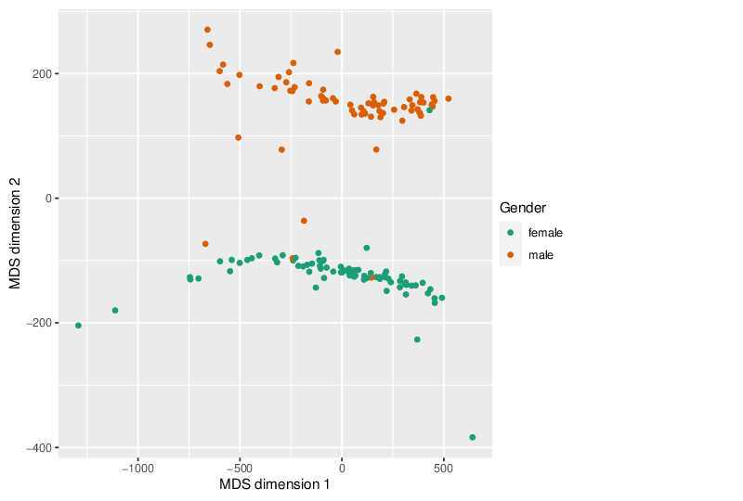
Figure S1 Multidimensional scaling (MDS) plot of all analyzed samples visualizing the association between gender and DNAm data (n = 150, including individuals with Stage III/IV + PPD>5 mm periodontitis, gingivitis, and healthy controls). The DNAm profile at the gene promoter region level clearly shows that samples cluster according to gender. Samples are represented as circles, with colors indicating gender.

Figure S2

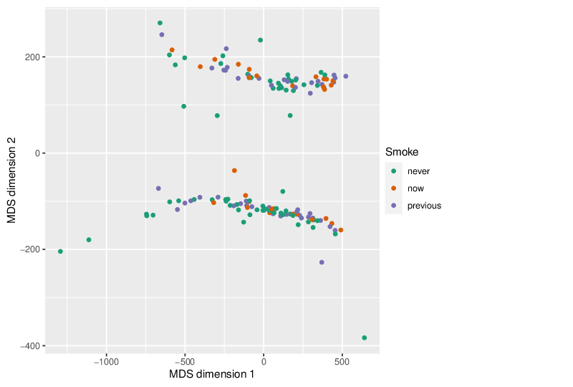
Figure S2 Multidimensional scaling (MDS) plot of all analyzed samples visualizing the association between smoking status and DNAm data (n = 150, including individuals with Stage III/IV + PPD>5 mm periodontitis, gingivitis, and healthy controls). When compared to gender (Figure S1), no clear DNAm patterns were observed with respect to smoking at the gene promoter region level. Samples are represented as circles, with colors indicating smoking status.
- Site-based level differential methylation
Site-based differential methylation for each site was calculated using the following metrics:
- The difference in methylation means between the two groups (mean diff.).
- The quotient of mean methylation levels (mean.quot.log2).
- A statistical test using Linear Models for Microarray Data (limma) to estimate whether the methylation values of two different groups originate from distinct distributions. This was assessed using the nominal p-value (diffmeth.p.val) and the false discovery rate-adjusted p-value (diffmeth.p.adj.fdr) based on the Benjamini and Hochberg method (1995).
Each site was assigned a combined rank based on these three criteria. The combined rank was calculated as the maximum (i.e., worst) rank among the three individual rankings. Lower-numbered ranks calculated as the maximum (i.e., worst) rank among the three ranked criteria, indicate greater differential methylation.
- Immune cell content
Figure S3
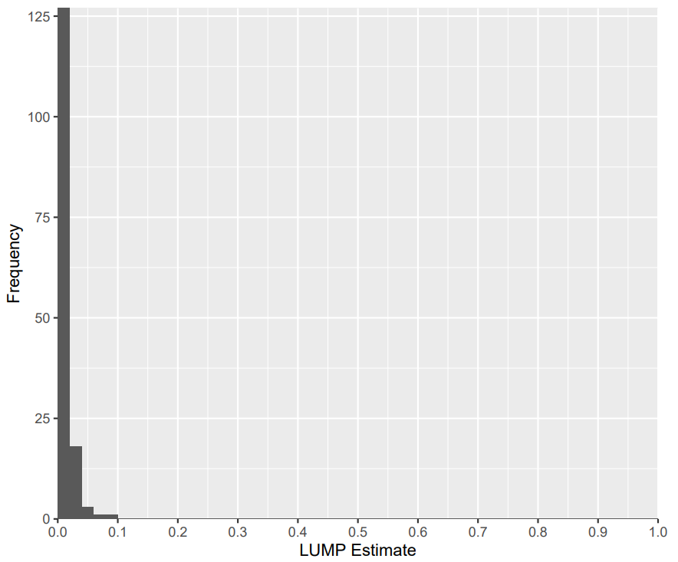
Figure S3 The distribution of immune cell content values based on LUMP algorithm.
- Table S1 Differentially methylated promoter and site number in the present study according to chromosome location
 | Hypomethylated |  | Hypermethylated
Chromosome | Promoters | Sites | Promoters | Sites
Chr1 | 343 | 575 | 374 | 643
Chr2 | 215 | 353 | 230 | 434
Chr3 | 234 | 384 | 191 | 331
Chr4 | 162 | 228 | 137 | 243
Chr5 | 151 | 253 | 156 | 277
Chr6 | 213 | 431 | 199 | 380
Chr7 | 168 | 281 | 174 | 295
Chr8 | 112 | 187 | 115 | 214
Chr9 | 100 | 141 | 125 | 192
Chr10 | 153 | 264 | 141 | 272
Chr11 | 215 | 370 | 222 | 396
Chr12 | 184 | 309 | 190 | 335
Chr13 | 85 | 138 | 93 | 161
Chr14 | 145 | 260 | 133 | 230
Chr15 | 132 | 230 | 113 | 192
Chr16 | 126 | 183 | 154 | 286
Chr17 | 217 | 363 | 187 | 319
Chr18 | 53 | 101 | 40 | 57
Chr19 | 223 | 382 | 221 | 379
Chr20 | 96 | 173 | 102 | 161
Chr21 | 39 | 54 | 53 | 87
Chr22 | 45 | 62 | 87 | 172
Total | 3411 | 5722 | 3437 | 6056

- g:Profiler gene set libraries data versions

hsapiens (Human) - version: GRCh38.p14
GO:MF
–
annotations: BioMart
classes: releases/2024-01-17
GO:CC
–
annotations: BioMart
classes: releases/2024-01-17
GO:BP
–
annotations: BioMart
classes: releases/2024-01-17
KEGG
–
KEGG FTP Release 2024-01-22
REAC
–
annotations: BioMart
classes: 2024-1-25
WP
–
20240101
TF
–
annotations: TRANSFAC Release 2023.2
classes: v2
MIRNA
–
Release 9.0
HPA
–
annotations: HPA website: 23-07-17
classes: script: 24-01-02
CORUM
–
28.11.2022 Corum 4.1
HP
–
annotations: 01.2024
classes: None

7. Sample characteristics
Table S2 Characteristics of the groups
 | Healthy | Stage III/IV + PPD>5 mm periodontitis |  | p-value
Age range, years | 40-54 |  | 40-54
Age, mean (SD) | 46.2 (4.5) |  | 48.6 (3.9) | 0.005
Gender, n (%)
Women | 29 (58) |  | 24 (48) | 0.316
Men | 21 (42) |  | 26 (52)
Smoking, n (%)
Current smokers | 4 (8) |  | 22 (44) | <0.001
Former smokers | 14 (28) |  | 22 (44)
Never smokers | 32 (64) |  | 6 (12)

