Supplementary Figure S1 The expression distribution patterns of the hub genes among different cell types and tumor cell subtypes

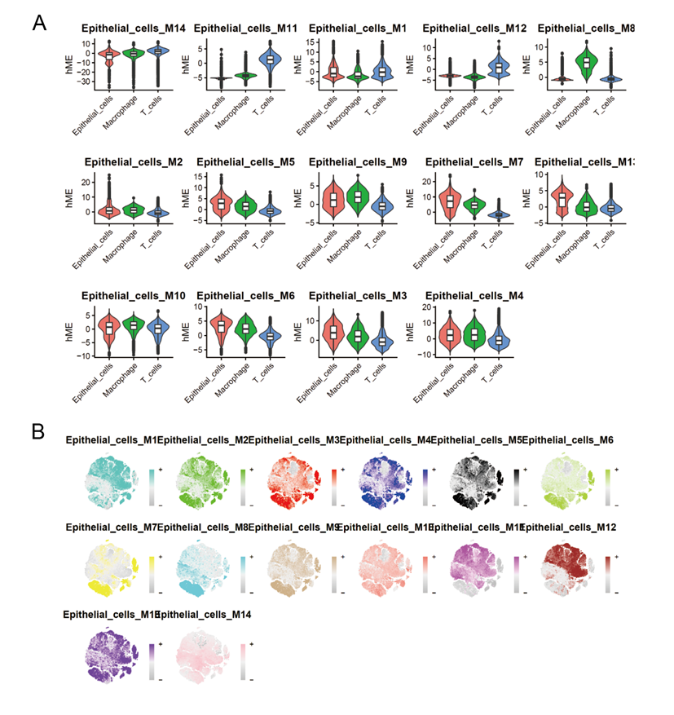

Supplementary Figure S2 Univariate and multivariate Cox regression analysis showed that the 3 gene risk score was an independent risk factor for LUAD patients

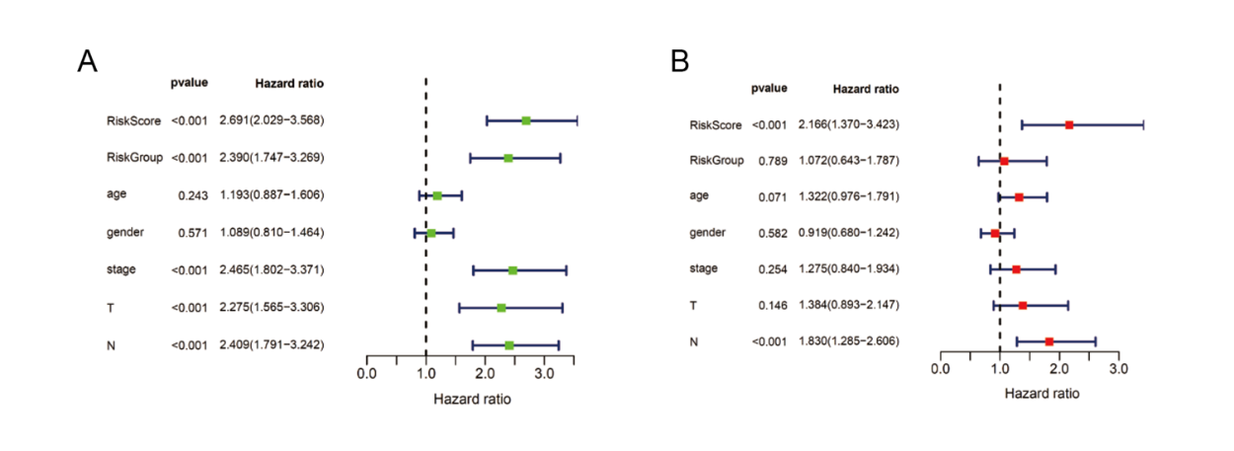

Supplementary Figure S3 CCK-8 assay revealed the viability in A549 cells transfected with si-NPTN and si-ALDOA groups
