Figure 2C: pcDNA3.1-AR
b
b
a

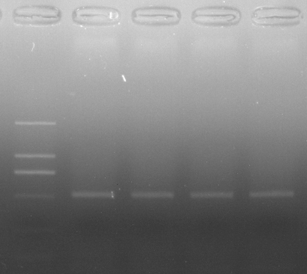
250
500
750
1000
WT
MUT
WT
MUT
293T
HeLa
bp
b
b
a
M
a
a

Supplementary Figure 2B: pcMINI-N-AR
b
b
a

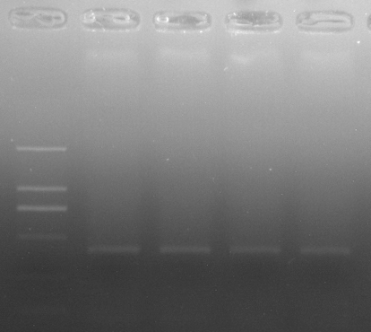
250
500
750
1000
HeLa
MUT
MUT
WT
WT
293T
M
b
a
b
a
bp

