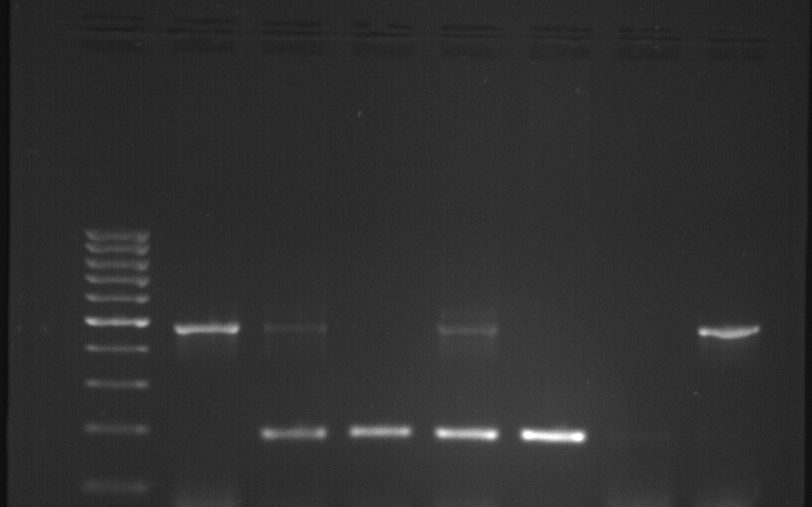
I/D
D/D
I/I
MWM
1
2
3
4
5
6
7
1000bp
500bp
200bp
100bp
Supplementary Figure 1: Identification of rs4646994 genotypes by agarose gel electrophoresis.
Legend: MWM = Molecular weight marker, 1 to 7 = Samples, I = Insertion allele, D = Deletion allele

