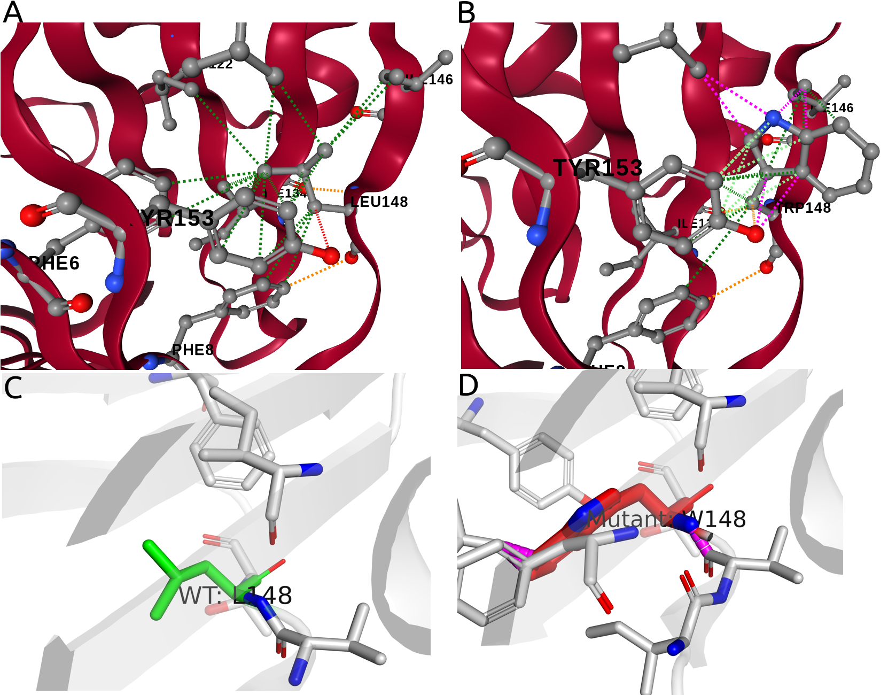
Supplementary Figure S1. Structural analysis of the TANGO2 p.Leu148Trp variant using complementary visualization approaches: DynaMut2 (A–B) and PyMOL (C–D), based on the crystal structure PDB 9BWA (1.70 Å resolution). (A) Wild-type Leu148 positioned within the tightly packed hydrophobic core. Interaction network generated using DynaMut2. Neighboring residues are shown as sticks. Green dashed lines indicate close contacts within van der Waals distance. (B) Mutant Trp148 showing the larger aromatic side chain. DynaMut2 interaction network reveals multiple steric clashes (magenta dashed lines), particularly with Ile146 and Tyr153. (C) Close-up PyMOL representation of wild-type Leu148 (green sticks), showing a compact side chain accommodated within the hydrophobic pocket. (D) Close-up PyMOL representation of mutant Trp148 (red sticks), demonstrating steric clashes due to the bulky indole ring. Magenta dashed lines highlight spatial conflicts with surrounding residues. Thermodynamic stability analysis using DynaMut2 predicted a destabilizing change in Gibbs free energy (ΔΔG = -2.25 kcal/mol), consistent with the observed structural disruption.

