Supplementary Table 1: Detailed search strategy with search strings for all databases.
Framework | Search Terms | Search Hits as on DD/MM/YYYY  (Last Updated)
PubMed Search
P- Population | ("India"[Mesh] OR "Indian population" OR "South Asian" OR "Indians" OR "Indian ethnicity") AND  ("hypertension"[Mesh] OR "high blood pressure") | 2400  14.05.2025  Time: 12:23
E-Exposure | ("single nucleotide polymorphism" OR "SNP" OR "genetic polymorphism" OR "genetic variant" OR "gene polymorphism" OR "genotype" OR "allele frequency" OR "genetic association") | 5,86,796  14.05.205  Time: 12:24
O-Outcomes | ("hypertension"[Mesh] OR "high blood pressure" OR "blood pressure" OR "systolic blood pressure" OR "diastolic blood pressure") | 7,08,360  14.05.2025  Time: 12:24
S-Study design | ("case-control study" OR "cohort study" OR "cross-sectional study" OR "genetic association study" OR "observational study") | 10,01,656  14.05.2025  Time: 12:25
Final Search String | (((("India"[Mesh] OR "Indian population" OR "South Asian" OR "Indians" OR "Indian ethnicity") AND ("hypertension"[Mesh] OR "high blood pressure")) AND (("single nucleotide polymorphism" OR "SNP" OR "genetic polymorphism" OR "genetic variant" OR "gene polymorphism" OR "genotype" OR "allele frequency" OR "genetic association"))) AND (("hypertension"[Mesh] OR "high blood pressure" OR "blood pressure" OR "systolic blood pressure" OR "diastolic blood pressure"))) AND (("case-control study" OR "cohort study" OR "cross-sectional study" OR "genetic association study" OR "observational study")) | 26  14.05.2025  Time: 12:25
Scopus
Framework | Search Terms | Search Hits as on DD/MM/YYYY
P- Population | (TITLE-ABS-KEY("India" OR "Indian population" OR "South Asian" OR "Indians")) AND  (TITLE-ABS-KEY("hypertension" OR "high blood pressure")) | 12,585  14.05.2025  Time: 12:26
E-Exposure | (TITLE-ABS-KEY("SNP" OR "single nucleotide polymorphism" OR "genetic polymorphism" OR "genetic variant" OR "genotype" OR "allele frequency" OR "genetic association")) | 968,541  14.05.2025  Time: 12:26
O-Outcomes | (TITLE-ABS-KEY("hypertension" OR "high blood pressure" OR "blood pressure" OR "systolic BP" OR "diastolic BP")) | 1,114,996  14.05.2025  Time: 12:27
S-Study design | (TITLE-ABS-KEY("case-control" OR "cross-sectional" OR "cohort study" OR "genetic association study" OR "observational study")) | 2,202,632  14.05.2025  Time: 12:27
Final Search String | (TITLE-ABS-KEY("India" OR "Indian population" OR "South Asian" OR "Indians")) AND  (TITLE-ABS-KEY("hypertension" OR "high blood pressure")) AND (TITLE-ABS-KEY("SNP" OR "single nucleotide polymorphism" OR "genetic polymorphism" OR "genetic variant" OR "genotype" OR "allele frequency" OR "genetic association")) AND (TITLE-ABS-KEY("hypertension" OR "high blood pressure" OR "blood pressure" OR "systolic BP" OR "diastolic BP")) AND (TITLE-ABS-KEY("case-control" OR "cross-sectional" OR "cohort study" OR "genetic association study" OR "observational study")) | 255  14.05.2025  Time: 12:28
Embase
P- Population | ('India'/exp OR 'Indian population' OR 'South Asian') AND  ('hypertension'/exp OR 'high blood pressure') | 11,256  14.05.2025  Time: 12:29
E-Exposure | ('single nucleotide polymorphism'/exp OR 'snp' OR 'genetic polymorphism' OR 'genetic variant' OR 'genotype' OR 'allele frequency' OR 'genetic association') | 954,253  14.05.2025  Time: 12:29
O-Outcomes | ('hypertension'/exp OR 'high blood pressure' OR 'blood pressure' OR 'systolic blood pressure' OR 'diastolic blood pressure') | 1,336,951  14.05.2025  Time: 12:29
S-Study design | ('case control study'/exp OR 'cross sectional study'/exp OR 'cohort analysis'/exp OR 'genetic association study'/exp OR 'observational study') | 2,566,051  14.05.2025  Time: 12:29
Final Search String | ('India'/exp OR 'Indian population' OR 'South Asian') AND  ('hypertension'/exp OR 'high blood pressure') AND ('single nucleotide polymorphism'/exp OR 'snp' OR 'genetic polymorphism' OR 'genetic variant' OR 'genotype' OR 'allele frequency' OR 'genetic association') AND ('hypertension'/exp OR 'high blood pressure' OR 'blood pressure' OR 'systolic blood pressure' OR 'diastolic blood pressure') AND ('case control study'/exp OR 'cross sectional study'/exp OR 'cohort analysis'/exp OR 'genetic association study'/exp OR 'observational study') | 162  14.05.2025  Time: 12:29

Google Scholar
Framework | Search Terms
P- Population | "India" OR "Indian population" OR "South Asian" OR "Indians" AND  "hypertension" OR "high blood pressure"
E-Exposure | "SNP" OR "genetic polymorphism" OR "genetic variant" OR "genotype" OR "allele frequency" OR "genetic association"
O-Outcomes | "hypertension" OR "high blood pressure" OR "blood pressure" OR "systolic BP" OR "diastolic BP"
S-Study design | "case-control" OR "cross-sectional" OR "cohort study" OR "genetic association study" OR "observational study"
Additional Steps: Manual Screening has been done

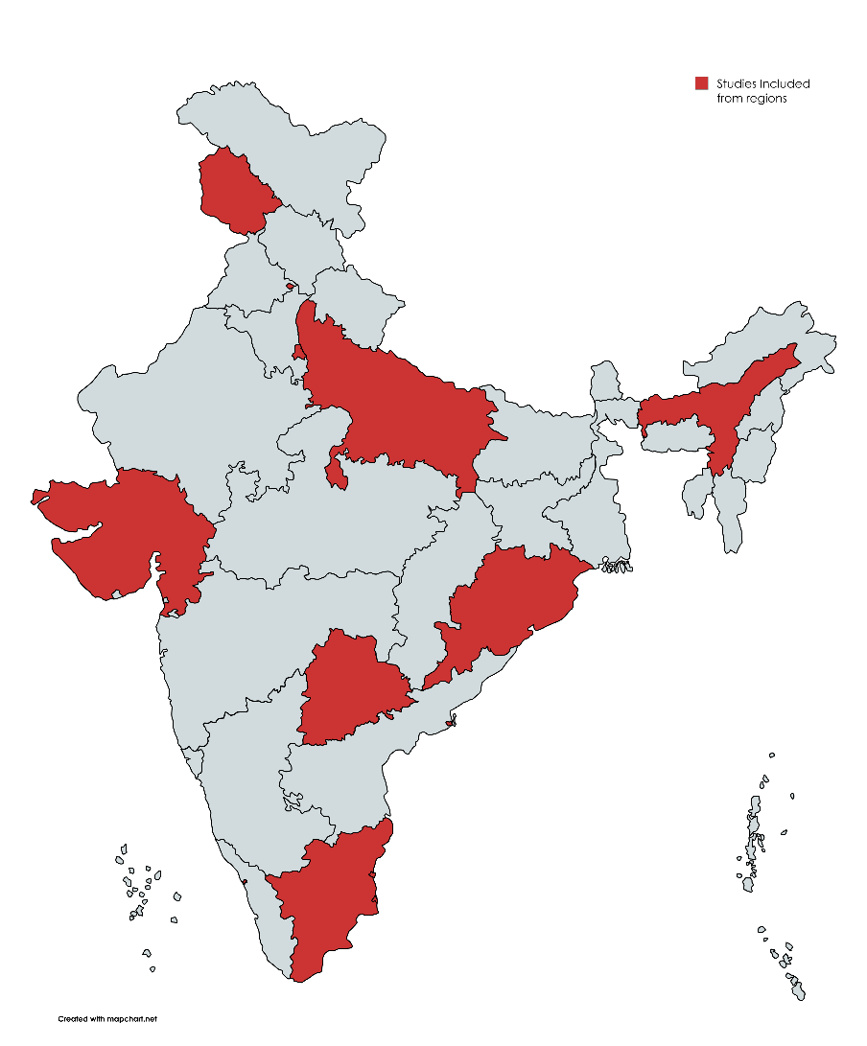

Supplementary Figure 1: Geographic Distribution of Included Studies on Hypertension-Associated SNPs Across Indian Regions

Supplementary Table 2: Quality assessment of included studies using Q Genie Tool.
Study | Q1 | Q2 | Q3 | Q4 | Q5 | Q6 | Q7 | Q8 | Q9 | Q10 | Q11 | TOTAL
Suchita Markan et al, (2007) [12] | 6 | 6 | 6 | 6 | 4 | 5 | 3 | 5 | 6 | 5 | 6 | 58/77
Srivastava K et al, (2007) [13] | 6 | 6 | 5 | 6 | 4 | 5 | 3 | 4 | 5 | 4 | 6 | 54/77
Periaswamy R et al, (2008) [14] | 7 | 6 | 5 | 6 | 4 | 5 | 5 | 5 | 6 | 4 | 6 | 59/77
Rajan S et al, (2010) [15] | 7 | 6 | 6 | 6 | 5 | 5 | 6 | 5 | 6 | 5 | 6 | 63/77
U Mohana Vamsi et al, (2013) [16] | 6 | 5 | 4 | 6 | 4 | 4 | 4 | 4 | 5 | 5 | 5 | 52/77
Arun Kumar AS et al (2014)., [17] | 6 | 5 | 5 | 6 | 4 | 5 | 4 | 4 | 5 | 5 | 5 | 54/77
Chandra S et al, (2014) [18] | 7 | 7 | 6 | 7 | 6 | 6 | 6 | 6 | 7 | 6 | 7 | 72/77
G. Padma et al, (2014) [19] | 7 | 6 | 5 | 6 | 5 | 5 | 5 | 6 | 6 | 6 | 7 | 64/77
Priyanka Shankarishan et al, (2014) [20] | 7 | 7 | 6 | 7 | 6 | 6 | 6 | 6 | 7 | 6 | 7 | 71/77
Patnaik M et al, (2014) [21] | 7 | 7 | 6 | 7 | 6 | 6 | 5 | 6 | 7 | 6 | 7 | 71/77
Singh KD et al, (2014) [22] | 7 | 6 | 5 | 7 | 6 | 6 | 6 | 6 | 7 | 6 | 7 | 70/77
Abbas S et al, (2014) [23] | 7 | 6 | 5 | 7 | 6 | 5 | 5 | 5 | 6 | 6 | 6 | 66/77
Parchwani DN et al, (2016) [24] | 7 | 6 | 6 | 7 | 6 | 6 | 5 | 6 | 6 | 6 | 6 | 76/77
Sopori S et al, (2024) [25] | 7 | 6 | 6 | 7 | 6 | 5 | 6 | 6 | 7 | 6 | 7 | 69/77

Supplementary Table 3: Baseline Characteristics of Case and Control Groups Across Included Studies
Study | Age |  | BMI |  | Systolic BP |  | Diastolic BP |  | Male/Female
Study | Case | Control | Case | Control | Case | Control | Case | Control | Case | Control
Suchita Markan et al, (2007) [12] | 47.7±12.4 | 46.2±10.8 | 23.4 ± 4.9 | 22.9 ± 4.3 | 139.9 ± 13.8 | 116.9 ± 10.9 | 88.9 ± 8.0 | 75.3 ± 5.8 | 83/70 | 69/64
Srivastava K et al, (2007) [13] | 46.78 ± 5.6 | 44.98±8.4 | NR | NR | 147.9 ± 14.7 | 120 ± 3.3 | 96 ± 8.5 | 80.6 ± 26 | 168/58 | 58/39
Periaswamy R et al, (2008) [14] | 44.90±0.38 | 47.44±0.38 | NR | NR | 153.5 ± 0.8 | 117.3 ± 0.4 | 97.7 ± 0.5 | 77.9 ± 0.3 | 213/225 | 201/243
Rajan S et al, (2010) [15] | 44.1±0.4 | 47.3±0.4 | 23.0±0.3 | 23.1±0.2 | 152.6 ± 0.8 | 118.0 ± 0.5 | 97.2 ± 0.5 | 78.1 ± 0.3 | 200/206 | 183/241
U Mohana Vamsi et al, (2013) [16] | 55.57±9.78 | 47.63 ± 9.65 | 27.20 ± 4.73 | 25.80±3.72 | 160.53 ± 20.98 | 120.05 ± 0.71 | 98.23 ± 12.87 | 80.00 ± 0.35 | 153/126 | 131/69
Arun Kumar AS et al (2014)., [17] | 49.6±0.5 | 44.5±0.5 | 24.24±0.3 | 22.2±0.2 | 144.4±1.1 | 117.7±0.5 | 91.2±0.6 | 77.1±0.3 | 116/163 | 132/189
Chandra S et al, (2014) [18] | 49.26±12.0 | 52.16±7.0 | 18.46±2.9 | 18.03±3.4 | 151.06±12.5 | 120±3.8 | 94.8±8.8 | 80.4±2.9 | 164/86 | 153/97
G. Padma et al, (2014) [19] | 54.9 ± 0.8 | 54.4 ± 0.6 | 24.4 ± 0.4 | 22.8 ± 0.2 | 148.3 ± 1.6 | 120.0 ± 0.01 | 91.2 ± 1.0 | 80.0 ± 0.0 | 100/115 | 125/105
Priyanka Shankarishan et al, (2014) [20] | 36.4 ± 12.3 | 36.2 ± 12.3 | NR | NR | 153.6 ± 19.6 | 116.3 ± 9.8 | 92.9 ± 9.9 | 74.7 ± 6.8 | 134/216 | 143/207
Patnaik M et al, (2014) [21] | 49.47 ± 10.38 | 48.82 ± 11.04 | 24.23 ± 3.99 | 23.16 ± 1.94 | 148.4 ± 18.40 | 116.2 ± 5.40 | 93.18 ± 9.94 | 78.14 ± 4.24 | 159/87 | 158/116
Singh KD et al, (2014) [22] | NR | NR | NR | NR | NR | NR | NR | NR | 109/102 | 130/81
Abbas S et al, (2014) [23] | 41.29 ± 11.39 | 40.03 ± 10.28 | NR | NR | 147.63 ± 21.16 | 131.89 ± 128.361 | 88.85 ± 11.018 | 78.66 ± 7.384 | 76/62 | 63/53
Parchwani DN et al, (2016) [24] | 48.8 ± 9.2 | 47.32 ± 8.4 | 25.4 ± 3.3 | 23.9 ± 2.6 | 138.6 ± 10.4 | 119.8 ± 8.2 | 90.2 ± 4.8 | 77.4 ± 3.8 | 171/86 | 159/111
Sopori S et al, (2024) [25] | 55.78 ± 12.6 | 52.17 ± 13.6 | 24.60 ± 4.4 | 24.34 ± 3.6 | 157.13 ± 9.9 | 115.64 ± 8.5 | 89.17 ± 8.9 | 73.04 ± 7.3 | 281/224 | 240/165
NR – Not reported
Supplementary Table 4: Detailed list of all enriched pathways and genes associated with hypertension.
Term | Adjusted P-value | Genes | Source
Regulation of Systemic Arterial Blood Pressure by Hormone (GO:0001990) | 0.001254 | CYP11B2;AGTR1 | GO Biological Process
Negative Regulation of Nuclear Receptor-Mediated Glucocorticoid Signaling Pathway (GO:2000323) | 0.016483 | CLOCK | GO Biological Process
Aldehyde Biosynthetic Process (GO:0046184) | 0.016483 | CYP11B2 | GO Biological Process
Tetrahydrofolate Interconversion (GO:0035999) | 0.016483 | MTHFR | GO Biological Process
Regulation of Systemic Arterial Blood Pressure by Renin-Angiotensin (GO:0003081) | 0.016483 | AGTR1 | GO Biological Process
Regulation of Nuclear Receptor-Mediated Glucocorticoid Signaling Pathway (GO:2000322) | 0.016483 | CLOCK | GO Biological Process
Glucocorticoid Biosynthetic Process (GO:0006704) | 0.016483 | CYP11B2 | GO Biological Process
Response to Potassium Ion (GO:0035864) | 0.016483 | CYP11B2 | GO Biological Process
Methionine Metabolic Process (GO:0006555) | 0.016483 | MTHFR | GO Biological Process
Aspartate Family Amino Acid Biosynthetic Process (GO:0009067) | 0.016483 | MTHFR | GO Biological Process
Renin-angiotensin system | 1.62E-06 | AGTR1;REN;AGT | KEGG 2021 Human
Diabetic cardiomyopathy | 6.16E-06 | NOS3;AGTR1;REN;AGT | KEGG 2021 Human
Renin secretion | 1.59E-05 | AGTR1;REN;AGT | KEGG 2021 Human
Aldosterone synthesis and secretion | 2.93E-05 | CYP11B2;AGTR1;AGT | KEGG 2021 Human
AGE-RAGE signaling pathway in diabetic complications | 2.93E-05 | NOS3;AGTR1;AGT | KEGG 2021 Human
Cortisol synthesis and secretion | 0.001261 | AGTR1;AGT | KEGG 2021 Human
Insulin resistance | 0.00298 | NOS3;AGT | KEGG 2021 Human
Vascular smooth muscle contraction | 0.003563 | AGTR1;AGT | KEGG 2021 Human
Apelin signaling pathway | 0.003563 | NOS3;AGTR1 | KEGG 2021 Human
Phospholipase D signaling pathway | 0.003563 | AGTR1;AGT | KEGG 2021 Human
Metabolism of Angiotensinogen to Angiotensins | 0.000883 | REN;AGT | Reactome 2022
Metabolism | 0.007821 | NOS3;CYP11B2;MTHFR;CLOCK;AGT | Reactome 2022
Peptide Hormone Metabolism | 0.007821 | REN;AGT | Reactome 2022
PPARA Activates Gene Expression | 0.008965 | CLOCK;AGT | Reactome 2022
Regulation of Lipid Metabolism by PPARalpha | 0.008965 | CLOCK;AGT | Reactome 2022
Metabolism of Lipids | 0.01301 | CYP11B2;CLOCK;AGT | Reactome 2022
NOSTRIN Mediated eNOS Trafficking | 0.01301 | NOS3 | Reactome 2022
Peptide Ligand-Binding Receptors | 0.01301 | AGTR1;AGT | Reactome 2022
Metabolism of Vitamins and Cofactors | 0.01301 | NOS3;MTHFR | Reactome 2022
Mineralocorticoid Biosynthesis | 0.01301 | CYP11B2 | Reactome 2022

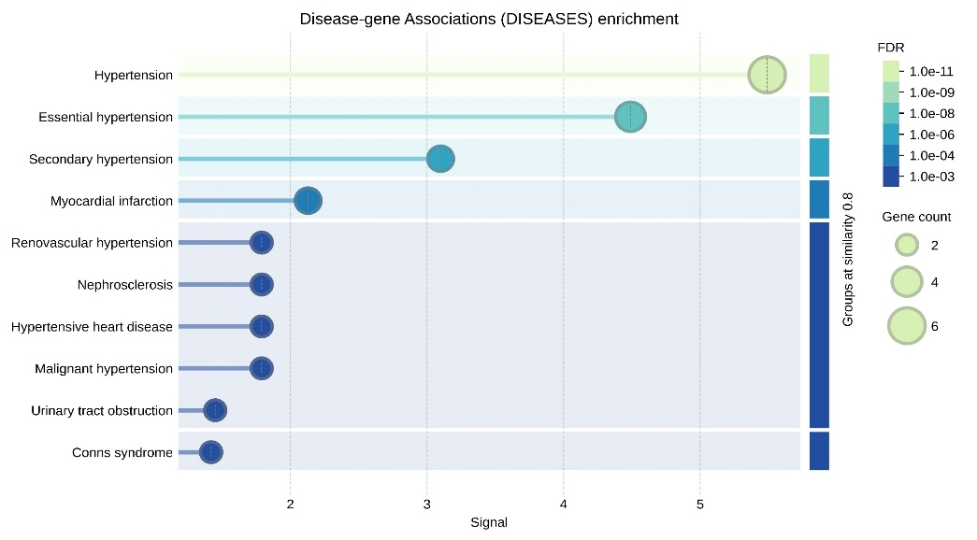
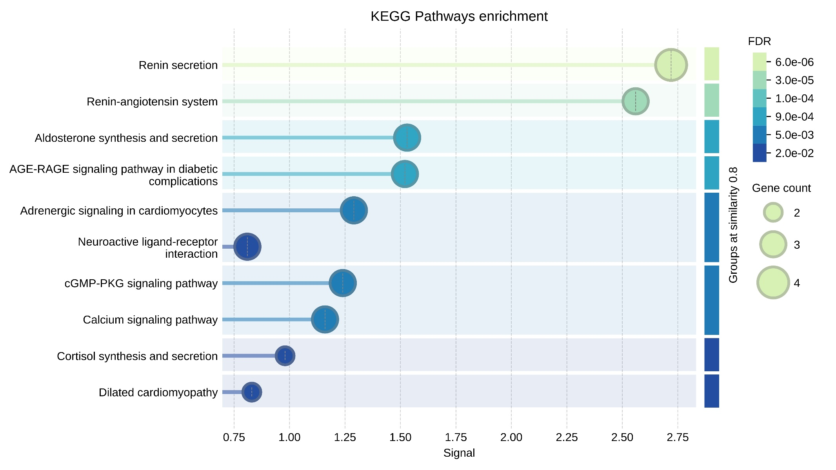
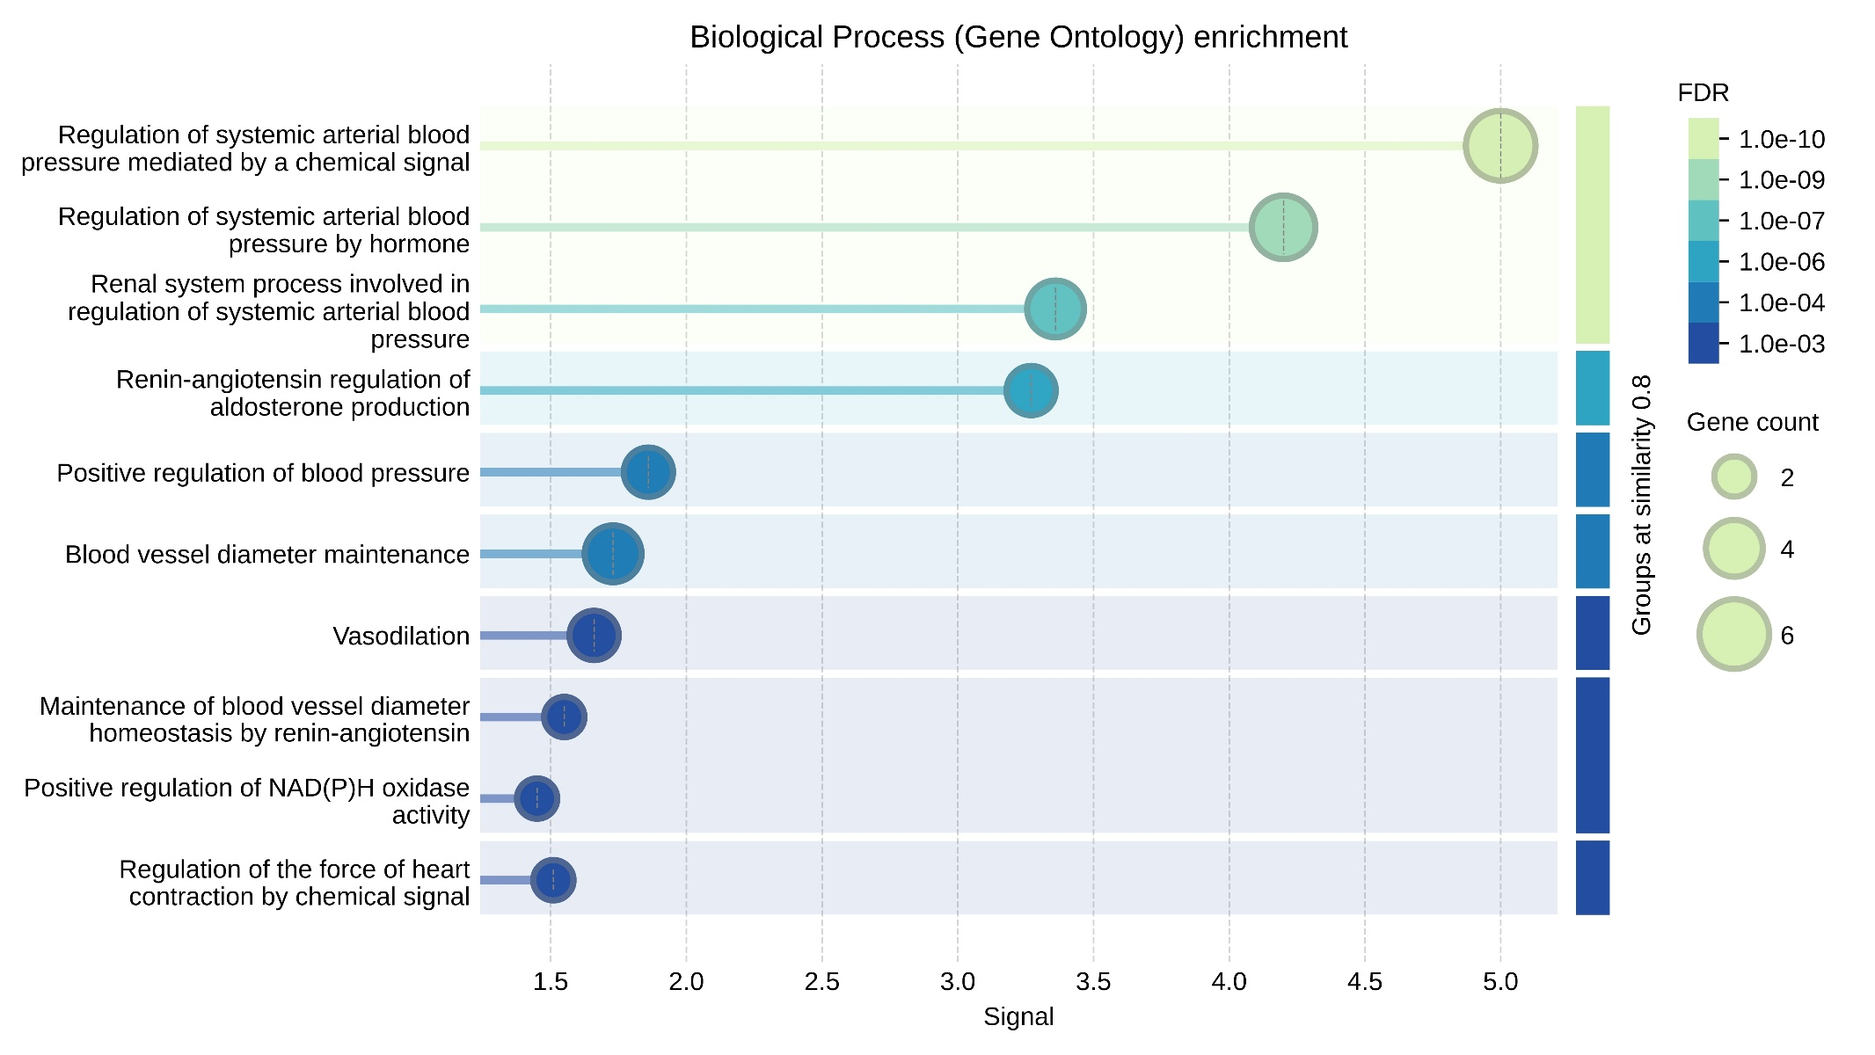

Supplementary Figure 2: Specific involvement of key genes across various enrichment databases.
Supplementary Table 5: eQTL Analysis of Hypertension-Associated SNPs
SNP (rsID) | eGene (Gene Affected) | Tissue (eQTL Active) | Direction of expression association | p-value | NES
rs1801133 | MTHFR | Artery – Tibial | Downregulated | 0.0000061 | -0.11
rs1801131 | MTHFR | Artery – Tibial | Upregulated | 1.4e-25 | 0.25
rs1799983 | NOS3 | Cells - Cultured fibroblasts | Downregulated | 0.0000021 | -0.21
rs2070744 | NOS3 | Skin - Not Sun Exposed | Upregulated | 0.0000019 | 0.15
rs2368564 | REN | NS | NS | NS | NS
rs2004776 | AGT | Brain - Cerebellar Hemisphere | Downregulated | 2.2e-17 | -0.58
rs699 | AGT | Artery - Coronary | Downregulated | 0.000025 | -0.26
rs5186 | AGTR1 | Skin - Sun Exposed (Lower leg) | Downregulated | 2.8e-9 | -0.19
rs1799998 | CYP11B2 | Testis | Upregulated | 0.000037 | 0.16
rs34789226 | CLOCK | NS | NS | NS | NS
NES, normalized effect size; NS, no significant eQTL identified. GTEx eQTL associations are tissue-specific observational findings and do not establish causal effects on hypertension.

