RNA extraction and semiquantitative RT-PCR
Total RNA from A7r5 cells was isolated using TRI REAGENT. The first-strand cDNA was synthesized from 2 µg of total RNA. PCR was performed using 200 ng of cDNA with the following thermal profile: 1 min 94 ºC, 1 min annealing, 1 min 72 ºC, and a final elongation step at 72 ºC for 15 min. TM and GAPDH fragments were amplified with primer concentration of 400 nM and 40 nM, respectively. PCR products were resolved on 2% agarose gels as previously described [1].

Cell adhesion assay
The ability of A7r5 cells to adhere to type I collagen or fibronectin was quantified according to a published method [2]. Clear-bottom 96-well plates were coated with 40 µg/ml collagen type I or 5 µg/ml fibronectin in PBS for 16 h at 4 ºC. Non-specific binding site were blocked with 2% BSA in PBS. A7r5 cells were transfected with 1µg of pEGFP, pEGFP-TM, pEGFP-TMΔL or pEGFP-TM^{S490, 492A} for 12 h and cultured for 36 h. The detached cells (6 x 10³ cells/100 µl) were added to the plain or coated 96 well plates and incubated for 30 min at 37 ºC. Non-adherent cells were removed by washing with DMEM. The cells were fixed with 4% paraformaldehyde, stained with 0.1% crystal violet for 25 min, and solubilized with 0.5% triton X-100. The optical density at 595 nm (OD 595) was determined using a microplate reader.

References:
[1] I.C. Lo, T.M. Lin, L.H. Chou, S.L. Liu, L.W. Wu, G.Y. Shi, et al., Ets-1 mediates platelet-derived growth factor-BB-induced thrombomodulin expression in human vascular smooth muscle cells, Cardiovasc Res. 81 (2009) 771-779.
[2] K. Lessan, D.J. Aguiar, T. Oegema, L. Siebenson, A.P. Skubitz, CD44 and beta1 integrin mediate ovarian carcinoma cell adhesion to peritoneal mesothelial cells, Am J Pathol. 154 (1999) 1525-1537.

Table S1. Primer sequence, annealing temperature, and PCR cycles for rat TM and GAPDH.
Primer |  | Sequence | Annealing temperature (ºC) | PCR cycles | Product size (bp)
Rat TM | Sense | CCATCTTCAGACATATTGGGC | 60 | 30 | 199
Rat TM | Reverse | GCCATATCTCCCTAAGCAG | 60 | 30 | 199
Rat GAPDH | Sense | GTTCCAGTATGACTCTACCC | 58 | 25 | 424
Rat GAPDH | Reverse | ACTCTTCTGAGTGGCAGTGATGGC | 58 | 25 | 424

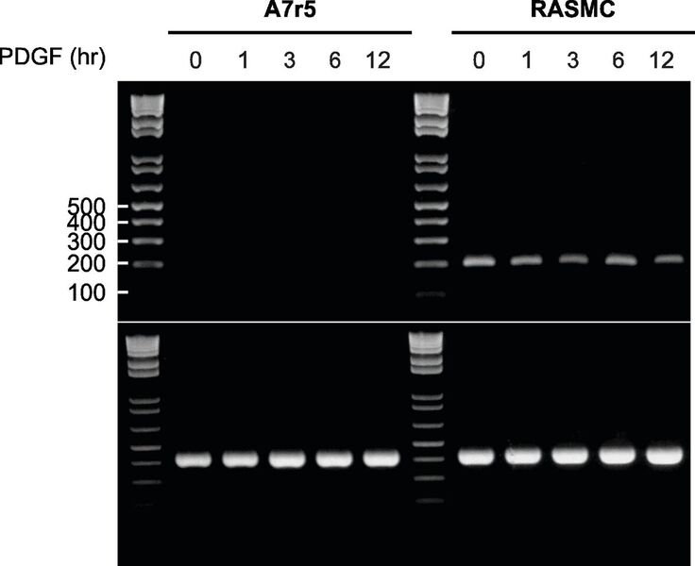

Figure S1. Representative RT-PCR analysis of TM mRNA expression in A7r5 cells and RASMCs. A7r5 and rat aortic smooth muscle cells (RASMCs) were serum-starved for 2 days and stimulated with PDGF (10 ng/ml) for 0, 1, 3, 6 and 12 h. RT-PCR products for TM with expected size of 199 bp were detected in RASMC but not in A7r5 cells. GAPDH mRNA RT-PCR products were examined as the internal control. The molecular size marker is a 1-kb DNA ladder.

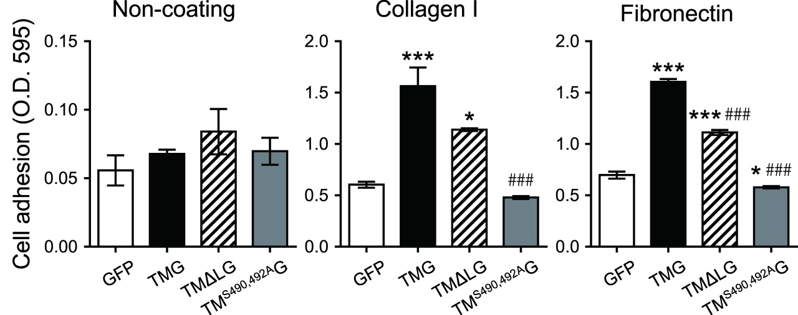

Figure S2. Thrombomodulin (TM) enhanced VSMCs adhesion in a chondroitin sulfate-dependent manner. A7r5 cells were transfected with pEGFP, pEGFP-TM, pEGFP-TMΔL or pEGFP-TM^{S490, 492A} for 12 h and cultured for 36 h. The cells (6 x 10³ cells) were added to wells without coating, or coated with type I collagen or fibronectin, and incubated for 30 min at 37 ºC. The adhered cells were fixed, stained with 0.1% crystal violet, and solubilized with 0.5% triton X-100. The optical density at 595 nm (OD 595) was determined using a microplate reader. Results were expressed as mean ± SEM (n = 3). *P<0.05, ***P<0.001, compared with the GFP-expressing group; ###P<0.001, compared with the TM-GFP-expressing group.

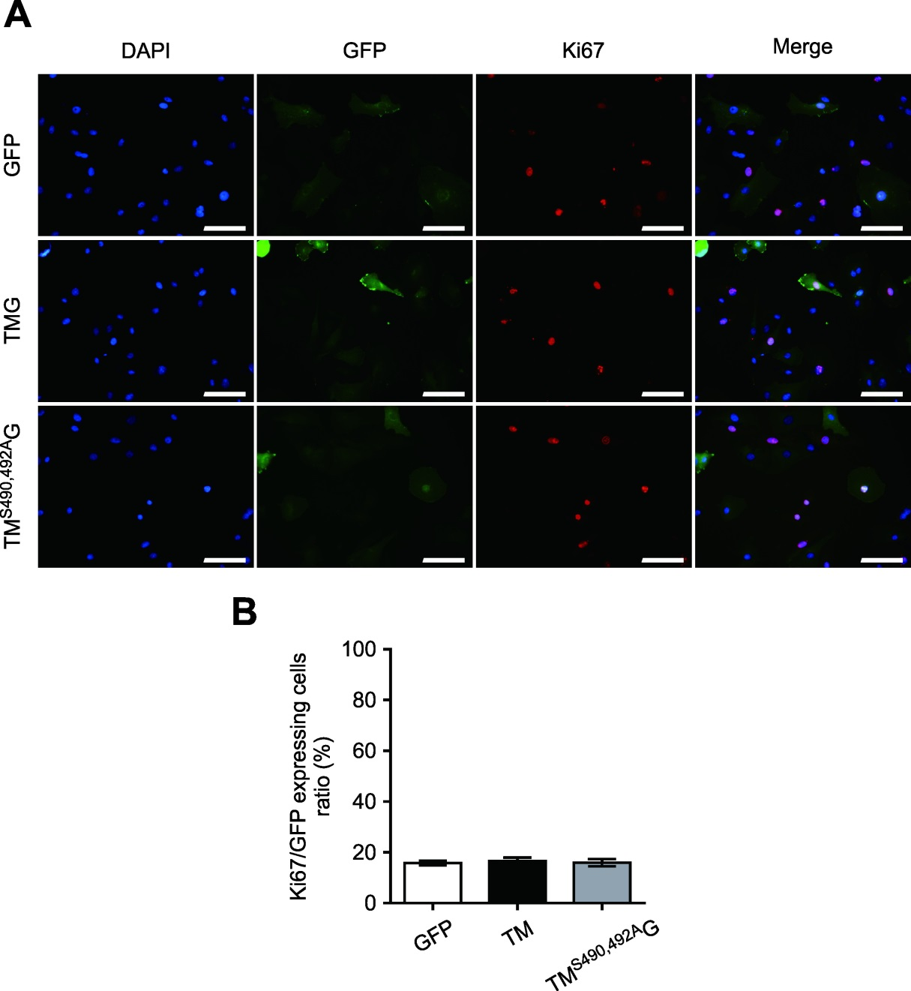
Figure S3. Thrombomodulin (TM) overexpression did not affect PDGF-stimulated proliferation of A7r5 cells. A7r5 cells were transfected with 1 µg of pEGFP, pEGFP-TM, or pEGFP-TM^{S490,492A} for 24 h, serum-starved for 48 h, and treated with 10 ng/ml PDGF-BB for 24 h. Cells were fixed with 4% paraformaldehyde and then stained with Ki-67(red) and DAPI (blue). A shows representative results and B summarizes the ratio of Ki-67-positive cells in cells expressing vector alone, TM-GFP, and TM^{S490, 492A}-GFP from at least 3 independent experiments. Results were expressed as mean ± SEM. Scale bar: 100 µm.

