Additional data
Additional Figure S1

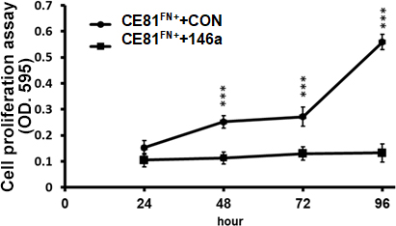
A

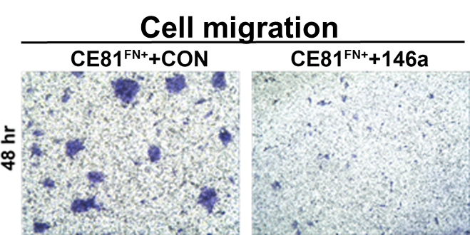
B
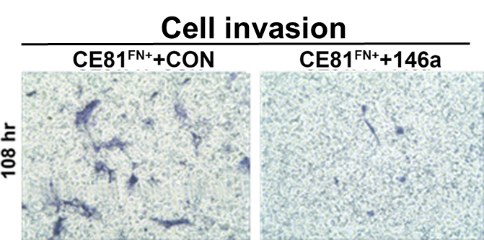
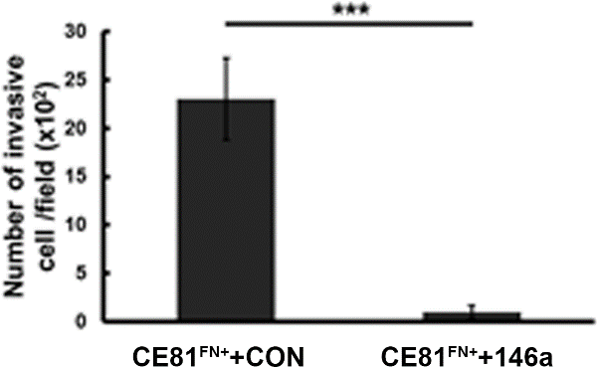
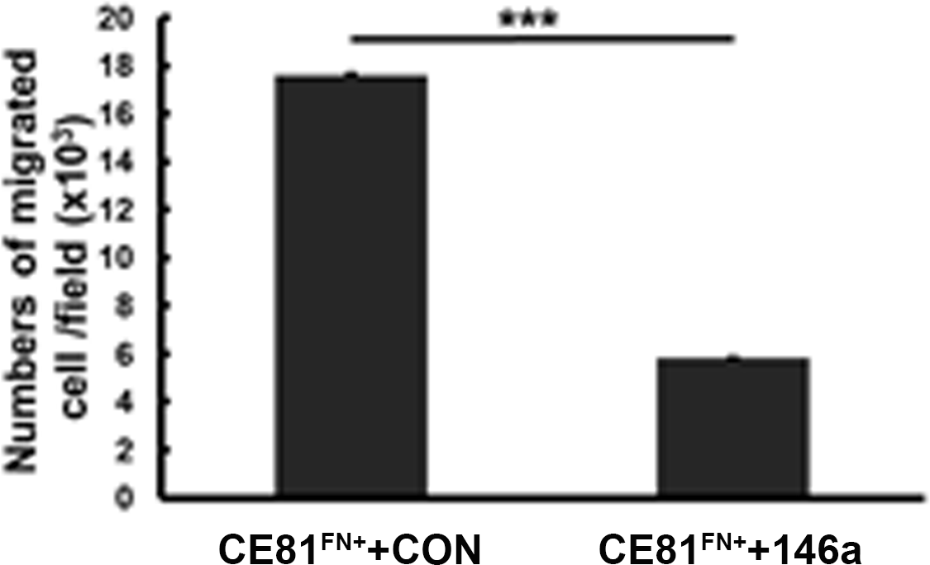C

Additional Figure S2

Additional Figure S3
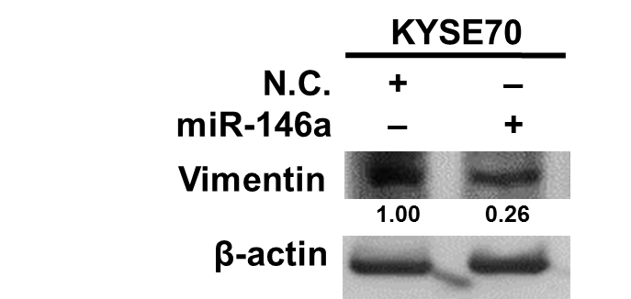
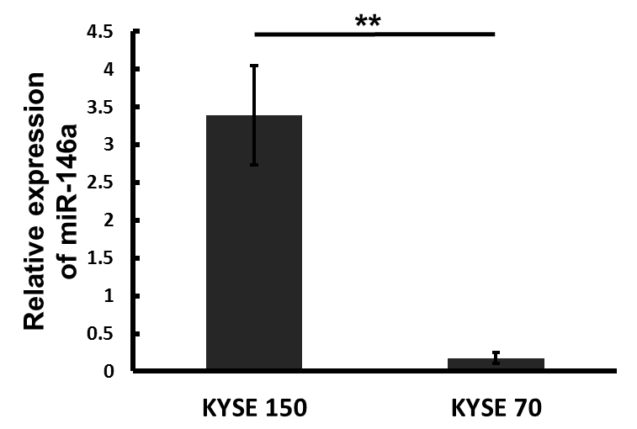
A
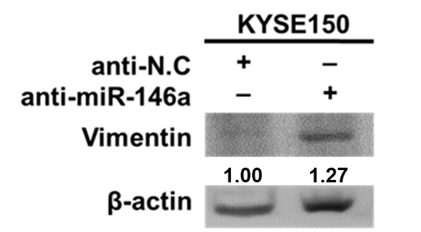
B C
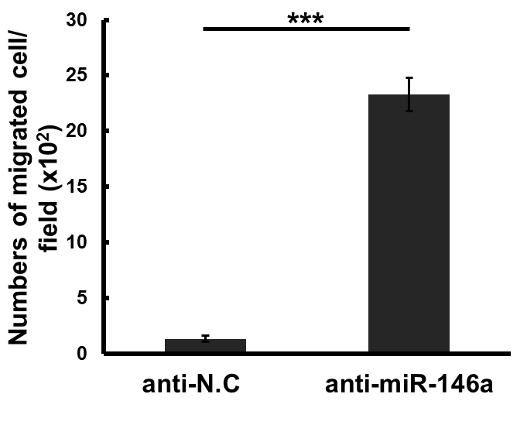
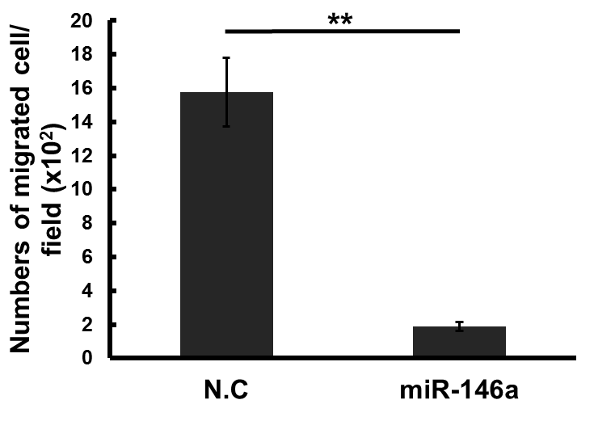
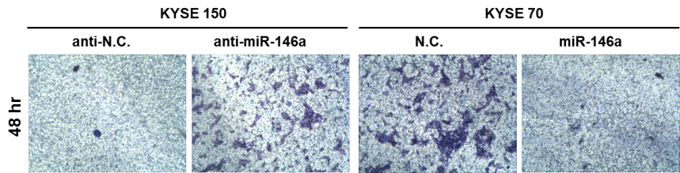
D

Additional Figure S4
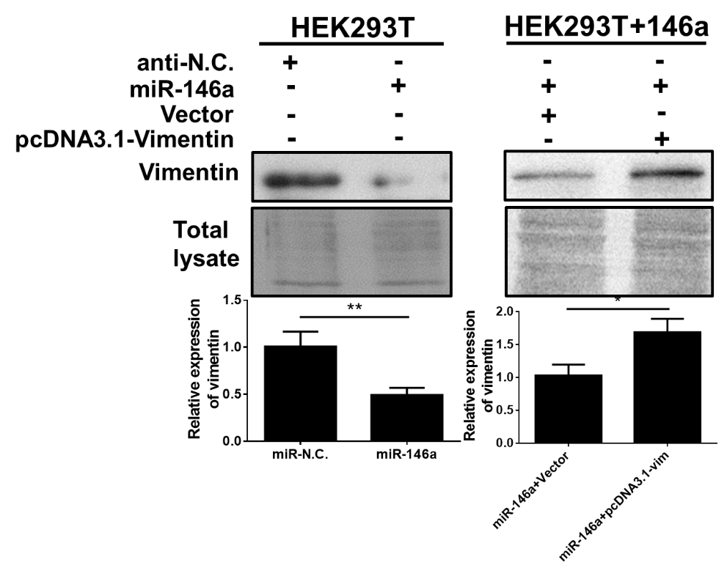
A

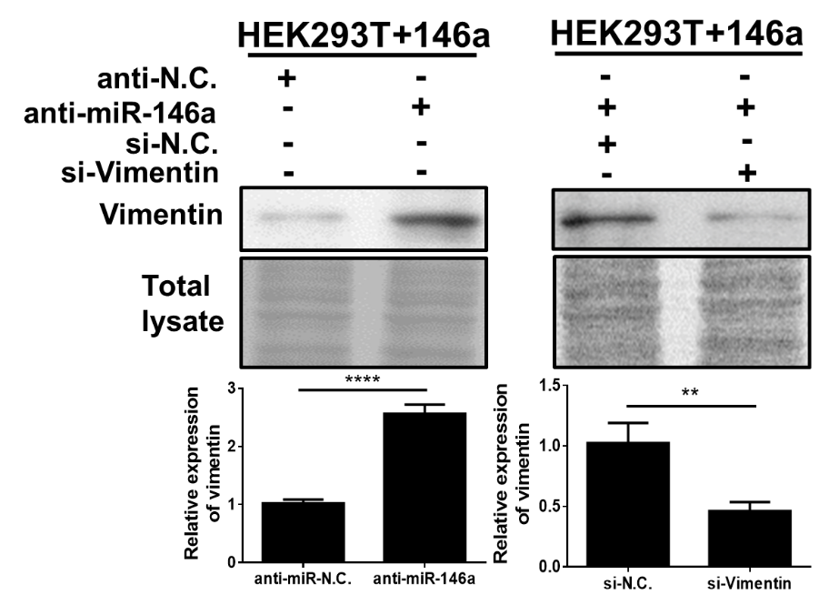
B

Additional Figure S5

Additional Figure S6

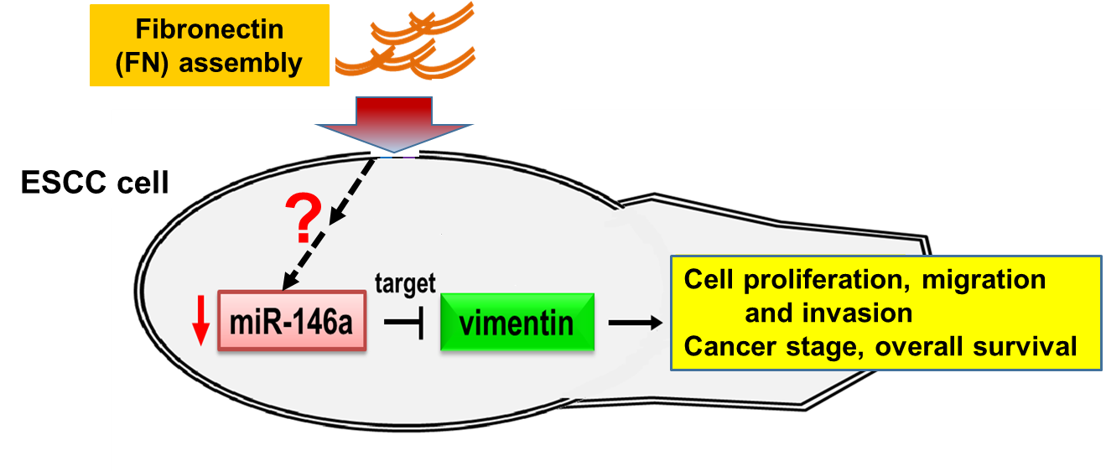

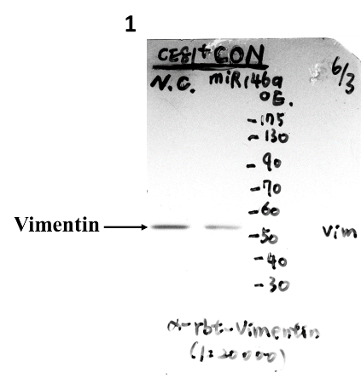
Additional Figure S7
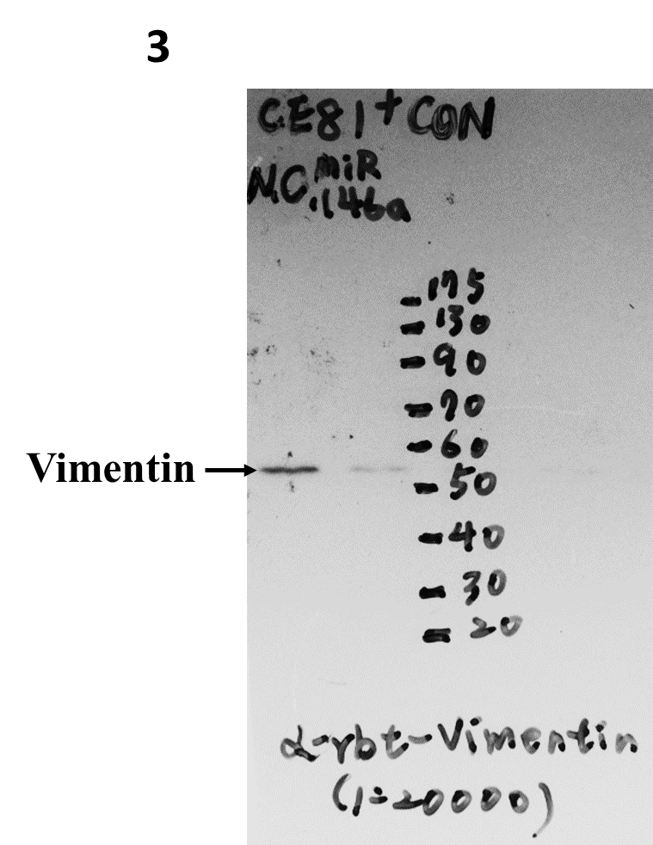
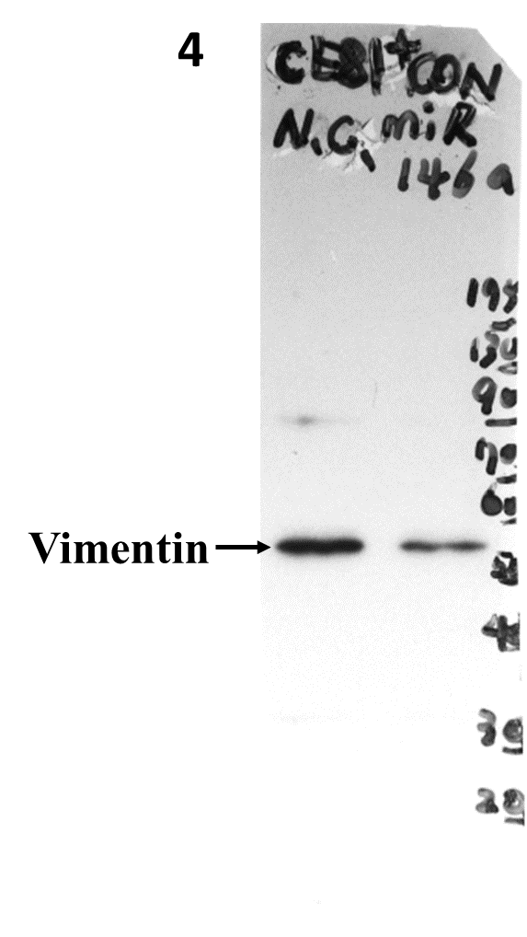
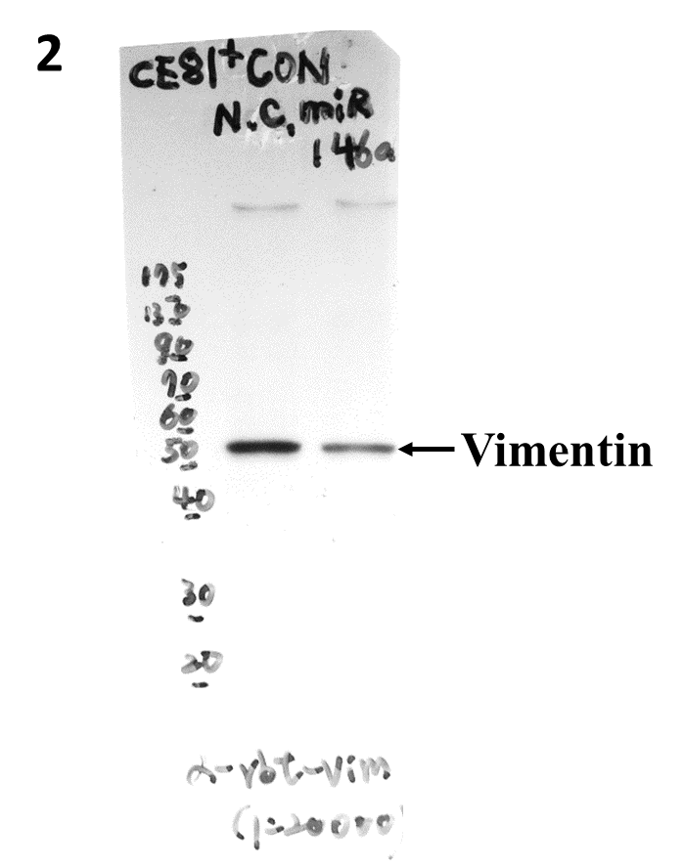
A

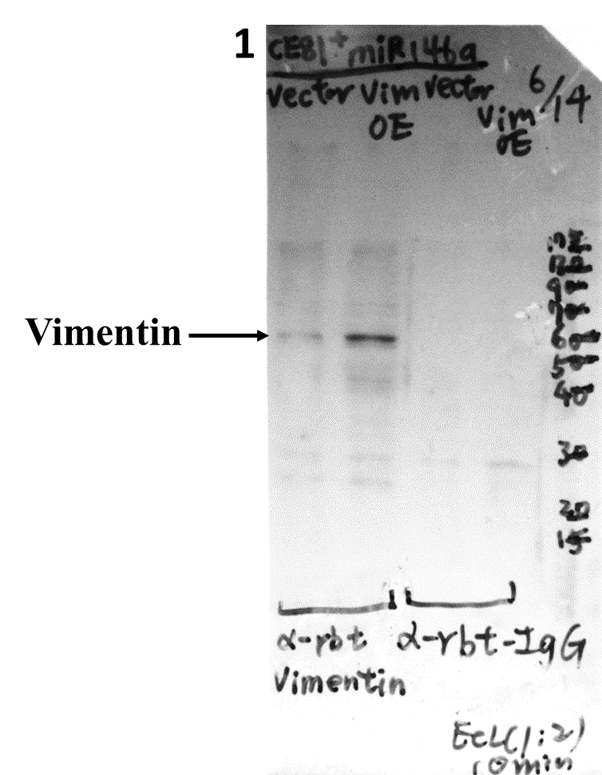
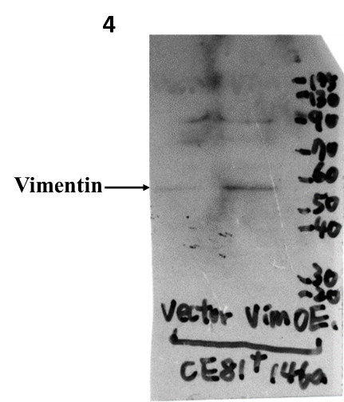
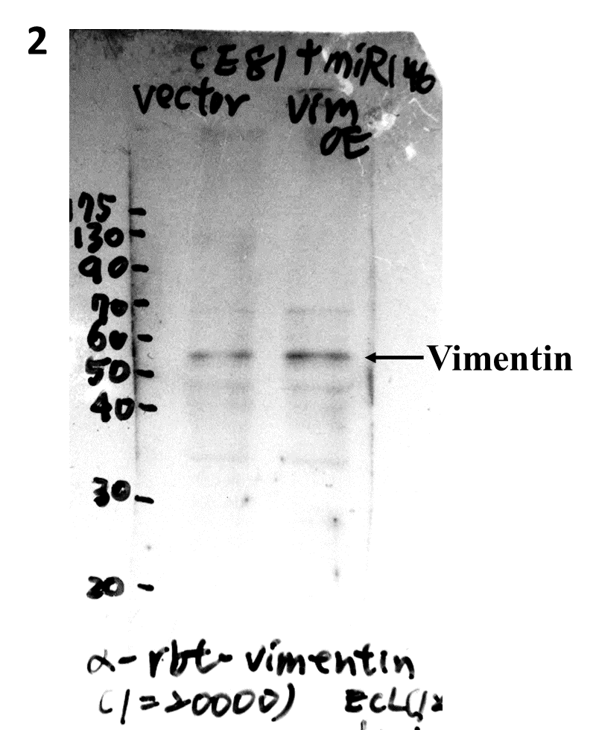
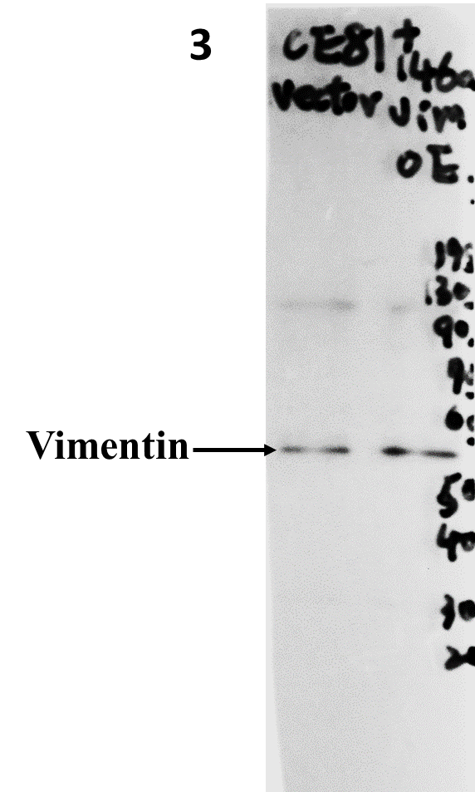
B

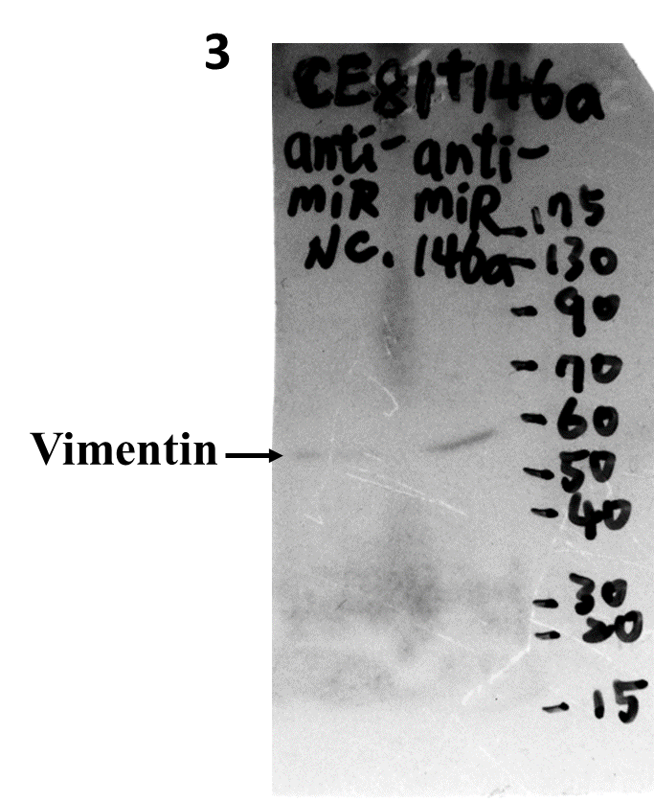
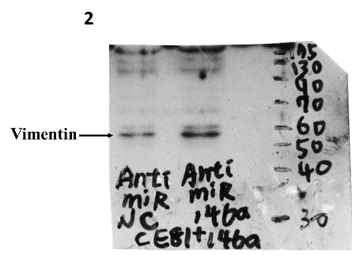
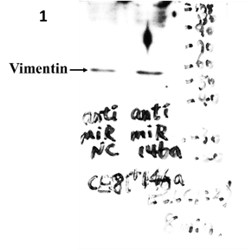
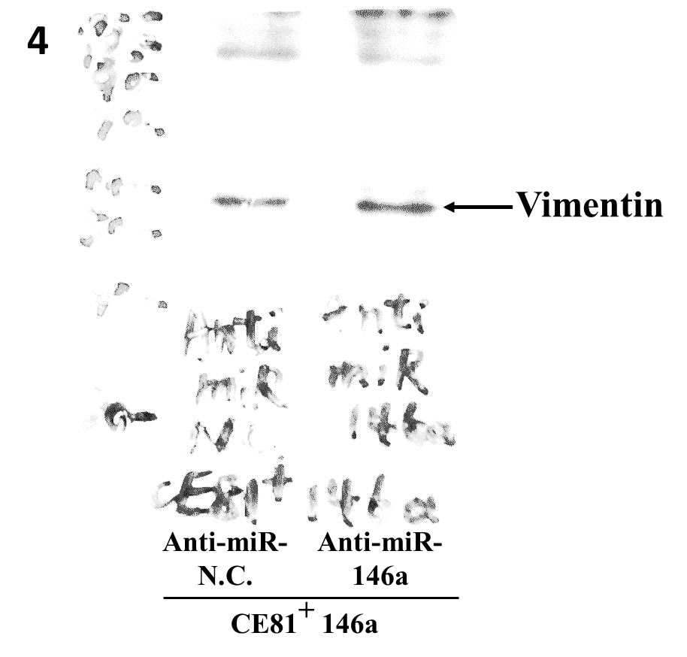
C

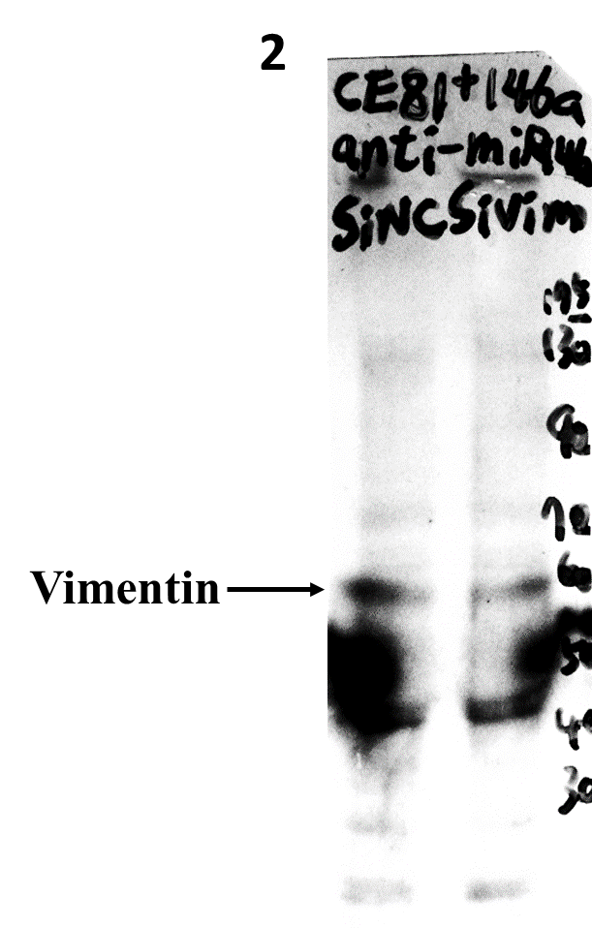
D
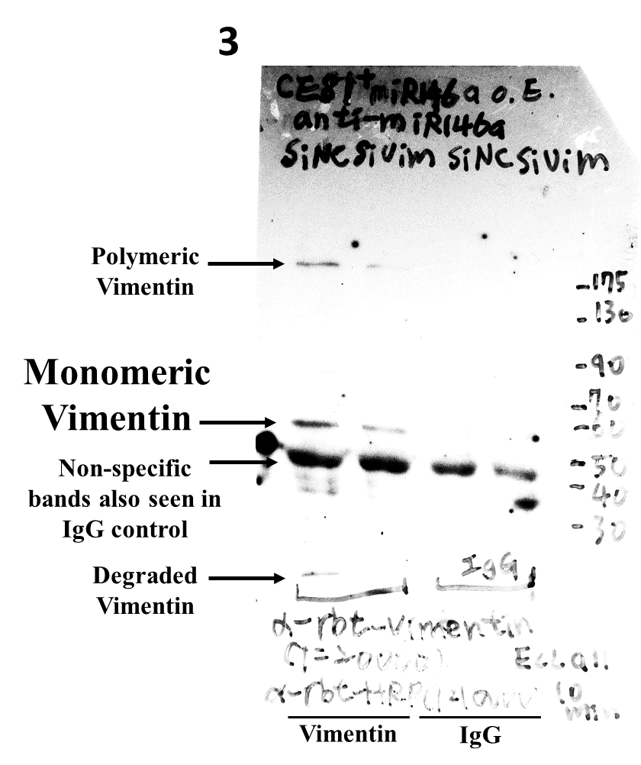
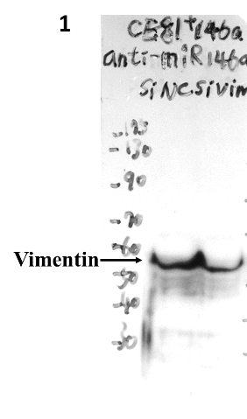

Additional data legends

Additional Figure S1. Proliferation, migration and invasion of CE81^{FN+}+CON and CE81^{FN+}+146a cells. (A) Cell proliferation of CE81^{FN+}+CON and CE81^{FN+}+146a was determined by MTT assay for 24, 48 and 96 hr. (B) The migration ability of CE81^{FN+}+CON and CE81^{FN+}+146a cells were investigated by Transwell™ migration assay at 48 hr. (C) The invasion ability of CE81^{FN+}+CON and CE81^{FN+}+146a cells were investigated by Transwell™ migration assay at 108 hr. The cell number was counted by Image J software. The data was analyzed by Student t test. ***: p<0.001.

Additional Figure S2. Mir-146a targeting vimentin 3’-UTR was examined by luciferase reporter assay in HEK 293T cells. The pre-miR-146a or its negative control (N.C.) was co-transfected with either wild-type or mutant-type of pMIR-Reporter-Vimentin 3’UTR plasmid into the HEK 293T cells. The luciferase activity was determined by a luminometer and normalized with Renilla luciferase activity (pRL-TK). The data were analyzed by Student’s t test. Statistically significant difference was indicated (***P<0.001; ns: no significance).

Additional Figure S3. MiR-146a and negatively regulated vimentin affect ESCC KYSE cell migration. (A) The expression levels of miR-146a in ESCC KYSE150 and 70 cells were measured by real-time PCR. (B) KYSE 150 cells were transiently transfected with 100 pmole/l of anti-miR-146a or scramble microRNA (anti-N.C.) using Lipofectamine™ for 48 hr followed by measuring the level of vimentin by Western blotting. (C) KYSE70 cells were transiently transfected with miR-146a or scramble microRNA (N.C.) followed by measuring the level of vimentin by Western blotting. β-actin was used as internal control. (D) The cells received the same treatment as (B and C) were used for Transwell™ migration assay. The quantitative data are shown by counting the number of the migrated cells on the bottom of the membrane after 48 hr. P-values were obtained by Student’s t test. **: p<0.01, ***: p<0.001. This experiment was repeated three times.

Additional Figure S4. Protein expression of vimentin is negative regulation by miR-146a. (A) Vimentin is downregulated by miR-146a relies on transient transfection of HEK293T cell and analyzes by Western blotting. Overexpression of vimentin in transiently transfected with pcDNA3.1-vimentin into HEK293T+146a stable cells compared to vector control. (B) The level of vimentin was increased in HEK293T+146a stable cells harboring with anti-miR-146a compared to the scramble anti-N.C. group. Up-regulation of vimentin in HEK293T+146a stable cells with anti-miR-146a can be suppressed by transiently transfected with si-vimentin.

Additional Figure S5. MiR-146a level inversely correlates with ESCC patient tumor stages. A total of 68 ESCC patient specimens were analyzed for miR-146a expression level by real-time PCR. The relative expression fold of miR-146a was normalized to U54. The relative expression levels of miR-146a was showed in figure which acculated form raw data of real-time PCR (Stage I and II miR146a/U54≧1.5 fold, and Stage III and IV < 1.5 fold). The stages of the ESCC patient specimens were determined by the pathologist in NCKU hospital. The data was analyzed by Student t test.

Additional Figure S6. The hypothetic model of fibronectin assembly-mediated miR-146a suppressing ESCC cell mobility through targeting vimentin. The fibronectin abundant assembling was negatively correlated with miR-146a expression. MiR-146a suppresses cell mobility by inhibition of vimentin.

Additional Figure S7. Raw data of western blot images for Figure 4B and 4E in triplicate or quadruplicate. Protein expression levels of vimentin in CE81^{FN+}+CON and CE81^{FN+}+146a stable cells were analyzed after transient transfection with various DNA constructs. (A) Quadruplicate results of vimentin expression levels in CE81^{FN+}+CON stable cells after transient transfection with scrambled microRNA (miR-NC) or mimic-miR-146a as referred to the Figure 4B (left panel). (B) Quadruplicate results of vimentin expression levels in CE81^{FN+}+CON cells after co-transfection with mimic-miR-146a and vector or pcDNA3-vimentin as referred to the Figure 4B (right panel). (C) Quadruplicate results of vimentin expression levels in CE81^{FN+}+146a cells after transient transfection with scramble anti-N.C. or anti-miR-146a as referred to the Figure 4E (left panel). (D) Triplicate results of vimentin expression levels in the CE81^{FN+}+146a stable cells after transient co-transfection with anti-miR146a and siN.C. or vimentin siRNA (si-vimentin) as referred to the Figure 4E (right panel).

Additional Table S1 List of primers and sequences
Usage | Primer name | Primer sequence
Real-time PCR | hsa-miR-146a  U54^{b}  (For miRNA detection)  VIM  IGSF1  FBXL10  CASK  PBX2  UHRF1 | F: 5’-TGAGAACTGAATTCCATGGGTT-3’  F:5’-GGTACCTATTGTGTTGAGTAACGGTGA-3’  Paired with universal primer form NcodeTM VILOTM cDNA synthesis miRNA kit  F: 5’-CAGATGCGTGAAATGGAAGA-3’  R: 5’-TGGAAGAGGCAGAGAAATCC-3’  F: 5’-GCCTAATCGTGGTGGTTGTT-3’  R: 5’-GTGCCTGGTTCTCCTTCTTG-3’  F: 5’-TCAAACGCTGTGGAAACATC-3’  R: 5’-AAAGGAAAGTGTCGGCTCAC-3’  F: 5’-AGTTCTGGGGTGGTTTTGC-3’  R: 5’-ACCTTTCCAATCCCTTCAGC-3’  F: 5’-ATAGCCAAAGGGGTTCTGGT-3’  R: 5’-CACTGCCTCCACATCAAATG-3’  F: 5’-GGCTGTTGATGTTTCTGGTG-3’  R: 5’-GCCCGAGATGTTTCCTCTTT-3’
ISHª | hsa-miR-146a probe | 5’-AACCCATGGAATTCAGTTCTCA-3’
Construct | 3’UTR of vimentin-wild type F  3’UTR of vimentin-wild type R  3’UTR of vimentin-mutant type F | 5’-ATAAGCTTAGTTAACAACCGACACTCC-3’  5’-ATACTAGTGAGTTTTTCCAAAGATTTATT  GAAG-3’  5’-ATAAGCTTACTACATTACAACCGACACTCC  TA-3’
F: forward primer; R: reverse primer; 3’UTR:3’-un-translated region
a: In Situ Hybridization
b: used as the internal control

Additional Table S2. Correlation of miR-146a and vimentin protein expression with clinicopathologic parameters of sixty-eight ESCC patients
Expression pattern | Age | Gender | Tumor stage  (I&II vs. III& IV) | Two-year survival
miR-146a | 0.9586 | 0.3666 | 0.1535 | P< 0.0001
vimentin | 0.454 | 0.8665 | 0.3473 | P< 0.05
miR-146a & Vimentin | 1 | 1 | 0.7133 | 0.4884
@ The association of age, gender, tumor stage, and two-year survival with level of miR-146a, vimentin or miR-146a & vimentin was analyzed by unpaired t test.
@ Multivariant analysis was conducted for the correlation of low-miR146a (miR-146a <0.8) plus high vimentin expression (Vimentin >1.8) with clinicopathologic parameters by Fisher's exact test.

