Supplementary data
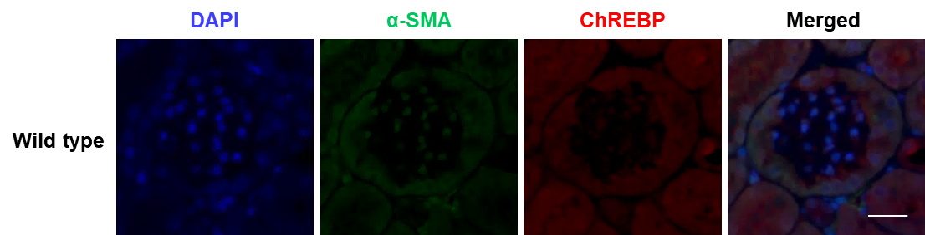
Additional file 1: Fig. S1. Glomerular expression of ChREBP and α–smooth muscle actin (α-SMA) in wild type mice (related to Fig. 1C). Representative images depicting the expression of α-SMA (green) and ChREBP (red) in the kidney tissue sections of wild type mice. The nuclei were counterstained with DAPI (blue). Scale bar, 20 μm; n=3.

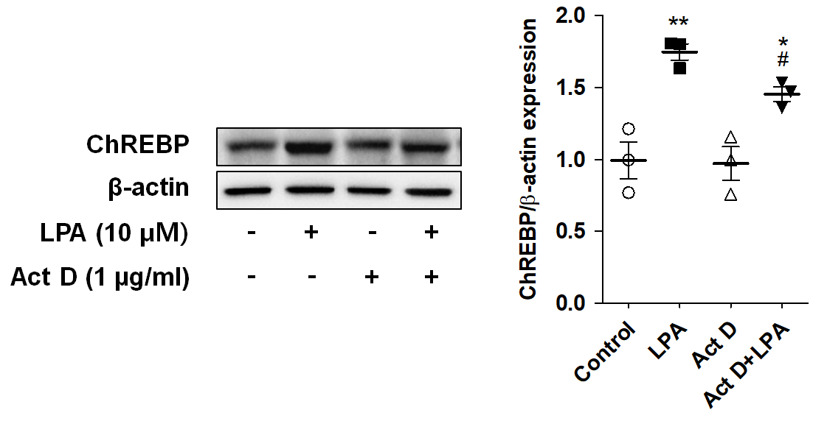
Additional file 1: Fig. S2. The LPA-induced expression of ChREBP protein is partially mediated via transcription in SV40 MES13 cells. SV40 MES13 cells were pretreated with actinomycin D (Act D, 1 μg/ml) for 1 h, and subsequently treated with LPA for 3 h. The protein level of ChREBP was analyzed by western blotting, quantified using ImageJ software, and normalized to that of β-actin. The data are presented as the mean ± SEM of results obtained from three independent experiments. *p<0.05, **p<0.01 vs. vehicle only (control); #p<0.05 vs. LPA only.

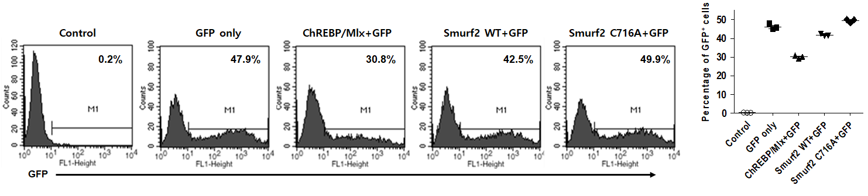
Additional file 1: Fig. S3. Transfection efficiency of ChREBP and Smurf2 overexpression in SV40 MES13 cells. SV40 MES13 cells were seeded at a density of 3 × 10⁵ cells/60-mm dish, 24 h prior to transfection. In order to determine the transfection efficiency of ChREBP or Smurf2 overexpression, the cells were transiently co-transfected with the enhanced green fluorescent protein (EGFP) and ChREBP/Mlx, EGFP and Smurf2 wt, or EGFP and Smurf2 C716A expression vectors using Lipofectamine 3000, according to the manufacturer’s instructions. The GFP-positive cells were quantified by flow cytometry after 24 h of transfection. The values in the representative flow cytometry histograms indicate the percentage of GFP-positive cells in the total cell population. The data are presented as the mean ± SEM of results obtained from three independent experiments.

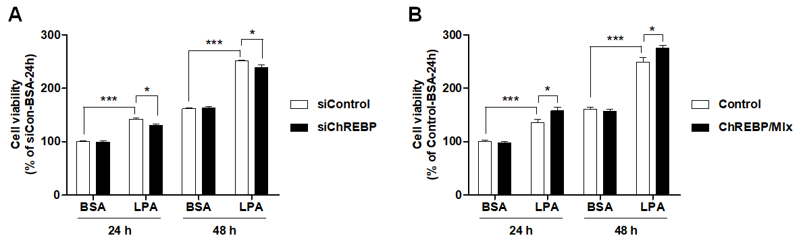

Additional file 1: Fig. S4. ChREBP mediates the LPA-induced proliferation of SV40 MES13 cells. (A) SV40 MES13 cells were transfected with a control siRNA (siCon) or ChREBP siRNA (siChREBP) and treated with LPA for 24 or 48 h. Cell viability was analyzed by CCK8 assay and calculated as a percentage relative to that of siCon-BSA cells at 24 h. (B) The SV40 MES13 cells were co-transfected with vectors expressing ChREBP and Mlx (ChREBP/Mlx), or transfected with an empty pcDNA vector (Control), and treated with LPA for 24 or 48 h. Cell viability was analyzed by CCK8 assay and calculated as a percentage relative to that of the Control-BSA cells at 24 h. The data are presented as the mean ± SEM of results obtained from three independent experiments. *p<0.05, **p<0.01, ***p<0.005.

Additional file 1: Table S1. Primers used for quantitative real-time PCR
Gene name | Sequences 5′-3′
ChREBP | Forward 5′-AGAACCGACGTATCACACACATCT-3′
 | Reverse 5′-CAGGGTGTCGAATCCTAGCTTAA-3′
Fibronectin | Forward 5′-TGACGATGGGAAGACCTACCA-3′
 | Reverse 5′-GGAACAAATGGCTCCGAGATAT-3′
TGF-β | Forward 5′-GCAGTGGCTGAACCAAGGA-3′
 | Reverse 5′-AGCAGTGAGCGCTGAATCG-3′
IL-1β | Forward 5′-CTACAGGCTCCGAGATGAACAAC-3′
 | Reverse 5′-TCCATTGAGGTGGAGAGCTTTC-3′
Smurf2 | Forward 5′-TGGGGACATGTCTAACCCC-3′
 | Reverse 5′-TTTTGCACAGAGTACTGTCAGG-3′
Traf4 | Forward 5′-GAGCCTGTGCAGGTGTCTAC-3′
 | Reverse 5′-AGACTCCTTCACTGAGAAACTCC-3′
Trib3 | Forward 5′-CAGCAACTGTGAGAGGACGA-3′
 | Reverse 5′-AGTCATCACGCAGGCATCTT-3′
Ttc3 | Forward 5′-CCATAGCAGGCGCAATTCAG-3′
 | Reverse 5′-AACATACTCGCTGCTGTGCT-3′
Usp11 | Forward 5′-CCACGCATACAAGTGTTGCACC-3′
 | Reverse 5′-CTCAATCCGACCAGTCACCTCA-3′
18s rRNA | Forward 5′-CACTACGCGCAGTATGTGCT-3′
 | Reverse 5′-TGAATGGCCTCCTTATCCTG-3′

