Additional file 3.

Table S1. Experimental protocol of ion-exchange chromatography.
Table S2. Experimental protocol of size-exclusion chromatography.
Table S3. Data collection and refinement statistics of the LGp40 crystal.
Figure S1. IL-12p40 levels of crude extracts used to stimulate mouse BMDC.
Figure S2. Ion-exchange chromatography of crude extracts on a DEAE-Sepharose Fast Flow column.
Figure S3. IL-12p40 levels of IE1-1 to IE4-2 fractions (fractions from ion-exchange chromatography) used to stimulate mouse BMDC.
Figure S4 Size-exclusion chromatography of fractions from crude extract IE1 on a Sephacryl S-300 HR column.
Figure S5. Size-exclusion chromatography of fractions from crude extract IE2 on a Sephacryl S-300 HR column.
Figure S6. Size-exclusion chromatography of fractions from crude extract IE3 on a Sephacryl S-300 HR column.
Figure S7. Identification and purification of sub-fraction IE3-3G1.
Figure S8. GAPDH derived from probiotics and pathogens are dissimilar.
Figure S9. RNA-seq analysis showed differentially regulated gene expression between LGp40 and CDp40-stimulated BMDM.
Figure S10. The plasminogen interaction and plasmin activation ability of LGp40 decreased when the GAPDH activity was lost.

Table S1. Experimental protocol of ion-exchange chromatography.
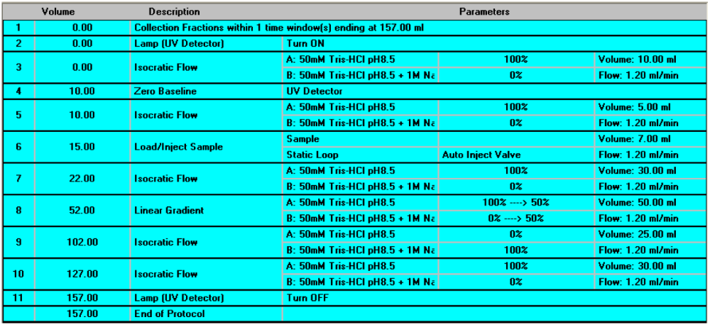
Buffer A: 50 mM Tris-HCl (pH 8.5); Buffer B: 1 M NaCl in 50 mM Tris-HCl (pH 8.5)

Table S2. Experimental protocol of size-exclusion chromatography.
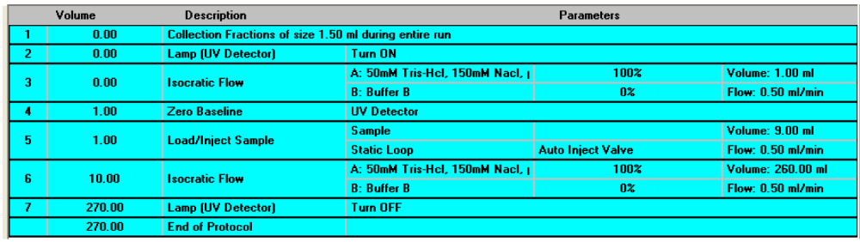
Buffer A: 50 mM NaCl in 50 mM Tris-HCl (pH 9.5)

Table S3. Data collection and refinement statistics of the LGp40 crystal.
Crystal | LGp40 (7WWW)
Data collection
Radiation source | NSRRC BL13C1
Wavelength (Å) | 0.97622
Space group | I4₁22
Unit cell parameter
a (Å) | 114.92
b (Å) | 114.92
c (Å) | 118.62
Resolution (Å) | 30-1.88 (1.95-1.88)ª
Number of reflections | 32168 (3031)
Completeness (%) | 98.8 (94.8)
Redundancy | 12.0 (10.5)
R_{merge} (%) | 6.7 (54.6)
I/σ (I) | 41.7 (3.7)
Overall Wilson B factor (Å²) | 32.0
Refinement
Resolution | 29.7-1.88 (1.98-1.88)
Reflections (work) | 30413 (4180)
Reflections (free) | 1625 (240)
R_{work} (%) | 13.4 (20.3)
R_{free} (%) | 21.7 (31.3)
Geometry deviations
Bond length (Å) | 0.007
Bond angles (º) | 1.4
Mean B-values (Å) / No.
Protein atoms | 44.2 / 2534
Water molecules | 52.5 / 247
Ligand atoms | 39.8 / 48
Ramachandran plot (%)^{b}
Favored region | 97.6
Allowed region | 2.4
ªValues in the parentheses are for the highest resolution shells.
^{b}Categories were defined by RAMPAGE.

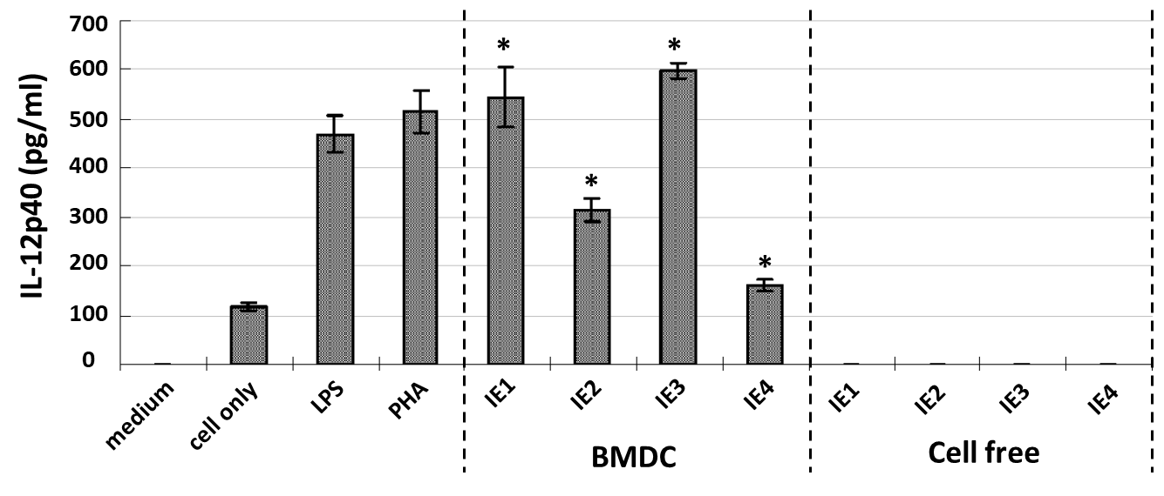
Fig. S1 IL-12p40 levels of crude extracts used to stimulate mouse BMDC.
AS 0-25% precipitates (IE1), AS 25-50% precipitates (IE2), AS 50-75% precipitates (IE3), and AS 75-100% precipitates (IE4). (n = 3, *p < 0.05 compared to cell only group, one-way ANOVA with Bonferroni multiple comparison test.)

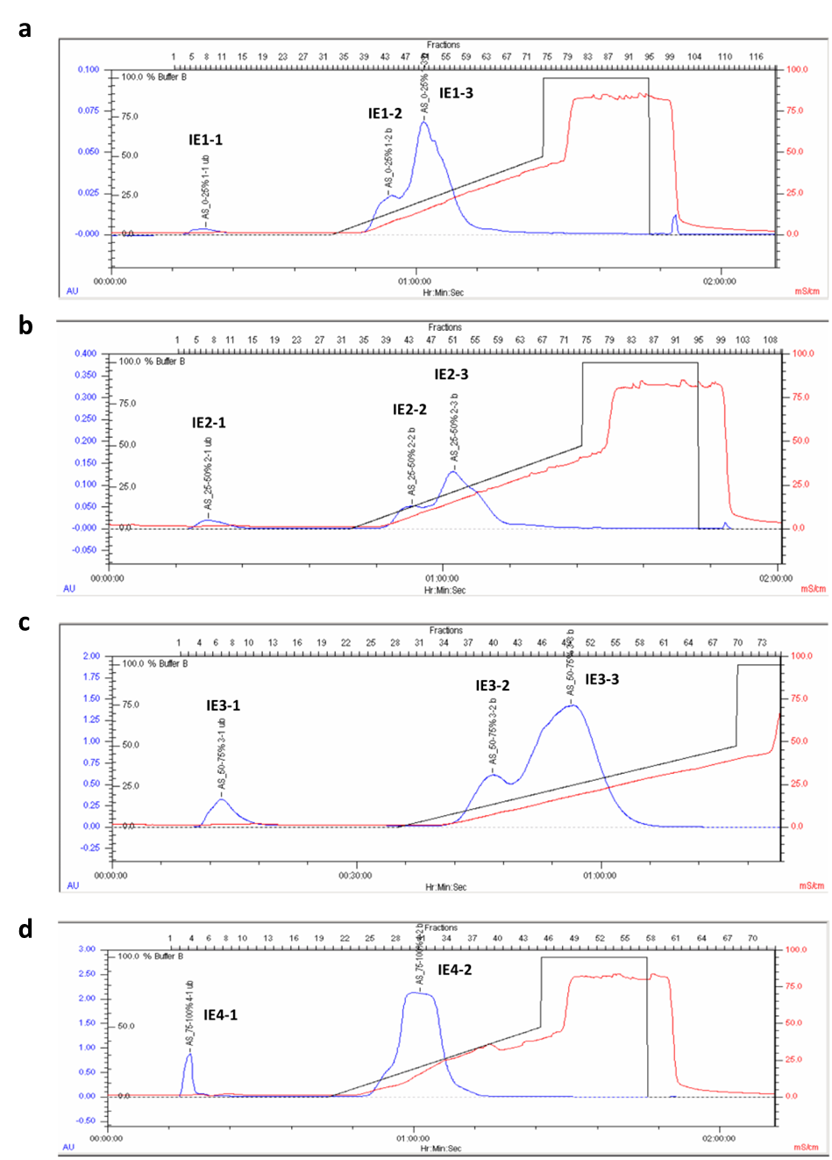

Fig. S2 Ion-exchange chromatography of crude extracts on a DEAE-Sepharose Fast Flow column.
The curve of elution in DEAE Sepharose Fast Flow chromatography. Samples were a AS 0-25% precipitates (IE1), b AS 25-50% precipitates (IE2), c AS 50-75% precipitates (IE3), and d AS 75-100% precipitates (IE4). Starting chromatography buffer (buffer A): 50 mM Tris-HCl (pH 8.5). Elution buffer (buffer B): 1 M NaCl in starting buffer. Elution was a linear gradient (from 0 to 1 M) of NaCl in Tris-HCl buffer. Detection wavelength: UV 280 nm; Flow rate: 1.2 ml/min; Collection rate: 1 ml/tube.

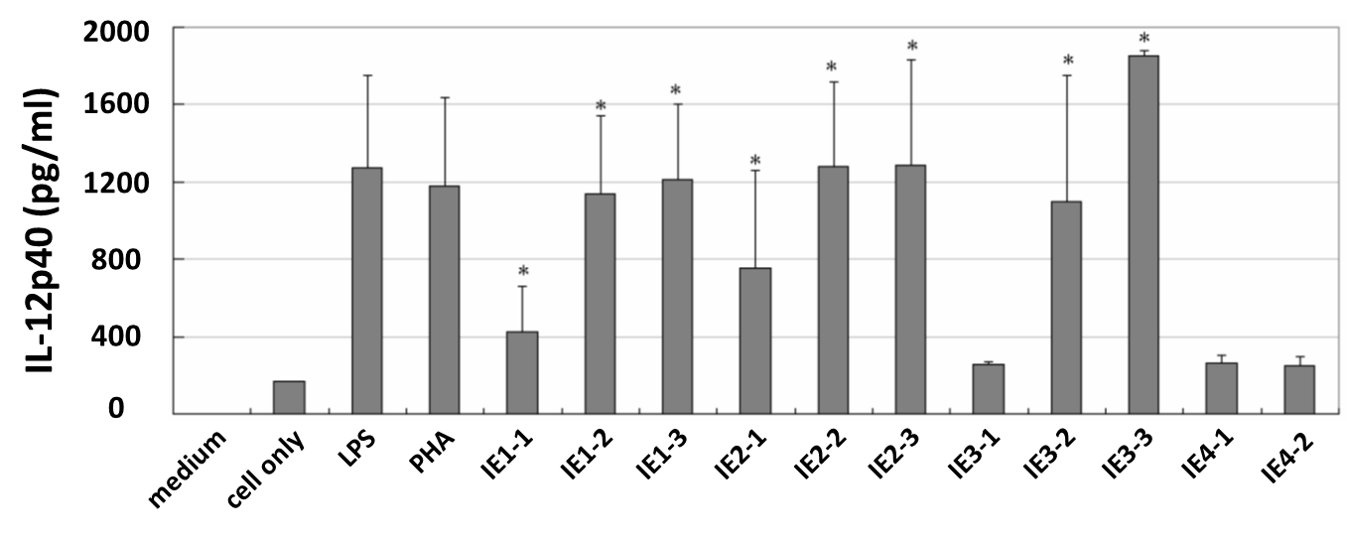
Fig. S3 IL-12p40 levels of IE1-1 to IE4-2 fractions (fractions from ion-exchange chromatography) used to stimulate mouse BMDC.
n = 3, *p < 0.05 compared to cell only group, one-way ANOVA with Bonferroni multiple comparison test.

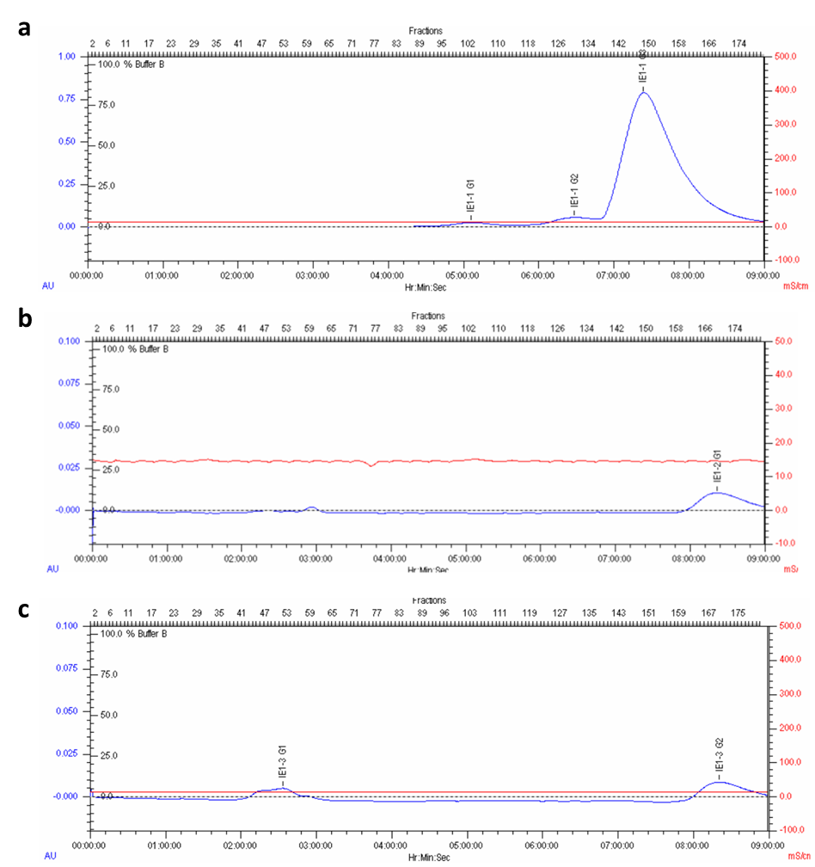
Fig. S4 Size-exclusion chromatography of fractions from crude extract IE1 on a Sephacryl S-300 HR column.
The curve of elution in Sephacryl S-300 HR chromatography. Samples were fraction a IE1-1, b IE1-2, and c IE1-3 from DEAE-Sepharose Fast Flow column. Equilibration and elution buffer (buffer A): 50 mM NaCl in 50 mM Tris-HCl (pH 9.5). Detection wavelength: UV 280 nm; Flow rate: 0.5 ml/min; Collection rate: 1 ml/tube.

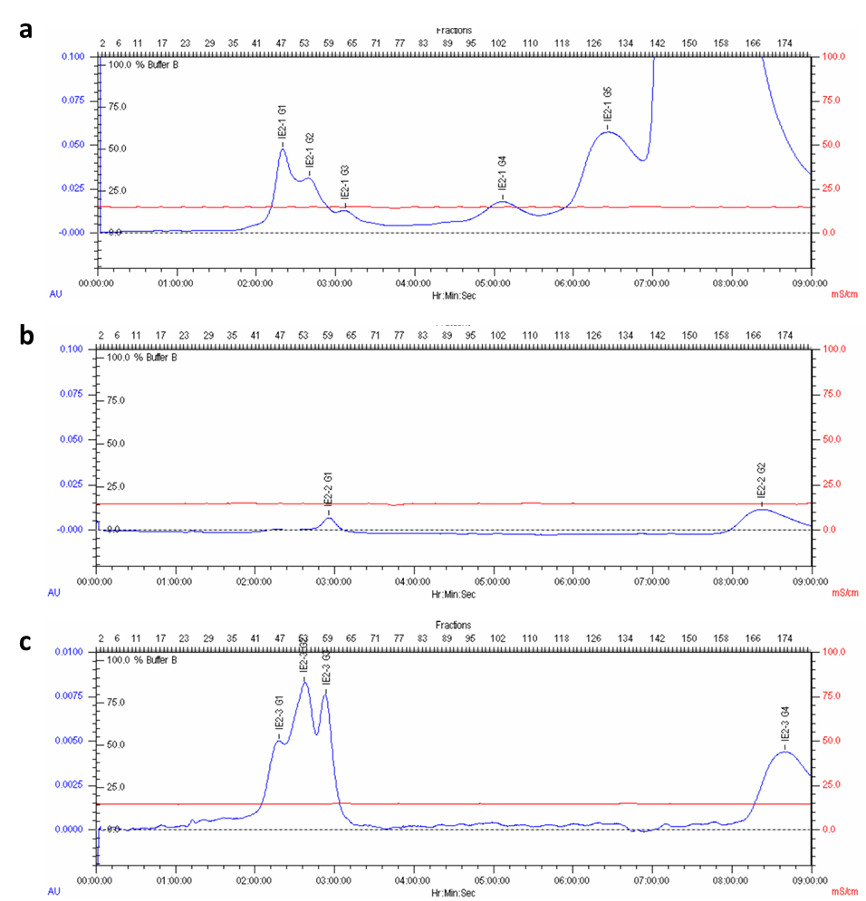
Fig. S5 Size-exclusion chromatography of fractions from crude extract IE2 on a Sephacryl S-300 HR column.
The curve of elution in Sephacryl S-300 HR chromatography. Samples were fraction a IE2-1, b IE2-2, and c IE2-3 from DEAE-Sepharose Fast Flow column. Equilibration and elution buffer (buffer A): 50 mM NaCl in 50 mM Tris-HCl (pH 9.5). Detection wavelength: UV 280 nm; Flow rate: 0.5 mL/min; Collection rate: 1 mL/tube.

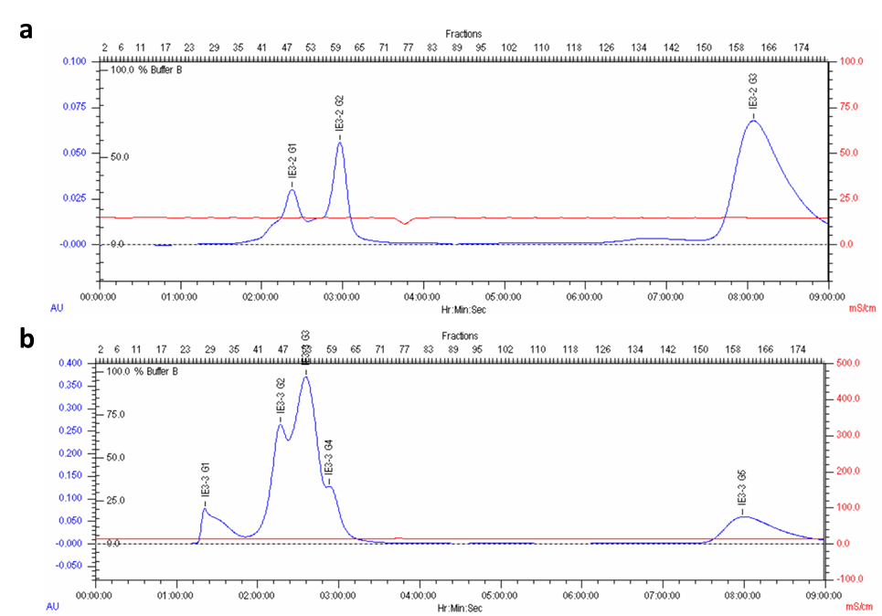
Fig. S6 Size-exclusion chromatography of fractions from crude extract IE3 on a Sephacryl S-300 HR column.
The curve of elution in Sephacryl S-300 HR chromatography. Samples were fraction a IE3-2 and b IE3-3 from DEAE-Sepharose Fast Flow column. Equilibration and elution buffer (buffer A): 50 mM NaCl in 50 mM Tris-HCl (pH 9.5). Detection wavelength: UV 280 nm; Flow rate: 0.5 mL/min; Collection rate: 1 mL/tube.

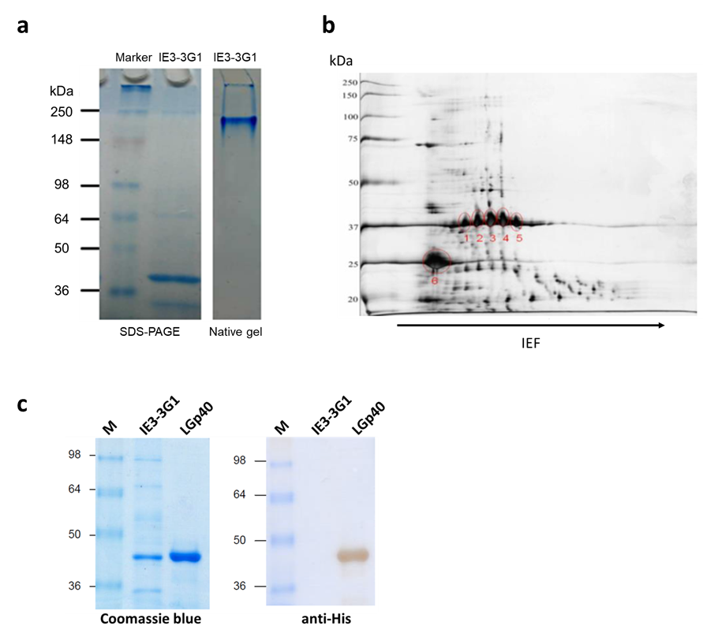
Fig. S7 Identification and purification of sub-fraction IE3-3G1.
a Sub-fraction IE3-3G1 was subjected to electrophoresis on a 10% SDS-PAGE gel and a native gel. b 2-DE separation of proteins from fraction IE3-3G1. c Sub-fraction IE3-3G1 and recombinant LGp40 protein were subjected to electrophoresis on a 10% SDS-PAGE gel and were detected by His-tag antibody.

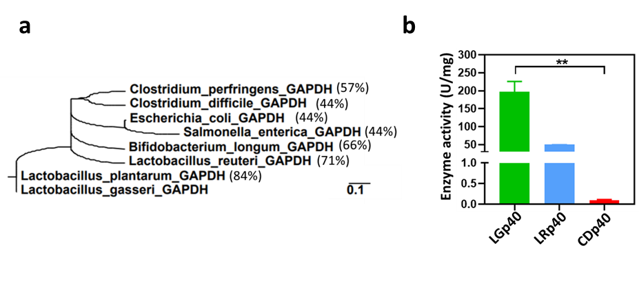
Fig. S8 GAPDH derived from probiotic and pathogen are dissimilar.
a Phylogenetic relationship of the GAPDH. b Enzyme activity of recombinant proteins (n= 3-6, **p < 0.01, one-way ANOVA with Bonferroni multiple comparison test).

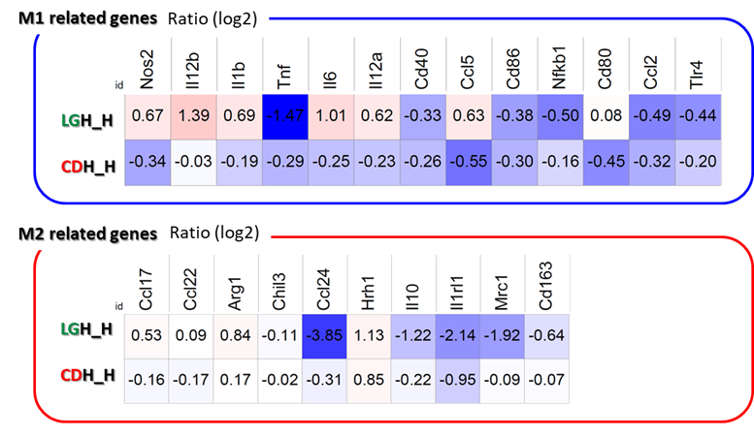
Fig. S9 RNA-seq analysis showed differentially regulated gene expression between LGp40- and CDp40-stimulated BMDM.
BMDM were pre-incubated with LGp40 and CDp40 and then re-stimulated with HDM. Afterward, these cells were harvested and ran the RNA-seq analysis.

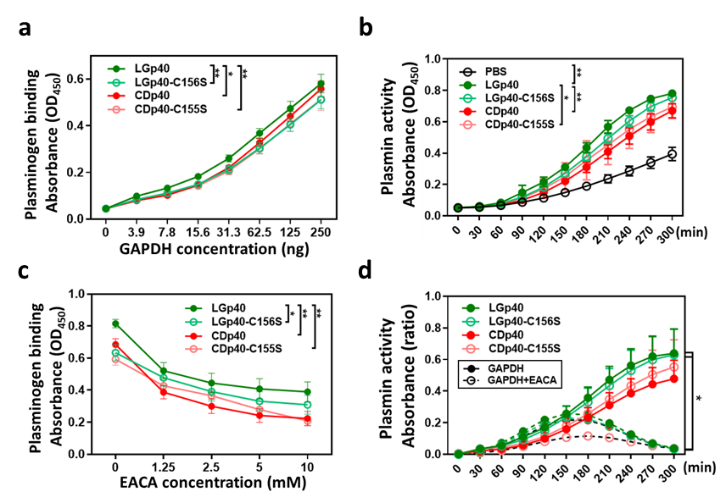
Fig. S10 The plasminogen interaction and plasmin activation ability of LGp40 decreased when the GAPDH activity was lost.
a Increasing concentration of recombinant proteins (3.9 to 250 ng) interact with plasminogen in vitro. b Kinetic changes of uPA-mediated plasmin activation by the recombinant proteins. c Binding of recombinant proteins to plasminogen in presence of increasing concentration of the lysine analog EACA (1.25 to 10mM) was measured by ELISA. d Kinetic changes of uPA-mediated plasmin activation by the recombinant proteins in presence of EACA (Ration with PBS). Experiment was repeated 3 times (*p < 0.05 and **p < 0.01, two-way ANOVA with Bonferroni multiple comparison test).

