Additional file 1

Periostin Promotes Ovarian Cancer Metastasis by Enhancing M2 Macrophages and Cancer-associated Fibroblasts via Integrin-mediated NF-κB and TGF-β2 Signalling

Sheng-Chieh Lin, Yi-Chu Liao, Po-Ming Chen, Ya-Yu Yang, Yi- Hsiang Wang, Shiao-Lin Tung, Chi-Mu Chuang, Yu-Wen Sung, Te-Hsuan Jang, Shuang-En Chuang and Lu-Hai Wang*

This file includes:
Additional Figures:
Fig. S1. The expression of POSTN is elevated in the late stage ovarian cancer patients, and POSTN regulates migratory, invasive, colony forming and cell adhering abilities of ovarian cancer cells.
Fig. S2. POSTN promotes NF-κB and its related signaling molecules, is colocalized with integrin β3 and integrin β5 and regulates ovarian cancer cell migration and invasion.
Fig. S3. POSTN-silencing reduces ovarian cancer malignancy in vivo.
Fig. S4. Direct effect of POSTN on THP-1 migration and differentiation.
Fig. S5. POSTN expression is associated with increasing abundance of CAF.

Additional Tables:
Table S1. Reagents used in this study
Table S2. siRNA and shRNA clones used in this study
Table S3. Antibodies used in this study
Table S4. qPCR primers used in this study
Table S5. Summary of TissueScan cohort (#HORT102, OriGene)
Table S6. Summary of ovarian cancer patients from CMUH (IRB#: CMUH 107-REC1-095)

Figures:
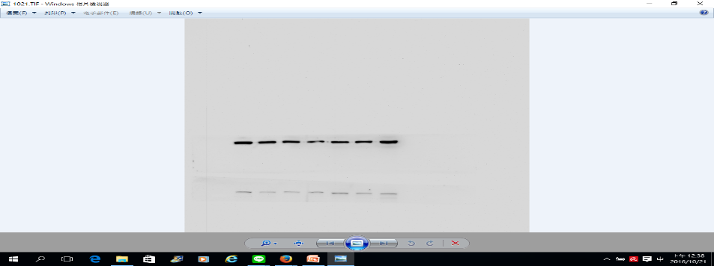
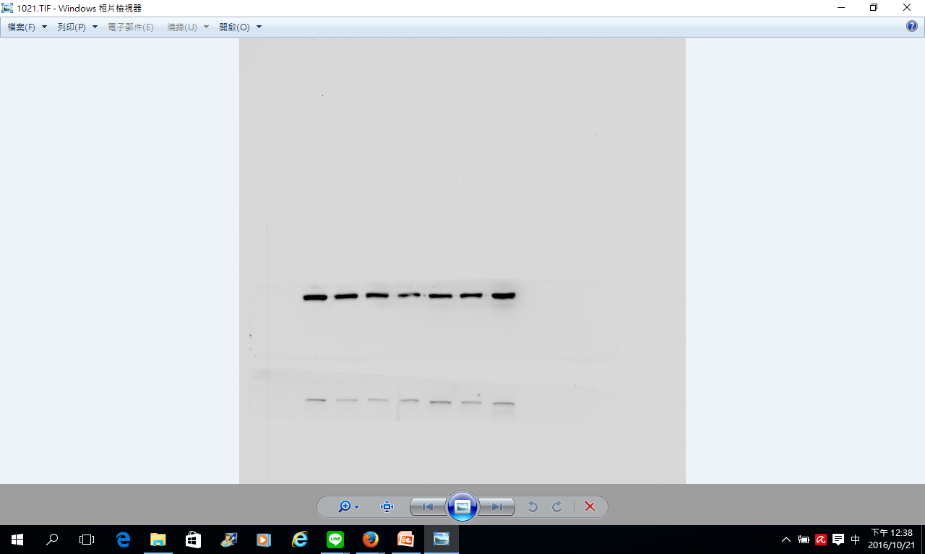
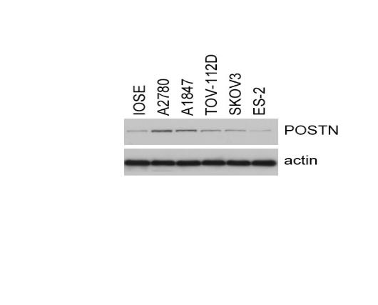
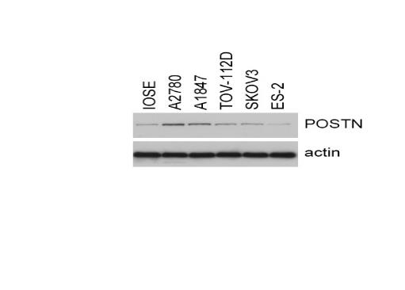
POSTN
Actin
SKOV-I6
A2780
F1120
OVS1
IOSE
A2780
A1847
TOV-112D
SKOV3
ES-2
A

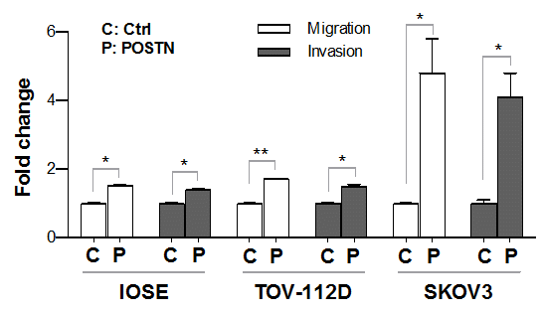
B

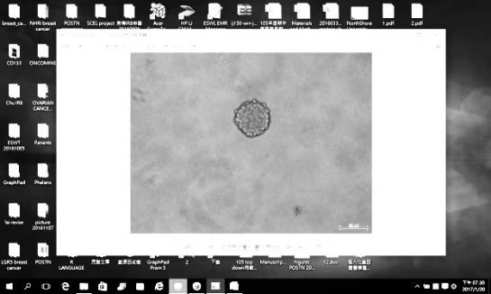
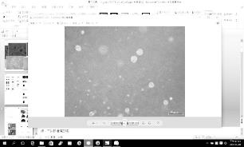
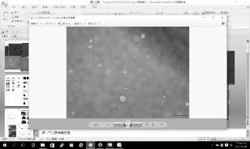
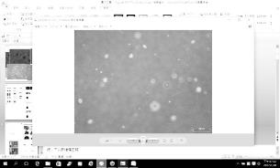
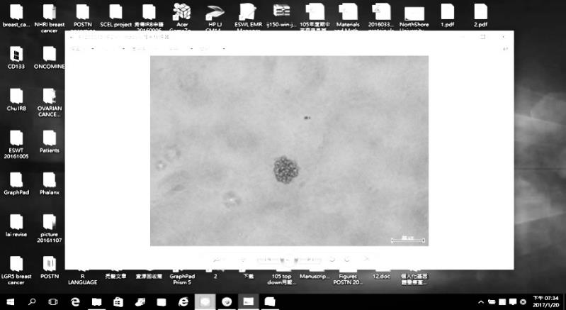
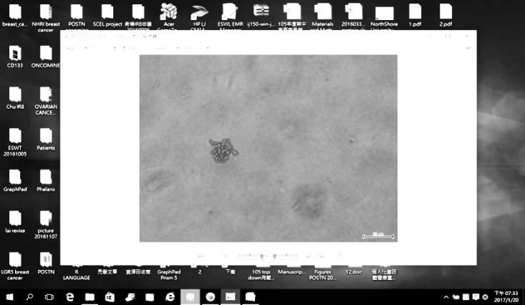
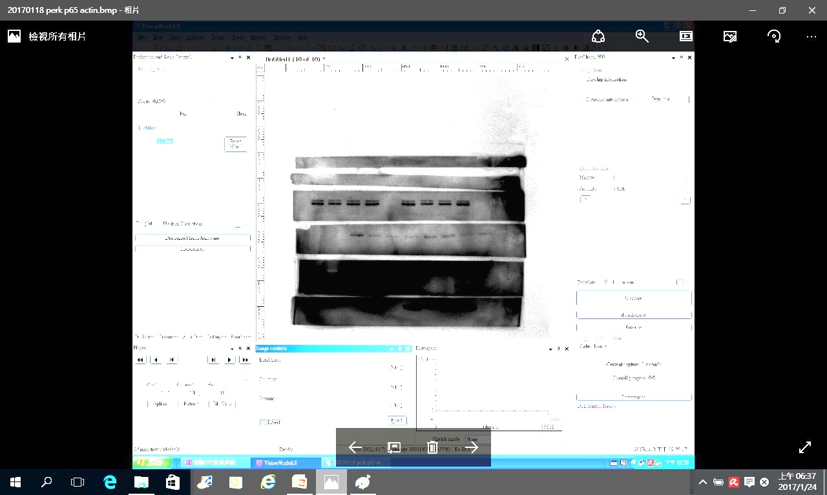
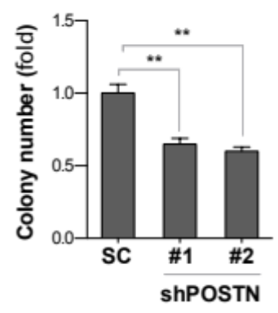
50 μm
SC
shPOSTN#1
shPOSTN#2
OVS1
50 μm
50 μm
50 μm
50 μm
50 μm
OVS1
SC
shPOSTN#1
shPOSTN#2
POSTN
Actin
D
C
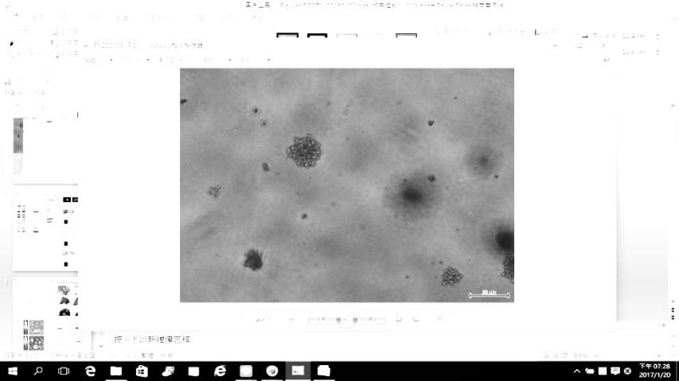
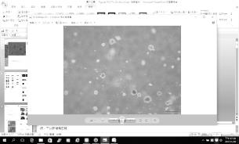
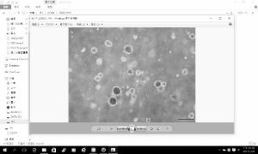
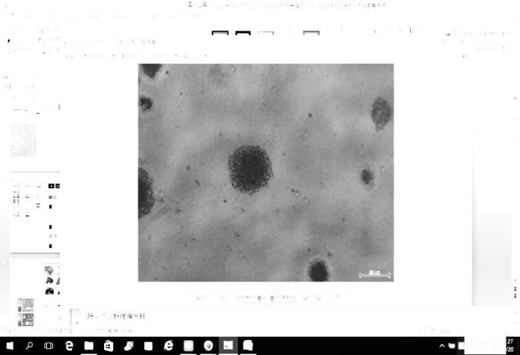
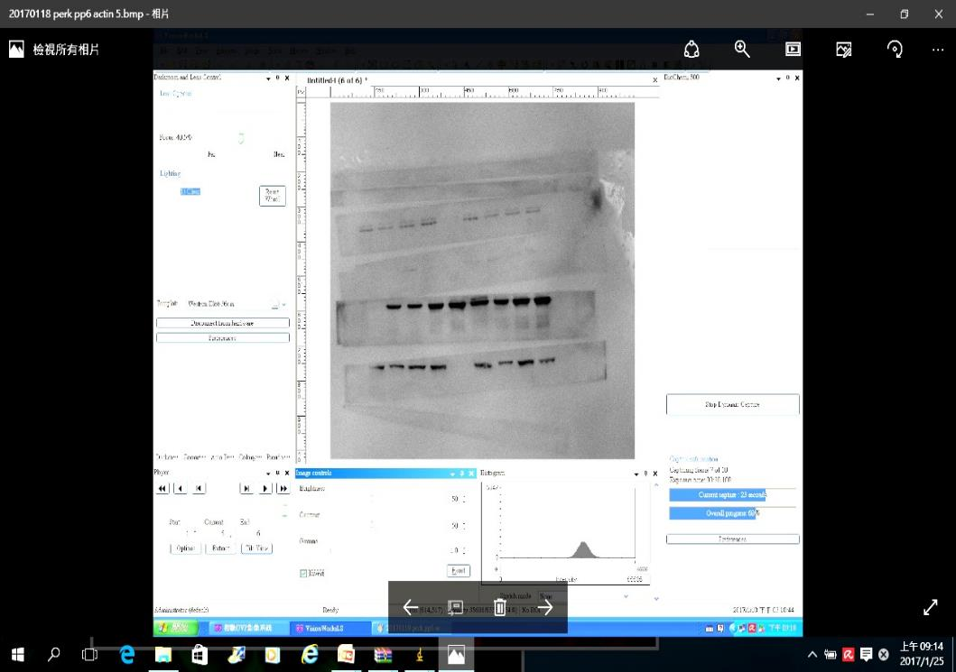
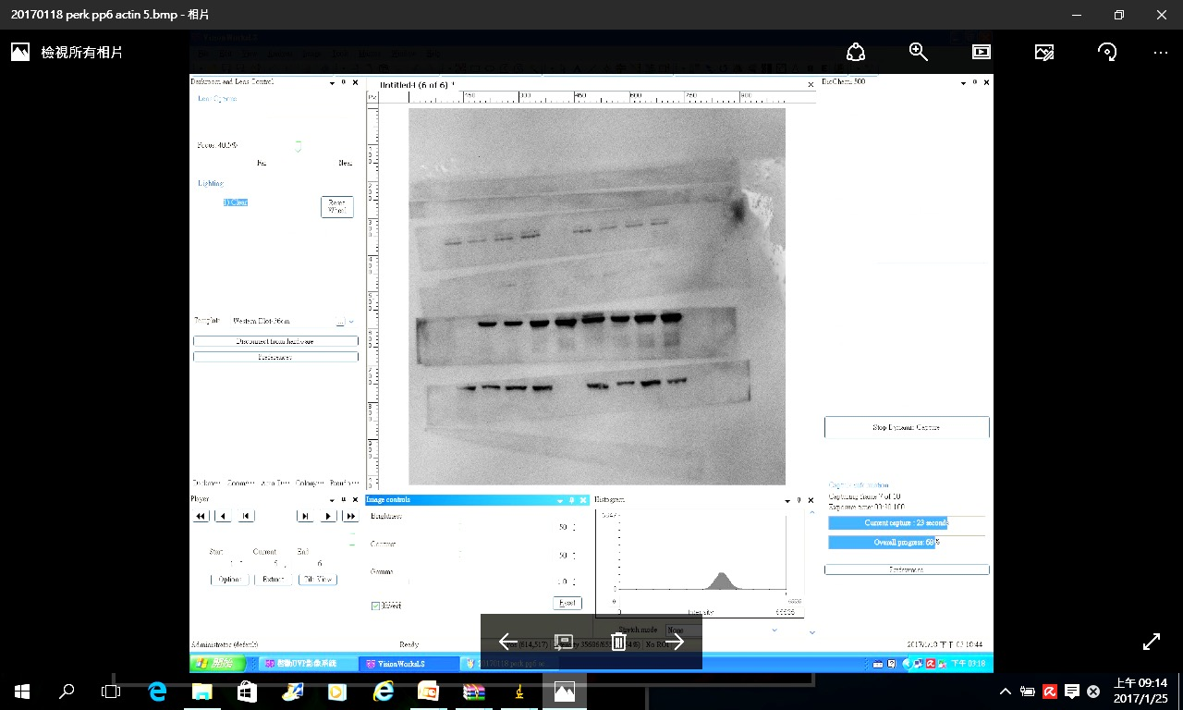
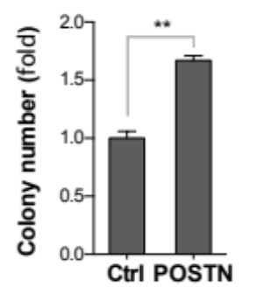
Ctrl
POSTN
TOV-112D
50 μm
50 μm
50 μm
50 μm
TOV-112D
Ctrl
POSTN
POSTN
Actin
C

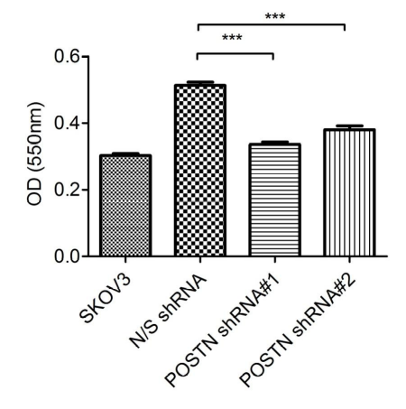
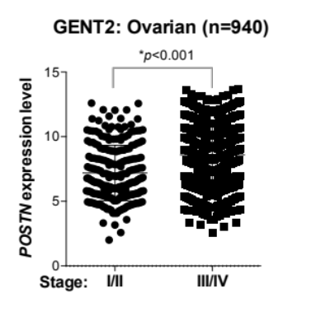
SKOV-I6
E
F

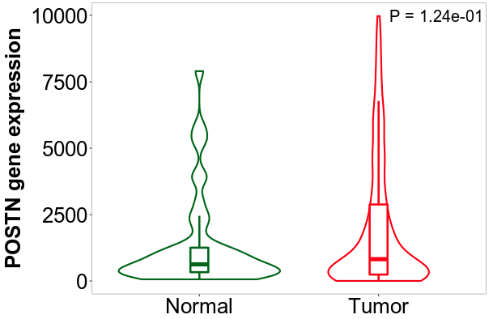
H
G
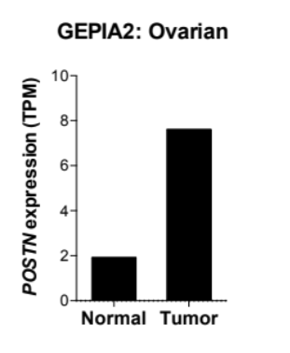
Additional Fig. S1. The expression of POSTN is elevated in the late stage ovarian cancer patients, and POSTN regulates migratory, invasive, colony forming and cell adhering abilities of ovarian cancer cells. A Endogenous POSTN expression of a panel of human ovarian cancer cell lines was evaluated by Western blotting. B Cell migration and invasion assay of IOSE, TOV-112D and SKOV3 cells with ectopic expression of POSTN. C: control. P: POSTN overexpression. *p < 0.05, **p < 0.01. C and D Effect of knockdown or overexpression of POSTN in OVS1 and TOV-112D cells, respectively, on soft agar colony and sphere formation. 1×10⁴ cells were seeded per well in 6-well plates containing 0.4% low melting agar or sphere forming medium and cultured for 7 days. E Effect of POSTN on cell adhesion. Adhesion ability was assayed for SKOV3, SKOV-I6 transfected with control (N/S shRNA) or POSTN shRNA (shRNA#1 and #2). Data are presented as means ± SD. (***p < 0.001). F-H RNA expression level of POSTN among different stages of ovarian cancer patients from online databases with larger ovarian cancer cohorts i.e. GENT2 (F), GEPIA2 (G) and TMNplot (H). * p < 0.05.

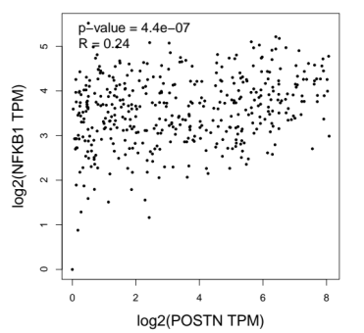
A
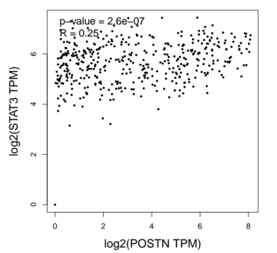
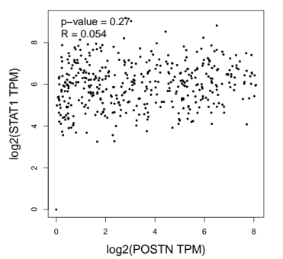
B
B
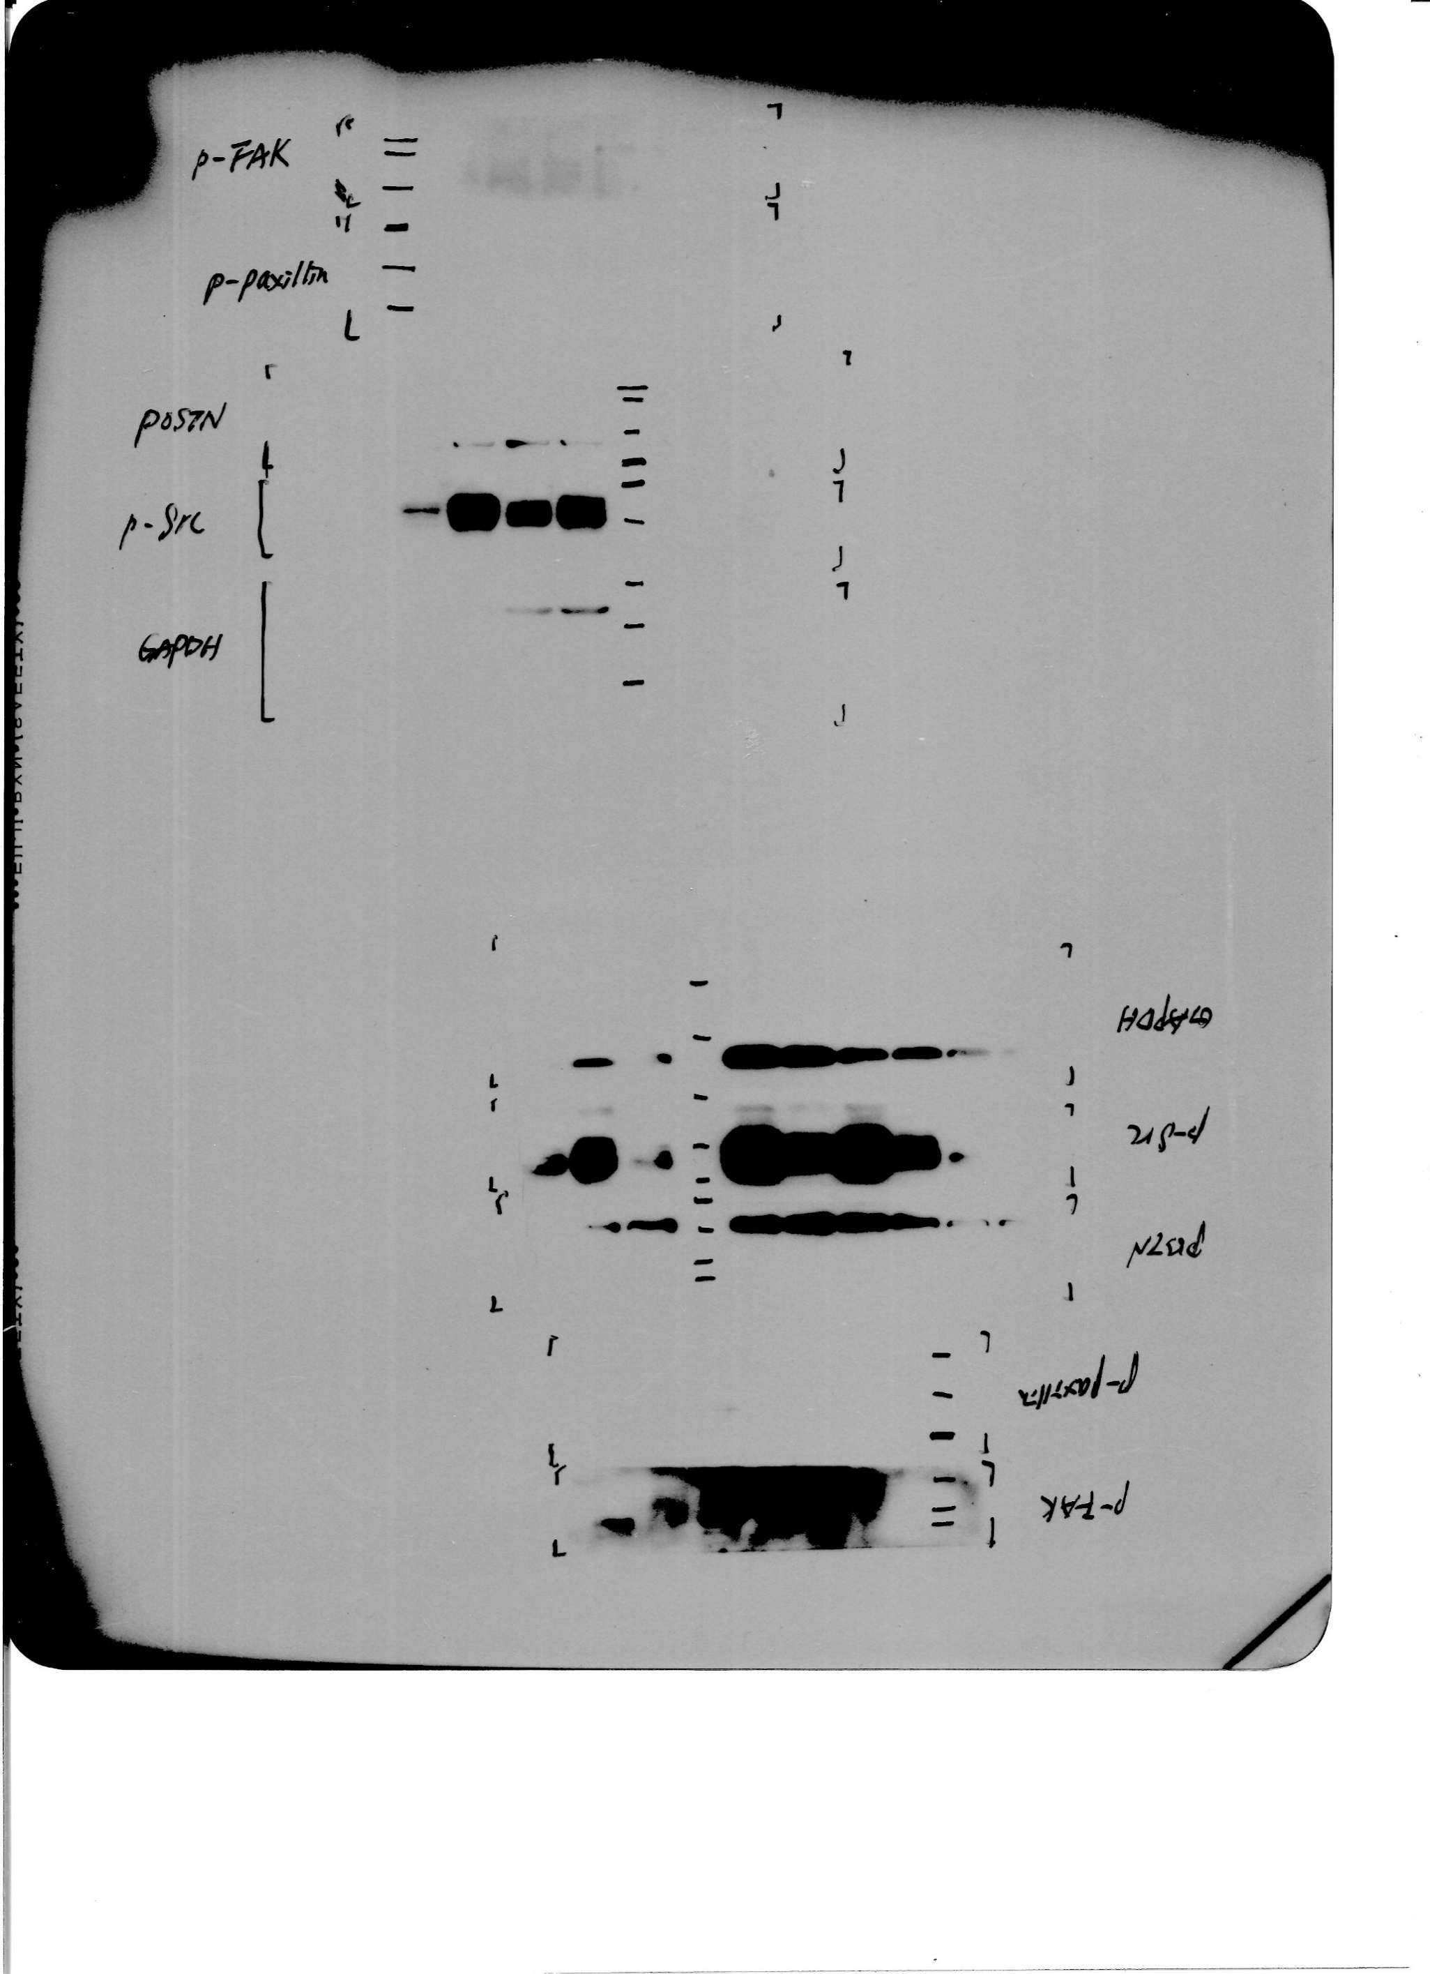
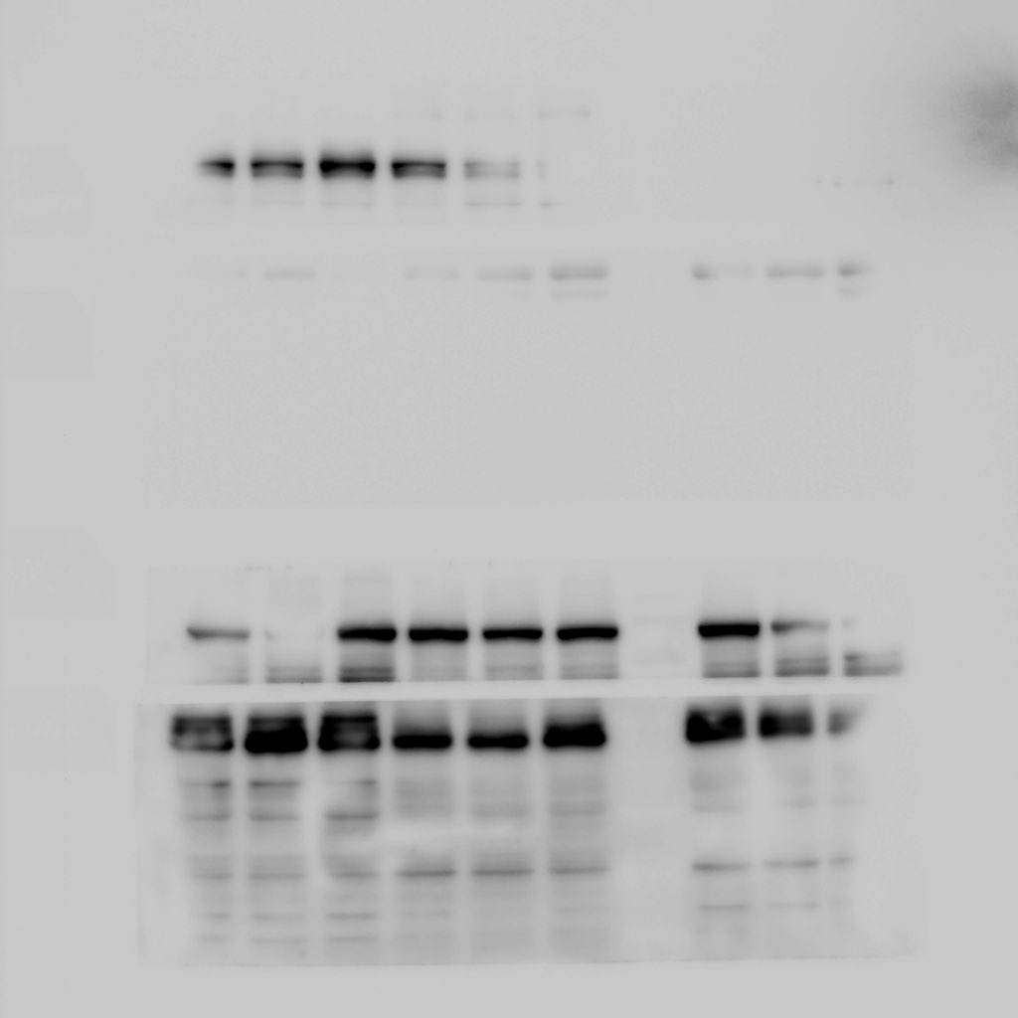
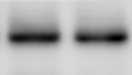
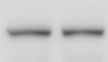
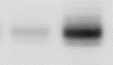
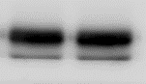
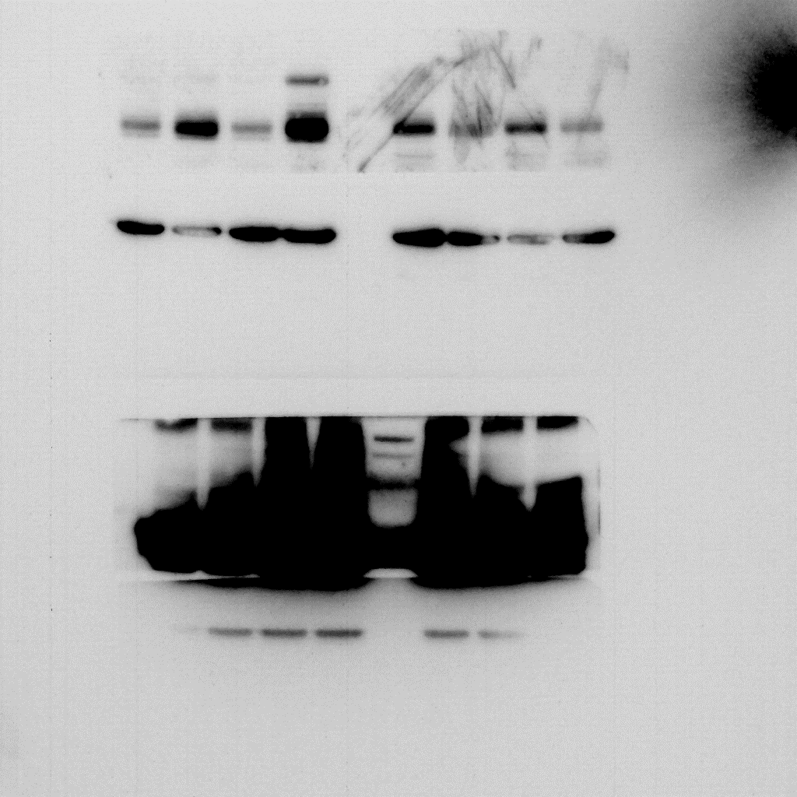
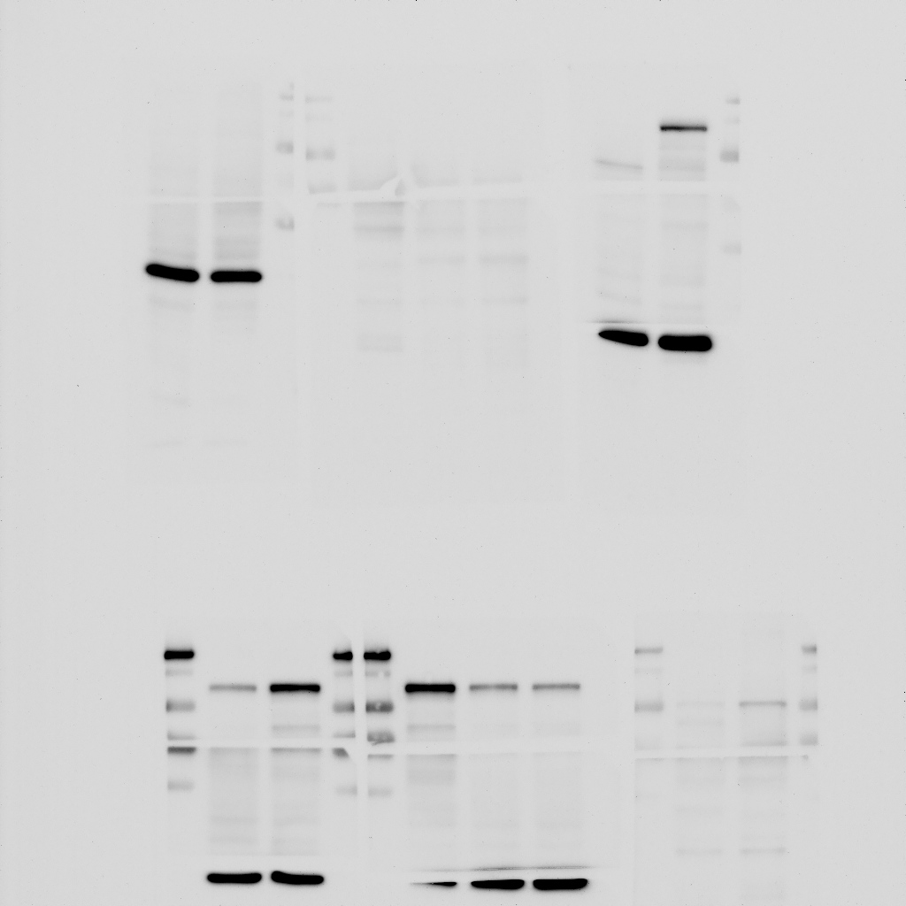
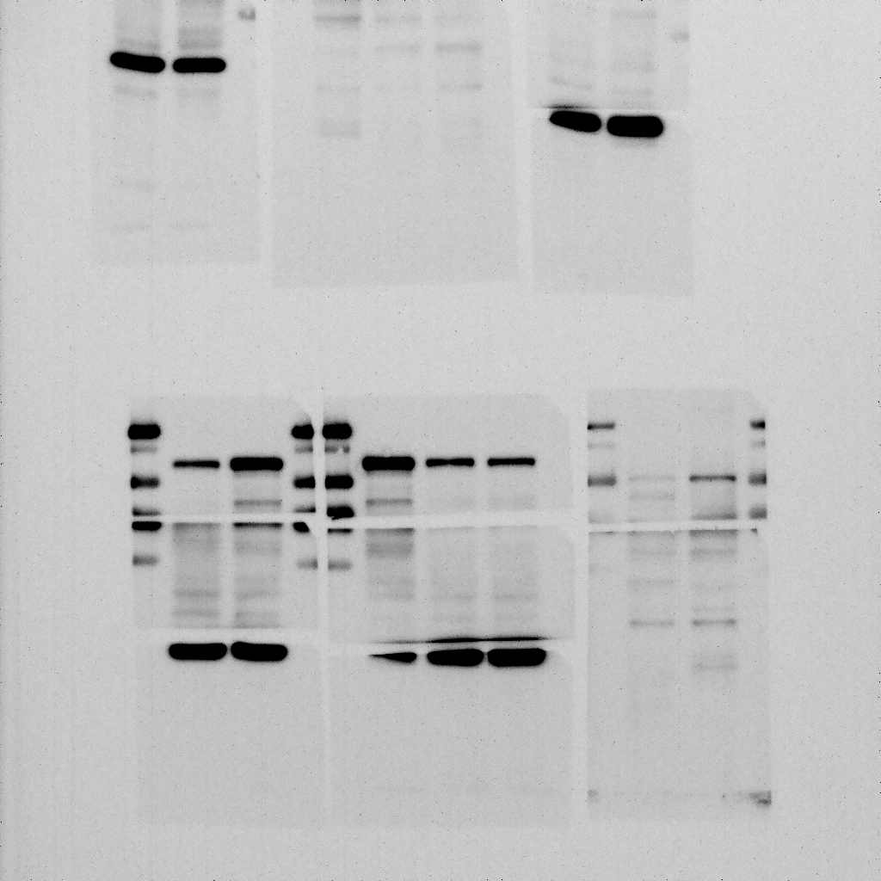
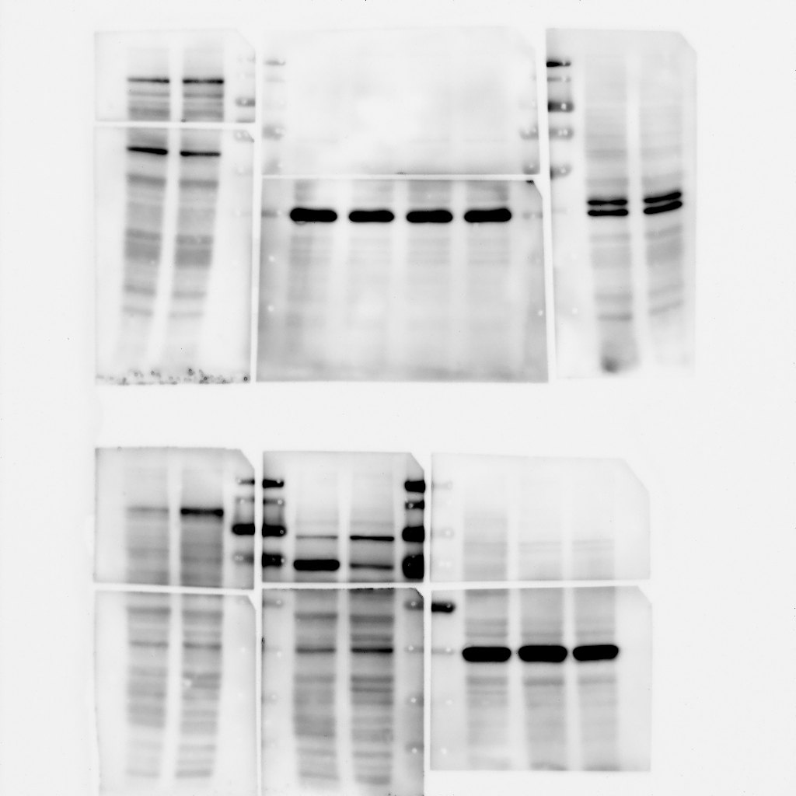
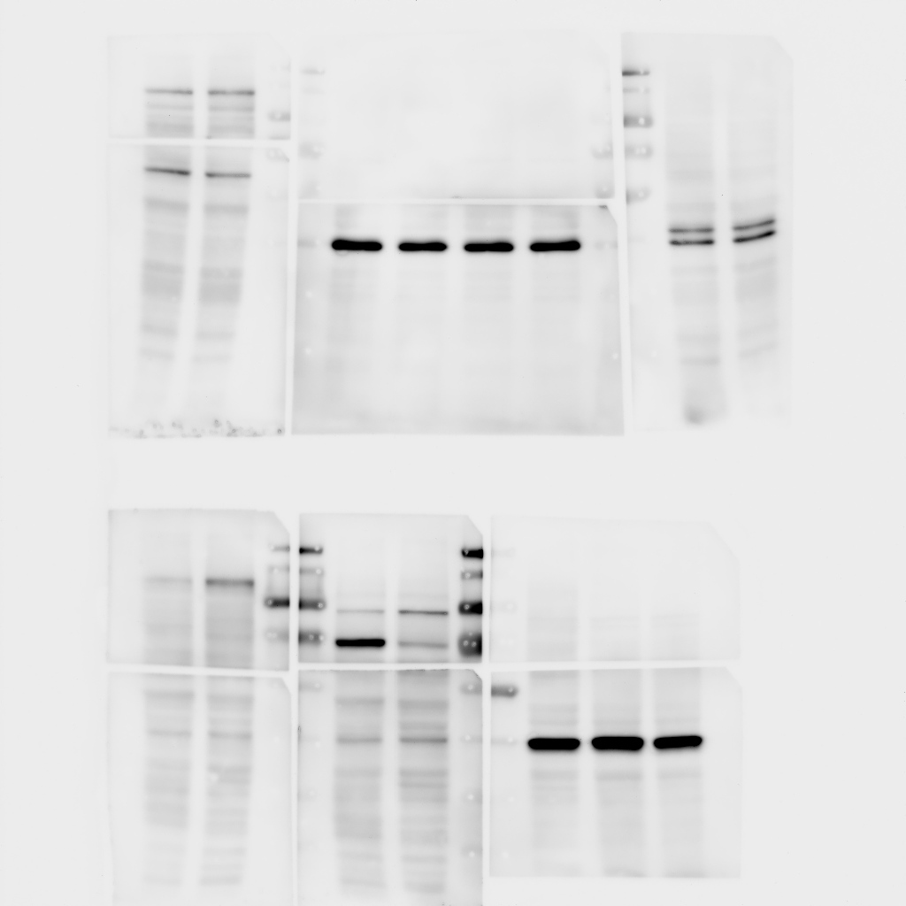
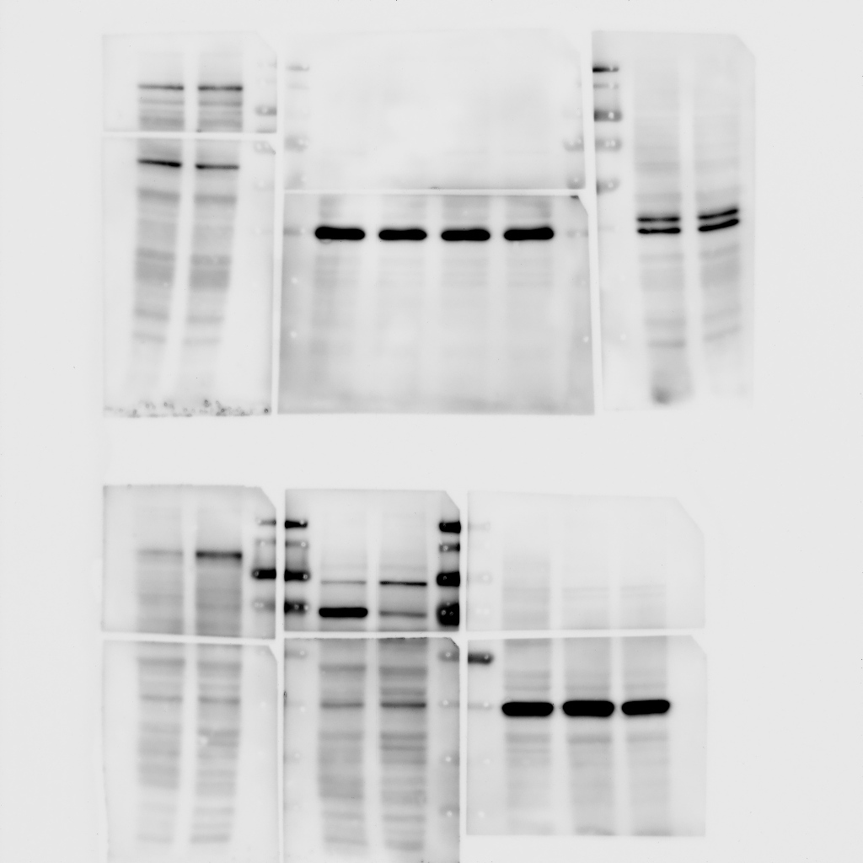
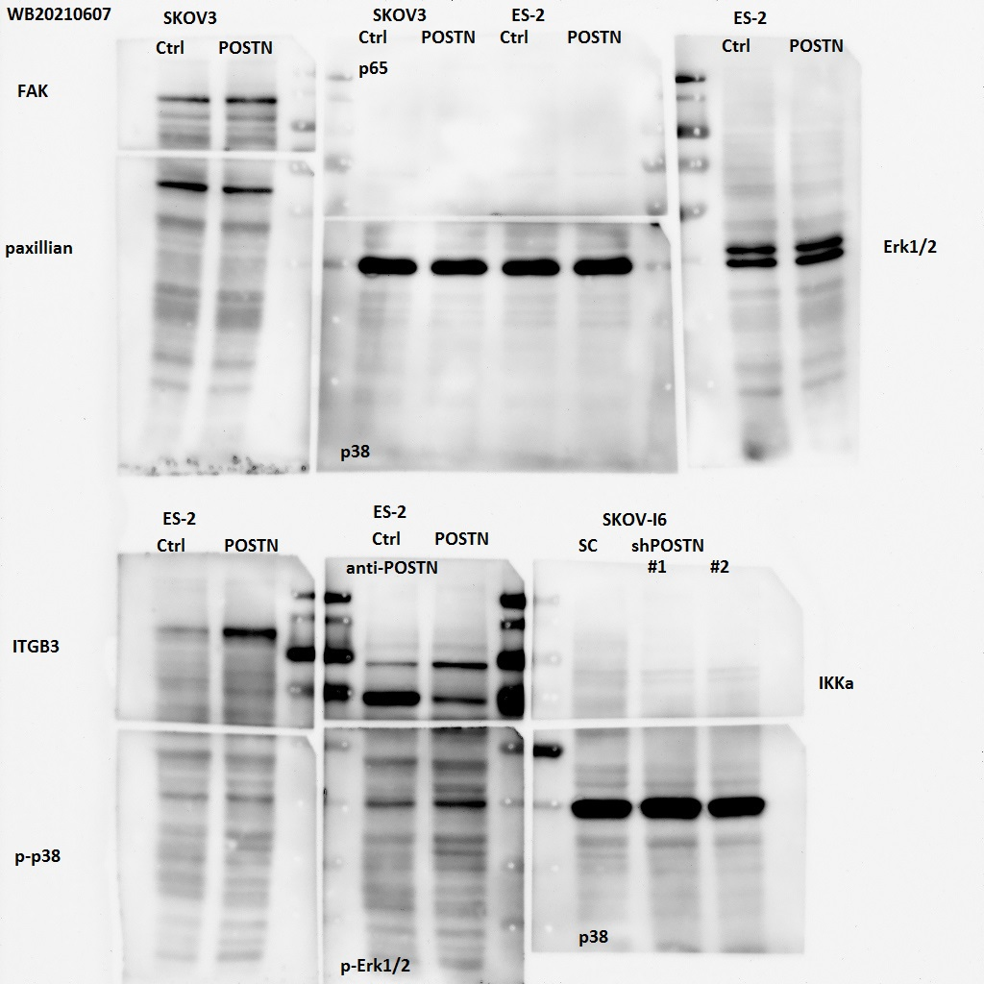
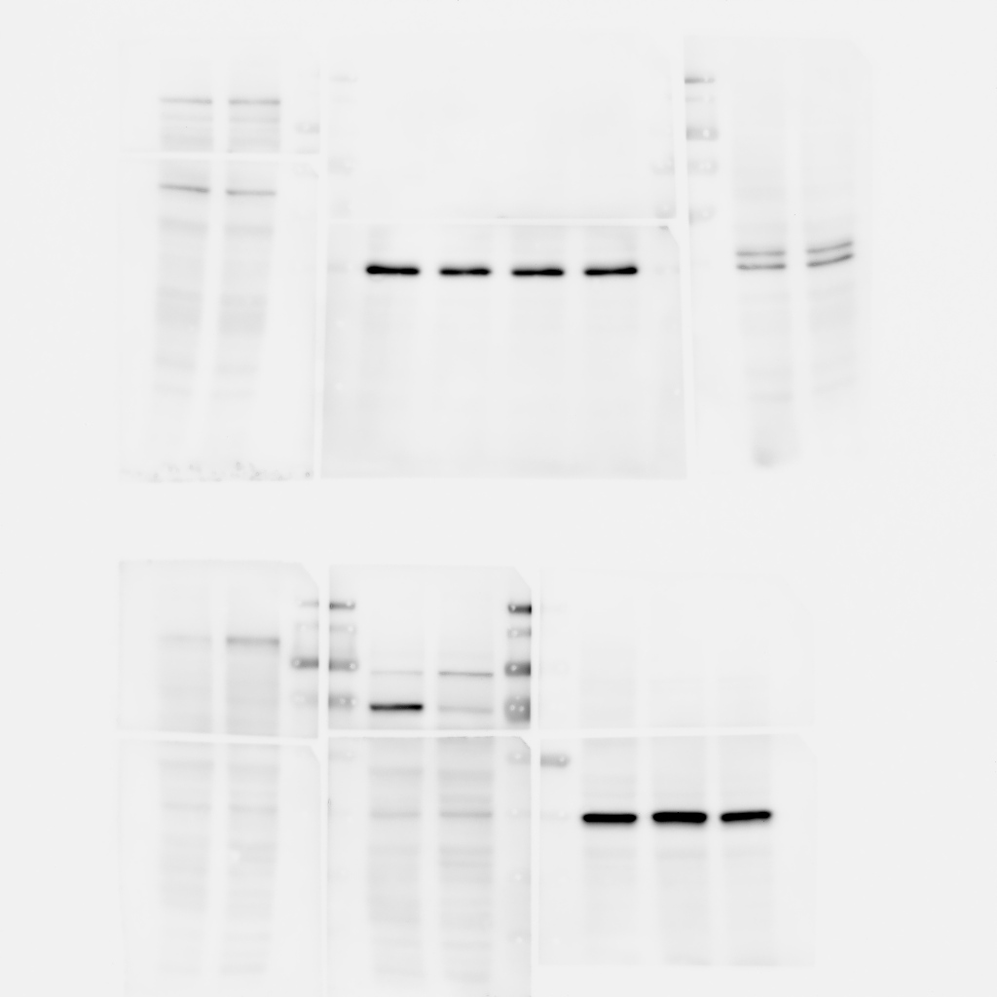
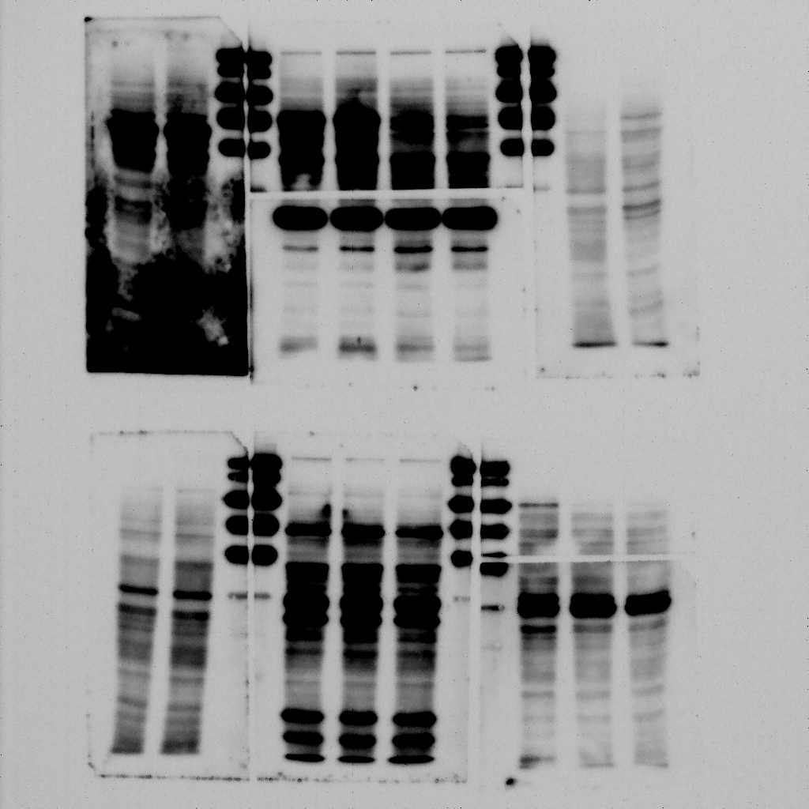
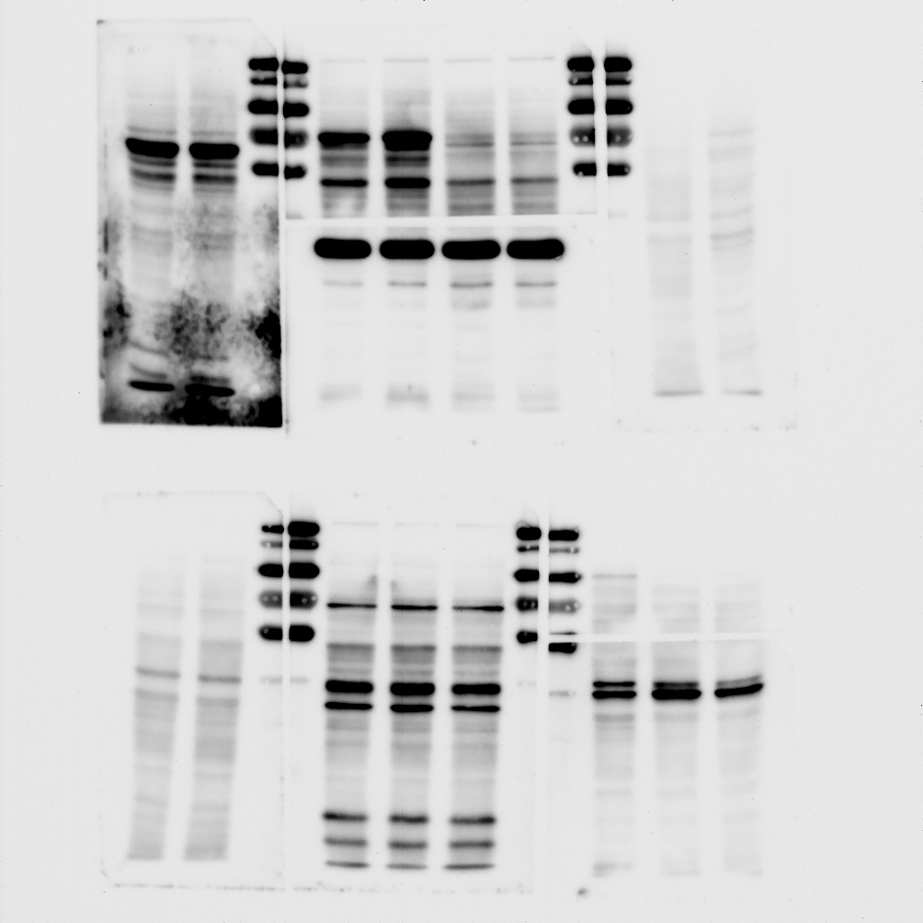
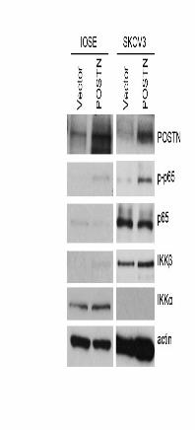
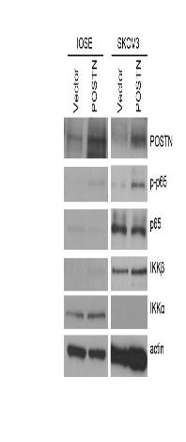
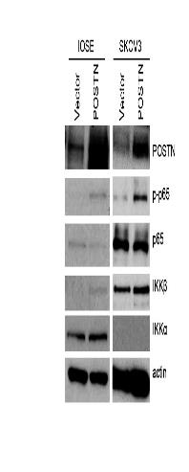
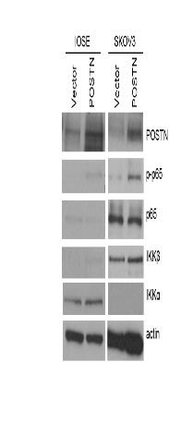
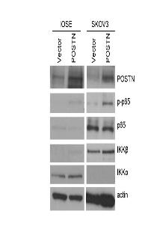
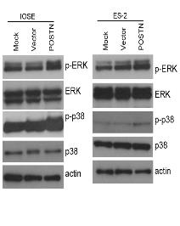
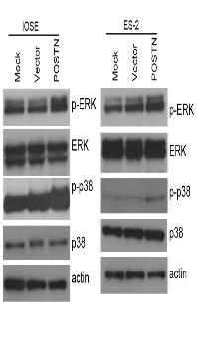
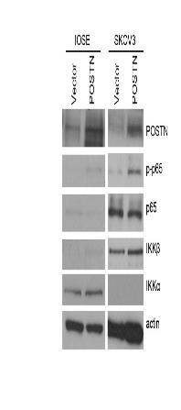
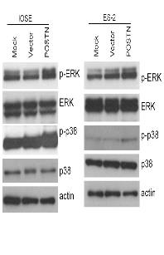
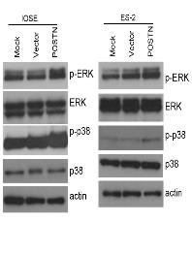
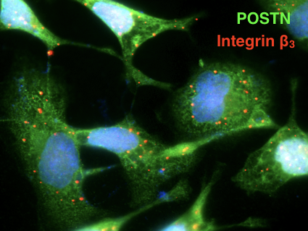
ES-2
Ctrl
POSTN
Integrin β3
p-NFkB p65
p-p38
p-Erk
Erk
p38
NFkB p65
IKKα
IKKβ
POSTN
p-Paxillin (Y118)
p-FAK (Y861)
Integrin β5
FAK
p-Src (Y416)
Src
GAPDH
Paxillin
p65
Actin
IKKα
p-p38
p-p65
IKKβ
p38
Erk
p-Erk
POSTN
IOSE
Ctrl
POSTN
CB
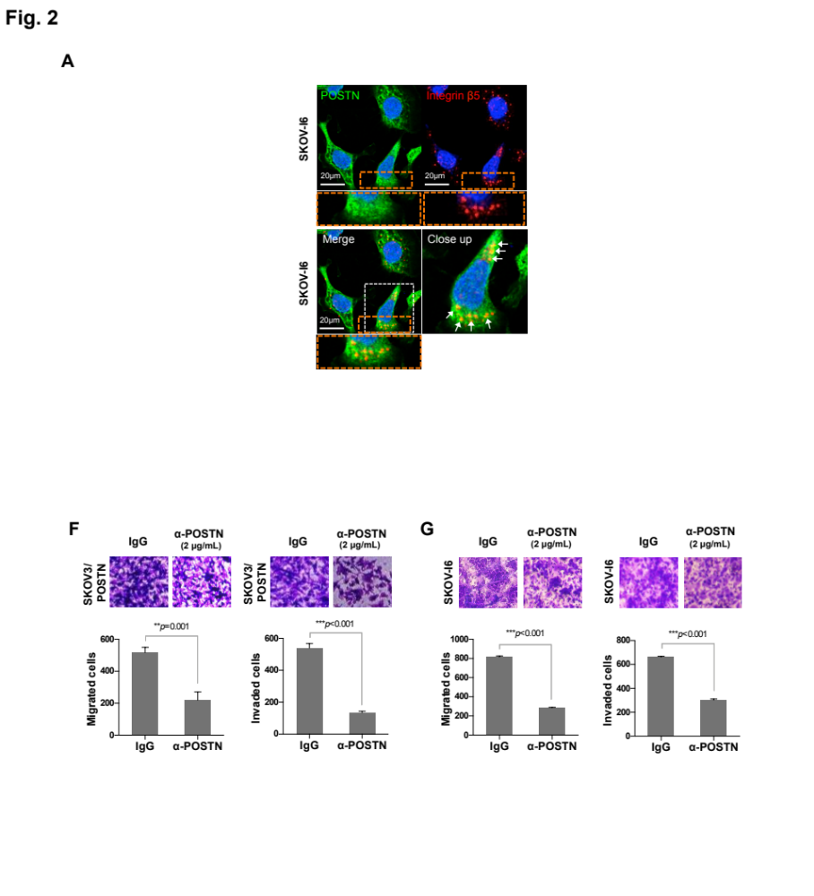
D

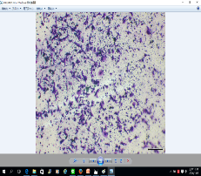
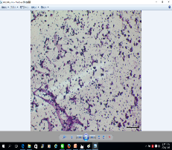
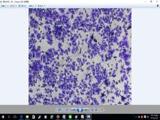
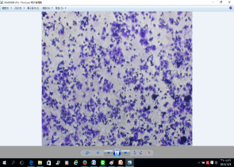
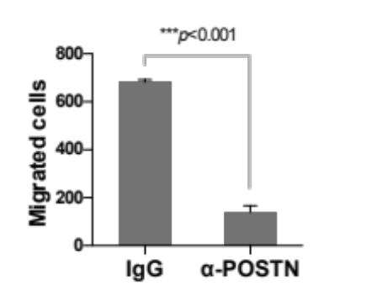
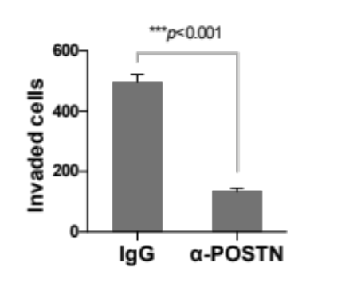
E
OVS1
OVS1
IgG
α-POSTN
α-POSTN
(2 μg/mL)
(2 μg/mL)
IgG

Additional Fig. S2. POSTN promotes NF-κB and its related signaling molecules, is colocalized with integrin β3 and integrin β5 and regulates ovarian cancer cell migration and invasion. A Correlation plot between POSTN and NF-κB (left), POSTN and STAT1 (center), POSTN and STAT3 (right) expression in ovarian cancer patients analyzed by GEPIA2. B Western blot analysis showing that overexpression of POSTN increased downstream signaling molecules of the NF-κB pathway. The expression of POSTN (C, D, green), integrin β3 (C, red) or integrin β5 (D, red) were distributed around the cell membrane boundary in SKOV-I6 cells. Nuclei were counterstained with DAPI (blue). Colocalized signals of POSTN and integrin β3 or integrin β5 were shown in yellow (white arrows). The scale bar represents 20 μm. E Migration and invasion assays of OVS1 cells treated with a POSTN specific monoclonal antibody (2 μg/mL) or control IgG. *** p < 0.001.

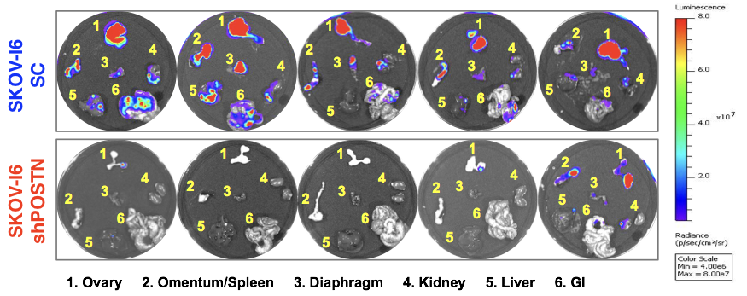

Additional Fig. S3. POSTN-silencing reduces ovarian cancer metastasis in vivo. Bioluminescent images of metastasized tumors in various organs of mice orthotopically implanted with POSTN-silenced SKOV3-I6 cells or scrambled control (SC) cells. Various organs of mice are as indicated.

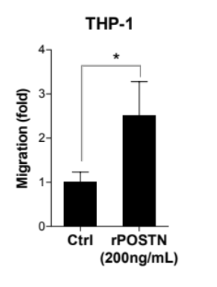
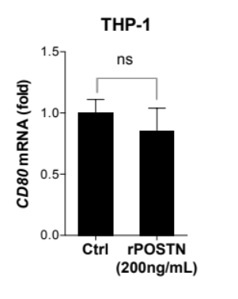
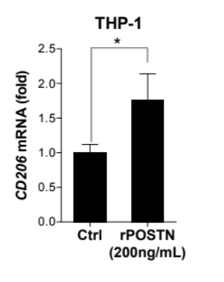
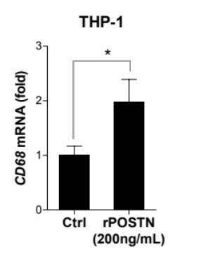
B
A

Additional Fig. S4. Direct effect of POSTN on THP-1 migration and differentiation. THP-1 cells were pre-treated with PMA for 18 h followed by adding recombinant POSTN (rPOSTN) (200 ng/mL) for 48 h. A The migration ability of THP-1 cells increased upon rPOSTN treatment. B qPCR analysis was performed to detect CD68 (pan macrophage) (left), CD206 (M2 macrophage) (center) and CD80 (M1 macrophage) (right) expression in THP-1 cells with or without rPOSTN direct treatment. Results showed direct POSTN treatment promoted M2 macrophage differentiation. *p < 0.05. (related to Fig. 4)

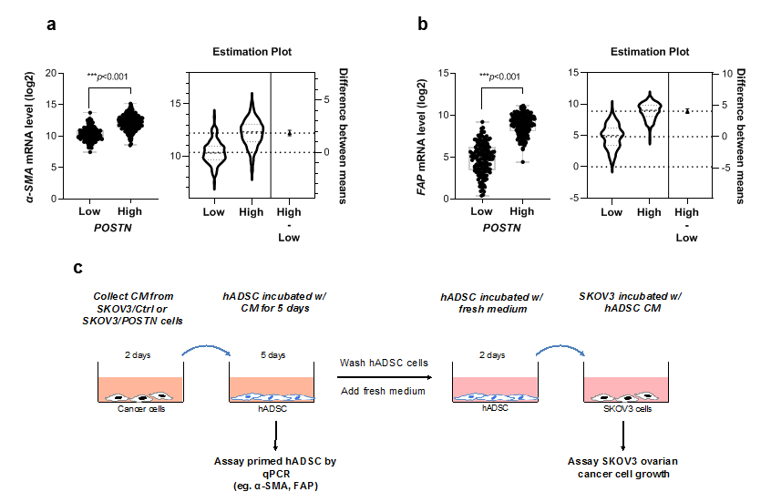
A
B
C
Additional Fig. S5. POSTN expression is associated with increasing abundance of cancer associated fibroblasts (CAFs). The mRNA levels of POSTN, α-SMA (ACTA2) and FAP were downloaded from TCGA ovarian cancer (OV) database (n=308). Patients with high and low levels of POSTN were divided according to the median expression level of POSTN. A Box and whiskers plot shows the mRNA levels of α-SMA between POSTN-low (n=154) and –high (n=154) ovarian cancer patients (A, left). Estimation plot shows the difference between means (A, right). B Box and whiskers plot shows the mRNA levels of FAP between POSTN-low (n=154) and –high (n=154) ovarian cancer patients (B, left). Estimation plot shows the difference between means (B, right). (Two tailed paired t-test, ***P < 0.001). C Schematic diagram of sequential culture of the fibroblast priming assay showing the effect of POSTN primed human adipose derived stem cells (hADSC) on the growth of SKOV3 cells. (related to Fig. 6 G-L)

Additional Tables
Table S1. Reagents used in this study
Reagent | Cat. No. | Company
Recombinant human POSTN protein (rPOSTN) | 3548-F2 | R&D Systems
NF-κB pathway inhibitors | Cat. No. | Company
[5-(p-fluorophenyl)-2-ureido]thiophene-3-carboxamide (TPCA-1) (Synonyms: IKK-2 Inhibitor IV) | 401481 | Merck/  Calbiochem
SN50 peptides (AAVALLPAVLLALLAPVQRKRQKLMP) | 481480 | Merck/  Calbiochem

Table S2. siRNA and shRNA clones used in this study
TRC Clone | Clone ID | Target sequences (5’ to 3’)
shPOSTN #1 | TRCN0000123055 | CGGTGACAGTATAACAGTAAA
shPOSTN #2 | TRCN0000123058 | CACTTGTAAGAACTGGTATAA
siITGB5 | Sense | GCGAAAGGAUGCACUGCAUtt
siITGB5 | Anti-sense | AUGCAGUGCAUCCUUUCGCtt

Table S3. Antibodies used in this study
Antibody | Cat # | Company | Application
POSTN | 19899-1-AP | Proteintech | IHC
CD206 | ab64693 | Abcam | IHC
F4/80 | Ab6640 | Abcam | IHC
α-SMA | 19245 | Cell Signaling Technology | IHC
CD68 | 11-0689 | eBioscience | FACS
CD80 | 12-0809 | eBioscience | FACS
CD206 | 17-2069 | eBioscience | FACS
POSTN | ab14041 | Abcam | WB
Actin | SC-56459 | Santa Cruz Biotechnology | WB
p-Erk1/2  (T202/Y204) | 9101 | Cell Signaling Technology | WB
Erk1/2 | 9102 | Cell Signaling Technology | WB
p-p38 MAPK (T180/Y182) | 4511 | Cell Signaling Technology | WB
p38 MAPK | 8690 | Cell Signaling Technology | WB
IKKα | 2682 | Cell Signaling Technology | WB
IKKβ | 2678 | Cell Signaling Technology | WB
p-NF-κB p65 (S536) | 3033 | Cell Signaling Technology | WB
NF-κB p65 | SC-109 | Santa Cruz Biotechnology | WB
ITGB5 | 4708 | Cell Signaling Technology | WB
Tubulin | SC-23948 | Santa Cruz Biotechnology | WB
Paxillin | 05-417 | Merck Millipore | WB
p-Paxillin (Y118) | 2541 (or 69363) | Cell Signaling Technology | WB
FAK | 05-537 | Merck Millipore | WB
p-FAK (Y861) | 07-832 | Merck Millipore | WB
Src | 2109 | Cell Signaling Technology | WB
p-Src (Y416) | 6943 | Cell Signaling Technology | WB
TGFβ2 | GTX16335 | GeneTex | WB
GAPDH | GTX100118 | GeneTex | WB
Integrin αVβ3 | MAB1976 | Merck Millipore | Neutralization
Integrin αVβ5 | MAB1961 | Merck Millipore | Neutralization

Table S4. qPCR primers used in this study
Gene | Forward sequences (5’-3’) | Reverse sequences (5’-3’)
POSTN | GAACCAAAAATTAAAGTGATTGAAGG | TGACTTTTGTTAGTGTGGGTCCT
actin | CGGCATCGTCACCAACTG | TCTCAAACATGATCTGGGTCATCT
IL-3 | ttgcctttgctggacttca | ctgttgaatgcctccaggtt
IL-10 | cataaattagaggtctccaaaatcg | aaggggctgggtcagctat
IL-12 | cactcccaaaacctgctgag | caatctcttcagaagtgcaagg
IL-16 | ggaagggctccctacacg | cacccagctgcaagatttc
MIP-1β | ctctccagcgctctcagc | accacaaagttgcgaggaag
MCP-1 | agtctctgccgcccttct | gtgactggggcattgattg
MCSF | agtccgagggatcctcca | cgctctctgaggctcttgat
TNFα | agcccatgttgtagcaaacc | tctcagctccacgccatt
RANTES | tgcccacatcaaggagtattt | ctttcgggtgacaaagacg
CCL2 | cagccagatgcaatcaatgcc | tggaatcctgaacccacttc
CCL10 | gtggcattcaaggagtacctc | Tgatggccttcgattctggatt
CCL11 | gacgctgtctttgcataggc | ggatttaggcatcgttgtccttt
CCL17 | atggccccactgaagatgctt | tgaacaccaacggtggagg
CCL18 | gggggctggtttcagaata | ctccttgtcctcgtctgcac
CCL22 | ggaggcaaagagtagggtgtaat | tcagccagaaaggcatagata
MMP-2 | ccccaaaacggacaaagag | cttcagcacaaacaggttgc
MMP-9 | gaaccaatctcaccgacagg | gccacccgagtgtaaccata
IL-1α | ggttgagtttaagccaatcca | tgctgacctaggcttgatga
IL-1β | tacctgtcctgcgtgttgaa | tctttgggtaatttttgggatct
α-SMA | CTATGCCTCTGGACGCACAACT | CAGATCCAGACGCATGATGGCA
FAP | GGAAGTGCCTGTTCCAGCAATG | TGTCTGCCAGTCTTCCCTGAAG

Table S5. Summary table of TissueScan cohort (#HORT102, OriGene)
Clinical variable | All | Normal | Subtypes
Clinical variable | All | Normal | Serous | Clear cell | Endometrioid | Mucinous
Number of cases | 48 | 8 (16.67%) | 33 (68.75%) | 1 (2.08%) | 5 (10.42%) | 1 (2.08%)
Age
> 40 | 45 (93.75%) | 5 (62.50%) | 33 (100%) | 1 (100%) | 5 (100%) | 1 (100%)
≤ 40 | 3 (6.25%) | 3 (37.50%) | --- | --- | --- | ---
Stage
Stage I | 8 (20.00%) | --- | 4 (12.12%) | 1 (100%) | 3 (60.00%) | 0
Stage II | 9 (22.50%) | --- | 8 (24.24%) | 0 | 1 (20.00%) | 0
Stage III | 17 (42.50%) | --- | 15 (45.45%) | 0 | 1 (20.00%) | 1 (100%)
Stage IV | 6 (15.00%) | --- | 6 (18.18%) | 0 | 0 | 0

Table S6. Summary table of ovarian cancer patients from CMUH (IRB#: CMUH 107-REC1-095)
Clinical variable | All | Subtypes
Clinical variable | All | Serous | Clear cell | Endometrioid | Mucinous
Number of cases | 65 | 64 (98.46%) | 0 | 0 | 1 (1.54%)
Age
> 40 | 61 (93.85%) | 60 (93.75%) | 0 | 0 | 1 (100 %)
≤ 40 | 4 (6.15%) | 4 (6.25%) | 0 | 0 | 0
Stage
Stage I | 7 (10.77%) | 6 (9.38%) | 0 | 0 | 1 (100%)
Stage II | 8 (12.30%) | 8 (12.50%) | 0 | 0 | 0
Stage III | 41 (63.08%) | 41 (64.06%) | 0 | 0 | 0
Stage IV | 9 (13.85%) | 9 (14.06%) | 0 | 0 | 0

