Supplemental Data:

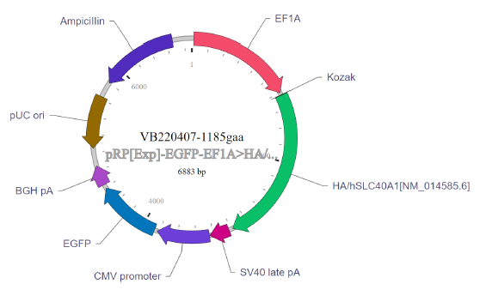
Supplemental Figure 1: HA-tagged Fpn Plasmid Map
HEK 293 cells were transfected with an HA-tagged Fpn plasmid in order to effectively pull down Fpn in co-IP experiments. The plasmid was designed using Vector Builder. The full sequence, as well as purchasing options, are available online https://en.vectorbuilder.com/vector/VB220407-1185gaa.html.

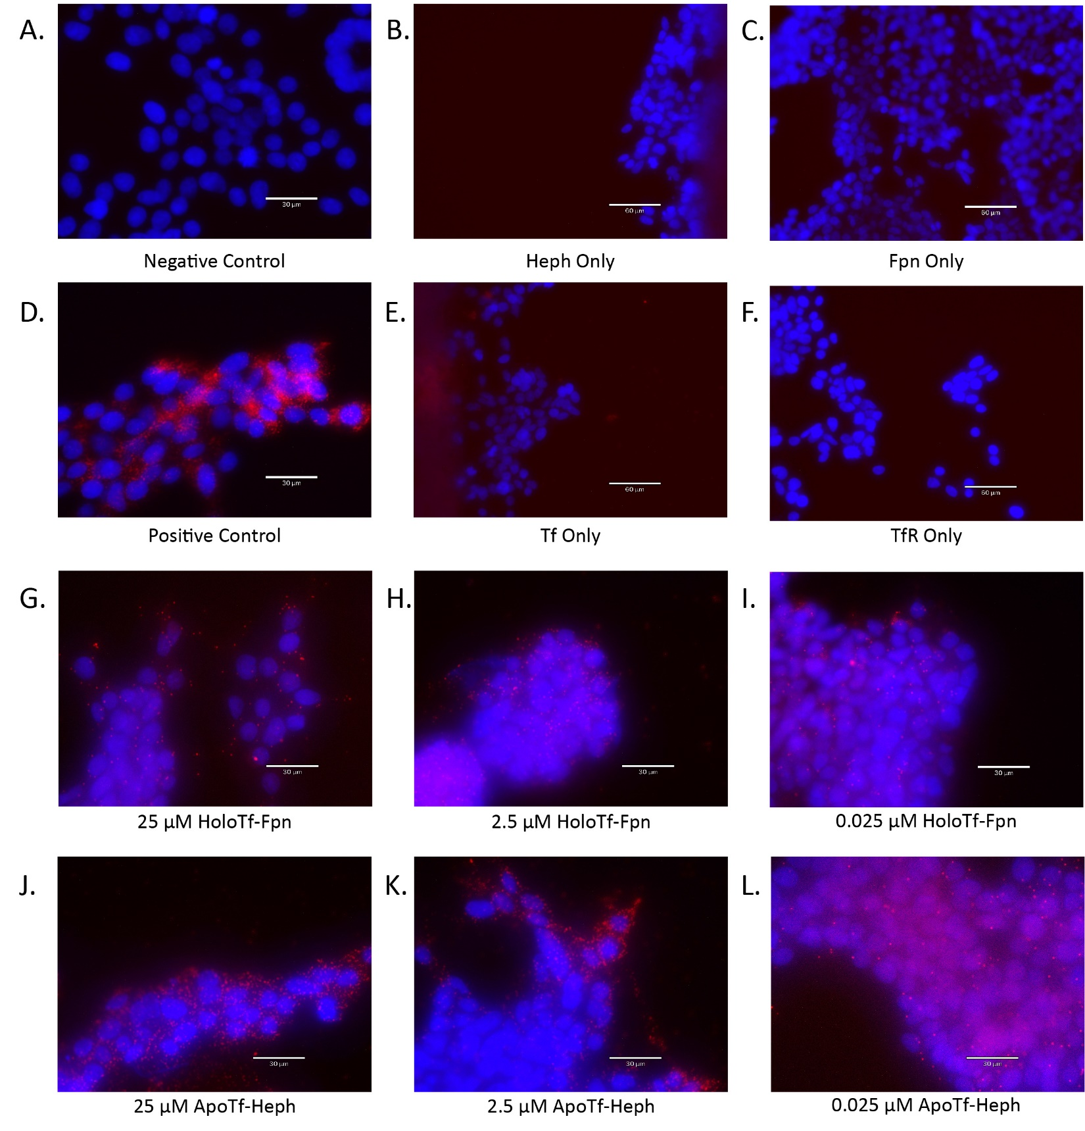
Supplemental Figure 2: PLA Controls
A number of controls were employed while optimizing the use of PLA to determine the interactions apo- and holo-Tf had with Heph and Fpn respectively. The negative control consisted of probing for two proteins known to not interact – here MBP and ferritin (A). The positive control consisted of probing for two proteins known to interact – here exogenous Tf and TfR (D). Furthermore, each antibody used to probe for Fpn, Heph, Tf, and TfR was assessed for nonspecific binding by performing solo incubations and ensuring the antibody alone did not produce PLA signal (B-C, E-F). In order to determine the best concentration of apo- and holo-Tf to use, we tested 0.025 μM, 2.5 μM, and 25 μM along with 0.25 μM (which was used for experiments) (G-L). All additional concentrations of apo- and holo-Tf show similar amounts of PLA puncta as the used 0.25 μM.

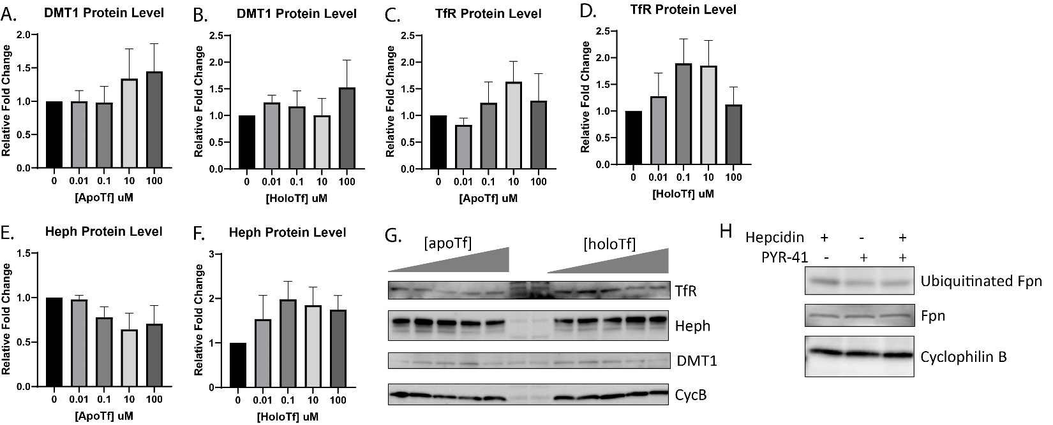
Supplemental Figure 3: Additional Iron Regulatory Proteins with Holo-Tf Incubation and PYR-41 Validation
iPSC-derived ECs were incubated with holo-Tf in the basal chamber of Transwell inserts. The cells were collected and additional iron regulatory proteins were probed for using immunoblotting. Neither apo- nor holo-Tf incubations resulted in significant changes to DMT1, Heph, or TfR protein levels (A-G). PYR-41’s inhibition of ubiquitination was validated using hepcidin to trigger Fpn ubiquitination (H). Exposure to hepcidin alone for 30 minutes increases ubiquitination of Fpn. When pretreated with PYR-41 for 30 minutes, the increased ubiquitination of Fpn is blocked. Total Fpn levels are unchanged. n=3 to 4 for all experiments, means of biological replicates ± SEM were evaluated for statistical significance using one- way ANOVA with Tukey’s posttest for significance.

