Additional file 1.

A secreted form of chorismate mutase (Rv1885c) in Mycobacterium bovis BCG contributes to pathogenesis by inhibiting mitochondria-mediated apoptotic cell death of macrophages
Mi-Hyun Lee^{1, 2, 7,} Hye Lin Kim^{1,5}, Hyejun Seo^{1,5,6}, Sangkwon Jung^{1,5}
and Bum-Joon Kim^{1,2,3,4,5,6,7*}

This Word file includes:
Additional materials
Additional Fig. S1 to S9
Additional Table S1 and S2

Additional materials
Genomic DNA extraction
The colonies of mycobacteria incubated on 7H10 agar supplemented with 0.2% glycerol and 10% OADC for 2 to 4 weeks were used to extract the mycobacterial gDNA. For lysis, five loopfuls of cells were lysed in 200 µL of lysis buffer (15% sucrose, 0.05 M EDTA, 0.05 M Tris-Cl; pH 8.0; filtered and stored at room temperature) and briefly vortexed. Before reacting the samples at 37°C and 160 rpm overnight, lysozyme (Sigma, 10837059001) was added at a final concentration of 20 mg/ml. After incubation at 37°C, 6.25 µL of 20 mg/ml proteinase K (Meridian, bio37084), 100 µL of 20% SDS (Sigma, L3771), and 8 µL of RNaseA/T1 (Thermo, EN0551) were added and reacted for 10 min at 65°C.
To purify gDNA, 1 volume of phenol‒chloroform-isoamyl alcohol (25:24:1; Invitrogen) was added and mixed well. The sample was centrifuged at 13,000 rpm for 10 min at 4°C, and the supernatant was collected. To precipitate and wash gDNA, 0.6 volumes of isopropanol were added, and the sample was stored at -20°C for 30 min, centrifuged, and washed with 70% ethanol. After the pellet was dried, it was redissolved in 20 µL of TE buffer (10 mM Tris-Cl, 1 mM EDTA; pH 8.0).

Growth curve analysis
To prepare stocks of wild-type BCG and B∆tbcm, colonies of each mycobacterium were seeded into complete 7H9 broth and grown to an OD₆₀₀ of 1.0. Mycobacterial stocks were stored in a deep freezer (at −80°C). Each frozen stock was seeded in 200 ml of complete 7H9 broth at initial OD₆₀₀ of 0.005. The OD value of the culture of wild-type BCG and B∆tbcm was measured every 2~3 days to generate a growth curve.

Cell culture and BMDM differentiation
BMDMs were generated from the femurs and tibias of 8- to 12-week-old BALB/c mice (female). Bone marrow cells were harvested by flushing the femurs and tibias. The collected cells were resuspended in red blood cell lysis buffer (Merck, R7757) and filtered through a 70 µM cell strainer (SPL, 93070). The cells were resuspended in RPMI 1640 medium containing 10% FBS (Gibco, 12483020), 1% penicillin‒streptomycin (Welgene, LS202-02), 30 ng/ml M-CSF (Peprotech, 315-02) and 1% L-glutamine (Sigma, G7513). The cell suspension was cultured in a 100 mm cell culture dish (SPL, 20100) and incubated at 37°C and 5% CO₂ for 7 days. Cells of the murine macrophage line J774A.1 (American Type Culture Collection, ATCC TIB-67) were cultured in complete RPMI 1640 and incubated at 37°C and 5% CO₂.

Histology
The collected lung tissues were fixed in 4% paraformaldehyde (SolMate, SM-P01-100) and embedded into paraffin blocks. Sections (4-5 μm thick) were prepared and deparaffinized with a xylene/ethanol solution. Rehydrated specimens were stained with hematoxylin and eosin (H&E) to evaluate the level of inflammation caused by infection. To detect apoptotic cells in the lung tissue, a TUNEL Assay Kit - HRP-DAB (Abcam, ab206386) was used according to the manufacturer’s protocol, and stained tissues were observed using a light microscope.

Cytokine assay
The splenocytes from infected mice were seeded at 1x10⁶ cells/well in a 96-well round bottom plate (SPL, 34096) and incubated at 37°C and 5% CO₂. After 3 days, supernatants were collected. In the case of infected BMDMs (1x10⁶), supernatants were collected 24 and 48 h post infection. To measure the levels of cytokines such as TNF-$α$ (Invitrogen, 88-7324-88) and IL-10 (Invitrogen, 88-7105-88), ELISA kits were used.

CFU assay
The intracellular CFU assay was performed at 24 and 48 h post infection. After treating BMDMs and J774A.1 cells (5x10⁵) with PBS containing 1% Triton X-100, the cells were serially diluted with PBS. In the case of organs, three organs (spleen, lung, liver) were homogenized with a 70 µM cell strainer (SPL, 93070) and diluted with PBS. The diluted solution was plated and cultured on 7H10 agar plates containing glycerol and OADC for 3 weeks at 37°C and 5% CO_{2.}

Library preparation and sequencing
We request RNA-sequencing and its analysis to e-biogen (Seoul, Korea). For library preparation of control and test RNAs, a QuantSeq 3’ mRNA-Seq Library Prep Kit (Lexogen, Inc., Austria) was used by following the manufacturer’s instructions. Each RNA sample was prepared with a primer containing an Illumina-compatible sequence. Reverse transcription was processed after 5’ end of primer was hybridized to the RNA. Second strand synthesis was instigated by a random primer with an Illumina-compatible linker sequence of its 5’ end. The double-stranded library underwent purification by magnetic beads to eliminate all reaction components. Furthermore, the library was amplified to incorporate complete adapter sequences for cluster generation. The final library was purified from PCR components and high-throughput sequencing was carried out as single-end 75 sequencing using NextSeq 550 (Illumina, Inc., USA).

RNA isolation and quantitative real-time PCR
Total RNA was isolated from infected BMDMs and J774A.1 cells (5x10⁵) at 0, 2, 4, 12 and 24 h post infection using TRIzol reagent (Invitrogen, 15596018). The RNA isolated from wild-type BCG and B∆tbcm was also prepared using TRIzol reagent. cDNA was synthesized using a SensiFASTTM cDNA Synthesis Kit (Bioline, BIO-65054) according to the manufacturer’s protocol. RT-qPCR was performed using a SensiFASTTM SYBR® Lo-ROX Kit (Bioline, BI0-94020). The relative expression level was calculated using the housekeeping gene β-actin for cells or the hsp65 for mycobacteria as a control. The primer sets used in RT‒qPCR are shown in the Table S2.

Cytochrome c ELISA
Infected BMDMs and J774A.1 cells (5x10⁵) were suspended in PBS containing 0.5% Triton X-100 at 8 h post infection. Cytochrome c release was evaluated using Rat/Mouse Cytochrome c Quantikine ELISA Kit (R&D Systems, MTCT0) according to the manufacturer’s protocol.

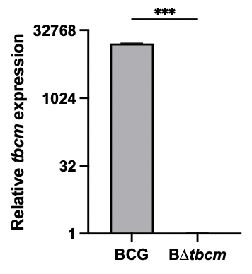

Fig. S1. The absence of tbcm mRNA in B∆tbcm
The relative expression levels of tbcm mRNA for both BCG and B∆tbcm were compared by normalizing them to the expression levels of hsp65 using RT-qPCR.


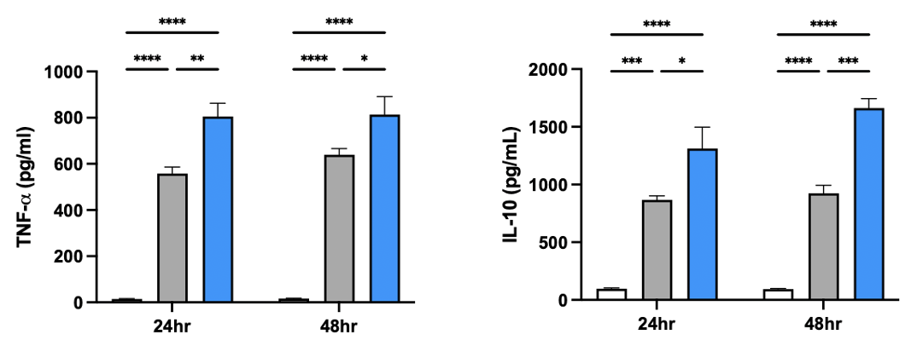

Fig. S2. B∆tbcm enhances cytokine production in BMDMs
BMDM were infected with BCG or B∆tbcm at 10 M.O.I for 24 h or 48 h. TNF-$α$ (left) and IL-10 (right) were detected in the culture supernatants by ELISA.

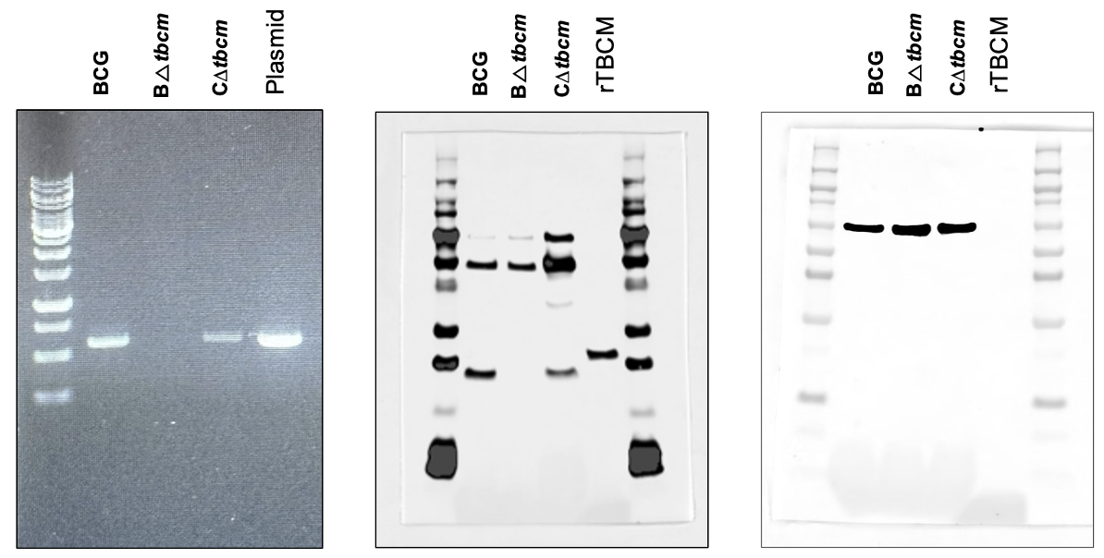
Fig. S3. Complementation of the ∆tbcm mutation in BCG.
Whole gel image of PBCR confirmation of tbcm gene (600bp) expression in C∆tbcm (left). Uncropped blot image of TBCM protein expression in C∆tbcm (middle) and hsp65 protein expression for normalization (right).

C
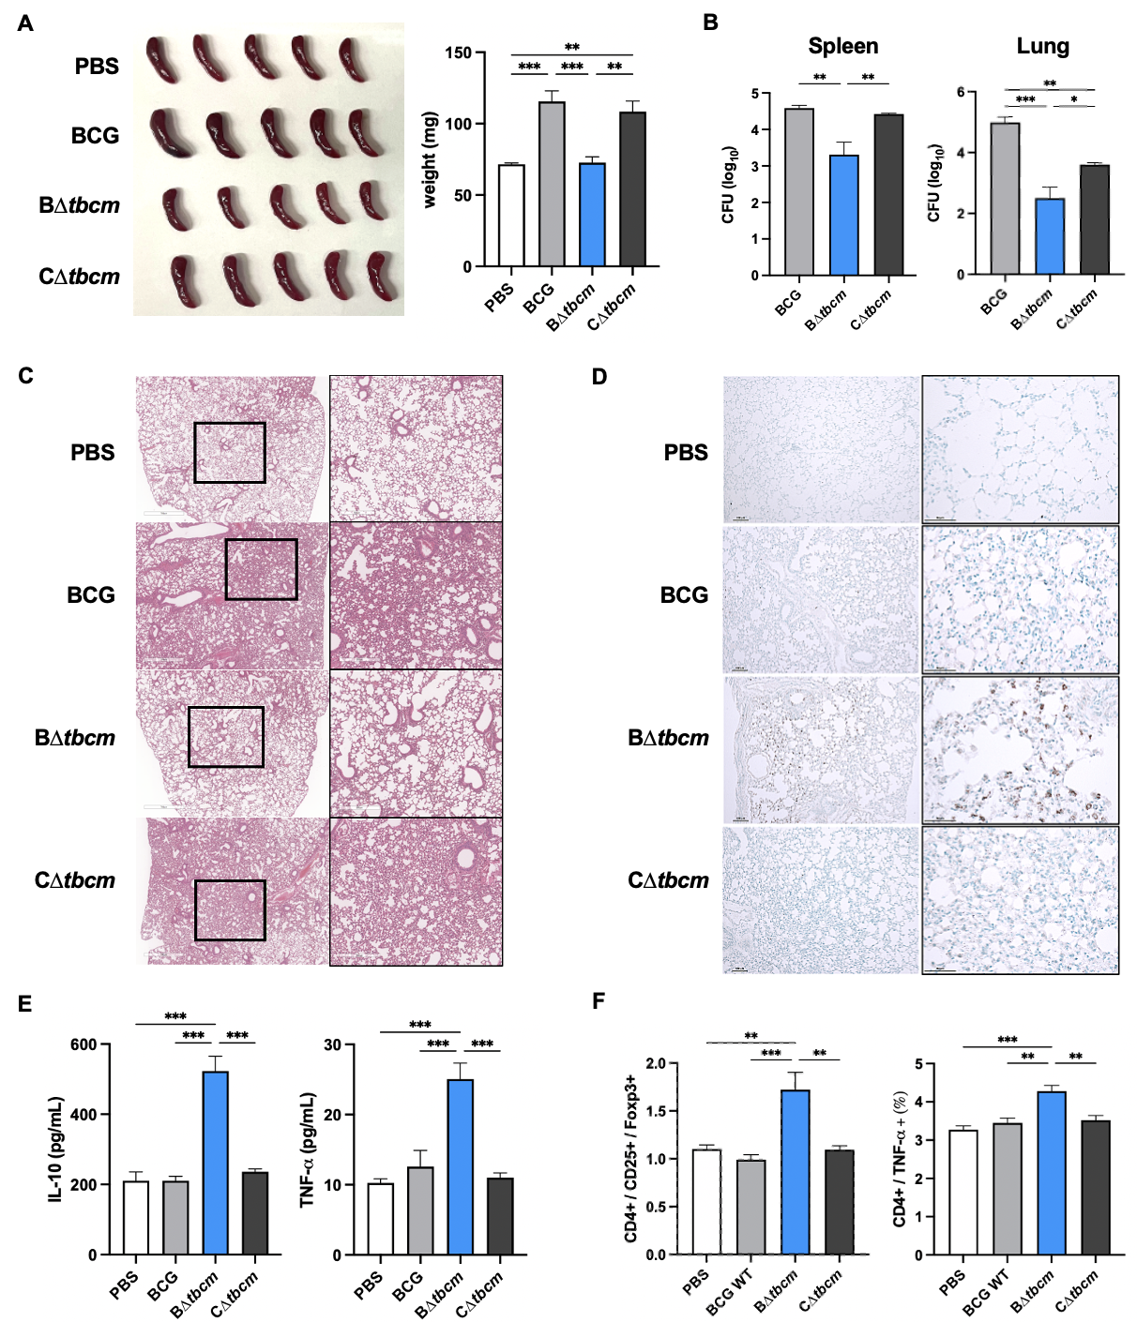

Fig. S4. Restored capacity to inhibit apoptosis by complementation of tbcm in a mouse model.
Female C57BL/6 mice (n=5 per group) were infected with BCG, B∆tbcm, or C∆tbcm (1x10⁶ CFU) intravenously and sacrificed after 4 weeks. (A) Comparison of spleen size (left) and weight (right). (B) The bacterial burdens in spleens and lungs were measured by the CFU assay. (C) Histopathological images (H&E staining) of lung tissues (scale bars, 300 $μ$m or 700 $μ$m). (D) Apoptotic cells in lung tissues were detected by the TUNEL assay (scale bars, 50 $μ$m or 100 $μ$m). (E) Splenocytes were isolated from infected mice and incubated for 3 days. The levels of IL-10 (left) and TNF-$α$ (right) were detected in the culture supernatants of splenocytes by ELISA. (F) CD25+/Foxp3+ regulatory T cell and CD4+/ TNF-α+ T cell subsets were analyzed in splenocytes by flow cytometry. One-way ANOVA with Tukey’s multiple comparison test. (*P<0.05, **P<0.01, ***P<0.001). Abbreviations: BCG, wild-type BCG; BΔtbcm, BCG Δtbcm mutant; CΔtbcm, complemented mutant.

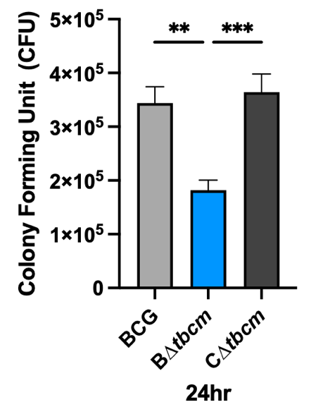
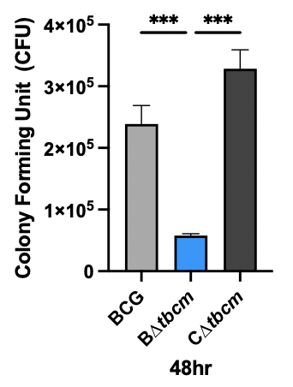

Fig. S5. Bacterial CFU in BMDM was reduced at B∆tbcm and recovered by complementation of tbcm
BMDMs (BALB/c, female) were infected with BCG, B∆tbcm, or C∆tbcm for 24h or 48h.

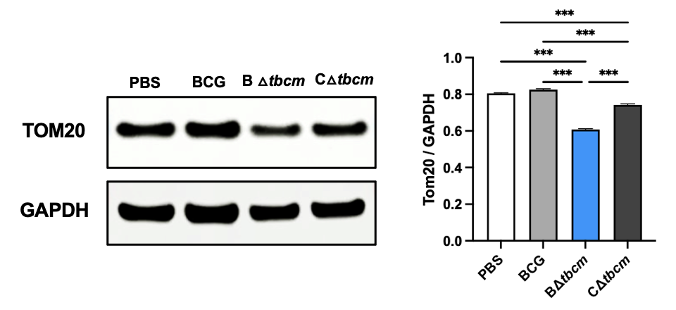

Fig. S6. TOM20 expression level was recovered by complementation of ∆tbcm mutation.
J774A.1 cells were infected with each strain for 18h. Immunoblot analysis of infected macrophages (whole cell lysate).

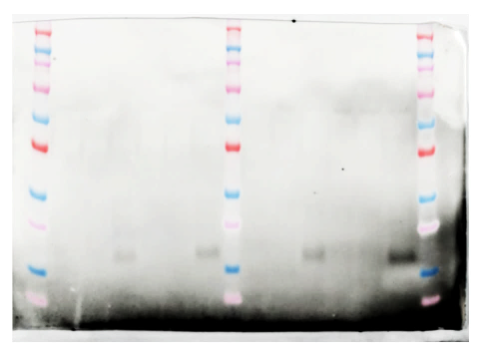
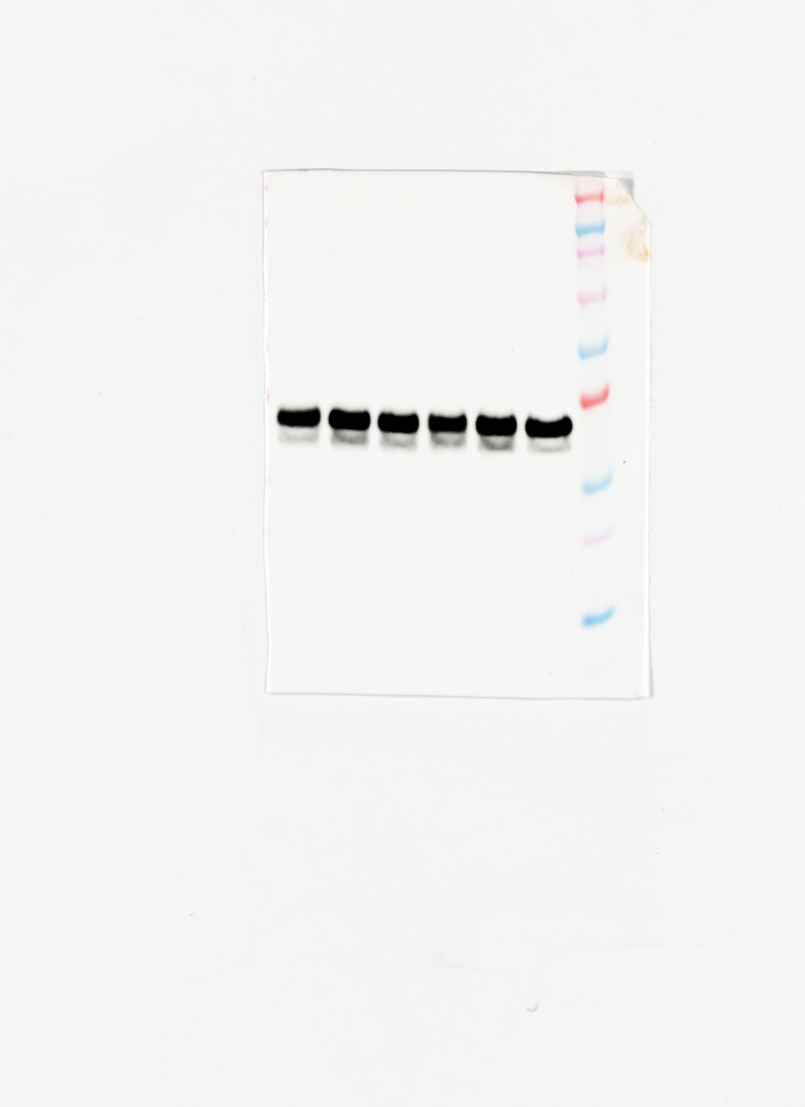
15kDa
20kDa
30kDa
40kDa

Fig. S7. Uncropped blot images of western blots shown in Fig. 3
Cleaved-caspase-3 (left), GAPDH (right)

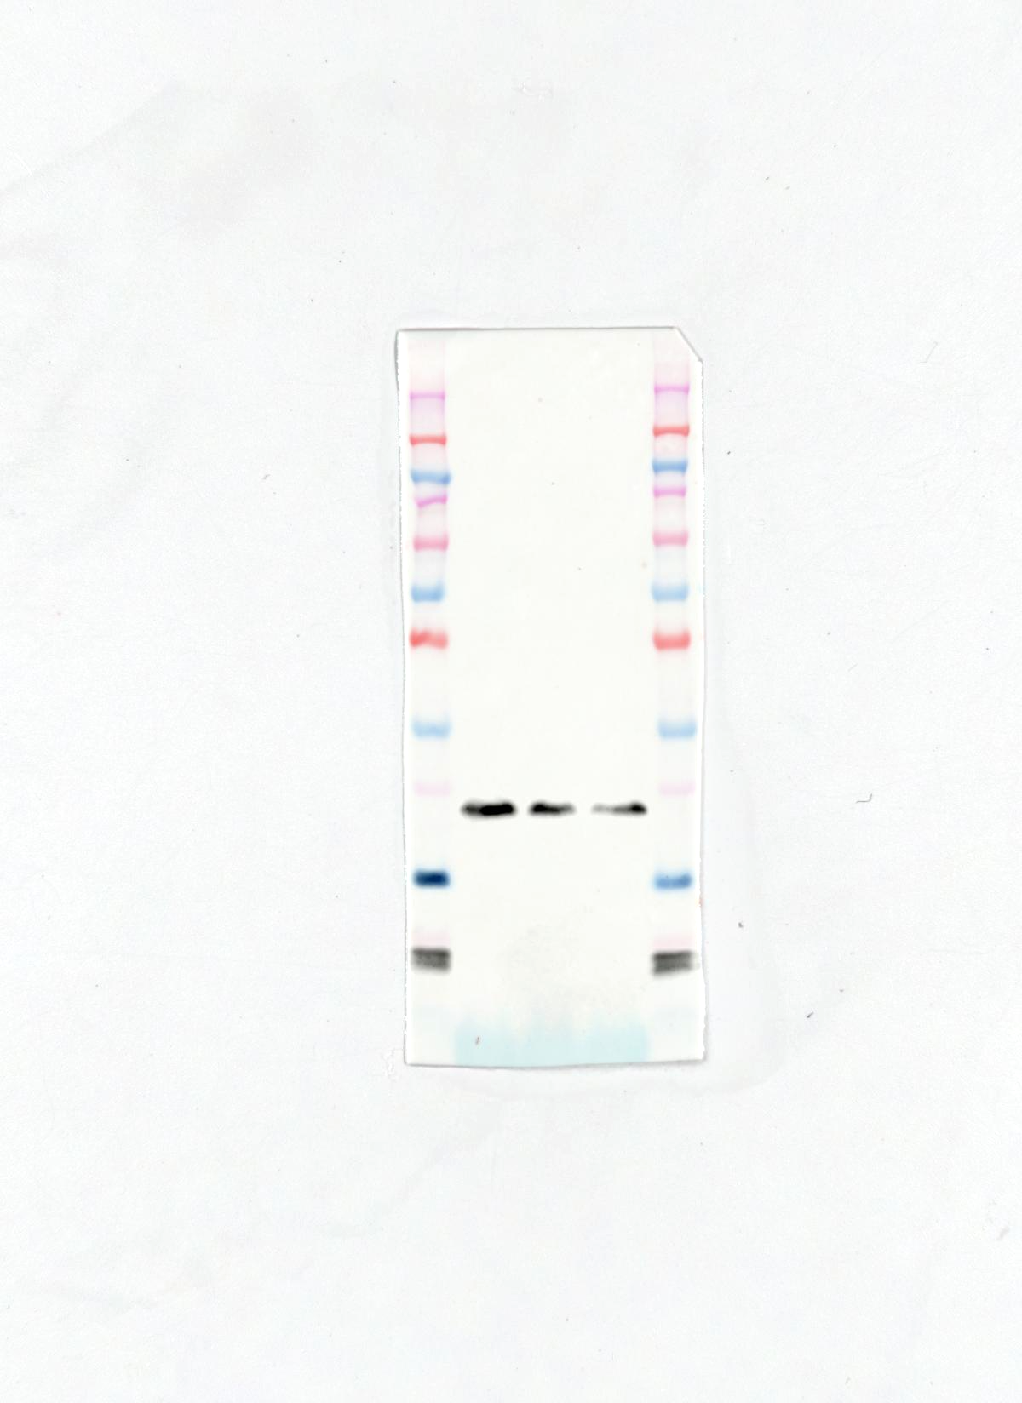
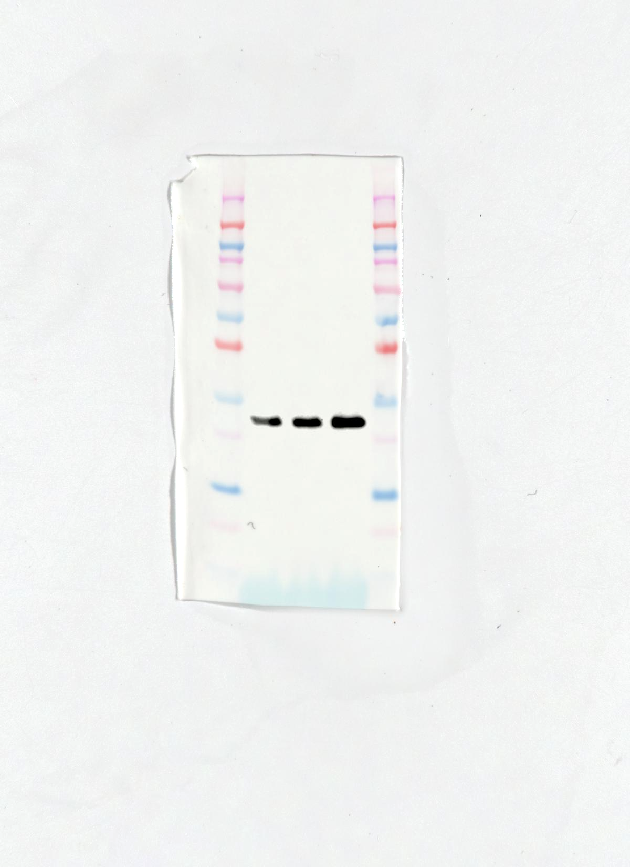
15kDa
20kDa
20kDa
30kDa
A
B

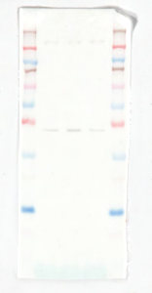
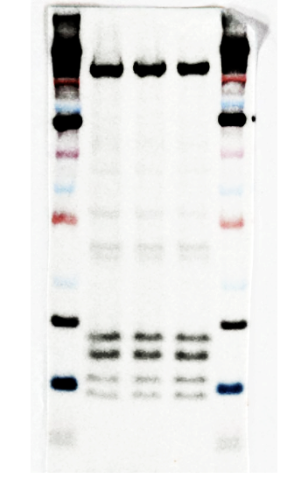
15kDa
20kDa
30kDa
40kDa
C
D

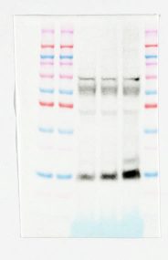
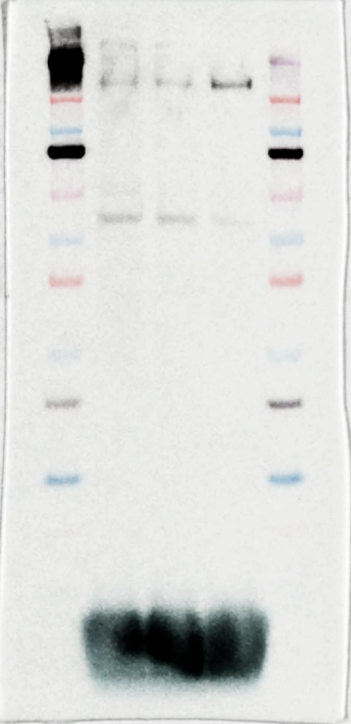
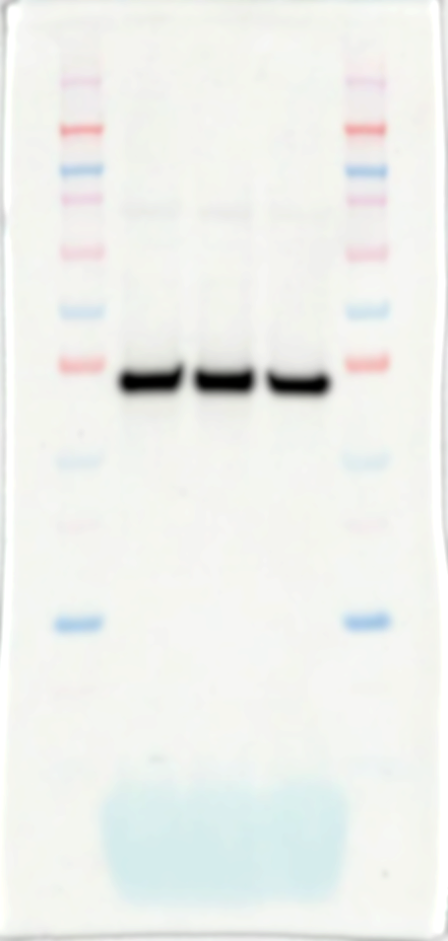
10kDa
15kDa
E
F
15kDa
20kDa
30kDa
40kDa
G

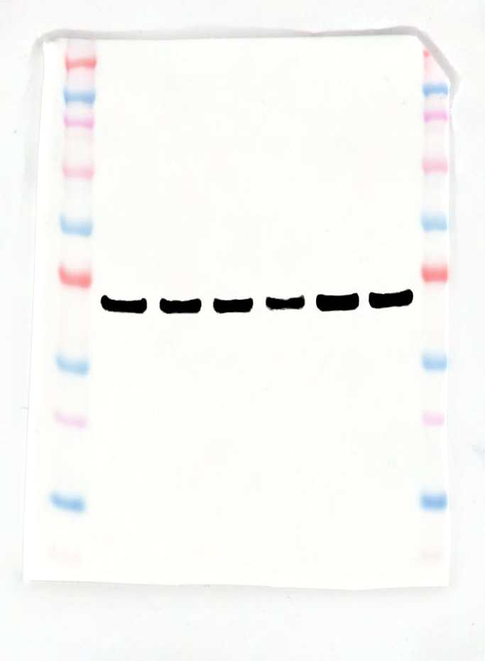
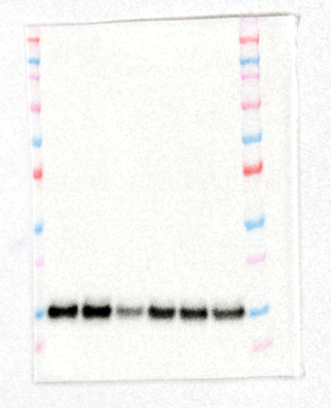
30kDa
40kDa
I
15kDa
20kDa
H

Fig. S8. Uncropped blot images of western blots shown in Fig. 5
Mitochondrial fraction A) BAX, B) BAK, C) COX IV and D) GAPDH
Cytosolic protein E) Cytochrome c, F) COX IV and G) GAPDH
Whole cell lysate H) TOM20 and I) GAPDH

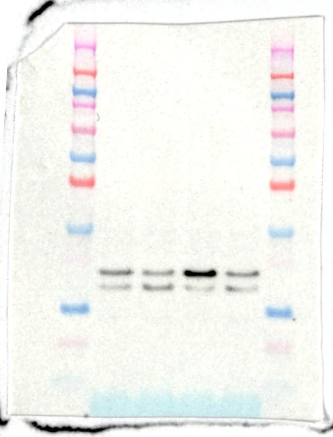
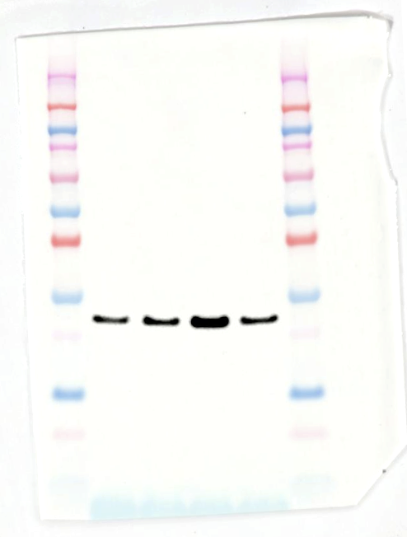
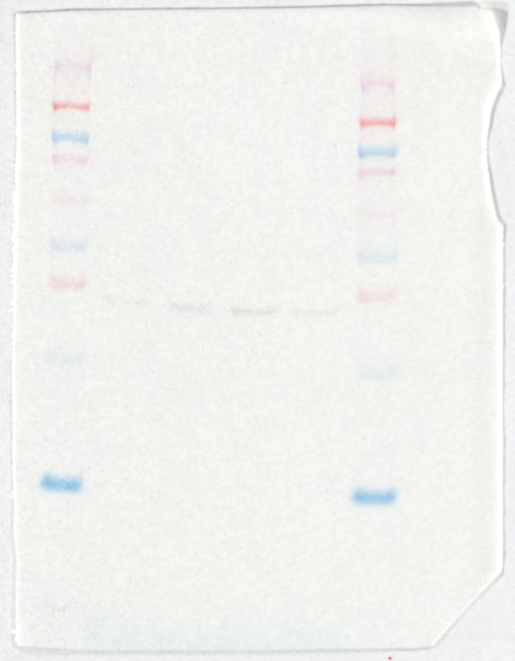
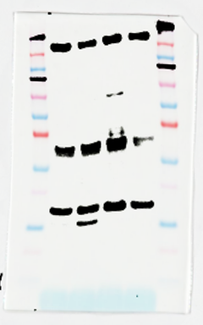
B
A
15kDa
20kDa
A
20kDa
30kDa
B
30kDa
40kDa
15kDa
20kDa
C
D

C
D

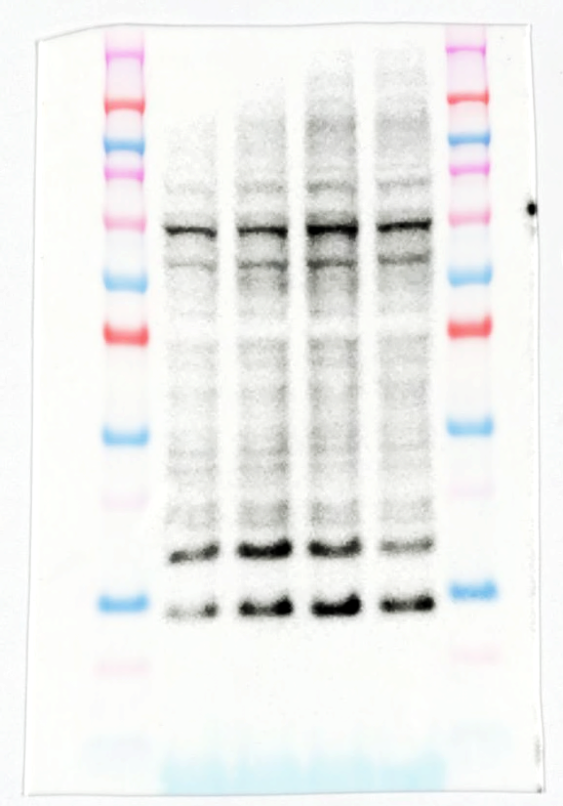
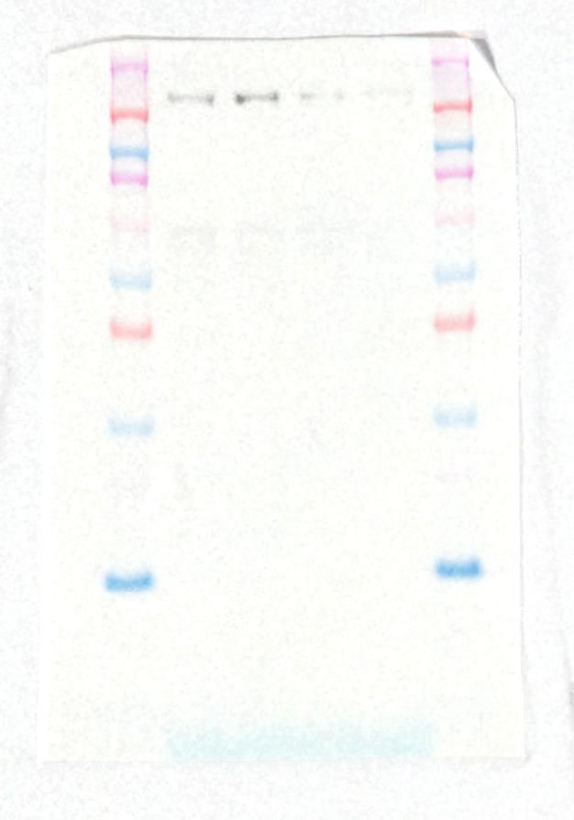
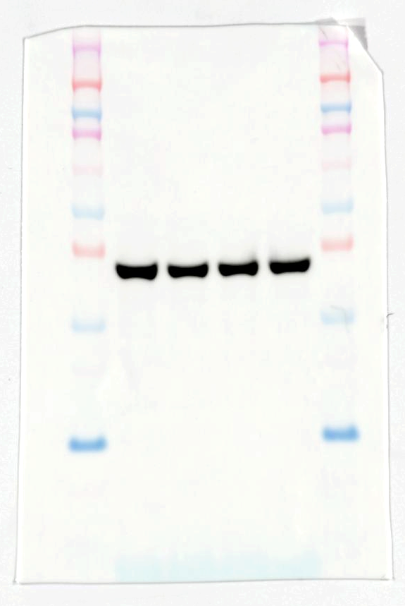
10kDa
15kDa
30kDa
40kDa
E
F
G
15kDa
20kDa

Fig. S9. Uncropped blot images of western blots shown in Fig. 6
Mitochondrial fraction A) BAX, B) BAK, C) COX IV and D) GAPDH
Cytosolic protein E) Cytochrome c, F) COX IV and G) GAPDH

Antibody | Dilution | Company | Catalog number
TBCM | 1:1000 | Bionics | -
Hsp65 | 1:200 | Santacruz | sc-57842
Cleaved caspase-3 | 1:1000 | Cell signaling | 9661S
Tom20 | 1:1000 | Cell signaling | 42406S
Cytochrome c | 1:1000 | Cell signaling | 11940S
BAX | 1:1000 | Cell signaling | 2772S
BAK | 1:1000 | Cell signaling | 12105S
COXIV | 1:1000 | Cell signaling | 4850S
GAPDH | 1:1000 | Thermo fisher | MA5-15738-HRP

Table S1. Used antibodies for western blot
Production of TBCM antibody was conducted by Bionics (Seoul, Korea).

Gene  symbol | Forward primer (5’-3’) | Reverse primer (5’-3’)
Bcl-2 | GAG TAC CTG AAC CGG CAT CT | TTG TTT GGG GCA GGT TTG TC
Caspase-7 | CCG AGT GCC CAC TTA TCT GT | ACC TGT CGC TTT GTC GAA GT
Caspase-9 | TTC CCA GGT TTT GTC TCC TG | GGG ACT GCA GGT CTT CAG AG
Apaf1 | GAT CCA CAC AGG CCA TCA CA | GGC GGG AGT CTA TGT TCC AC
Trim39 | TGG AGG TGA CTT CAG TAT CCA T | TCA CAT CCG CAA TTA GCT GTT
Sarm1 | TCG CAA TTT TGT CCT GGT G | AGC TTA AAG CAG TCA CAA TCT CC
Slc25a26 | TCT GGG GCA ACA GTG TGT AG | TAC TAA GTG TGT GCG GCG GT
Ndufa8 | GAG TTT ATG CTG TGC CGC TG | TAC TCT GTG AAA GGC TCC GC
Dtymk | GTC CTG TTC CTC CAG TTA C | AGC ATC CAC CAT CTT CCA
β-actin | GCA ATT ATT CCC CAT GAA CG | GGC CTC ACT AAA CCA TCC AA
tbcm | GCA AAG TTG GGC GAA GAT G | ATC CGA TTA TTC AGG GAG TCG ATC
hsp65 | GTC GAG GAG TCC AAC ACC TT | GAG CTG ACC AGC AGG ATG TA

Table S2. Primer sets for RT-qPCR

