Supporting Information for
TEM1/endosialin/CD248 promotes pathologic scarring and TGF-β activity through its receptor stability in dermal fibroblasts

Yi-Kai Hong, Yu-Chen Lin, Tsung-Lin Cheng, Chao-Han Lai, Yi-Han Chang, Yu-Lun Huang, Chia-Yi Hung, Chen-Han Wu, Kuo-Shu Hung, Ya-Chu Ku, Yen-Ting Ho, Ming-Jer Tang, Shu-Wha Lin, Guey-Yueh Shi, John A McGrath, Hua-Lin Wu, and Chao-Kai Hsu

Corresponding authors:
Hua-Lin Wu, halnwu@mail.ncku.edu.tw
Chao-Kai Hsu, kylehsu@mail.ncku.edu.tw

This file includes:
Figures S1 to S12
Tables S1 to S4

Supplementary reference
1. Hsu C.K., Lin H.H., Harn H.I., Ogawa R., Wang Y.K., Ho Y.T., Chen W.R., Lee Y.C., Lee J.Y., Shieh S.J., Cheng C.M., McGrath J.A. and Tang M.J. Caveolin-1 Controls Hyperresponsiveness to Mechanical Stimuli and Fibrogenesis-Associated RUNX2 Activation in Keloid Fibroblasts. J Invest Dermatol. 138(1):208-218, 2018.

Supplementary figures
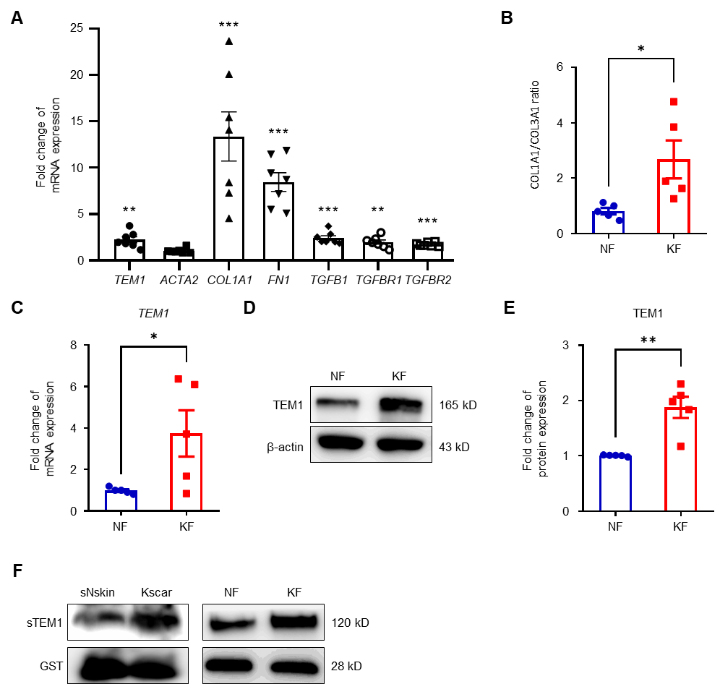
Fig. S1 TEM1 is upregulated in the tissues and fibroblasts of keloids. A Re-analyses of microarray data from our previous publication [1] reveal the relative fold change of TEM1, ACTA2, COL1A1, FN1, TGFB1, TGFBR1, TGFBR2 gene expression in Kscar (n = 7), compared with that in sNscar (n = 7). B The mRNA levels of COL1A1 and COL3A1 from the cell lysates of normal fibroblasts (NFs) (n = 4) and keloid fibroblasts (KFs) (n = 4) are detected using real-time PCR and then neutralized by ACTB gene. The ratio of COL1A1 to COL3A1 is shown. C The mRNA level of TEM1 expression is examined with real-time PCR and then neutralized by ACTB gene. The fold change of TEM1 mRNA expression in KFs (n = 4) is calculated with reference to NFs (n = 4). D The protein levels of TEM1 expression in NFs (n = 5) and KFs (n = 5) are assayed by Western blotting. E The intensity of each protein expression relative to ACTB is calculated based on the results of Western blotting. The fold change of TEM1 protein expression in KFs is determined as compared with NFs. F The conditioned medium harvested from tissues and fibroblasts of sNskin and Kscar was analyzed for TEM1 expression using Western blotting. Bar graphs show mean ± SEM. * P < 0.05, ** P < 0.01, *** P < 0.001. P-values are determined by an unpaired two-tailed Student’s t-test.
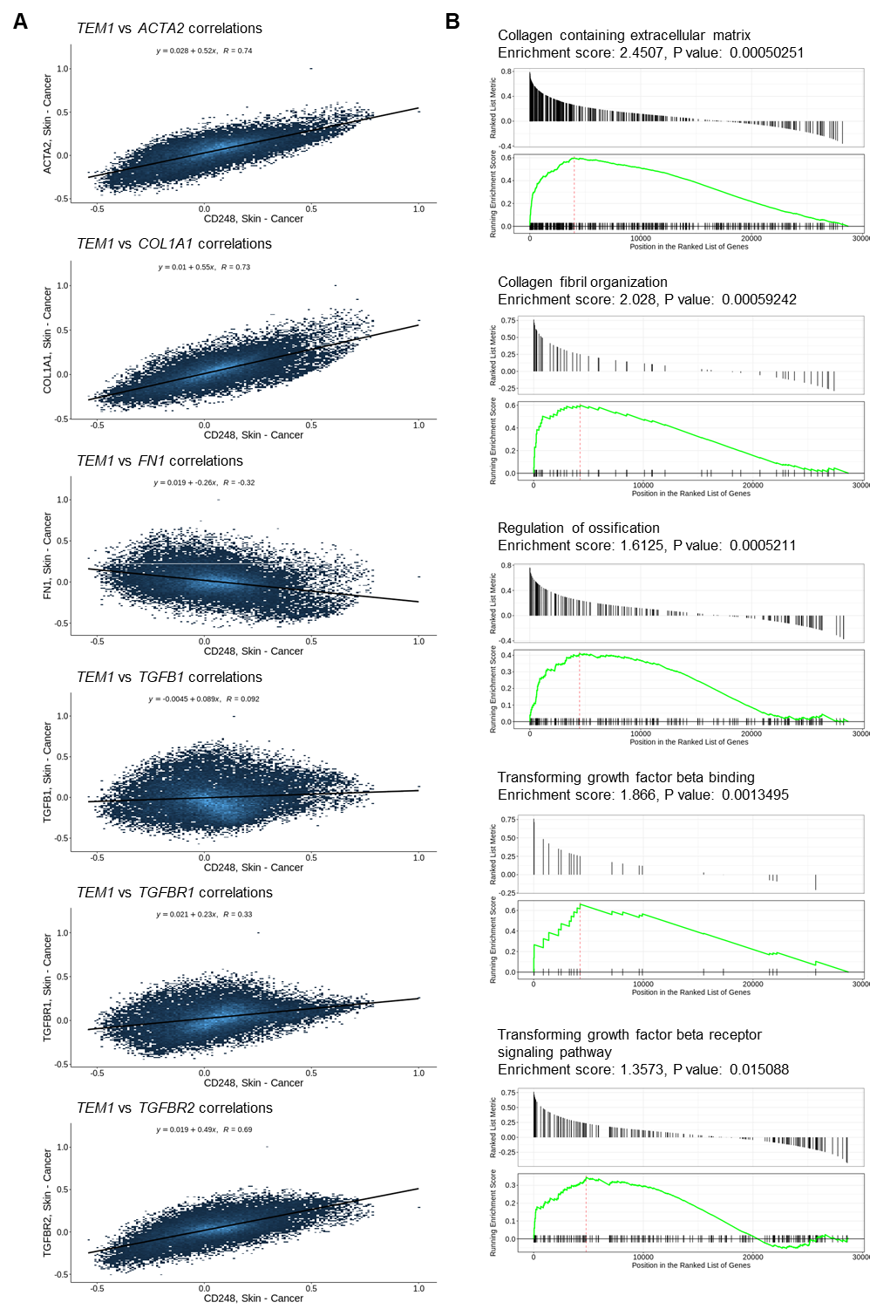
Fig. S2 TEM1 is correlated with TGF-β pathways predicted by Correlation AnalyzeR software. A The co-expression correlation of TEM1 with ACTA2, COL1A1, FN1, TGFB1, TGFBR1, and TGFBR2 is analyzed by Correlation AnalyzeR software in human skin samples. B Correlated gene set enrichment of TEM1 gene is also analyzed by Correlation AnalyzeR software in human skin samples.

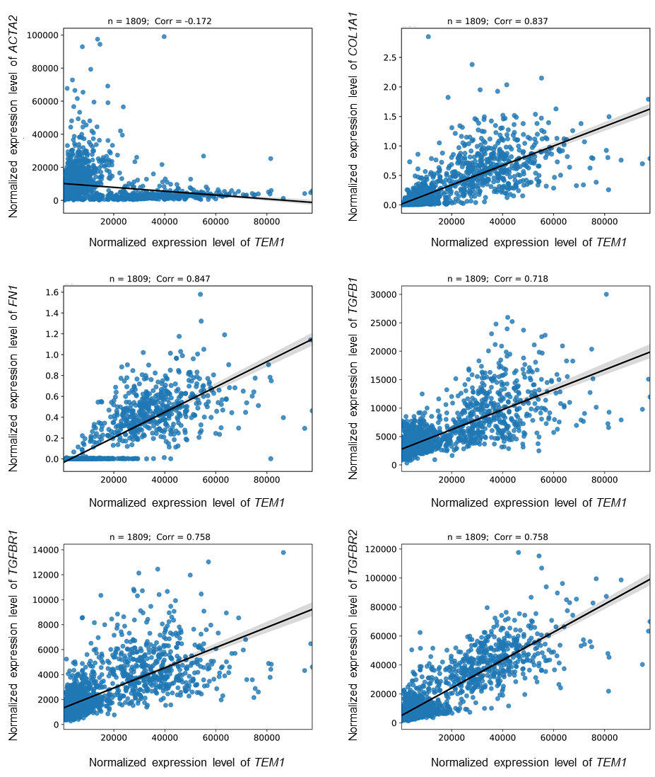
Fig. S3 TEM1 is correlated with TGF-β related genes predicted by GRNdb software. The co-expression correlation of TEM1 with ACTA2, COL1A1, FN1, TGFB1, TGFBR1, and TGFBR2 is analyzed by GRNdb software in human skin samples.

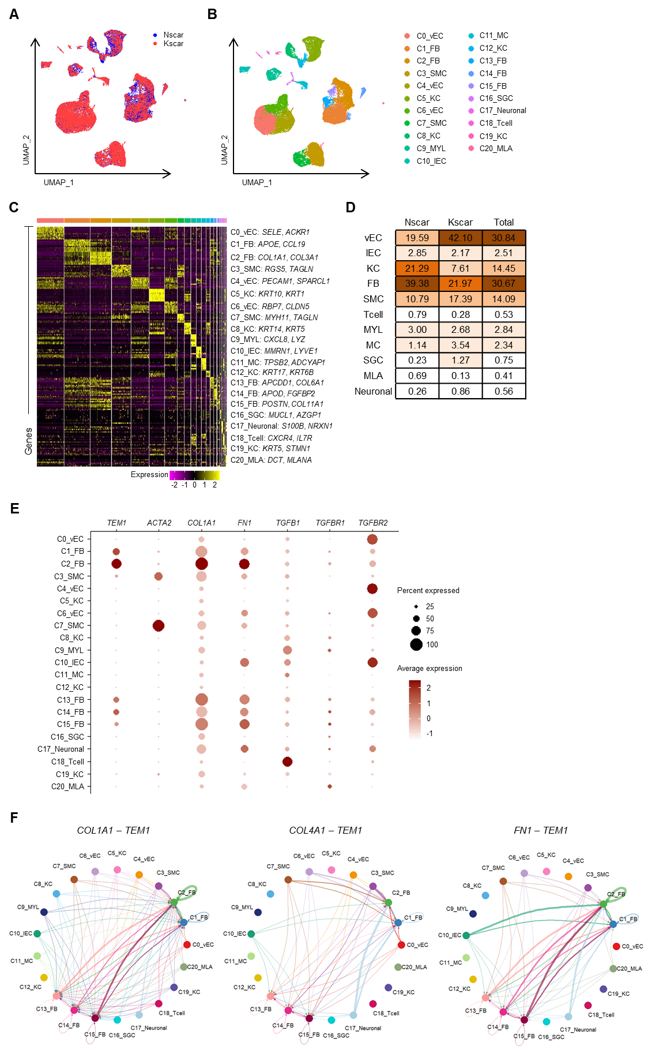
Fig. S4 Cellular heterogeneity in normal scars and keloids is identified at single cell level. A, B Uniform manifold approximation and projection (UMAP) plot reveals the integrated result of normal scars and keloids (A), and cellular heterogeneity with 21 distinct cell clusters (B). General identity is labeled on the right side. C Heatmap shows the top 10 differentially expressed genes (DEGs) in each cell type. Selected genes for each cluster are shown on the right side. D The percentages of each cell type in normal scars and keloids are present. E A set of distinctly expressed genes in all populations are shown by dot plots. F Circle plots illustrating autocrine and paracrine signaling interactions of ligand-receptor pairs: COL1A1-TEM1, COL4A1-TEM1, and FN1-TEM1 across various cell populations.

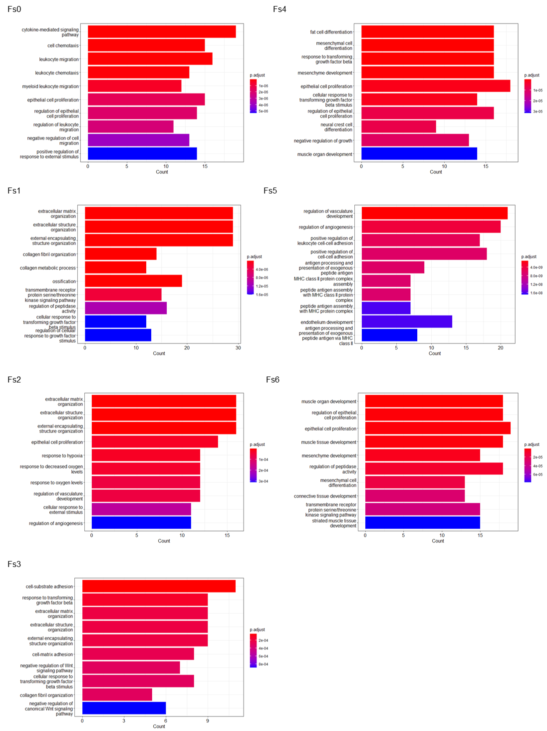
Fig. S5 Biological functions in each fibroblast subset of normal scars and keloids are annotated by GO database. The GO biological processes of DEGs in each fibroblast subgroup are analyzed by clusterProfiler software.

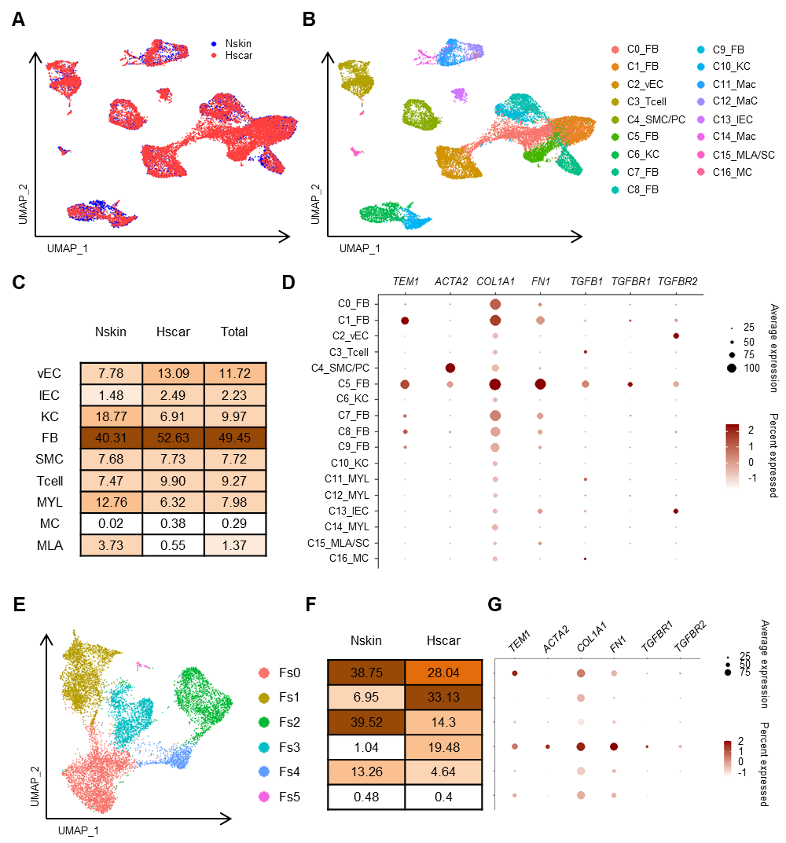
Fig. S6 Cellular heterogeneity in normal skin and hypertrophic scars is identified at single cell level. A, B Uniform manifold approximation and projection (UMAP) plot reveals the integrated result of normal skin and hypertrophic scar (A), and cellular heterogeneity with 17 distinct cell clusters (B). General identity is labeled on the right side. C The percentages of each cell type in normal scars and keloids are present. D A set of distinctly expressed genes in all populations are shown by dot plots. E The subclusters of all ﬁbroblasts from normal scars and keloids are further classified into 6 distinct subtypes (Fs0–Fs5). F Percentages of each fibroblast subgroup in normal scars and keloids are presented. G Sets of distinctly expressed genes in all fibroblast subsets are shown by dot plots.

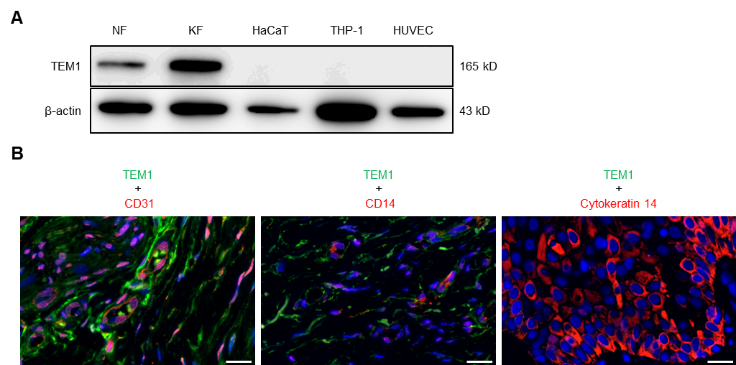
Fig. S7 TEM1 protein is specifically expressed in primary dermal fibroblasts. A The expression of TEM1 and β-actin proteins in the lysate of different cell types including NF, KF, HaCaT, THP-1, and HUVEC lines is determined by Western blotting. B The tissue sections from keloid scar are immunostained for TEM1, CD31, CD14, and cytokeratin 14. The nucleus is stained with DAPI. Scale bar = 20 μm.

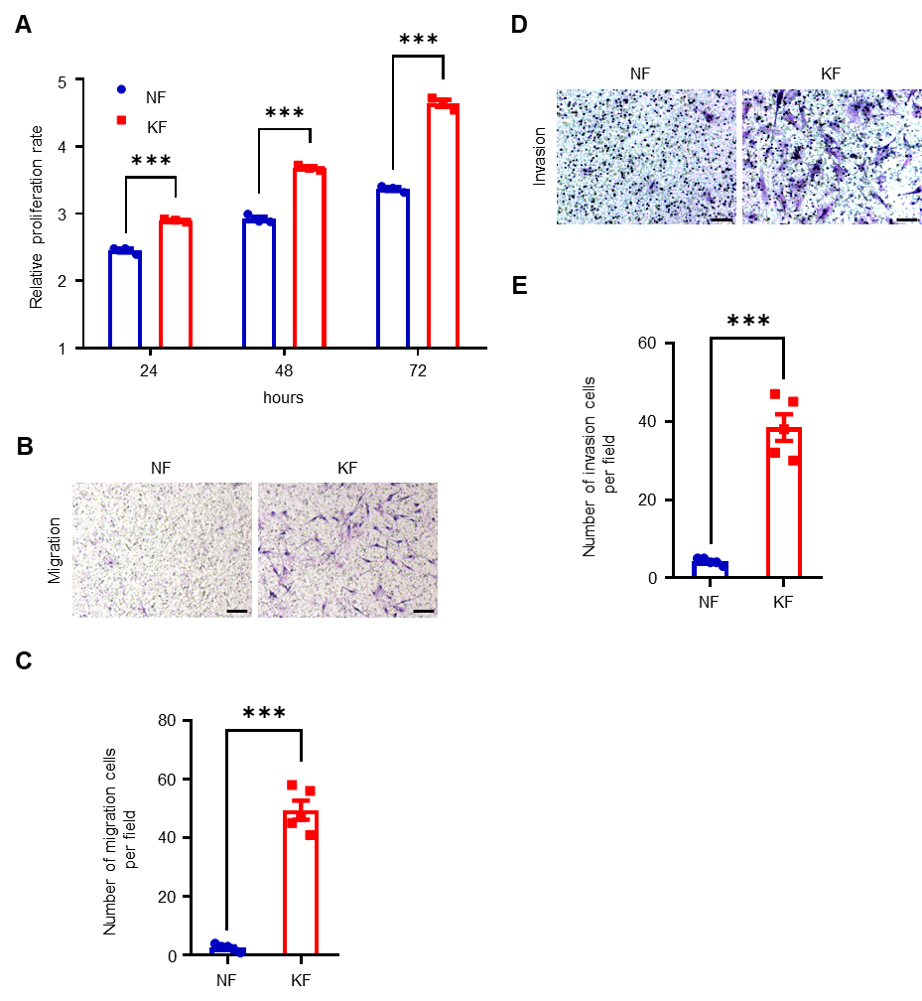

Fig. S8 Proliferation, migration, and invasion are enhanced in keloid fibroblasts as compared with normal fibroblasts. A The cell viability of fibroblasts in 10% FBS is measured by WST-1 assay. Relative proliferation of 24, 48, and 72 hours to 0 hour is shown. B, C Cell migration of fibroblasts is measured by transwell migration assay with 10% FBS as chemoattractant. Scale bar = 100 μm. D, E Cell invasion of fibroblasts is assayed using matrigel-coated transwell migration assay with 10% FBS as chemoattractant. Scale bar = 100 μm. Bar graphs show mean ± SEM. *** P < 0.001. P-values are determined by unpaired two-tailed Student’s t-test and two-way analysis of variance.

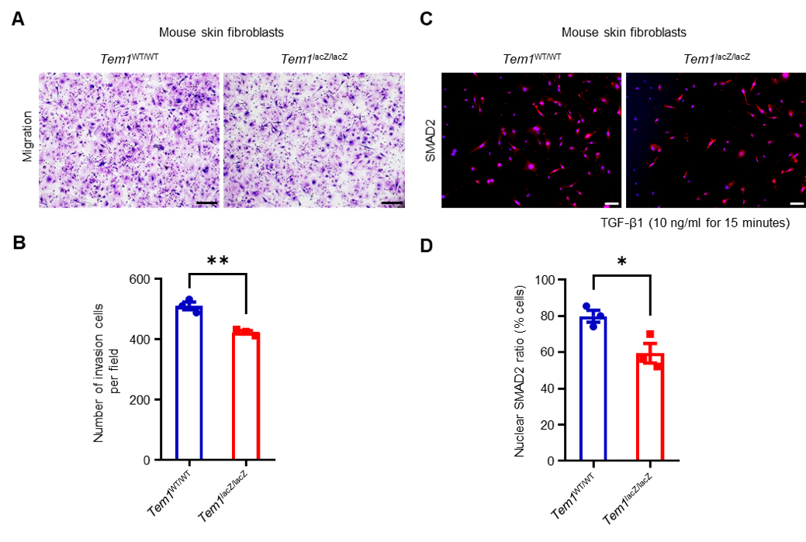
Fig. S9 The effect of TEM1 on mouse skin fibroblast cell migration and SMAD2 nuclear translocation. A, B Transwell migration assay showcasing the migratory capabilities of mouse skin fibroblasts derived from Tem1^{wt/wt} and Tem1^{lacZ/wt} mice, using 10% FBS as the chemoattractant. Scale bar = 100 μm. C, D Immunofluorescence study of SMAD2 nuclear translocation in mouse skin fibroblasts following treatment with TGF-β1 at a concentration of 10 ng/ml. Quantification of the nuclear SMAD2 to DAPI ratio was performed using ImageJ. Scale bar = 100 μm.

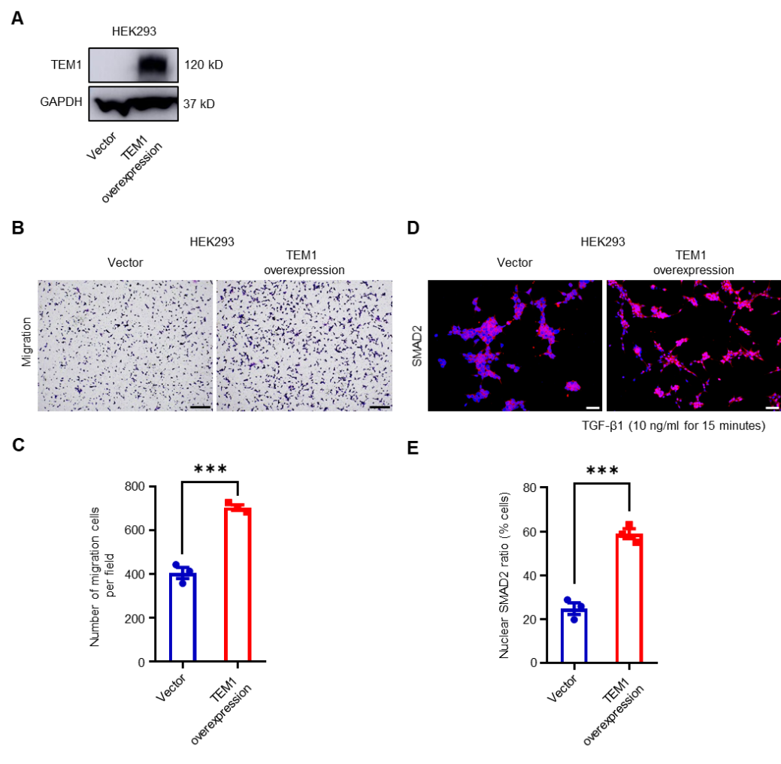
Fig. S10 The effect of TEM1 on cell migration and nuclear translocation of SMAD2 in HEK293 cell line. A Establishment of a TEM1-overexpressing HEK293 cell line via transfection using pEGFP-hTEM1, with pEGFP-N1 serving as the control vector. TEM1 protein expression levels are evaluated using Western blotting. B, C Assessment of HEK293 cell migration capabilities using a transwell migration assay, with 10% FBS acting as the chemoattractant. Scale bar = 100 μm. D, E Immunofluorescence study of SMAD2 nuclear translocation in HEK293 cells post-treatment with TGF-β1 at 10 ng/ml concentration. The proportion of nuclear SMAD2 relative to DAPI is quantitatively analyzed using ImageJ. Scale bar = 100 μm.

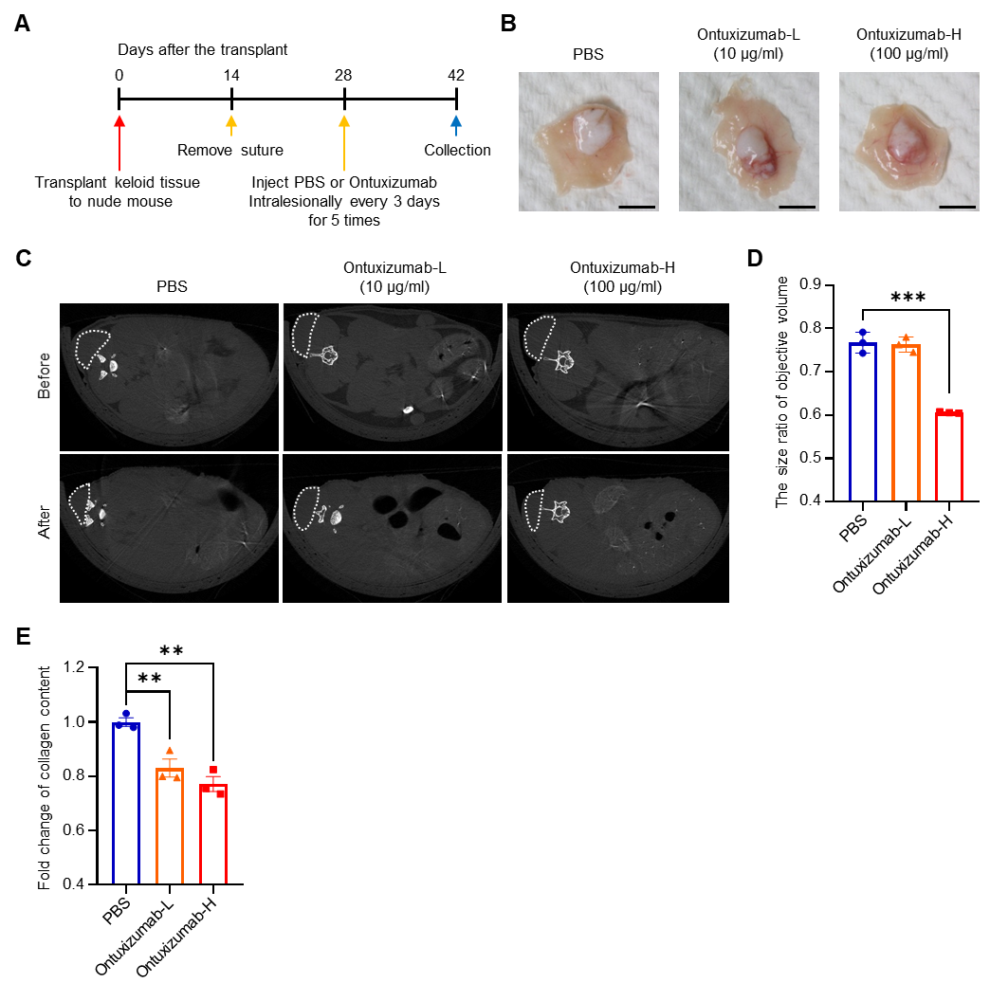
Fig. S11 Effect of ontuxizumab on keloid size and collagen density in a xenograft nude mouse model. A Experimental timeline detailing the steps in the keloid xenograft nude mouse model, from transplantation of keloid tissue to collection post-treatment. B Morphological observation of keloid tissues from xenografted nude mice after local injection with either PBS, low-dose ontuxizumab (10 μg/ml), or high-dose ontuxizumab (100 μg/ml), visualized using a dissecting microscope. Scale bar = 5 mm. C Micro-computed tomography images highlighting the keloid lesions before and after ontuxizumab treatment. D Quantification of the size ratio of keloid volume post-treatment in comparison to the volume before treatment, which is used as a reference. E Analysis of collagen density in excised keloid tissues. Tissues were stained with picrosirius red and subsequently quantified using ImageJ in a blinded manner.

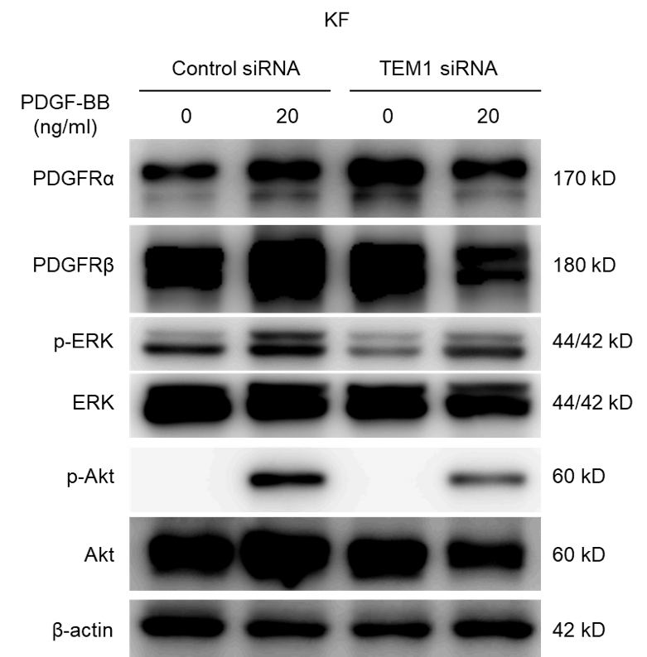
Fig. S12 TEM1 is essential for PDGF-mediated activity in keloid fibroblasts. The amount of protein expression, including PDGFRα, PDGFRβ, p-ERK, ERK, p-Akt, and β-actin, in KFs treated with PDGF-BB (20 ng/ml) for 15 minutes is analyzed using Western blotting.

Supplementary tables
Table S1. Patient data
Cell type | Age (years) | Sex | Biopsy site | Duration (years)
Keloid
K-1 | 23 | Female | Ear | 3
K-2 | 27 | Male | Chest | 12
K-3 | 23 | Male | Ear | 2
K-4 | 28 | Male | Ear | 1.5
K-5 | 21 | Female | Ear | 2
K-6 | 25 | Male | Shoulder | 5
K-7 | 29 | Male | Chest | 14
K-8 | 57 | Female | Chest | 10
Control
N-1 | 34 | Male | Back | --
N-2 | 37 | Male | Forearm | --
N-3 | 19 | Female | Abdomen | --
N-4 | 22 | Female | Upper arm | --
N-5 | 36 | Female | Back | --
N-6 | 28 | Male | Buttock | --
N-7 | 39 | Female | Abdomen | --
N-8 | 39 | Male | Shoulder | --

Table S2. Primers for RT-qPCR
Gene | Species | Primer type | Seqence
CD248 | human | Forward | AGTGTTATTGTAGCGAGGGACA
CD248 | human | Reverse | CCTCTGGGAAGCTCGGTCTA
GAPDH | human | Forward | AGGTCATCCCTGAGCTGAACGG
GAPDH | human | Reverse | CGCCTGCTTCACCACCTTCTTG
COL1A1 | human | Forward | GAGGGCCAAGACGAAGACATC
COL1A1 | human | Reverse | CAGATCACGTCATCGCACAAC
COL3A1 | human | Forward | GGAGCTGGCTACTTCTCGC
COL3A1 | human | Reverse | GGGAACATCCTCCTTCAACAG
TGFBR1 | human | Forward | CACAGAGTGGGAACAAAAAGGT
TGFBR1 | human | Reverse | CCAATGGAACATCGTCGAGCA
TGFBR2 | human | Forward | AAGATGACCGCTCTGACATCA
TGFBR2 | human | Reverse | CTTATAGACCTCAGCAAAGCGA
Col1a1 | mouse | Forward | CAGTCGATTCACCTACAGCACG
Col1a1 | mouse | Reverse | GGGATGGAGGGAGTTTACACG
Col3a1 | mouse | Forward | GTTCTAGAGGATGGCTGTACTAAACACA
Col3a1 | mouse | Reverse | TTGCCTTGCGTGTTTGATATTC
Fn1 | mouse | Forward | TGCACAACCAATGAAGGGG
Fn1 | mouse | Reverse | ATCTCGAAGCTGCGAGTAGG
Acta2 | mouse | Forward | GCGGGCATCCACGAAACCACCTAT
Acta2 | mouse | Reverse | GCTTTGGGCAGGAATGATTTGGAA

Table S3. Antibodies
Primary antibody,  Company (Product catalog number) | Primary Ab raised species, isotype, concentration | MW  (kD) | Secondary Ab Concentration
Primary antibody,  Company (Product catalog number) | Primary Ab raised species, isotype, concentration | MW  (kD) | WB | IHC/ICC
TEM1/CD248  Proteintech (18160-1-AP) | Rabbit, IgG  (WB 1:4000; ICC 1:100) | 165 | 1:4000 | 1:200
TEM1/CD248  Atlas Antibodies (HPA051856) | Rabbit, IgG  (ICC, IHC, IF 1:100) | - |  | 1:200
GAPDH  Santa Cruz (sc-32233) | Mouse, IgG  (WB 1:5000) | 37 | 1:4000
β-actin  Santa Cruz (sc-47778) | Mouse, IgG  (WB 1:2000) | 43 | 1:4000
p-ERK  Santa Cruz (sc-7383) | Mouse, IgG  (WB 1:1000) | 42/44 | 1:4000
ERK  Santa Cruz (sc-94) | Rabbit, IgG  (WB 1:10000) | 42/44 | 1:4000
p- SMAD2  Cell signaling (8828S) | Rabbit, IgG  (WB 1:1000) | 60 | 1:4000
SMAD2/3  Santa Cruz (sc-133098) | Mouse, IgG  (WB 1:1000; ICC 1:50) | 60 | 1:4000 | 1:200
COL1A1  Santa Cruz (sc-293182) | Mouse, IgG  (IF 1:20) |  |  | 1:200
FN1  Santa Cruz (sc-8422) | Mouse, IgG  (WB 1:1000; IF 1:20) | 210 | 1:4000 | 1:200
α-SMA  Sigma (A2547) | Mouse, IgG  (IF 1:100) |  |  | 1:200
Ubiquitin  Cell signaling (#3936) | Mouse, IgG  (WB 1:5000) | 220 | 1:4000
Cyclin D1  Cell signaling (#2978) | Rabbit, IgG  (WB 1:5000) | 36 | 1:4000
α-SMA  Abcam (ab5694) | Rabbit, IgG  (WB 1:5000) | 42 | 1:4000 | 1:200
COL1A1  Santa Cruz (sc-8784R) | Rabbit, IgG  (WB 1:2000) |  | 1:4000 | 1:200
TGFBR1  Santa Cruz (sc-101574) | Mouse, IgG  (WB 1:200) | 54 | 1:4000
TGFBR2  Santa Cruz (sc-17792) | Mouse, IgG  (WB 1:200, IF 1:20, ICC 1:20) | 63-95 | 1:4000 | 1:200
CD31  Santa Cruz (sc-1506) | Goat, IgG  (IF 1:20) |  |  | 1:200
CD14  Santa Cruz (sc-1182) | Mouse, IgG  (IF 1:20) |  |  | 1:200
Cytokeratin 14  Abcam (ab7800) | Mouse, IgG  (IF 1:200) |  |  | 1:200

Table S4. Pathway analysis of gene ontology in differentially expressed genes of cluster 1 in Fig. 4D
Ranking | ID | Description | -LOG₁₀ P-value
1 | GO:0030198 | extracellular matrix organization | 28.76406
2 | GO:0043062 | extracellular structure organization | 28.66811
3 | GO:0031589 | cell-substrate adhesion | 23.08732
4 | GO:0001667 | ameboidal-type cell migration | 21.27629
5 | GO:0009100 | glycoprotein metabolic process | 20.96941
6 | GO:1901342 | regulation of vasculature development | 19.97379
7 | GO:0009101 | glycoprotein biosynthetic process | 18.29928
8 | GO:0090130 | tissue migration | 17.80523
9 | GO:0045765 | regulation of angiogenesis | 17.71907
10 | GO:0010631 | epithelial cell migration | 17.40397
11 | GO:0090132 | epithelium migration | 17.26612
12 | GO:0007264 | small GTPase mediated signal transduction | 16.42769
13 | GO:0007160 | cell-matrix adhesion | 16.40896
14 | GO:0070085 | glycosylation | 15.42294
15 | GO:0006486 | protein glycosylation | 15.16995
16 | GO:0043413 | macromolecule glycosylation | 15.16995
17 | GO:0043542 | endothelial cell migration | 15.10688
18 | GO:0045785 | positive regulation of cell adhesion | 14.82794
19 | GO:0030199 | collagen fibril organization | 14.4059
20 | GO:0032963 | collagen metabolic process | 14.24041
21 | GO:0007265 | Ras protein signal transduction | 14.04269
22 | GO:0071560 | cellular response to transforming growth factor beta stimulus | 13.98634
23 | GO:0034446 | substrate adhesion-dependent cell spreading | 13.94003
24 | GO:0001655 | urogenital system development | 13.83584
25 | GO:0090287 | regulation of cellular response to growth factor stimulus | 13.73381
26 | GO:0071559 | response to transforming growth factor beta | 13.69091
27 | GO:0034329 | cell junction assembly | 13.6125
28 | GO:0007229 | integrin-mediated signaling pathway | 13.47118
29 | GO:0010632 | regulation of epithelial cell migration | 13.44067
30 | GO:0051271 | negative regulation of cellular component movement | 12.98626
75 | GO:0016055 | Wnt signaling pathway | 9.415286
170 | GO:0008277 | regulation of G protein-coupled receptor signaling pathway | 6.139243
199 | GO:0035791 | platelet-derived growth factor receptor-beta signaling pathway | 5.819267
209 | GO:0035924 | cellular response to vascular endothelial growth factor stimulus | 5.711744
347 | GO:0044344 | cellular response to fibroblast growth factor stimulus | 4.548023
442 | GO:0007173 | epidermal growth factor receptor signaling pathway | 3.910373

