LysECD7-SMAP do not reveals cytotoxic effects or resistance development. High activity against prokaryotic cells, as well as the presence of a cationic charged C-terminal peptide, suspect that the enzyme may be active against eukaryotic cells as well, limiting its use in clinical settings. However, in vitro cytotoxicity assays against human red blood cells and eukaryotic cells showed that LysECD7-SMAP administration in concentration up to 1 mg ml⁻¹ has no toxic effect (Fig. S6a). The hemolysis percent was low and did not exceed 5%, that is unsignificant. Viability of HEK293 cells varied from 93.7% in 16 µg ml⁻¹ concentration to 139.3% in 1 mg ml⁻¹ concentration, and minimal cells disaggregation was shown in 1 mg ml⁻¹ concentration (Fig. S6b, c).
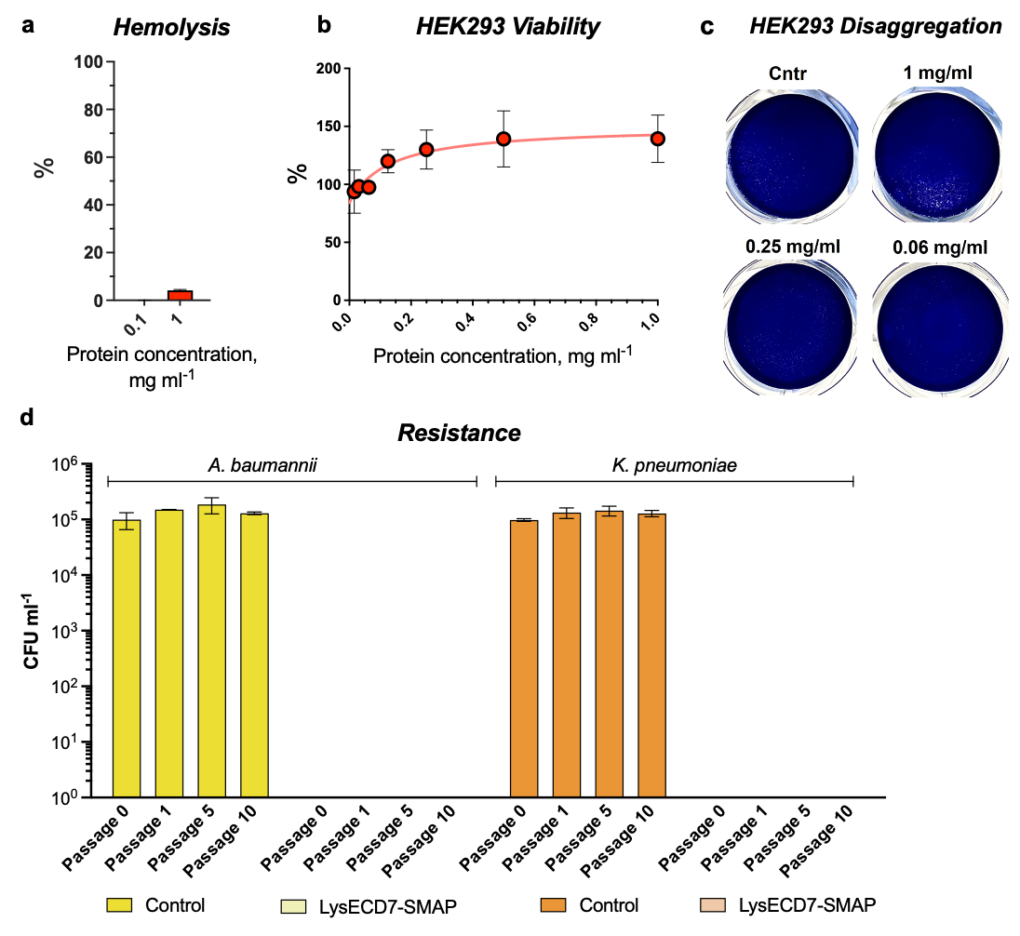
Figure S6. LysECD7-SMAP in vitro safety characteristics. a Hemolytic activity of LysECD7-SMAP against human red blood cells after 1 h exposure. b LysECD7-SMAP cytotoxic activity on the viability of HEK293 cells was determined with an MTT assay after 1 h exposure. The mean values with SD are shown, all experiments were performed in triplicate. c HEK293 cell-disagregation assay after 48 h of incubation with different concentrations of LysECD7-SMAP. d Bactericidal activity of LysECD7-SMAP against initial and 10 serials passed strains of A. baumannii and K. pneumoniae clinical isolates.
The resistance development measured with the serial passage experiments was studied on A. baumannii and K. pneumoniae clinical isolates in a plate lysis assay. After 10 passages we did not detect difference in antibacterial activity of LysECD7-SMAP against initial and passed strains, proposing that no resistance is developed towards endolysin (Fig. S6d).

