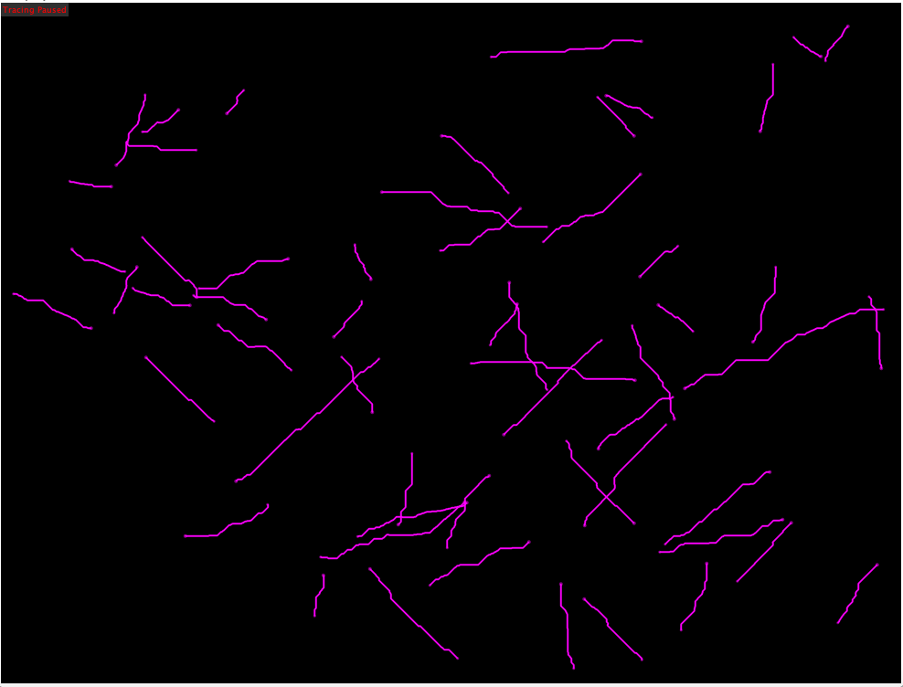
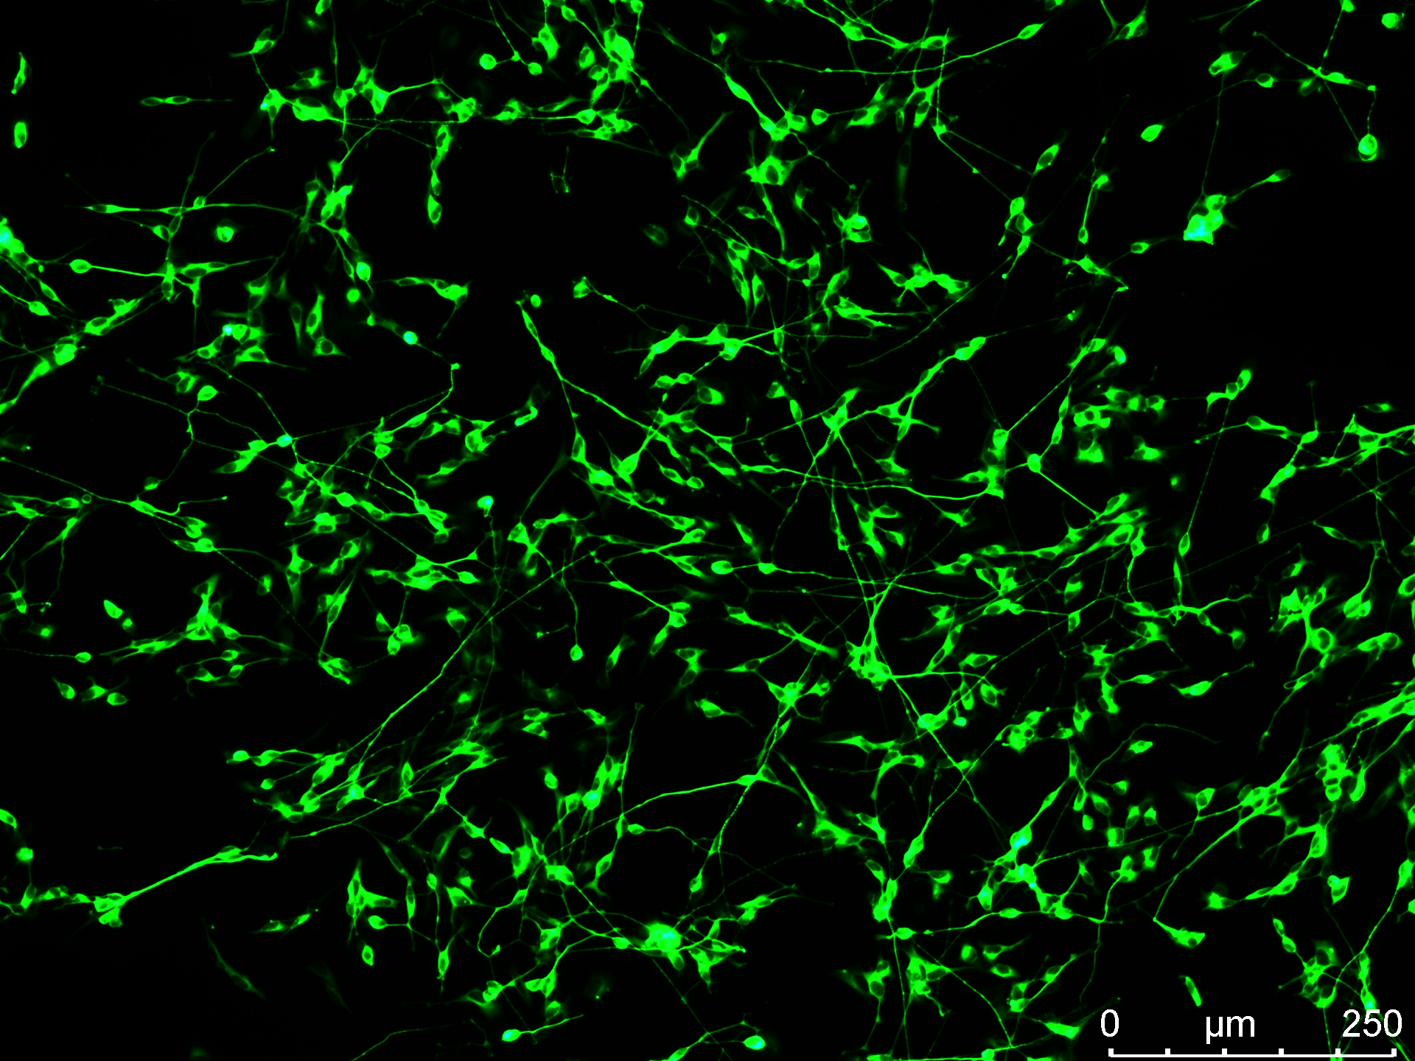

FIGURE S1. Representative images of neurite outgrowth quantified using the FIJI plugin Simple Neurite Tracer (SNT.V4.2.1), based on B-III tubulin fluorescence images of SH-5YSY cells.

