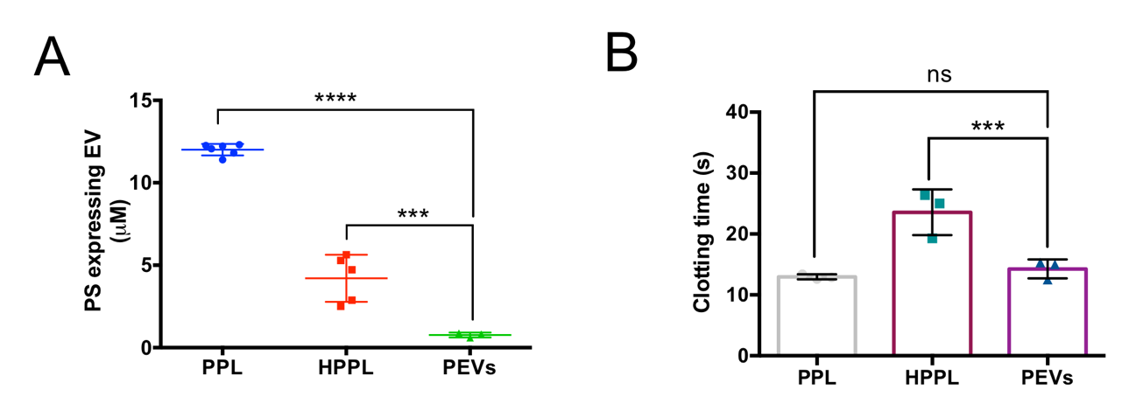

FIGURE S3. Procoagulant assays. (A) Phosphatidylserine (PS)-expressing PEVs. (B) STA-Phospholipids pro-coagulant activity (clotting time). Results are expressed as the means ± SD (N = 3). (***p < 0.001, ****p < 0.0001), compared to PPL and HPPL, ns (no significant). Abbreviations: Platelet-extracellular vesicles (PEVs), Platelet pellet lysate (PPL), Heat-treated platelet pellet lysate (HPPL).

