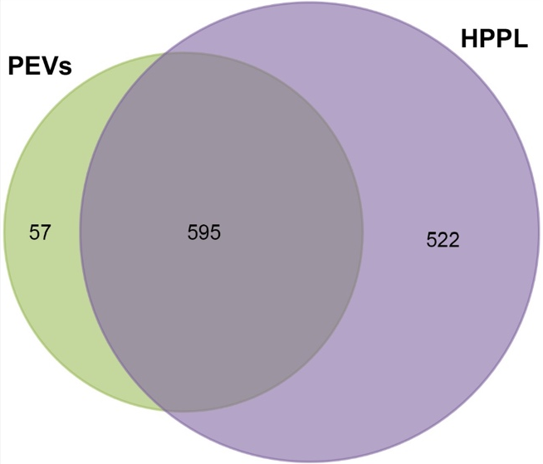

Figure S5. Totals of 1117 and 652 (with a false discovery rate [FDR] of <1%, at the protein level) were identified in HPPL and PEVs, respectively by LC-MS/MS. The Venn diagram illustrates that 595 proteins (90% of the PEV proteins) were also present in HPPL.

