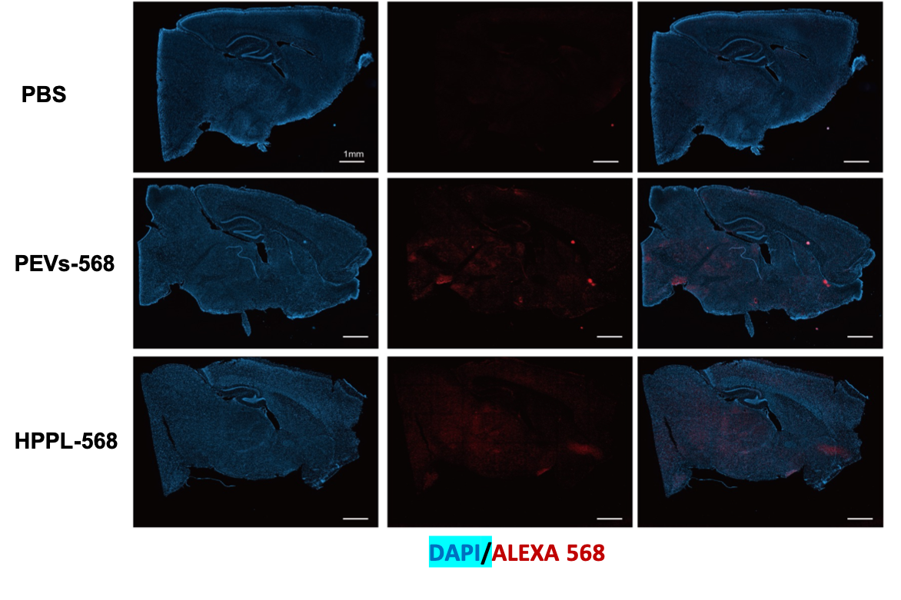FIGURE S4. PEVs diffusion in the mice brain. PEVs were observed diffusing through a sagittal section of the mice brain. Detection of PEVs labelled with Alexa Fluor 568 was performed using a fluorescence slide scanner. After 7 hours of intranasal delivery, a distinct red fluorescent spot was visible in the brain slice that received PEVs and HPPL labelling, in contrast to the control with PBS-labeled Alexa Fluor. This diffusion was observed evenly throughout the brain, extending to the cortex, hippocampus, thalamus, and striatum.

