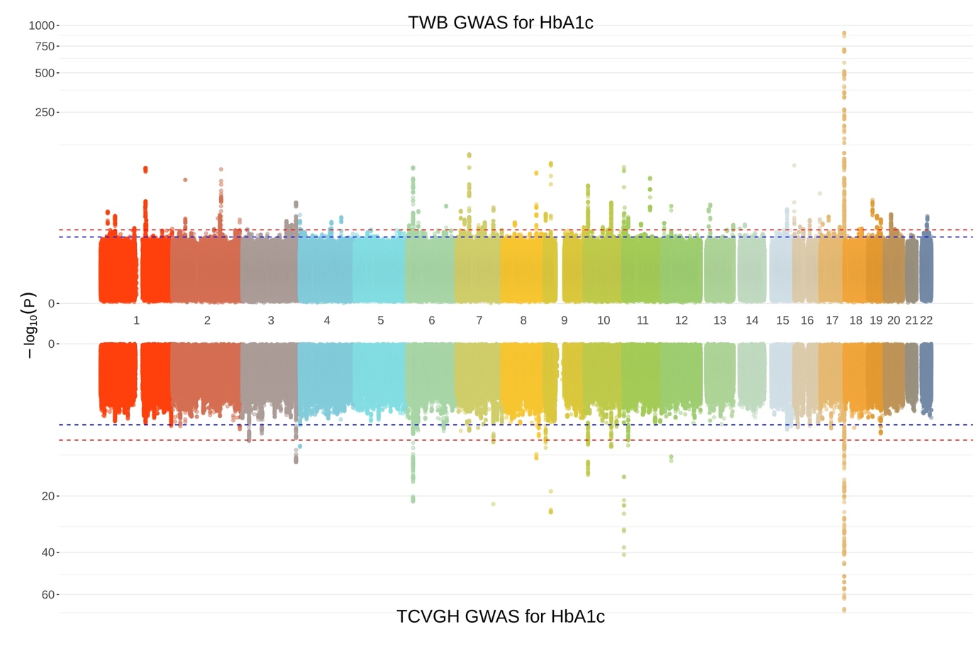
Figure S1. Mirror Manhattan plot for HBA1C in the TWB (top) and TCVGH (bottom) cohorts. Red horizontal dashed lines indicate the significance threshold (−log10(5×10⁻⁸). Blue horizontal dashed lines indicate suggestive significance threshold (−log10(1×10⁻⁵).
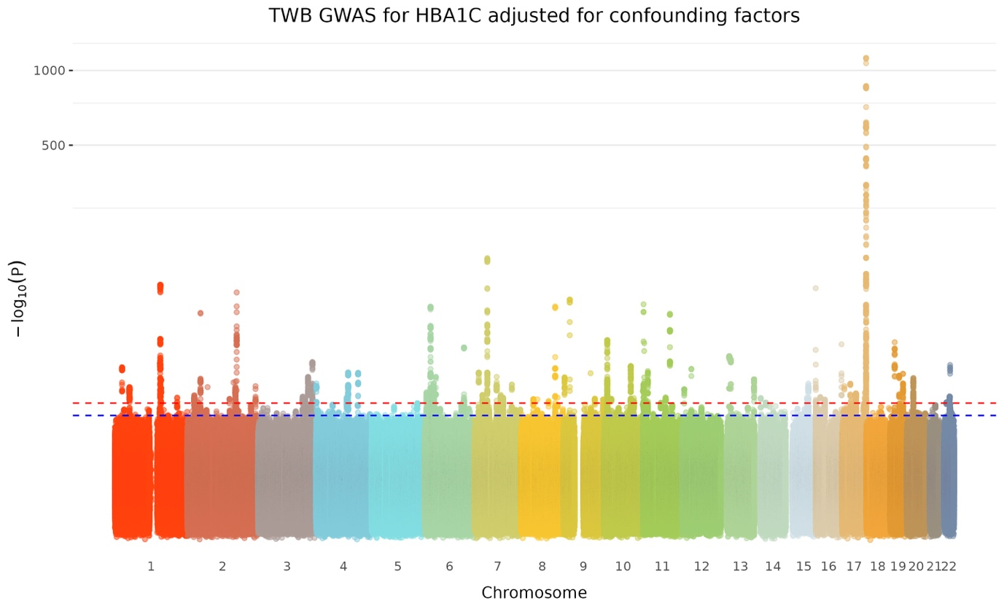Figure S2. Manhattan plot for HBA1C in the TWB cohort adjusting for additional confounding factors. Red horizontal dashed lines indicate the significance threshold (−log10(5×10⁻⁸). Blue horizontal dashed lines indicate suggestive significance threshold (−log10(1×10⁻⁵).
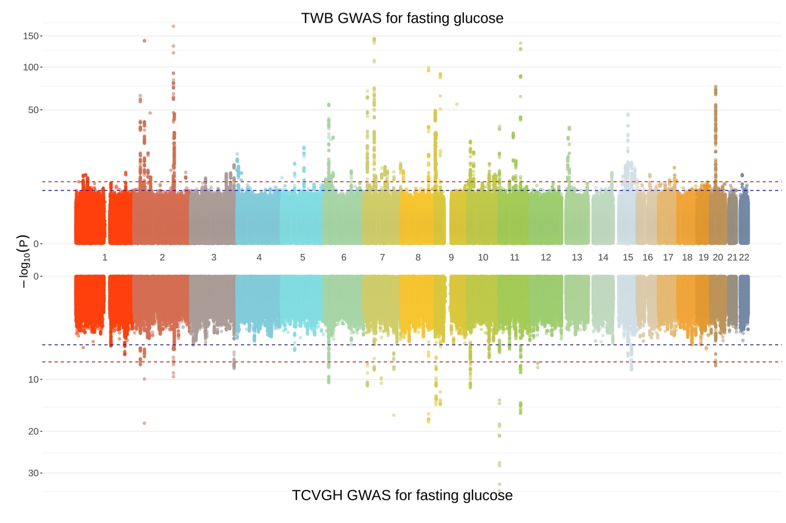Figure S3. Mirror Manhattan plot for fasting glucose in the TWB (top) and TCVGH (bottom) cohorts. Red horizontal dashed lines indicate the significance threshold (−log10(5×10⁻⁸). Blue horizontal dashed lines indicate suggestive significance threshold (−log10(1×10⁻⁵).

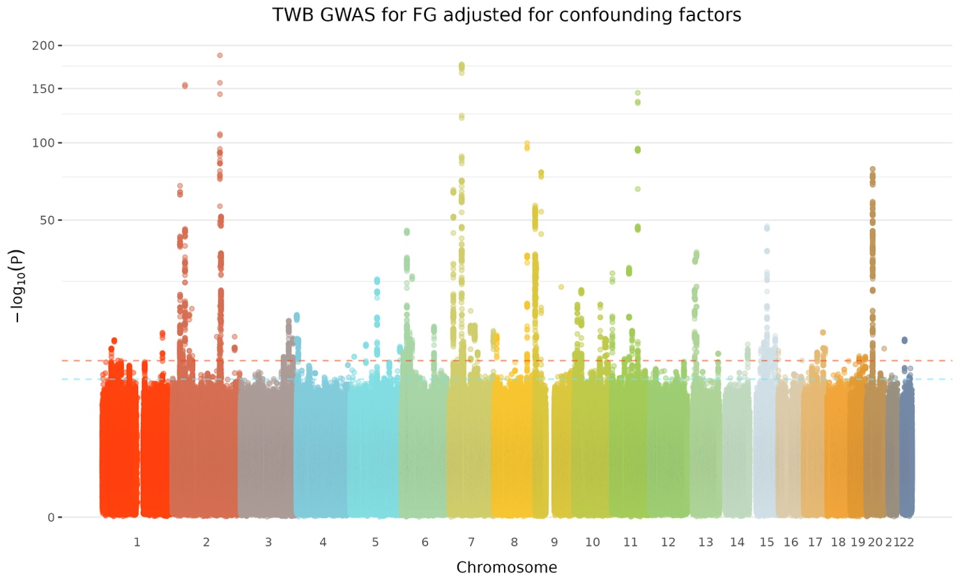Figure S4. Manhattan plot for fasting glucose in the TWB cohort adjusting for additional confounding factors. Red horizontal dashed lines indicate the significance threshold (−log10(5×10⁻⁸). Blue horizontal dashed lines indicate suggestive significance threshold (−log10(1×10⁻⁵).

