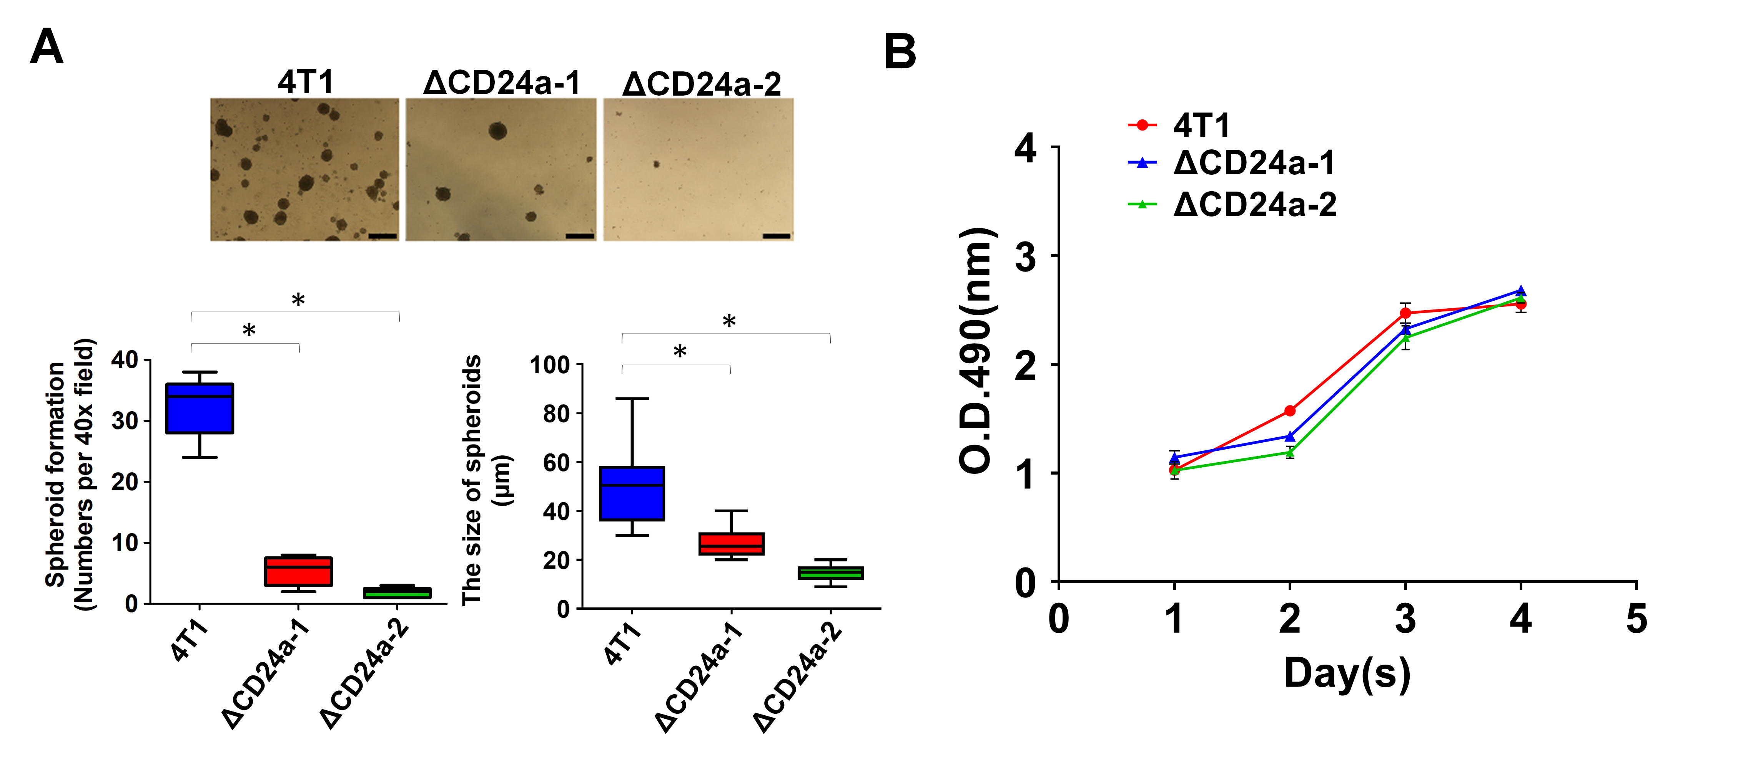
Supplementary Fig. S4. CD24a knockout impairs spheroid formation of 4T1 cells without affecting cell metabolic activity. A, Upper panel. Representative light microscopy images of tumor spheroids formed by 4T1, CD24a-1, and CD24a-2 cells cultured using the spheroid culture protocol. Scale bar: 100 μm. Lower panel. Quantification of the number and size of 4T1, CD24a-1, and CD24a-2 tumor spheroids. * P<0.01 by one-way ANOVA with Tukey’s post-hoc test. B, Analysis of cell metabolic of 4T1 and CD24a knockout cell using MTS assay. Data represent the mean of three independent experiments performed in triplicate.

