Supplementary Information
Dynamic Expression of Complement Receptor Immunoglobulin (CRIg) on Monocytes and its Role in Phagocytosis and Killing of Staphylococcus aureus
Khalida Perveen, Gailin Yang, Cameron D. Skurray, Andy Ngo, Nikki Black, Trishni Putty, Asmitabahen Patel, Annabelle G. Small, Muhammad Y. Gulam, Mihir D. Wechalekar, Timothy Sadlon, Simon C. Barry, Alex Quach, Charles S. Hii and Antonio Ferrante

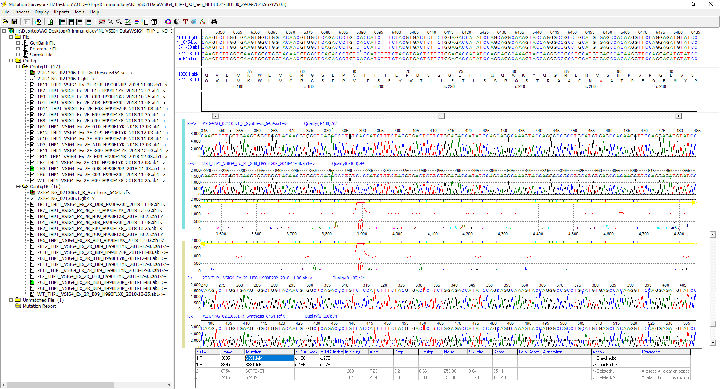
CRIg KO THP-1 ~ VSIG4(NM_007268.3):c.196del, p.(Thr66ProfsTer23)
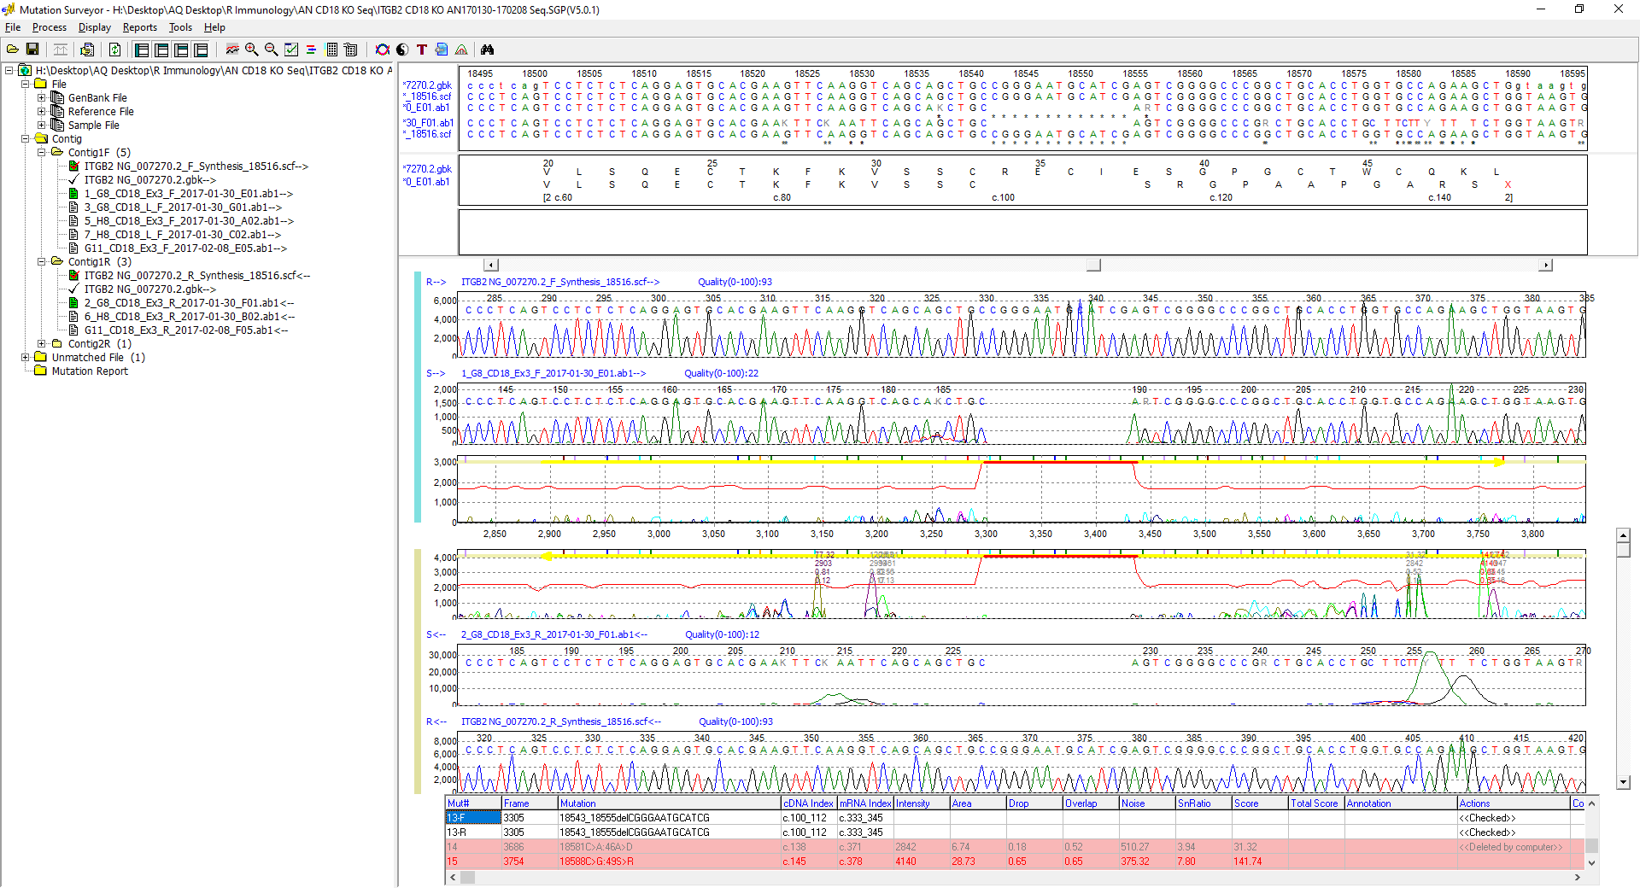
CD18 KO THP-1 ~ ITGB2(NM_001127491.3):c.100_112del, p.(Arg34SerfsTer12)
Fig. S1. Sanger sequencing of the mutated regions of genomic DNA from CRIg and CD18 KO THP-1 cells compared with reference sequences. Related to Fig. 7. Mutations were induced in the VSIG4 gene (RefSeq NG_021306.1, NM_007268.3) exon 2 and ITGB2 gene (RefSeq NG_007270.2, NM_001127491.3) exon 3, respectively.

Fig. S2. Gating strategy for surface CRIg expression. Related to Fig. 1.
Dot plotes shoing the gating of A monoctyes, B whole blood leukocytes and C murine monocyte using whole blood.

Fig. S3. CRIg expression on the monocytic cell lines THP-1/MonoMac-6 (MM-6) and promyeblastoid HL-60 cell line. Related to Fig. 7.
Data from the flow cytometry analyses are presented as Median Fluorescence Intensity (MFI) values and MFI for isotype controls were subtracted from the anti-CRIg values. Measurements were taken from separate cultures and the graph shows mean ± SD of n = 3.

Fig. S4. Effect of protein inhibition on Whole Blood CRIg surface expression.
Samples were treated with various concentrations of puromycin and incubated at 37°C for the indicated time points prior to surface staining with anti-CRIg mAb and analysed via flow cytometry. Statistical significance indicates there is no change in surface CRIg expression at 30m, 1h or 2h at any of the tested concentrations. (n= 5)

Fig. S5. Effect of TNF on Whole Blood CRIg surface expression on human neutrophils.
Whole blood was treated with TNF (50 ng/mL, 20 min, n =5) and CRIg expression by human neutrophils was analysed in whole blood assays.
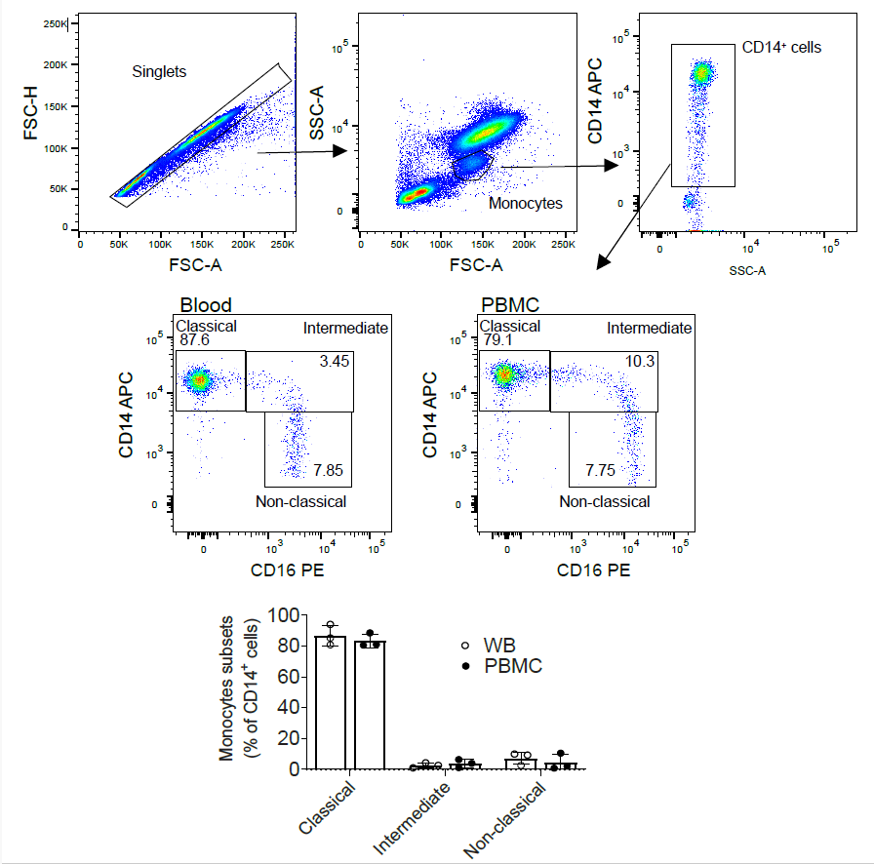
Fig. S6. Gating strategies for monocyte subsets in whole blood assays for CRIg detection. Related to Fig. 3. Whole blood was surface-stained for CD14, CD16, and CRIg and acquired on the flow cytometer. Singlets were gated by FSC-H/FSC-A, and SSC was used to distinguish monocytes, with further gating of CD14⁺ monocytes. Monocyte subpopulations were based on CD14⁺⁺CD16⁻ cells (classical monocytes), CD14⁺⁺CD16⁺ cells (intermediate monocytes) and CD14⁺CD16⁺⁺ cells (non-classical monocytes). Statistical significance indicates there is no change in monocyte subpopulation before or after purification. Measurements were taken from different individuals, and the graph shows the mean ±SD (n=3).
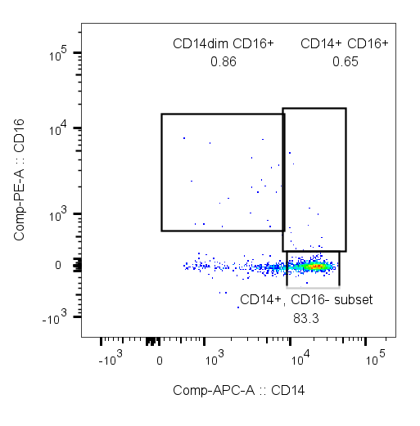
Fig. S7. Cryo-preserved PBMC assay for detection of monocyte subsets. Related to Fig. 3. PBMC were isolated from blood using Fiocol as per method section, cryopreserved and thaw then surface-stained for CD14 and CD16, acquired on the flow cytometer and analysed as per Fig. S6. Representative of two individual samples.

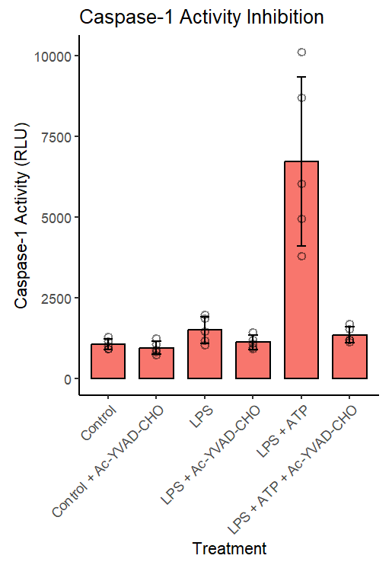
Fig. S8. Inhibition of Caspase-1 activity by Ac-YVAD-CHO treatment. Related to Fig. 5.
Healthy donor PBMCs (1 × 10⁶/mL, n = 5) were cultured with or without LPS (100 ng/mL) for 3h in 96-well flat-bottom plates. This was followed by pulsing with adenosine triphosphate (ATP, 5 mM) for 30 minutes in selected LPS cultures. Subsequently, Caspase-Glo 1 reagent (Promega), with or without the Caspase-1 inhibitor, Ac-YVAD-CHO, was added to the cultures. Relative luminescence units (RLU) were measured using a PerkinElmer Victor X4 multilabel plate reader. The graph shows bars and error bars as mean ± SD.

Table S1. Key Resources Table
REAGENT or RESOURCE | SOURCE | IDENTIFIER
Antibodies
Mouse anti-human Z39Ig (CRIg) antibody (clone 6H8) | Santa Cruz Biotechnology | Cat# sc-53977
Mouse anti-human CRIg (clone 3C9) | Munawara et al.[1] | N/A
Mouse α-mouse CRIg (clone 14G8) | Genentech | N/A
Rat anti-mouse Ly-6G and LY-6C (clone RB6-8C5) | BD Biosciences | Cat# 553127
Anti-CD45 APC-H7 (clone 2D1) | BD Biosciences | Cat# 560178
Anti-CD3 PE-Cy5 (clone UCHT1) | BD Biosciences | Cat# 555334
Anti-CD20 APC (clone L27) | BD Biosciences | Cat# 340941
Anti-CD14 FITC (clone M5E2) | BD Biosciences | Cat# 555397
Anti-CD18 PE (clone 6.7) | BD Biosciences | Cat# 555924
Anti-CD11b PE (clone D12) | BD Biosciences | Cat# 347557
Anti-CD11c FITC (clone B-ly6) | BD Biosciences | Cat# 561355
Mouse IgG1-κ isotype control FITC | BD Biosciences | Cat#556649
Mouse IgG1-κ isotype control PE (clone MOPC-21) | BD Biosciences | Cat# 559320
Mouse monoclonal anti-GAPDH (clone 71.1) | Sigma-Aldrich | Cat# G8795
HRP-conjugated rabbit anti-mouse | Dako | Cat# P0260
Anti-CD16 PE (clone 3G8) | Beckman Coulter | Cat# IM1238U
Anti-CD16 APC (clone RMO52) | Beckman Coulter | Cat# IM2580U
Bacterial and virus strains
Staphylococcus aureus (Oxford strain) | NCTC | Cat# NCTC 6571
pHrodo™ Red S. aureus Bioparticles™ | Thermo Fisher | Cat# A10010
Chemicals, peptides, and recombinant proteins
Recombinant human tumour necrosis factor | ProSpec-Tany Technogene | Cat# CYT-223
Phorbol myristate acetate | Sigma-Aldrich | Cat# P8139
Lipopolysaccharide (Escherichia coli O127:B8) | Sigma-Aldrich | Cat# L4516
Experimental models: Cell lines
Human: THP-1 cell line | ATCC | Cat # TIB-202
Human: HEK293T cell line | ATCC | Cat # CRL-3216
Human: K562 cell line | ATCC | Cat # CCL-243
Human: HL-60 cell line | ATCC | Cat# CCL-240
Human: MonoMac-6 cell line | Cellosaurus | Cat# CVCL_1426
Oligonucleotides
Primers for VSIG4 and ITGB2 see Table S2 | This paper | N/A
Primers for VSIG4 transcript variant see Table S3 | This paper | N/A
Software and algorithms
GraphPad Prism 10 | GraphPad Prism 10 | N/A
FlowJo v10.1 | FlowJo v10.1 | N/A
Mutation Surveyor v4.0.11 | Mutation Surveyor v4.0.11 | N/A
Image Lab™ Software v3.0 | Bio-Rad Laboratories | N/A
Other
Caspase-Glo® 1 Inflammasome Assay | Promega | Cat# G9951
Fluorescein isothiocyanate isomer I (FITC) | Sigma-Aldrich | Cat#F4274

Table S2. Summary of the manually designed primers that amplify the exons targeted by the CRISPR/Cas9 constructs. Related to Fig. 7.
CRISPR/Cas9 Target | Forward Primer | Reverse Primer
VSIG4 Exon 2 | 5’ GCAAAGAGCAAAAGGGCACA 3’ | 5’CTGCCTGTCCACTTCCTCTG 3’
ITGB2 Exon 3 | 5’ GCTGTAGCTGTGCTGTTTCC 3’ | 5’GGAGTTGTTGGTCCTCTGGG 3’
The primers were designed so that the cleavage site is not in the centre of the amplicon and the detection reaction will yield two distinct product bands.

Table S3. Primers specific for each of the six transcript isoforms of the VSIG4 gene. Related to Fig. 6.
VSIG4 transcript variant | Forward primer | Reverse primer
1 | 5’ TTTGTGGTCAAAGACTCCTCAAAGC 3’ | 3’ TGGCATGTGCCCTGGCT 5’
2 | 5’ TGTCCAGAAACACTCCTCAAAGCT 3’ | 3’ TGGCATGTGCCCTGGCT 5’
3 | 5’ TGTCCAGAAACACTCCTCAAAGCT 3’ | 3’ GAGAGACTTTCTTACCTGGCTGCTT 5’
4 | 5’ TTTGTGGTCAAAGACTCCTCAAAGC 3’ | 3’ GAGAGACTTTCTTACCTGGCTGCTT 5’
5 | 5’ TTTGTGGTCAAAGACTCCTCAAAGC 3’ | 3’ GACACTTTGGGCTGGCTGCT 5’
6 | 5’ TGTCCAGAAACACTCCTCAAAGCT 3’ | 3’ GACACTTTGGGCTGGCTGCT 5’
The primer pairings are unique to each transcript isoform and amplify exons 4-7 of each form.

Table S4. Summary of the six predicted human alternatively spliced VSIG4 transcript products, their length in amino acids, and their predicted molecular weight. Related to Fig. 6.
Transcript variant | No. of amino acids | Predicted molecular weight (kDa)
1 – huCRIg(L) | 399 | 44
2 – huCRIg(S) | 305 | 33.9
3 | 227 | 25.4
4 | 321 | 35.6
5 | 347 | 38.2
6 | 253 | 28.08
Adapted from Small A., PhD thesis, University of Adelaide, 2021[2]

References
1. Munawara U, Perveen, K, Small, AG, Putty, T, Quach, A, Gorgani, NN; et al. Human Dendritic Cells Express the Complement Receptor Immunoglobulin Which Regulates T Cell Responses. Front Immunol. 2019;10:2892.
2. Small AG. Complement Receptor Immunoglobulin (CRIg): expression and function in human phagocytes [Thesis]: University of Adelaide; 2021.

