Additional File 1: Online supplement
TDI three dimension scores
FDC 400/12 µg significantly improved TDI three dimension scores (change in functional impairment, change in magnitude of task and change in magnitude of effort) at all time points compared with placebo (all p<0.001) and formoterol (all p<0.05) and at Weeks 12 and 24 compared with aclidinium (all p<0.05).
TDI stratified by GOLD group
Sub-analyses of TDI by GOLD group had low statistical power due to the reduction in patient numbers that is a consequence of stratification; patient numbers were particularly low in GOLD groups A and C (number of patients in the ITT population who had sufficient data for GOLD classification and had TDI data available at Week 24: group A: n=252; group B: n=1258; group C: n=89; group D: n=1117). When TDI data were stratified by GOLD group, FDC 400/12 µg significantly improved TDI focal score compared with placebo in GOLD groups A, B and D, but not group C (Figure S1). FDC 400/12 µg also significantly improved TDI focal score compared with aclidinium monotherapy in GOLD groups A and D (Figure S1).
E-RS domain scores and responders
Over 24 weeks, FDC 400/12 µg significantly improved scores in the E-RS breathlessness, cough and sputum and chest symptoms domains versus placebo (p<0.001; Figure S2). Additionally, E-RS scores in the breathlessness domain were significantly improved with FDC 400/12 µg versus formoterol (p<0.01) and aclidinium (p=0.001), and E-RS scores in the chest symptoms domain were significantly improved versus aclidinium (p<0.05) but not formoterol (Figure S2). A greater number of patients in the FDC 400/12 µg group achieved the proposed MCIDs in the breathlessness, cough and sputum and chest symptoms domains compared with placebo and monotherapy, and FDC 400/12 µg significantly increased the odds of achieving the MCID in each domain versus placebo (Table S1).
Individual night-time and early-morning symptoms, limitation of early-morning activities and nocturnal awakenings
Improvements in individual night-time and early-morning symptoms (cough, wheezing, shortness of breath and difficulty bringing up phlegm) were numerically greater with FDC 400/12 µg compared with each monotherapy, although not all comparisons reached statistical significance (night-time symptoms: p<0.05 vs aclidinium for wheezing and vs both monotherapies for shortness of breath; early-morning symptoms: p<0.05 vs aclidinium for cough and difficulty bringing up phlegm, and vs both monotherapies for wheezing and shortness of breath; no other comparisons reached statistical significance). Improvements in limitation of early-morning activities were significantly greater with FDC 400/12 µg compared with formoterol and aclidinium (both p<0.05) and nocturnal awakenings were significantly improved with FDC 400/12 µg compared with aclidinium (p<0.05) but not formoterol.
Rate of COPD exacerbations, stratified by GOLD group
Similar to the TDI sub-analysis, the analysis of exacerbations stratified by GOLD group had low statistical power due to low patient numbers (number of patients in the ITT-exacerbations population who had sufficient data for GOLD classification: group A: n=306; group B: n=1522; group C: n=99; group D: n=1392). When patients were stratified by GOLD group, the rate of HCRU exacerbations was higher in GOLD groups B (0.28–0.38 exacerbations per patient per year) and D (0.53–0.79 exacerbations per patient per year) compared with A (0.17–0.25 exacerbations per patient per year) and C (0.07–0.23 exacerbations per patient per year). A significant reduction in the rate of HCRU exacerbations of any severity was observed with FDC 400/12 µg versus placebo in GOLD group D (Figure S3A). The rate of EXACT exacerbations was similar in GOLD groups A (0.73–1.55), B (1.11–1.67) and D (1.34–1.56), and lower in GOLD group C (0.49–0.89). FDC 400/12 µg significantly reduced the rate of EXACT exacerbations versus placebo in GOLD groups A and B (Figure S3B). Monotherapy data are presented in Figure S3.
Table S1. E-RS responders
Patients achieving the proposed MCID [1], % | FDC  400/12 µg  (n=720) | Aclidinium  400 µg  (n=722) | Formoterol  12 µg  (n=716) | Placebo  (n=525)
Breathlessness (MCID 1 unit) | 47.0 | 40.4 | 37.9 | 33.2
OR vs placebo | 1.8*** | 1.6** | 1.3
Cough and sputum (MCID 0.7 units) | 41.6 | 36.0 | 34.0 | 30.7
OR vs placebo | 1.6** | 1.2 | 1.2
Chest symptoms (MCID 0.7 units) | 41.9 | 37.7 | 36.1 | 32.6
OR vs placebo | 1.5** | 1.3 | 1.2
Data are for the pooled ITT-exacerbations population
***p<0.001, **p<0.01 vs placebo
COPD, chronic obstructive pulmonary disease; E-RS, EXAcerbations of Chronic pulmonary disease Tool (EXACT)-Respiratory Symptoms questionnaire; FDC, aclidinium/formoterol fixed-dose combination; ITT, intent-to-treat; MCID, minimum clinically important difference; OR, odds ratio; TDI, Transitional Dyspnoea Index

Figure S1. Improvement in TDI at Week 24, stratified by GOLD group
Data are LS means ± SE for the pooled ITT population; ***p<0.001, **p<0.01, *p<0.05 vs placebo, ‡p<0.05 vs aclidinium, ††p<0.01 vs formoterol
FDC, aclidinium/formoterol fixed-dose combination; ITT, intent-to-treat; LS, least squares; MCID, minimum clinically important difference; SE, standard error; TDI, Transition Dyspnoea Index

Figure S2. Change from baseline in E-RS total score and domain scores over 24 weeks
Data are LS means ± SE for the pooled ITT population
E-RS, EXAcerbations of Chronic pulmonary disease Tool (EXACT)-Respiratory Symptoms (E-RS) questionnaire; FDC, aclidinium/formoterol fixed-dose combination; ITT, intent-to-treat; LS, least squares; ns, not significant; SE, standard error

Figure S3. Rate of COPD exacerbations of any severity based on HCRU (A) and EXACT (B) definitions, stratified by GOLD group
Data are LS means and RR (CI) for the pooled ITT exacerbations population; *p<0.05, **p<0.01 vs placebo; ^{ǂ}p<0.05 vs aclidinium
CI, confidence interval; COPD, chronic obstructive pulmonary disease; EXACT; EXAcerbations of Chronic pulmonary disease Tool; FDC, aclidinium/formoterol fixed-dose combination; HCRU, Healthcare Resource Utilisation; ITT, intent-to-treat; LS, least squares; RR, rate ratio

Figure S4. HCRU and EXACT exacerbations, stratified by concomitant ICS use
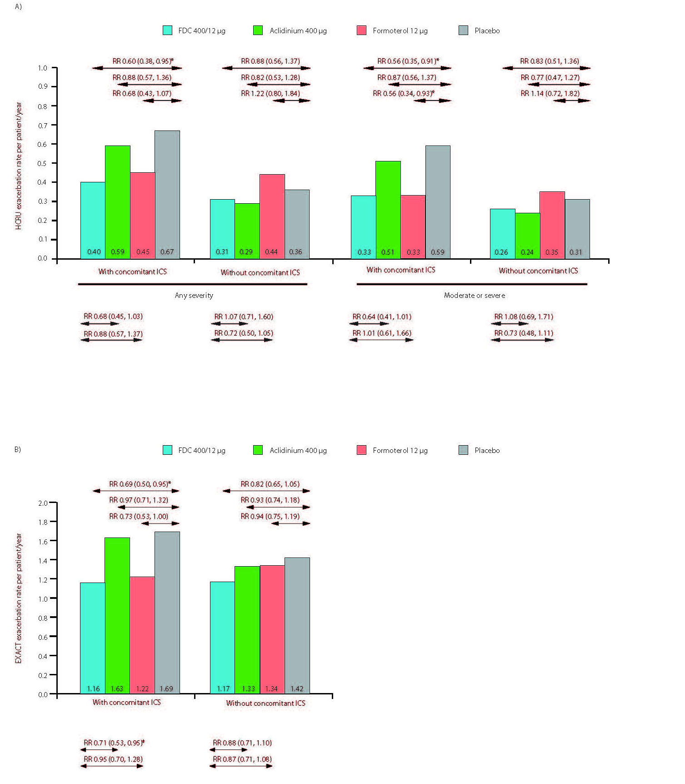
Data are LS means and RR (CI) for the pooled ITT exacerbations population; *p<0.05 vs placebo; ^{ǂ}p<0.05 vs aclidinium
CI, confidence interval; COPD, chronic obstructive pulmonary disease; EXACT, EXAcerbations of Chronic pulmonary disease Tool; FDC, aclidinium/formoterol fixed-dose combination; HCRU, Healthcare Resource Utilisation; ITT, intent-to-treat; LS, least squares; RR, rate ratio

References
1. Leidy NK, Murray LT, Monz BU, Nelsen L, Goldman M, Jones PW et al. Measuring respiratory symptoms of COPD: performance of the EXACT-Respiratory Symptoms Tool (E-RS) in three clinical trials. Respir Res 2014;15:124.

