Figure S1: Scatter plot of ACQ and miniAQLQ scores

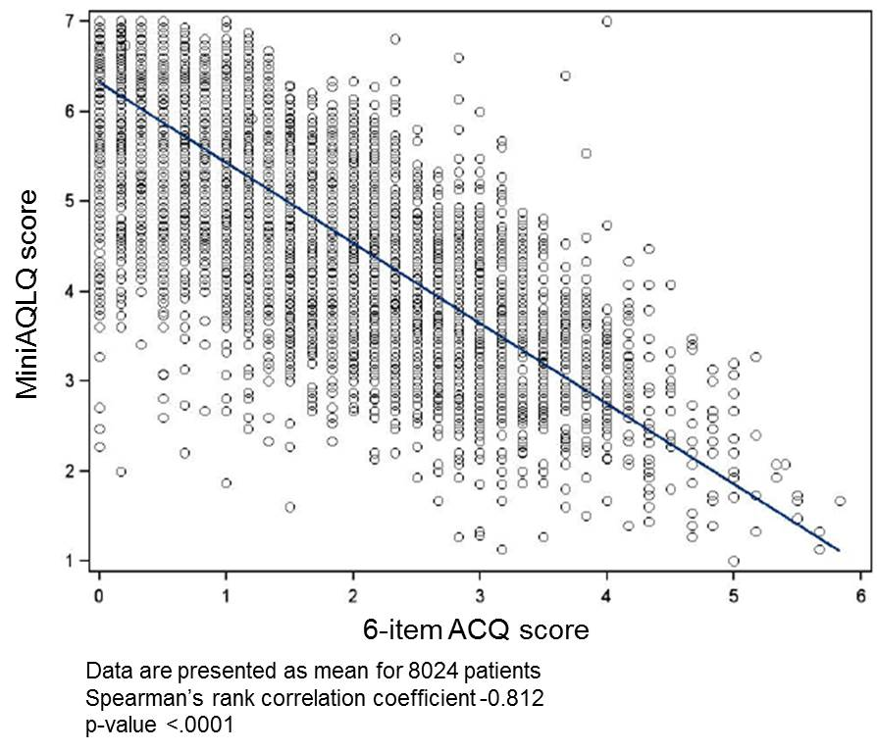

Table S1: Characteristics of asthma
 | Controlled  n=3526 (43.5) | Partly controlled  n=1462 (18.0) | Uncontrolled  n=3123 (38.5) | Overall p-value* | Overall population  n=8111 (100.0)
Age at diagnosis [years], n (%)  Under 18  18-39  40-64  ≥65 | 675 (21.6)  1156 (37.0)  1111 (35.5)  184 (5.9) | 299 (23.0)  475 (36.5)  476 (36.5)  52 (4.0) | 618 (21.9)  912 (32.3)  1145 (40.6)  147 (5.2) | <.001 | 1592 (21.9)  2543 (35.1)  2732 (37.7)  383 (5.3)
Diagnosis of childhood asthmaª, n (%) | 476 (15.2) | 226 (17.4) | 434 (15.4) | 0.178 | 1136 (15.7)
Diagnosis made by:  Respiratory Physician, n (%)  General Practitioner, n (%)  Other specialist, n (%) | 2438 (73.6)  551 (16.6)  323 (9.8) | 931 (68.7)  263 (19.4)  161 (11.9) | 2032 (70.7)  558 (19.5)  285 (9.9) | 0.003 | 5401 (66.6)  1372 (16.9)  769 (9.5)
Investigations made for diagnosis^{b}:  Spirometry, n (%)  Skin test, n (%)  Chest X-ray, n (%)  Peak expiratory flow, n (%)  Challenge test, n (%)  IgE measurements [RAST] , n (%)  FeNO, n (%)  Other, n (%) | 2817 (79.9)  1863 (52.8)  1481 (42.0)  954 (27.1)  783 (22.2)  728 (20.6)  242 (6.9)  115 (3.3) | 1139 (77.9)  742 (50.8)  658 (45.0)  435 (29.8)  237 (16.2)  291 (19.9)  91 (6.2)  43 (2.9) | 2517 (80.6)  1699 (54.4)  1572 (50.3)  769 (24.6)  366 (11.7)  663 (21.2)  120 (3.8)  139 (4.5) | 0.100  0.066  <.001  <.001  <.001  0.580  <.001  - | 6473 (79.8)  4304 (53.1)  3711 (45.8)  2158 (26.6)  1386 (17.1)  1682 (20.7)  453 (5.6)  297 (3.7)
Severity at diagnosis (GINA):  - intermittent, n (%)  - persistent, n (%)  mild  moderate  severe | 973 (33.2)  1959 (66.8)  831 (42.4)  879 (44.9)  249 (12.7) | 390 (32.6)  808 (67.4)  227 (28.1)  452 (55.9)  129 (16.0) | 684 (26.4)  1906 (73.6)  373 (19.6)  1084 (56.9)  449 (23.6) | <.001  <.001 | 2047 (30.5)  4673 (69.5)  1431 (30.6)  2415 (51.7)  827 (17.7)
Current^{c} worst frequency of asthma symptoms:  None  ≤ 2 days/week  > 2 days/week  Everyday | 2019 (57.3)  1304 (37.0)  131 (3.7)  70 (2.0) | 206 (14.1)  718 (49.1)  367 (25.1)  171 (11.7) | 141 (4.5)  775 (24.8)  1042 (33.4)  1165 (37.3) | <.001 | 2366 (29.2)  2797 (34.5)  1540 (19.0)  1406 (17.3)
Current^{c} need of SABA:  None  ≤ 2 days/week  > 2 days/week  Everyday | 2486 (70.5)  858 (24.3)  86 (2.4)  94 (2.7) | 563 (38.5)  517 (35.4)  223 (15.3)  159 (10.9) | 547 (17.5)  692 (22.2)  799 (25.6)  1085 (34.7) | <.001 | 3596 (44.3)  2067 (25.5)  1108 (13.7)  1338 (16.5)
Severe exacerbations^{d}, n (%)  1  2  >2 | 315 (8.9)  78 (2.2)  53 (1.5) | 150 (10.3)  42 (2.9)  37 (2.5) | 425 (13.6)  192 (6.1)  217 (6.9) | <.001 | 890 (11.0)  312 (3.8)  3017 (3.8)
Severe exacerbations^{d}, mean (SD) | 0.19 (0.6) | 0.26 (0.8) | 0.59 (1.4) | <.001 | 0.36 (1.1)
Patients participation in asthma education program:  Yes, last year  Yes, ever  No | 276 (7.8)  755 (21.4)  2495 (70.8) | 140 (9.6)  293 (20.0)  1029 (70.4) | 312 (10.0)  644 (20.6)  2167 (69.4) | 0.028 | 728 (9.0)  1692 (20.9)  5691 (70.1)
Investigators participation in asthma education program:  Yes, last year  Yes, ever  No | 742 (21.1)  1642 (46.6)  1142 (32.4) | 360 (24.6)  596 (40.8)  506 (34.6) | 760 (24.3)  1118 (35.8)  1245 (39.9) | <.001 | 1862 (23.0)  3356 (41.4)  2893 (35.7)
Patients regularly measuring PEF:  Yes  No  Sometimes  Never | 169 (4.8)  1878 (53.3)  330 (9.4)  1149 (32.5) | 75 (5.1)  808 (55.3)  129 (8.8)  450 (30.8) | 158 (5.1)  1770 (56.7)  278 (8.9)  917 (29.4) | 0.133 | 402 (5.0)  4456 (54.9)  737 (9.1)  2516 (31.0)
FeNO: fractional exhaled nitric oxide; GINA: Global Initiative for Asthma; IgE: immunoglobulin E; n: number of patients; PEF: peak expiratory flow; RAST: radioallergosorbent test; SABA: short-acting beta agonist; SD: standard deviation.
ª Age at diagnosis < 12 years
^{b} Patients could have done more than one investigation
^{c} Referred to the last week
^{d} Referred to the last 12 months
* p-value Chi−square for categorical variables and Kruskal-Wallis test for quantitative variables

Table S2: Lung function
 | Controlled  n=3526 | Partly controlled  n=1462 | Uncontrolled  n=3123 | Overall p-value* | Overall population  n=8111
Spirometry within the last 12 weeks, n (%) | 2646 (75.0) | 1095 (74.9) | 2205 (70.6) | <.001 | 5946 (73.3)
PEF [L/sec), mean (SD) | 6.72 (2.23) | 6.20 (2.12) | 5.43 (2.14) | <.001 | 6.13 (2.25)
FEV₁ [L], mean (SD) | 2.77 (0.95) | 2.61 (0.91) | 2.29 (0.94) | <.001 | 2.56 (0.96)
FVC [L], mean (SD) | 3.64 (1.14) | 3.48 (1.12) | 3.12 (1.17) | <.001 | 3.42 (1.17)
FEV₁ [% predicted normal], mean (SD) | 88.04 (19.6) | 82.92 (20.9) | 76.03 (23.6) | <.001 | 82.8 (22.0)
FEV₁/FVC [(%], mean (SD) | 76.15 (10.25) | 74.96 (12.37) | 73.37 (14.42) | <.001 | 74.90 (12.40)
FEV₁: forced expiratory volume in 1 second; FVC: forced vital capacity; L: litre; n: number of patients; PEF: peak expiratory flow; SD: standard deviation.
* p-value based on Chi−square for categorical variables and Kruskal-Wallis test for quantitative variables

Table S3: Propensity to adhere to therapy
 | Controlled  n=3472 | Partly controlled  n=1442 | Uncontrolled  n=3070 | Overall  p-value* | Overall population  n=7984
Morisky score, mean (SD) | 1.03 (1.14) | 1.08 (1.16) | 1.08 (1.22) | 0.417 | 1.06 (1.18)
Adherence level, n (%)  High adherence  Medium adherence  Low adherence | 1541 (44.4)  1479 (42.6)  452 (13.0) | 606 (42.0)  624 (43.3)  212 (14.7) | 1391 (45.3)  1180 (38.4)  499 (16.3) | 0.398 | 3538 (44.3)  3283 (41.1)  1163 (14.6)
n=number of patients; SD=standard deviation
*p−value based on Kruskal−Wallis test and Gamma Test of Monotone Trend

Table S4: Healthcare resources consumption
 | Controlled  n=3524 | Partly controlled  n=1462 | Uncontrolled  n=3122 | Overall  p-value* | Overall population  n=8108
Patients with ER attendanceª, n (%):  None  1  >1 | 136 (3.9)  3388 (96.1)  92 (2.6)  44 (1.2) | 68 (4.7)  1394 (95.3)  49 (3.4)  19 (1.3) | 237 (7.6)  2885 (92.4)  121 (3.9)  116 (3.7) | <.001  <.001 | 441 (5.4)  7667 (94.6)  262 (3.2)  179 (2.2)
Patients with hospitalizationª, n (%):  None  1  >1 | 103 (2.9)  3517 (99.8)  5 (0.1)  2 (0.1) | 43 (2.9)  1459 (99.8)  2 (0.1)  1 (0.1) | 225 (7.2)  3111 (99.6)  6 (0.2)  5 (0.2) | <.001  0.734 | 351 (4.6)  8087 (99.7)  13 (0.2)  8 (0.1)
Days of hospitalization^{a,b}, mean (SD) | 4.3 (5.5) | 4.4 (7.5) | 5.9 (8.2) | 0.031 | 5.3 (7.5)
Number of days^{c} missed from work due to asthma, mean (SD) | 0.16 (1.6) | 0.39 (3.5) | 1.03 (6.5) | <.001 | 0.53 (4.4)
Patients receiving support by the family, n (%) | 1342 (38.5) | 646 (45.0) | 1547 (49.5) | <.001 | 3535 (44.4)
n=number of patients; ER=Emergency Room; SD=standard deviation
ª in the last 12 months
^{b} only patients reporting an hospitalization were considered
^{c} in the last 12 weeks
*p-value based on Chi−square (or Fisher exact test) for categorical variables and Kruskal-Wallis test for quantitative variables

Table S5: Healthcare and economic resources consumption by country
 |  |  | Austria |  | Belgium |  | France |  | Germany |  | Greece |  | Hungary
 |  |  | C | NWC | C | NWC | C | NWC | C | NWC | C | NWC | C |  | NWC
Subjects, n |  |  | 157 | 167 | 190 | 192 | 235 | 618 | 568 | 503 | 120 | 219 | 193 |  | 658
Visits to a respiratory specialistª |  |  | 2.9 (2.5) | 4.0 (4.3) | 2.1 (2.2) | 3.2 (5.2) | 1.2 (1.0) | 1.6 (2.1) | 2.5 (1.8) | 2.5 (1.7) | 4.6 (3.2) | 3.5 (3.3) | 2.3 (1.3) |  | 2.2 (1.5)
p-value* |  |  | 0.078 |  | 0.574 |  | 0.021 |  | 0.846 |  | <0.001 |  | 0.454
Spirometries |  |  | 2.7 (2.4) | 3.9 (3.6) | 1.2 (0.5) | 1.6 (0.9) | 1.4 (0.9) | 1.9 (1.7) | 1.9 (0.9) | 2.0 (1.1) | 3.1 (2.3) | 3.0 (4.3) | 1.8 (1.2) | 2.4 (1.6)
p-value* |  |  | 0.006 |  | <0.001 |  | <0.001 |  | 0.078 |  | <0.001 |  | <0.001
Allergic tests |  |  | 1.1 (0.3) | 1.3 (0.7) | 1.2 (0.6) | 1.2 (0.4) | 2.4 (3.3) | 2.0 (3.0) | 2.5 (5.6) | 2.0 (4.7) | 2.6 (6.4) | 4.4 (7.5) | 1.0 (0.0) | 1.2 (0.4)
p-value* |  |  | 0.027 |  | 0.987 |  | 0.775 |  | 0.422 |  | 0.086 |  | 0.294
Days of hospitalizationª |  |  | 0.1 (0.7) | 1.1 (0.3) | 0.1 (0.8) | 0.6 (3.9) | 0.0 (0.5) | 0.0 (0.4) | 0.0 (0.2) | 0.1 (1.1) | 0.3 (1.8) | 0.8 (2.9) | 0.3 (2.6) | 0.8 (4.6)
p-value* |  |  | 0.653 |  | 0.007 |  | 0.204 |  | 0.135 |  | 0.215 |  | 0.126
Single day/emergency room accessª |  |  | 0.0 (0.1) | 0.0 (0.1) | 0.0 (0.1) | 0.1 (0.4) | 0.0 (0.1) | 0.0 (0.2) | 0.0 (0.1) | 0.0 (0.2) | 0.2 (0.6) | 0.3 (1.0) | 0.0 (0.0) | 0.0 (0.1)
p-value* |  |  | 0.969 |  | 0.001 |  | 0.317 |  | 0.143 |  | 0.616 |  | 0.348
Days missed from work due to asthma^{b} |  |  | 0.1 (0.6) | 0.6 (2.6) | 0.0 (0.4) | 0.7 (3.4) | 0.1 (0.7) | 0.6 (6.5) | 0.0 (0.1) | 0.7 (4.9) | 0.8 (3.6) | 0.9 (3.2) | 0.0 (0.4) | 0.2 (1.8)
p-value* |  |  | 0.014 |  | 0.002 |  | 0.114 |  | <0.001 |  | 0.480 |  | 0.488
Support received by the family, n (%) |  |  | 49 (31.2) | 66 (39.5) | 34 (17.9) | 87 (45.3) | 51 (21.7) | 383 (62.0) | 108 (19.0) | 153 (30.4) | 81 (67.5) | 169 (77.2) | 59 (30.6) | 133 (20.2)
p-value** |  |  | 0.118 |  | <.001 |  | <.001 |  | <.001 |  | 0.053 |  | 0.002
Investigators participation in education programª, n (%) |  |  | 17 (10.8) | 4 (2.4) | 35 (58.3) | 27 (37.0) | 5 (7.1) | 4 (16.7) | 7 (1.3) | 18 (3.6) | 39 (52.7) | 95 (51.4) | 137 (71.7) | 359 (73.3)
p-value** |  |  | 0.002 |  | 0.014 |  | 0.171 |  | 0.011 |  | 0.844 |  | 0.685

 |  | Italy |  | Netherlands |  | Poland |  | Spain |  | Turkey |  | United Kingdom
 |  | C | NWC | C | NWC | C | NWC | C | NWC | C | NWC | C | NWC
Subjects, n |  | 684 | 417 | 73 | 201 | 321 | 716 | 611 | 430 | 215 | 224 | 159 | 240
Visits to a respiratory specialistª |  | 1.5 (1.5) | 2.3 (3.2) | 2.5 (1.7) | 3.3 (2.4) | 1.1 (1.9) | 1.3 (2.3) | 1.8 (1.7) | 2.6 (4.8) | 2.4 (3.3) | 2.8 (3.9) | 0.1 (0.4) | 0.1 (0.7)
p-value* |  | 0.002 |  | 0.005 |  | 0.138 |  | <0.001 |  | 0.303 |  | 0.995
Spirometries |  | 2.9 (4.8) | 2.5 (5.2) | 2.7 (2.4) | 2.7 (2.6) | 1.5 (1.0) | 1.5 (1.0) | 1.3 (0.9) | 1.5 (1.9) | 2.1 (1.80) | 2.1 (2.2) | 1.4 (1.3) | 1.1 (0.5)
p-value* |  | 0.118 |  | 0.451 |  | 0.246 |  | 0.126 |  | 0.256 |  | 0.646
Allergic test |  | 1.1 (0.4) | 1.7 (2.4) | 1.1 (0.4) | 1.2 (0.4) | 2.3 (4.2) | 1.5 (2.1) | 1.0 (0.0) | 1.3 (1.8) | 1.0 (0.1) | 1.1 (0.3) | 0 | 1.7 (1.5)
p-value* |  | 0.093 |  | 0.731 |  | 0.370 |  | 0.333 |  | 0.177 |  | -
Days of hospitalizationª |  | 0.1(0.8) | 0.3 (2.1) | 0.4 (1.4) | 0.6 (2.1) | 0.1 (0.7) | 0.2 (1.5) | 0.3 (1.9) | 0.3 (1.5) | 0.0 (0.2) | 0.3 (1.4) | 0.1 (0.5) | 0.1 (1.1)
p-value* |  | 0.007 |  | 0.341 |  | 0.003 |  | <0.001 |  | <0.001 |  | 0.190
Single day/emergency room accessª |  | 0.0 (0.2) | 0.2 (1.0) | 0.1 (0.2) | 0.1 (0.5) | 0.0 (0.2) | 0.0 (0.2) | 0.2 (0.6) | 0.6 (1.6) | 0.2 (1.0) | 0.9 (2.3) | 0.0 (0.2) | 0.0 (0.3)
p-value* |  | 0.001 |  | 0.355 |  | 0.284 |  | <0.001 |  | <0.001 |  | 0.565
Days missed from work due to asthma^{b} |  | 0.2 (1.5) | 0.9 (4.6) | 0.5 (3.5) | 1.7 (7.6) | 0.1 (1.7) | 0.8 (5.3) | 0.3 (2.3) | 2.1 (11.4) | 0.1 (0.9) | 1.1 (5.1) | 0.1 (0.6) | 0.4 (2.3)
p-value* |  | <0.001 |  | 0.038 |  | <0.001 |  | <0.001 |  | <0.001 |  | 0.016
Support received by the family, n (%) |  | 263 (38.5) | 160(38.4) | 49 (67.1) | 113 (56.2) | 210 (65.4) | 504 (70.4) | 256 (41.9) | 250 (58.1) | 177 (82.3) | 159 (71.0) | 5 (3.1) | 16 (6.7)
p-value** |  | 0.979 |  | 0.053 |  | 0.110 |  | <0.001 |  | 0.005 |  | 0.123
Investigators participation in education programª, n (%) |  | 105 (41.8) | 27 (32.5) | 2 (11.1) | 8 (15.4) | 92 (36.4) | 370 (59.6) | 197 (41.8) | 96 (33.2) | 66 (42.9) | 66 (40.0) | 40 (30.1) | 46 (23.8)
p-value** |  | 0.133 |  | 0.655 |  | <0.001 |  | 0.018 |  | 0.605 |  | 0.209
C: patients with controlled asthma (6-item ACQ score < 1.5); NWC: patients with not well controlled asthma (6-item ACQ <1.5).
n: number of patients. For some variables the n could be slightly different from those reported in the first row because of missingness.
Data are presented as mean (SD) unless otherwise stated;* p-value based on Chi−square test; ** p-value based on Wilcoxon test.
ª in the last 12 months; ^{b} in the last three months

