MICROVASCULAR REACTIVITY IS ALTERED EARLY IN PATIENTS WITH
ACUTE RESPIRATORY DISTRESS SYNDROME
Diego Orbegozo Cortés et al.
Additional file

Additional file Table 1. Main characteristics of ARDS survivors and non-survivors
VARIABLE | SURVIVORS  (n=24) | NON-SURVIVORS  (n=8) | P
Age (years) | 63(44-72) | 63(58-66) | 0.83
Male n(%) | 16(67) | 5(63) | 1.00
Body mass index (Kg/m²) | 25(22-28) | 29(24-31) | 0.15
Sepsis n(%) | 12(50) | 4(50) | 1.00
Primary ARDS n(%) | 9(38) | 0(0) | 0.07
Trauma n(%) | 4(17) | 0(0) | 0.55
Surgery n(%) | 15(62) | 3(38) | 0.25
Chronic lung disease n(%) | 3(13) | 2(25) | 0.58
Mean arterial pressure (mmHg) | 84(80-93) | 75(72-78) | 0.01
Heart rate (bpm) | 99(84-105) | 87(71-96) | 0.08
Temperature (°C) | 37.1(36.6-37.5) | 36.3(34.8-36.7) | 0.02
Inspired O₂ fraction (%) | 50(40-50) | 48(40-80) | 0.72
Respiratory rate (bpm) | 24(18-30) | 22(20-27) | 0.63
Hemoglobin O₂ saturation (%) | 97(95-99) | 97(96-99) | 0.83
Positive end-expiratory pressure (cmH20) | 7(5-8) | 5(5-10) | 0.20
pH | 7.40(7.34-7.46) | 7.38(7.35-7.43) | 0.54
PCO₂ (mmHg) | 38(36-46) | 37(35-43) | 0.56
Lactate (mmol/L) | 1.2(0.8-2.1) | 2.3(1.5-5.6) | 0.04
PaO₂/FiO₂ ratio | 172(126-225) | 191(116-259) | 0.90
Creatinine (mg/dL) | 1.0(0.7-1.4) | 1.5(0.7-2.0) | 0.42
Renal replacement therapy n(%) | 2(8) | 2(25) | 0.25
Total bilirubin (mg/dL) | 0.6(0.5-1.0) | 0.9(0.7-2.4) | 0.22
Platelets (x10³/µL) | 151(91-226) | 102(71-121) | 0.06
Leukocytes (cells x10³/µL) | 13.0(10.5-16.2) | 13.0(7.6-23.6) | 0.70
Hemoglobin (mg/dL) | 9.5(8.9-10.7) | 10.3(9.1-12.8) | 0.27
Sedation n(%) | 12(50) | 7(87) | 0.10
APACHE II score | 21(19-25) | 25(22-33) | 0.07
SOFA score | 8(5-11) | 15(12-16) | <0.01
Norepinephrine (mcg/Kg/min) | 0.00(0.00-0.08) | 0.27(0.03-0.60) | 0.01
Dobutamine (mcg/Kg/min) | 0(0-2) | 3(0-8) | 0.13
Ventilator-free days at 28 days (days) | 24(19-25) | 0(0-0) | <0.01
ICU length of stay (days) | 7.7(5.1-14.0) | 7.3(3.6-11.9) | 0.66

Additional file Table 2. Univariate analysis of variables to predict death or more than 7 days of mechanical ventilation
Variable | OR | 95% CI | P
Age | 0.982 | 0.942-1.025 | 0.41
Primary | 0.733 | 0.156-3.450 | 0.70
Sepsis | 0.605 | 0.150-2.445 | 0.48
PaO₂/FiO₂ ratio | 0.998 | 0.987-1.008 | 0.65
Norepinephrine dose | 27.884 | 0.154-5045.675 | 0.21
Surgical admission | 0.038 | 0.044-0.913 | 0.04
APACHE II score | 1.165 | 0.998-1.361 | 0.05
SOFA score | 1.154 | 0.964-1.383 | 0.12
Asc slope | 0.982 | 0.970-0.995 | 0.01
OR: odds ratio; CI: confidence interval

Additional file Table 3. Multivariable analysis of variables to predict death or more than 7 days of mechanical ventilation
Variable | OR | 95% CI | P
APACHE II score | 1.218 | 0.981-1.551 | 0.07
Asc slope | 0.981 | 0.967-0.996 | 0.01
OR: odds ratio; CI: confidence interval

Additional file Figure 1. Comparison of NIRS Asc slope in different groups of ARDS patients
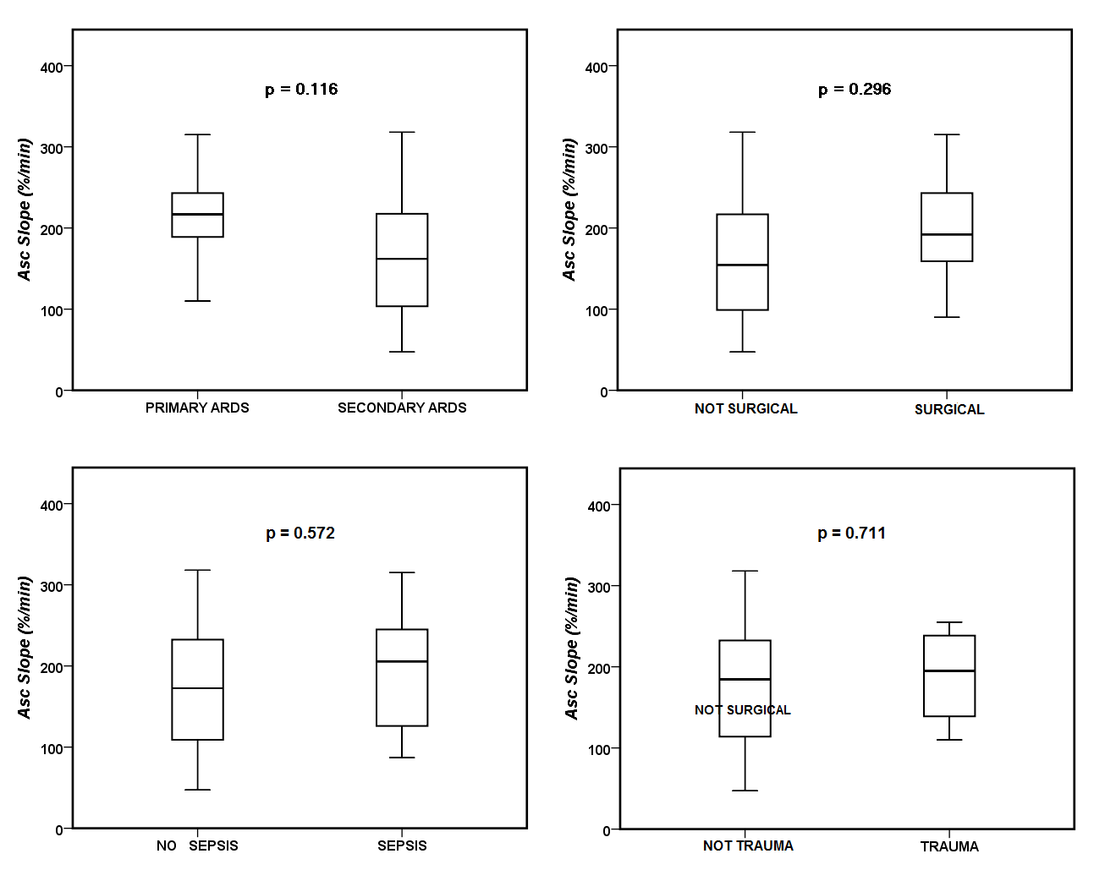

Additional file Figure 2. Comparison of NIRS Asc slope in different groups of ARDS patients according to the presence or not of sepsis and septic shock

