Additional file 1
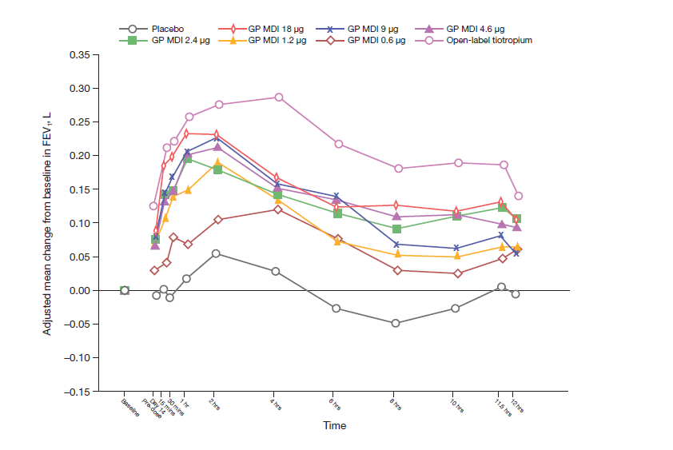
Fig. S1: Adjusted change from baseline in FEV₁ over time on Day 14 (mITT population)
FEV₁ forced expiratory volume in 1 second; GP glycopyrrolate; MDI metered dose inhaler; mITT modified intent-to-treat

Fig. S2: LSM difference in FEV₁ AUC_{0–12} on Day 14, vs placebo MDI (mITT population)
* p < 0.05; ** p < 0.01; *** p < 0.001; † p < 0.0001
AUC_{0–12} area under the curve from 0 to 12 hours; CI confidence interval; FEV₁ forced expiratory volume in 1 second; GP glycopyrrolate; LSM least squares mean; MDI metered dose inhaler; mITT modified intent-to-treat

