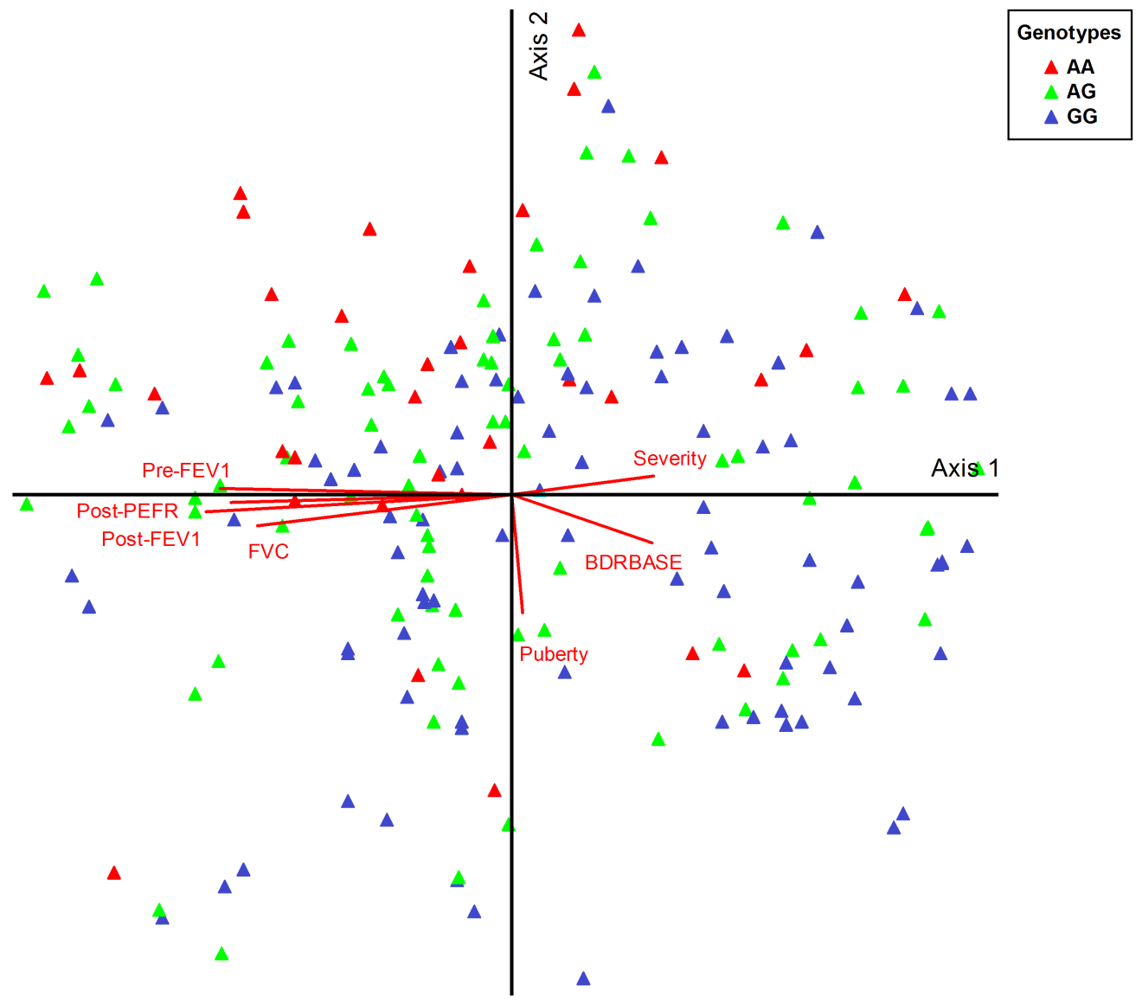
Figure S1. Principal components analysis of asthmatic patients. Ordination plot constructed using 211 patients strand and 20 clinical and laboratory variables. Samples are distributed along two axes. Axis 1 explains 22.6% of variance among patients, whereas axis 2 resolves 11.3% of variance. Samples are scattered and colored according to their genotype; AA (red), AG (green), and GG (blue). PCA did not reveal clustering of patients according to their genotypes.

