 |  |  |  | Table S1; Range of Cytokines and Chemokines for MSD assay
 |  |  |  |  |  | COPDGene |  |  | SPIROMICS
Full name |  | abbreviation | limit of detection (pg/mL) |  | CV% median (IQR) | # below LOD | Median value | # above LOD | # below LOD | Median value | # above LOD
Interleukin-2 |  | IL-2 | 0.09–938 |  | 7 (3 – 12) | 311 | 0.18 | 0 | 84 | 0.27 | 0
Interleukin-6 |  | IL-6 | 0.06–488 |  | 5 (2 – 8) | 1 | 1.78 | 1 | 0 | 1.06 | 0
Interleukin-8 |  | IL-8 | 0.04–375 |  | 4 (1 – 5) | 0 | 13.53 | 1 | 0 | 5.16 | 0
Interleukin-10 |  | IL-10 | 0.03–233 |  | 5 (2 – 9) | 0 | 1.31 | 0 | 0 | 0.36 | 0
tumor necrosis factor-α |  | TNFα | 0.05–458 |  | 5 (2 – 8) | 0 | 10.04 | 0 | 0 | 2.29 | 0
Interferon gamma |  | IFNγ | 0.20–938 |  | 4 (2 – 8) | 1 | 4.11 | 0 | 0 | 4.61 | 1
Eotaxin |  | eotaxin | 3.26–1120 |  | 10 (3-33) | 2 | 80.03 | 0 | 0 | 83.43 | 0
C-C motif chemokine 17 |  | CCL17 | 0.22–1120 |  | 16 (8-30) | 1 | 52.34 | 10 | 0 | 56.95 | 0
C-C motif chemokine 26 |  | CCL26 | 1.77–3750 |  | 11 (3-25) | 11 | 8.38 | 6 | 3 | 10.38 | 0

Table S2: Regression Models and Covariates for each Phenotype
Phenotype | Outcome |  | Regression model | Age | Gender | Race | Smoking  (current or former) | ATS Pack Years | Height | Height² | Age² | FEV₁% | BMI | Previous COPD Exacerbations | SGRQ | CT scanner
Spirometry | FEV₁% |  | Linear
 | FEV₁/FVC |  | Linear | X | X
 | FEV1 ml/yr |  | Mixed | X | X |  | X | X |  | X | X | X
CT | Emphysema severity (LAA%) |  | Beta |  |  |  |  |  |  |  |  |  | X |  |  | X
 | Emphysema progression (adjusted lung density) |  | Mixed | X | X |  |  | X |  | X | X | X | X | X | X
Clinical | Chronic Bronchitis |  | logistic | X | X |  |  | X | X |  |  |  |  | X
 | Exacerbations |  | Negative binomial with zero inflation |  | X |  |  |  |  |  |  | X |  | X | X

Table S3: Biomarkers associated with age
 |  | COPDGene |  |  | SPIROMICS
biomarker | ß | sd | P | ß | sd | P
Eotaxin | 0.002 | 0.000 | < 10⁻⁷ | 0.003 | 0.001 | < 10⁻⁵
CCL26 | 0.000 | 0.001 | 0.8234 | 0.000 | 0.001 | 0.8558
CCL17 | -0.001 | 0.001 | 0.2967 | 0.000 | 0.001 | 0.6724
IFN-γ | 0.003 | 0.001 | 0.0001 | 0.004 | 0.001 | 0.0005
IL10 | 0.000 | 0.001 | 0.8799 | 0.002 | 0.001 | 0.0894
IL2 | 0.005 | 0.001 | < 10⁻⁴ | 0.003 | 0.001 | 0.0036
IL6 | 0.003 | 0.001 | 0.0006 | 0.003 | 0.001 | 0.0003
IL8 | 0.002 | 0.001 | 0.0160 | 0.003 | 0.001 | 0.0005
TNF-α | 0.002 | 0.001 | 0.0107 | 0.004 | 0.001 | < 10⁻⁹

Table S4: Biomarkers associated with female gender
 |  | COPDGene |  |  | SPIROMICS
biomarker | ß | sd | P | ß | sd | P
Eotaxin | -0.025 | 0.008 | 0.0014 | -0.023 | 0.011 | 0.0387
CCL26 | -0.088 | 0.017 | < 10⁻⁶ | -0.128 | 0.025 | < 10⁻⁶
CCL17 | -0.019 | 0.017 | 0.2748 | -0.015 | 0.019 | 0.4375
IFN-γ | 0.029 | 0.014 | 0.0459 | 0.023 | 0.020 | 0.2456
IL10 | -0.035 | 0.016 | 0.0304 | -0.031 | 0.017 | 0.0678
IL2 | -0.044 | 0.019 | 0.0206 | -0.070 | 0.021 | 0.0008
IL6 | -0.004 | 0.015 | 0.7692 | -0.019 | 0.017 | 0.2706
IL8 | 0.001 | 0.013 | 0.9661 | -0.004 | 0.014 | 0.7949
TNF-α | 0.007 | 0.012 | 0.5776 | 0.012 | 0.011 | 0.2638

Table S5: Biomarkers associated with BMI
 |  | COPDGene |  |  | SPIROMICS
biomarker | ß | sd | P | ß | sd | P
Eotaxin | -0.005 | 0.001 | < 10⁻¹⁴ | -0.006 | 0.001 | < 10⁻¹⁸
CCL26 | 0.003 | 0.001 | 0.0377 | 0.001 | 0.002 | 0.5882
CCL17 | -0.002 | 0.001 | 0.0791 | -0.004 | 0.002 | 0.0252
IFN-γ | -0.001 | 0.001 | 0.2626 | 0.003 | 0.002 | 0.1345
IL10 | -0.003 | 0.001 | 0.0418 | 0.000 | 0.002 | 0.8097
IL2 | -0.002 | 0.002 | 0.1026 | 0.003 | 0.002 | 0.1636
IL6 | 0.008 | 0.001 | < 10⁻⁶ | 0.007 | 0.002 | < 10⁻⁵
IL8 | -0.003 | 0.001 | 0.0018 | -0.002 | 0.001 | 0.1485
TNF-α | 0.001 | 0.001 | 0.4663 | 0.004 | 0.001 | 0.0001

Table S6: Biomarkers associated with current smoking
 |  | COPDGene |  |  | SPIROMICS
biomarker | ß | sd | P | ß | sd | P
Eotaxin | 0.014 | 0.008 | 0.0853 | 0.028 | 0.011 | 0.0108
CCL26 | -0.001 | 0.018 | 0.9620 | 0.067 | 0.026 | 0.0109
CCL17 | 0.106 | 0.018 | < 10⁻⁸ | 0.088 | 0.019 | < 10⁻⁵
IFN-γ | -0.074 | 0.015 | < 10⁻⁵ | -0.098 | 0.020 | < 10⁻⁵
IL10 | -0.001 | 0.017 | 0.9637 | -0.060 | 0.017 | 0.0005
IL2 | -0.098 | 0.020 | < 10⁻⁵ | -0.124 | 0.021 | < 10⁻⁸
IL6 | 0.050 | 0.016 | 0.0020 | -0.037 | 0.017 | 0.0347
IL8 | 0.023 | 0.014 | 0.0962 | -0.016 | 0.014 | 0.2592
TNF-α | 0.032 | 0.013 | 0.0127 | -0.044 | 0.011 | 0.0001

Table S7: Biomarkers associated with FEV₁/FVC
 |  | COPDGene |  |  | SPIROMICS |  | Combined
biomarker | ß | R²_{(adj)} | P | ß | R²_{(adj)} | P | P
Eotaxin | -0.360 | 0.009 | < 10⁻⁵ | -0.599 | 0.024 | 0.0000 | < 10⁻⁶
IL6 | -0.208 | 0.013 | < 10⁻⁶ | -0.376 | 0.025 | 0.0000 | < 10⁻⁶
R²_{(adj)} is the partial amount of additional variance explained by the biomarker in models with clinical covariates

Table S8: Amount of variance explained by biomarker and clinical covariate alone and in combination
 |  | COPDGene |  |  |  |  | SPIROMICS
Outcome | Biomarker |  | Biomarker alone | Clinical Covariates | Biomarker + clinical covariates | Biomarker alone |  | Clinical Covariates | Biomarker + clinical covariates
FEV₁% | eotaxin |  | 0.007 | NA | NA | 0.039 |  | NA | NA
FEV₁% | IL2 |  | 0.002 | NA | NA | 0.007 |  | NA | NA
FEV₁% | IL6 |  | 0.049 | NA | NA | 0.042 |  | NA | NA
FEV₁% | IL8 |  | 0.002 | NA | NA | 0.005 |  | NA | NA
FEV₁/FVC | eotaxin |  | 0.020 | 0.145 | 0.154 | 0.037 |  | 0.086 | 0.110
FEV₁/FVC | IL6 |  | 0.022 | 0.145 | 0.158 | 0.032 |  | 0.086 | 0.111
Decline FEV₁ | IL6 |  | 0.058 | 0.330 | 0.360 | 0.044 |  | 0.262 | 0.297
Emphysema Progression | IL6 |  | 0.002 | 0.380 | 0.380 | unavailable |  | unavailable | unavailable
Emphysema Progression | IL8 |  | 0.000 | 0.380 | 0.379 | unavailable |  | unavailable | unavailable
Note that different methods are used to estimate explanation of variance for each statistical model and inter-model estimates should not be made; see methods for details; NA – not applicable since FEV₁%already contains clinical covariates.

Table S9: Biomarkers associated with decline in FEV₁ (ml/yr) for all subjects
 |  | COPDGene |  |  | SPIROMICS |  | Combined
biomarker | ß | R²_{(mod)} | P | ß | R²_{(adj)} | P | P
none |  | 0.330 |  |  | 0.262
Eotaxin | -0.013 | 0.331 | 0.0528 | 0.004 | 0.277 | 0.8471 | 0.126
IL6 | -0.007 | 0.360 | 0.0263 | 0.021 | 0.297 | 0.1573 | 0.260
R²_{(mod)} is the amount of variance explained by the mixed model with clinical covariates

Table S10: Biomarkers associated with decline in FEV₁ (ml/yr) by COPD or no COPD in COPDGene subjects
 | No COPD |  |  | COPD
biomarker | ß | R²_{(mod)} | P | ß | R²_{(adj)} | P
none |  | 0.519 |  |  | 0.258
Eotaxin | 0.005 | 0.519 | 0.5353 | -0.023 | 0.259 | 0.0199
CCL26 | 0.006 | 0.517 | 0.1357 | 0.001 | 0.257 | 0.7354
CCL17 | 0.002 | 0.522 | 0.6090 | 0.000 | 0.257 | 0.9441
IFN-γ | -0.009 | 0.519 | 0.0497 | 0.001 | 0.257 | 0.8924
IL10 | 0.000 | 0.521 | 0.9285 | -0.009 | 0.262 | 0.0861
IL2 | 0.001 | 0.513 | 0.6951 | -0.010 | 0.251 | 0.0425
IL6 | -0.005 | 0.543 | 0.2963 | -0.007 | 0.271 | 0.2268
IL8 | 0.000 | 0.520 | 0.9512 | -0.012 | 0.260 | 0.0619
TNF-α | -0.002 | 0.525 | 0.6849 | -0.007 | 0.259 | 0.3259
R²_{(mod)} is the amount of variance explained by the mixed model with clinical covariates; COPD includes GOLD 1-4; non-COPD all others

Figure S1: Subtyping of subjects based on airflow obstruction (FEV₁/FVC) and emphysema severity (LAA% < -950 HU). The vertical line represents the cutoff for COPD (post-bronchodilator FEV₁/FVC < 0.7). The horizontal line represents the cutoff for emphysema (LAA > 5%). Subjects with chronic bronchitis are shown by red cross and those without a blue circle. The upper panel shows those included in analysis and the lower panels show the whole cohort for COPDGene (left) and SPIROMICS (right).
Whole Cohrot
Analysis subset
SPIROMICS
COPDGene

Figure S2: Histograms of chemokines and cytokines in COPDGene and SPIROMICS (log10 transformed). Units are pg/ml

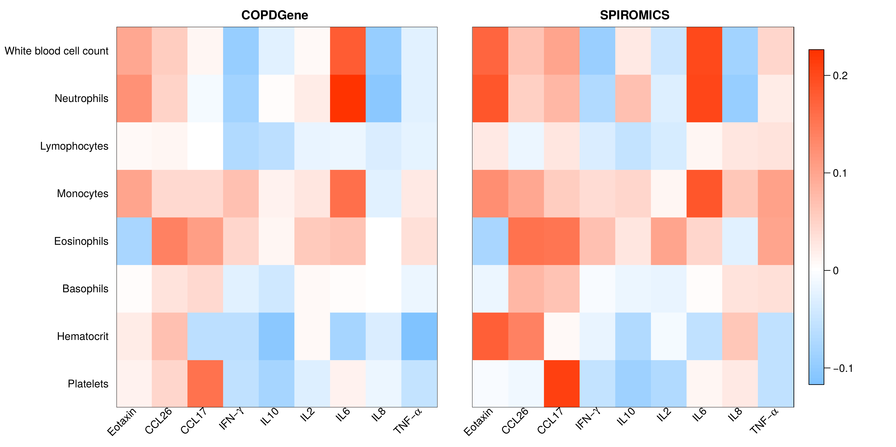
Figure S3. Pearson correlations between cytokines/chemokines and cell counts in COPDGene and SPIROMICS. Red squares are positive correlation coefficients and blue negative correlation coefficients with P <0.05. Cell counts were obtained by automated complete blood cell counts. The shading of each cell represents the correlation coefficient as indicated in the legend.

Figure S4: Combined Manhattan plots for all 9 biomarker-genotype associations in non-Hispanic White subjects from the COPDGene cohort \. The redline represents genome wide significance level adjusted for multiple testing (P < 10⁻⁹). Results for all 9 biomarkers are superimposed on the graph. Only one SNP was significantly associated with a biomarker (rs9302690 in CCL17; P = 10⁻¹¹).
CCL17

Figure S5: Beeswarm of plasma CCL17 measurements by rs9302690 genotype in the non-Hispanic White subjects in the COPDGene cohort. Subjects with the minor allele had significantly higher levels of CCL17 (P < 10⁻¹¹). Boxplots indicate 25th, 50th, and 75th percentiles.

