Title: Circulating MicroRNAs and Prediction of Asthma Exacerbation in Childhood Asthma

ONLINE SUPPLEMENTARY MATERIALS

e-Table 1: Asthma Exacerbation Clinical Score

Reported asthma symptoms
- Symptoms for >= 3 months of the year (1 point)
Question 81 on Baseline Asthma and Allergy History. If symptoms were present for >= 3 months, one point awarded.
- Symptoms precipitated by colds, cold air, exercise, dust (1 point each)
Each Variable (Question 43, 46, 39, and 36, respectively) was coded from 0-3 with 0 meaning “never causes asthma” to 3 “always or almost always causes asthma. One point was awarded if the answer was 1,2, or 3.

Current Asthma Medications
- Short-acting B2 agonist (1 point each)
Question 24: Variable was coded from 1-5 with 4-5 meaning less than once per week and never, respectively. No point was awarded if scored as 4 or 5.
- Inhaled steroids (1 point each)
Question 20: In the last 6 months how often has your child used ICS for asthma? As with question 24, no point was awarded if scored as 4 or 5 (less than once per week and never, respectively)
- Leukotriene inhibitors (1 point each)
The CAMP trial did not use LTM.

Healthcare utilization
- Ever hospitalized for asthma (1 point)
Question 16: If the answer was (yes/1), 1 point awarded.
- Ever admitted to ICU for asthma (1 point)
Question 20: If the answer was (yes/1), 1 point awarded.
- = 2 courses of steroids last year (1 point)
Question 30: Referred to >= 2 courses of steroid in 6 months rather than 1 year. Most subjects did not require steroid therapy. If the answer was >=2, 1 point was awarded.
- = 2 ER visits for asthma last year
Question 21: If there was >=2 ER visits in a year, 1 point was awarded
- Doctor visits last year - 3 or more (1 point)
Question 22
- Doctor visits last year - 6 or more (1 point)
Question 22

Medical History
- Personal history of eczema/hay fever (1 point)
Questions 92 and 96
- Parental history of asthma or atopy (1 point)
Derived from parental history data – father and mother self-reported status was utilized

- Smoke exposure as infant or current (1 point)
Derived from parental history data – father and mother self-reported status was utilized

Total Score
- Low risk (score ≤ 5)
- Intermediate or average risk (score 6-8)
- High risk (score ≥ 9)

e-Table 2: Cross-validation (10-fold) of AUROC (all data)
 | miR-clinical model | miR model | Clinical model
cvAUROC | 0·74 | 0·66 | 0·66
95 % CI | 0·66 – 0·82 | 0·57 – 0·75 | 0·56 – 0·75

e-Table 3: DAVID Biocarta Pathway Analysis
Pathway | Gene Count | P-value | Corrected P-value^
Inactivation of Gsk3 by AKT causes accumulation of b-catenin in Alveolar Macrophages | 5 | 2·4x10⁻⁴ | 1·7x10⁻²
Influence of Ras and Rho proteins on G1 to S Transition | 4 | 3·9x10⁻³ | 6·5x10⁻²
Cyclins and Cell Cycle Regulation | 4 | 3·1x10⁻³ | 8·0x10⁻²
NF-κβ Signaling Pathway | 4 | 2·3x10⁻³ | 8·0x10⁻²
^ Benjamini-Hochberg correction

e-Table 4: Top DAVID GOTERM_BP DIRECT

Term | Gene Count | Percentage of Genes | P-value | Corrected P-value^
Positive regulation of fibroblast proliferation | 4 | 12·9 | 1·2x10⁻⁴ | 1·5x10⁻²
Positive regulation of phospholipase C activity | 3 | 9·7 | 1·1x10⁻⁴ | 1·8x10⁻²
Pentose-phosphate shunt | 3 | 9·7 | 1·7x10⁻⁴ | 1·8x10⁻²
Positive Regulation of gene expression | 6 | 19·4 | 9·2x10⁻⁵ | 2·0x10⁻²
Negative regulation of transcription from RNA polymerase II promoter | 8 | 25·8 | 2·2x10⁻⁴ | 2·0x10⁻²
^ Benjamini-Hochberg correction

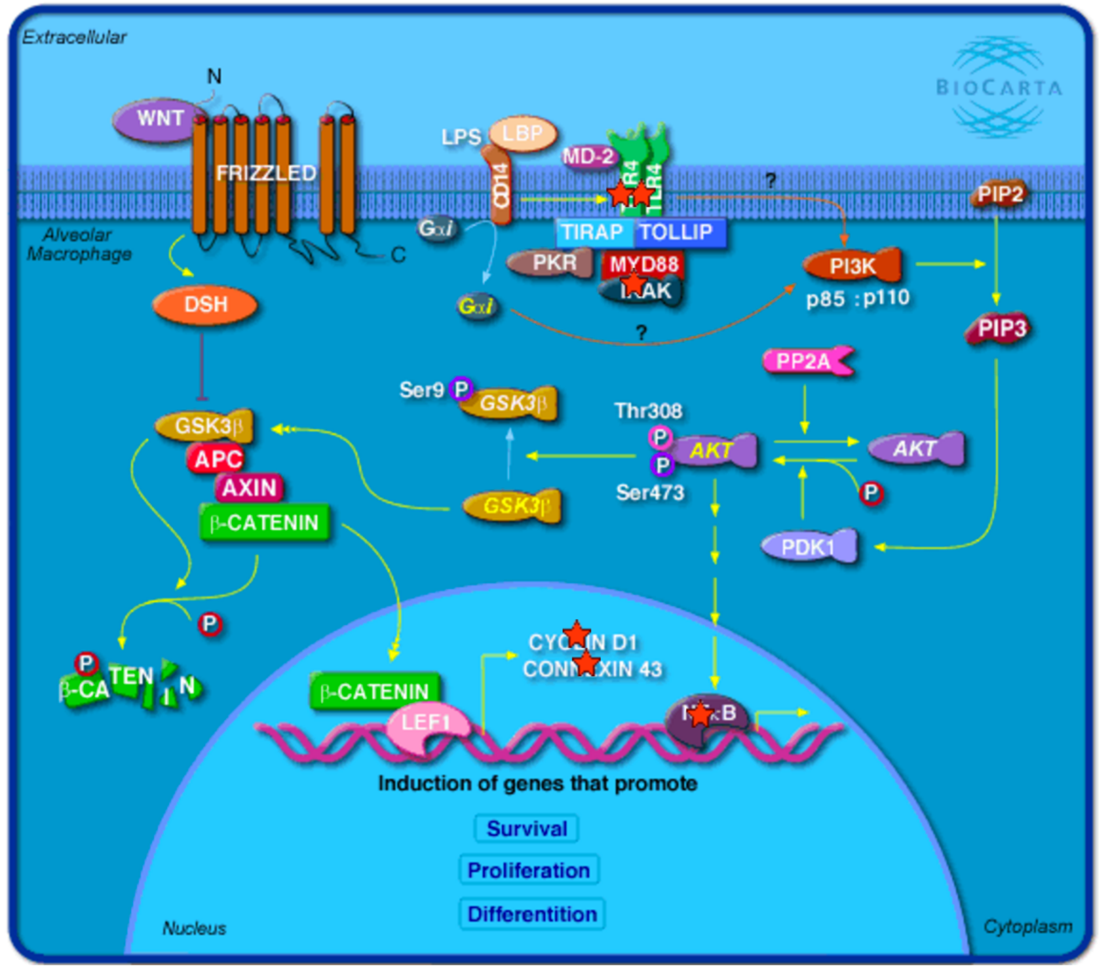

e-Figure 1: DAVID (Database from Annotation, Visualization, and Integrated Discovery) Biocarta Pathway analysis - Inactivation of GSK3 by AKT causes accumulation of b-catenin in alveolar macrophages. miRTarBase 6.0 was used to determine experimentally validated microRNA-target interactions with genes. The gene list was subsequently used for pathway analysis. The genes marked with the red star are targeted by the microRNA.

References
1. The Childhood Asthma Management Program (CAMP): design, rationale, and methods. Childhood Asthma Management Program Research Group. Controlled clinical trials. 1999;20(1):91-120.

