Additional file 2
Table S1 Patient demographics and baseline characteristics (ECLIPSE study)
 | CID+ population  (N=1442) | CID- population  (N=531) | Total  (N=1973)
Age (years) mean (SD) | 63.5 (6.99) | 63.0 (7.18) | 63.4 (7.04)
Male, n (%) | 923 (64) | 361 (68) | 1284 (65)
BMI, kg/m², mean (SD) | 26.4 (5.5) | 27.1 (6.1) | 26.6 (5.7)
Current smoker at screening, n (%) | 511 (35) | 194 (37) | 705 (36)
Post-bronchodilator % predicted FEV₁, mean (SD) | 47.7 (15.7) | 51.2 (15.4) | 48.7 (15.7)
ICS users at screening, n (%) | 1122 (78) | 324 (61) | 1446 (73)
Previous exacerbations (%)
0 | 657 (46) | 383 (72) | 1040 (53)
1 | 404 (28) | 99 (19) | 503 (25)
2 | 215 (15) | 29 (5) | 244 (12)
≥3 | 166 (12) | 20 (4) | 186 (9)

BMI, body mass index; CID, clinically important deterioration; CID+, presence of a CID within 6 months of enrollment into the study; CID-, absence of a CID within 6 months of enrollment into the study; ECLIPSE, Evaluation of COPD Longitudinally to Identify Predictive Surrogate End-points; FEV₁, forced expiratory volume in 1 second; ICS, inhaled corticosteroid; SD, standard deviation

Table S2 Long-term outcomes based on single-component short-term CIDs (TORCH study; ITT population)
 | Short-term CID type (in first 6 months) CID+ vs CID- status
Outcome after 36 months | Composite CID | FEV₁ CID only | SGRQ CID only | Exacerbation CID only
Change in FEV₁/mLª | -117 (-134, -100)* | -193 (-213, -172)* | -51 (-74, -27)* | -38 (-57, -20)*
Change in SGRQ score/SGRQ unitsª | +6.42 (5.40, 7.45)* | +3.56 (2.31, 4.80)* | +10.14 (8.91, 11.38)* | +3.70 (2.56, 4.83)*
Change in exacerbation rate^{b} | 1.61 (1.50, 1.72)* | 1.02 (0.95, 1.11) | 1.12 (1.02, 1.22)† | 2.21 (2.06, 2.36)*
*P < 0.001; †P < 0.05
ªLS mean (95% CI) change from baseline at 36 months; ^{b}HR (95% CI) for exacerbations 6–36 months from randomization.
CI, confidence interval; CID, clinically important deterioration; CID+, presence of a CID within 6 months of enrollment into the study; CID-, absence of a CID within 6 months of enrollment into the study; COPD, chronic obstructive pulmonary disease; FEV₁, forced expiratory volume in 1 second; ITT, intent-to-treat; SGRQ, St George’s Respiratory Questionnaire; TORCH, Towards a Revolution in COPD Health

Figure S1 Proportions of patients experiencing CIDs in the ECLIPSE study
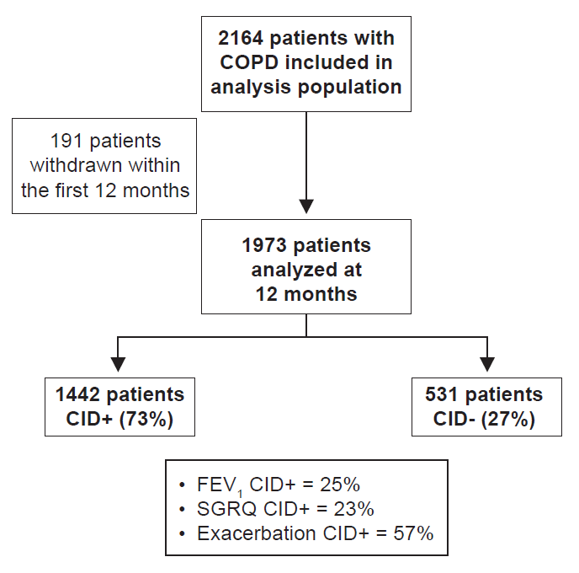 CID, clinically important deterioration; CID+, presence of a CID within 12 months of enrollment into the study; CID-, absence of a CID within 12 months of enrollment into the study; COPD, chronic obstructive pulmonary disease; ECLIPSE, Evaluation of COPD Longitudinally to Identify Predictive Surrogate End-points; FEV₁, forced expiratory volume in 1 second; SGRQ, St George’s Respiratory Questionnaire

