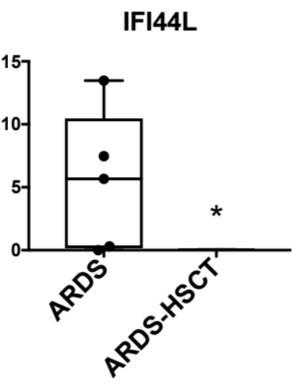
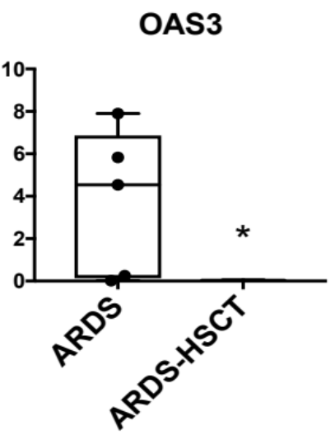
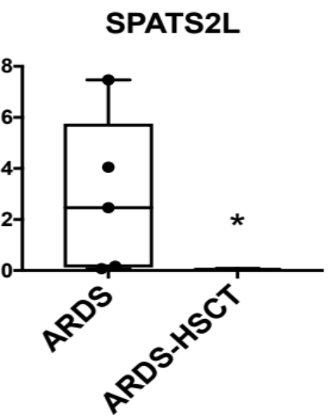
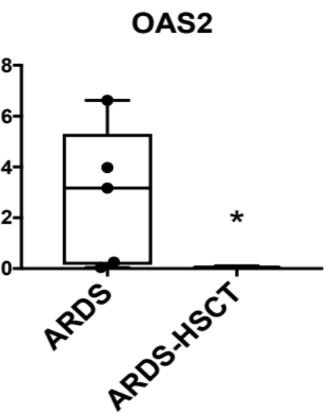
A
B
C
D
Figure 3. Transcript levels of several of the most differentially expressed genes were measured by qPCR to confirm changes found by RNA-seq. n=3/group, *p<0.05 vs ARDS by unpaired T-test.

Additional file 2: Figure S1. Transcript levels of several of the most differentially expressed genes were measured by qPCR to confirm changes found by RNA-seq. n=3/group, *p<0.05 vs ARDS by unpaired t-test.

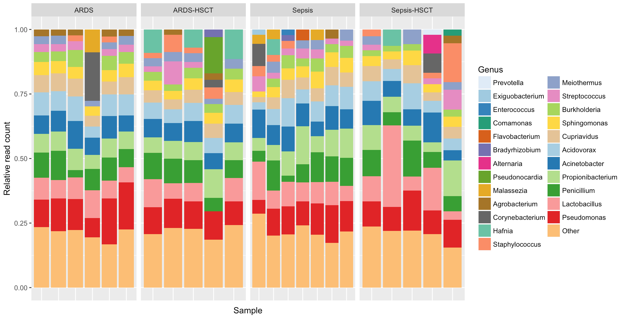

Additional file 2: Figure S2. Taxonomic classification of unmapped reads within each patient sample after human read removal. Relative read count indicates the fraction of reads belonging to a given genus out of all reads classified to at least genus-level specificity. Genera with minimum read fraction of 2% within a sample are displayed (otherwise collapsed into “Other”). No dramatic classwise differences are observed, and the lack of a recurrent abundant pathogen unique to ARDS-SCT patients suggests that undiagnosed bloodstream infection is an unlikely cause of ARDS in these SCT patients.

