Additional file 1: TDI focal score profile (ITT population)
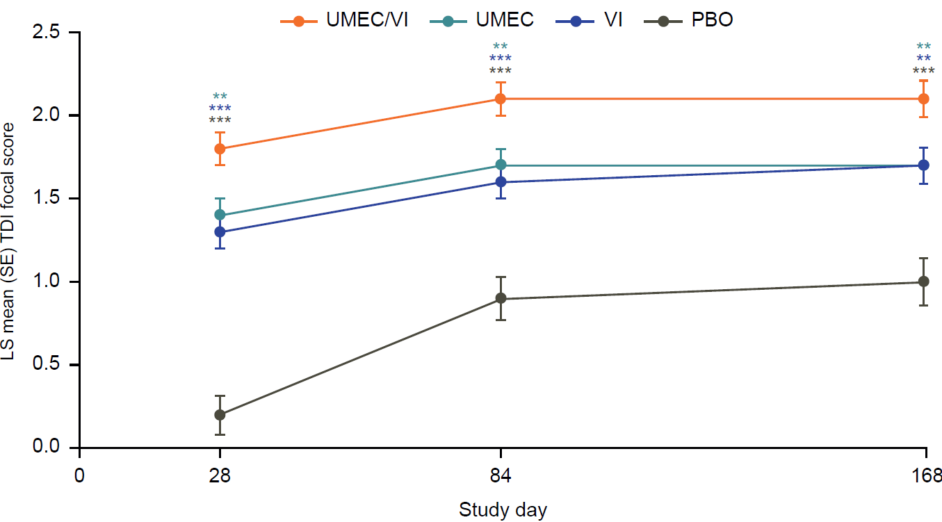

p-values reported indicate significant differences for UMEC/VI versus all three comparators: **p<0.01, ***p<0.001

ITT, intent-to-treat; LS, least squares; PBO, placebo; SE, standard error; TDI, transition dyspnea index; UMEC, umeclidinium; VI, vilanterol

