FROM BENCH TO BEDSIDE: IN VITRO AND IN VIVO EVALUATION OF A NEONATE-FOCUSED NEBULIZED SURFACTANT DELIVERY STRATEGY
Bianco F¹, Ricci F¹, Catozzi C¹, Murgia X², Schlun M³, Bucholski A³, Hetzer U³, Bonelli S¹, Lombardini M¹, Pasini E¹, Nutini M¹, Pertile M¹, Minocchieri S⁴, Simonato M⁵, Rosa B¹, Pieraccini G⁶, Moneti G⁶, Lorenzini L⁷, Catinella S¹, Villetti G¹, Civelli M¹, Pioselli B¹, Cogo P⁸, Carnielli V⁹ Dani C¹⁰*, Salomone F¹
¹Department of Preclinical Pharmacology, R&D, Chiesi Farmaceutici S.p.A., Parma, Italy.
²Scientific Consultancy, Saarbrücken, Germany.
³PARI Pharma GmbH, Starnberg, Germany.
⁴Division of Neonatology, Cantonal Hospital Winterthur, Winterthur, Switzerland.
⁵Pediatric Research Institute “Città della Speranza” Padova, Italy
⁶Mass Spectrometry Center (CISM), Polo Biomedico, Careggi University Hospital of Florence, Florence, Italy.
⁷Health Science and Technologies Interdepartmental Center for Industrial Research (HST-ICIR), University of Bologna, Bologna, Italy.
⁸Division of Pediatrics, Department of Medicine, University of Udine
⁹Polytechnic University of Marche and Azienda Ospedaliero-Universitaria Ospedali Riuniti, Ancona, Italy.
¹⁰Department of Neurosciences, Psychology, Drug Research and Child Health, Careggi University Hospital of Florence, Florence, Italy.
*Corresponding author:
Carlo Dani, MD, Division of Neonatology,
Careggi University Hospital, University of Florence School of Medicine,
Viale Morgagni, 85 Firenze, Italy (e-mail: cdani@unifi.It).
SUPPLEMENTARY INFORMATION

SUPPLEMENTARY TABLE 1. Baseline and post lung injury (Post-BAL) characteristics of surfactant-depleted adult rabbits treated with nasal continuous positive pressure ventilation (nCPAP), with intratracheal surfactant (Inst-SURF), or with different doses of nebulized surfactant (Neb-SURF100, Neb-SURF200, Neb-SURF400, and Neb-SURF600.
Group | Birth Weight  (kg) | Number of BALs | Baseline PaO₂ (mmHg) | Post-BALs PaO₂ (mmHg) | Baseline  Cdyn (mL/cmH₂O/kg) | Post-BALs  Cdyn (mL/cmH₂O/kg)
nCPAP | 1.72 ± 0.1 | 7.33 ± 1 | 473 ± 19 | 95 ± 11 | 0.88 ± 0.05 | 0.20 ± 0.02
Inst-SURF | 1.70 ± 0.1 | 5.10 ± 1 | 468 ± 13 | 70 ±17 | 1.09 ± 0.02 | 0.31 ± 0.04
Neb-SURF100 | 1.80 ± 0.1 | 7.44 ± 1 | 456 ± 14 | 91 ± 7 | 0.93 ± 0.06 | 0.28 ± 0.04
Neb-SURF200 | 1.71 ± 0.1 | 5.78 ± 1 | 472 ± 11 | 93 ± 8 | 1.07 ± 0.09 | 0.34 ± 0.02
Neb-SURF400 | 1.76 ± 0.1 | 6.22 ± 1 | 478 ± 8 | 101 ±10 | 1.02 ± 0.04 | 0.22 ± 0.02
BAL, Broncho-Alveolar Lavage; PaO₂, Arterial Oxygen Partial Pressure; C_{dyn}, Dynamic compliance.

SUPPLEMENTARY FIGURE 1. PrINT cast with silicon-coated nostrils.
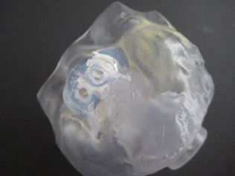

The infant nose-throat cast was 3D printed (1zu1 prototypen, Dornibirn, Austria) as a solid substance (material: DSM water clear ultra 10122). The nose area was silicon-coated to achieve a tight connection between cast and prongs.
SUPPLEMENTARY FIGURE 2. Nebulizer output assessment.
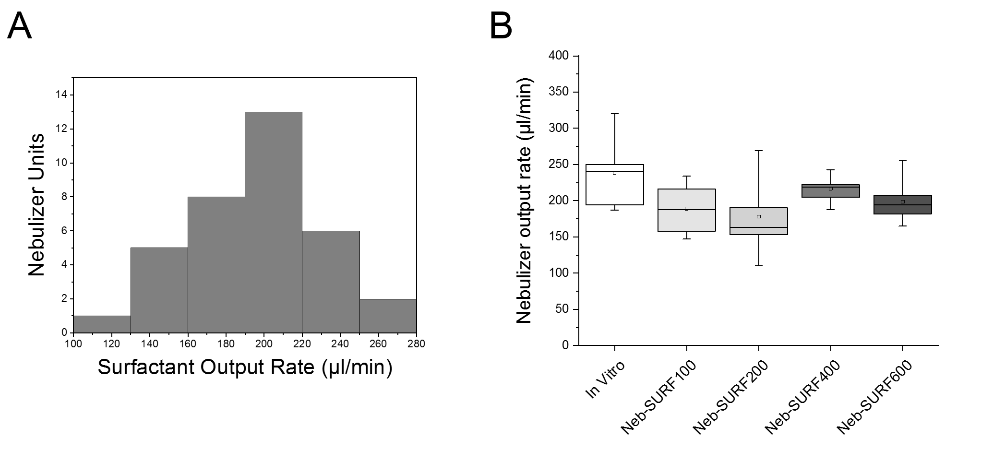
In total 41 independent nebulizer units were used in the present study. (A) Shows the distribution of the output rate of all devices. In (B) the box-plot shows the output rate as a function of the treatment group. The 5 nebulizers used in the in vitro study are also represented in the graph. The boxes encompass the 25-75 percentile. The horizontal line within the box represents the median, whereas the small square represents the mean. The whiskers indicate the maximum and minimum values for each group.

