Biomarkers of collagen synthesis biomarkers predict progression in the PROFILE idiopathic pulmonary fibrosis cohort.

Louise A Organ PhD¹, Anne-Marie Duggan MSc², Eunice Oballa MSc², Sarah Taggart MSci², Arthur R Kang’ombe², Rebecca Braybrooke RGN¹, Philip L Molyneaux MD PhD ^{3,4},Bernard North PhD², Yakshitha Karkera², Diana J Leeming PhD⁵, Morten A Karsdal PhD⁵, Carmel B Nanthakumar PhD², William A Fahy MD², Richard P Marshall MD PhD^{2,} R Gisli Jenkins MD PhD*¹, Toby M Maher MD PhD*^{3,4}

Additional file 1

Assay name | Target | Antibody type | Detection range, LLOQ-ULOQ (ng/mL) | Intra-assay variation (%) | Inter-assay variation (%) | Assay principle reference
C1M | MMP-2/9/13 degraded type I collagen | Monoclonal | 10-200 | 2.7-8.2 | 5.5-18.0 | (12)
C3M | MMP-9 degraded type III collagen | Monoclonal | 4-88 | 6.6-15.1 | 2.0-4.1 | (13)
C6M | MMP-2/9 degraded type vI collagen | Monoclonal | 6-267 | 2.0-8.0 | 4.0-18.0 | (32)
CRPM | MMP-1/9 degraded C-reactive protein | Monoclonal | 2.0-72.0 | 2.2-6.0 | 4.1-21.1 | (14)
BGM | MMP-9 degraded biglycan | Monoclonal | 4.1-190.0 | 2.0-6.0 | 5.0-20.0 | (33)
P1NP | N-terminal propeptide of type I collagen (formation marker) | Monoclonal | 14.0-516.0 | 1.0-8.0 | 3.0-13.0 | (9)
PRO-C3 | N-terminal propeptide of type III collagen (formation marker) | Monoclonal | 2.6-116.0 | 1.8-9.3 | 8.0-12.0 | (10)
PRO-C6 | C-terminal of type VI collagen (formation marker) | Monoclonal | 0-8-134.0 | 1.1-5.3 | 3.4-12.4 | (34)

Table S1. Target and assay performance characteristics for the ELISA assays specific to each neoepitope. The upper and lower limits of quantification, as well as intra- and inter-assay variation is also defined for each neoepitope specific assay. LLOQ= lower limit of quantification, ULOQ= Upper limit of quantification.

Control Subjects
 | P1NP | PRO-C3 | PRO-C6
P1NP | 1.00000  45
PRO_C3 | 0.09268  44 | 1.00000  47
PRO_C6 | 0.16857  45 | 0.39667  46 | 1.00000  49
IPF Subjects
 | P1NP | PRO-C3 | PRO-C6
P1NP | 1.00000  142
PRO_C3 | 0.24200  141 | 1.00000  144
PRO_C6 | 0.19174  141 | 0.51438  143 | 1.00000  144

Table S2. Spearman correlations for baseline serum concentrations of synthesis neoepitopes in control and IPF subjects. Each box shows the correlation coefficient and number of subjects with paired evaluable samples available.

 | Univariate HR | P value | Adjusted HR | P value
BGM | 1.408 (0.803, 2.469) | 0.2322 | 1.081 (0.570, 2.052) | 0.8111
C1M_01 | 1.838 (1.034, 3.266) | 0.0381 | 1.602 (0.853, 3.008) | 0.1427
C3M_01 | 2.443 (1.386, 4.305) | 0.0020 | 2.346 (1.244, 4.426) | 0.0084
C6M | 2.186 (1.249, 3.824) | 0.0062 | 2.020 (1.085, 3.760) | 0.0265
CRPM | 2.128 (1.207, 3.754) | 0.0091 | 2.339 (1.180, 4.635) | 0.0149
P1NP | 0.756 (0.440, 1.296) | 0.3088 | 0.959 (0.531, 1.733) | 0.8905
P1NP_C1M | 0.731 (0.414, 1.290) | 0.2793 | 0.839 (0.446, 1.580) | 0.5871
PRO-C3 | 1.622 (0.945, 2.786) | 0.0795 | 1.742 (0.940, 3.228) | 0.0777
PRO-C6 | 1.140 (0.672, 1.934) | 0.6280 | 1.415 (0.794, 2.520) | 0.2388
PROC3_C3M | 0.834 (0.488, 1.427) | 0.5085 | 1.021 (0.556, 1.876) | 0.9470
PROC6_C6M | 0.550 (0.318, 0.951) | 0.0324 | 0.611 (0.334, 1.116) | 0.1087

Table S3. Unadjusted and adjusted (for baseline FVC and DLco) univariate analysis of overall survival in relation to 3-month change in neoepitope concentrations. Data are expressed as mean hazard ratio (HR) with 95% CIs for all thresholds and represent the associated change in mortality risk based on a 2-fold increase in the explanatory value.

Spearman Correlation Coefficients
Number of Observations
 | BGM | C1M_01 | C3M_01 | C6M | CRPM | P1NP | P1NP_C1M | PRO_C3
BGM | 1.00000  130 | 0.56667  119 | 0.36018  129 | 0.45151  127 | 0.50657  129 | 0.05869  129 | -0.48759  119 | 0.10003  130
C1M_01 | 0.56667  119 | 1.00000  121 | 0.33709  121 | 0.56980  119 | 0.39893  120 | 0.00096  121 | -0.72496  121 | 0.04324  121
C3M_01 | 0.36018  129 | 0.33709  121 | 1.00000  131 | 0.44337  129 | 0.39043  130 | 0.08849  130 | -0.27157  121 | 0.21720  131
C6M | 0.45151  127 | 0.56980  119 | 0.44337  129 | 1.00000  129 | 0.48054  128 | 0.07186  128 | -0.37329  119 | 0.06312  129
CRPM | 0.50657  129 | 0.39893  120 | 0.39043  130 | 0.48054  128 | 1.00000  131 | 0.10430  130 | -0.23933  120 | 0.27018  131
P1NP | 0.05869  129 | 0.00096  121 | 0.08849  130 | 0.07186  128 | 0.10430  130 | 1.00000  131 | 0.45530  121 | 0.28505  131
P1NP_C1M | -0.48759  119 | -0.72496  121 | -0.27157  121 | -0.37329  119 | -0.23933  120 | 0.45530  121 | 1.00000  121 | 0.10783  121
PRO_C3 | 0.10003  130 | 0.04324  121 | 0.21720  131 | 0.06312  129 | 0.27018  131 | 0.28505  131 | 0.10783  121 | 1.00000  132
PRO_C6 | 0.05845  130 | -0.09033  121 | 0.11509  131 | -0.11485  129 | 0.12537  131 | 0.22182  131 | 0.14010  121 | 0.55443  132
PROC3_C3M | -0.14357  129 | -0.12427  121 | -0.36218  131 | -0.21142  129 | -0.00075  130 | 0.17241  130 | 0.19363  121 | 0.70560  131
PROC6_C6M | -0.32716  127 | -0.46267  119 | -0.35206  129 | -0.83062  129 | -0.26324  128 | 0.04950  128 | 0.35716  119 | 0.22069  129

Table S4. Spearman correlations for 3-month change in serum concentrations of synthesis and degradation neoepitopes in IPF subjects. Each box shows correlation coefficient and number of subjects with paired evaluable samples available

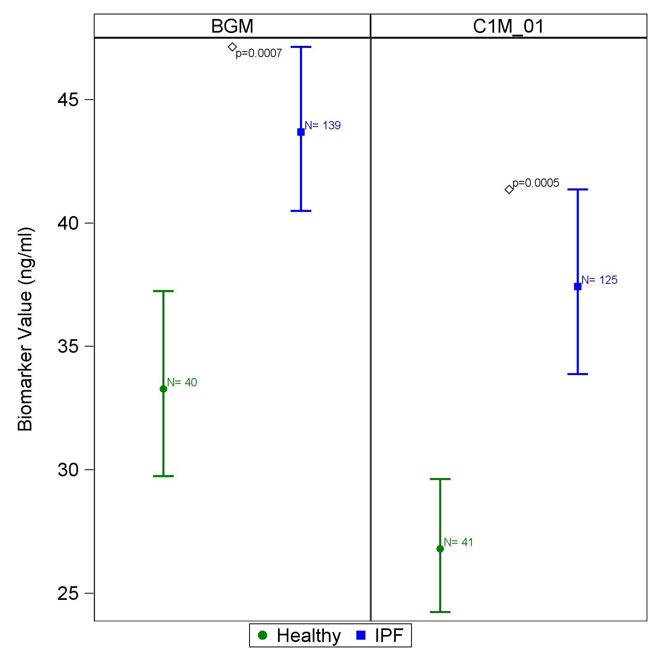
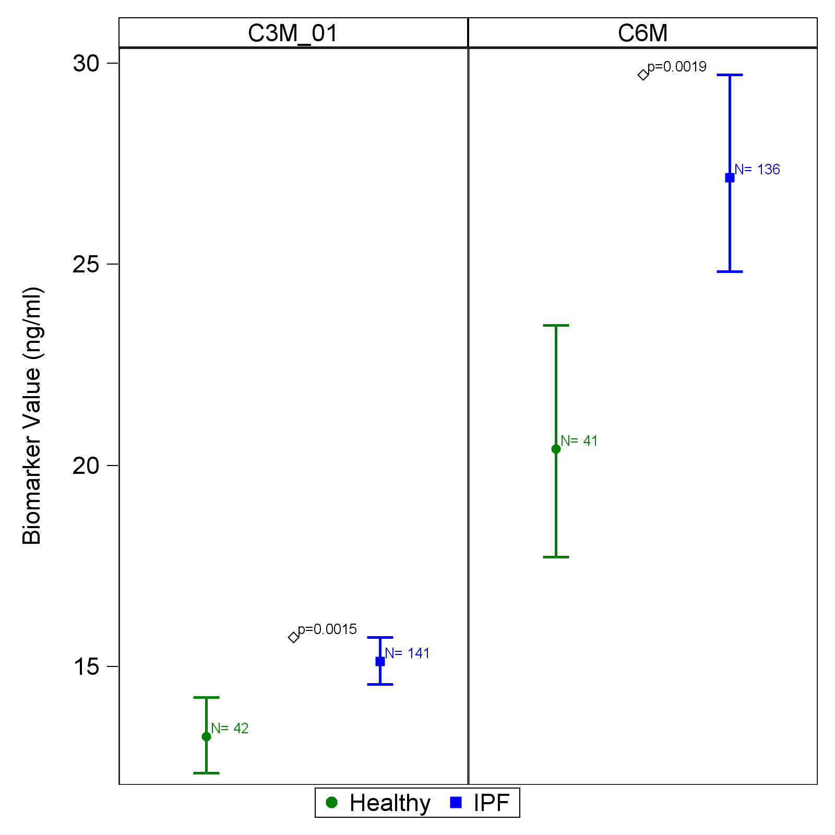
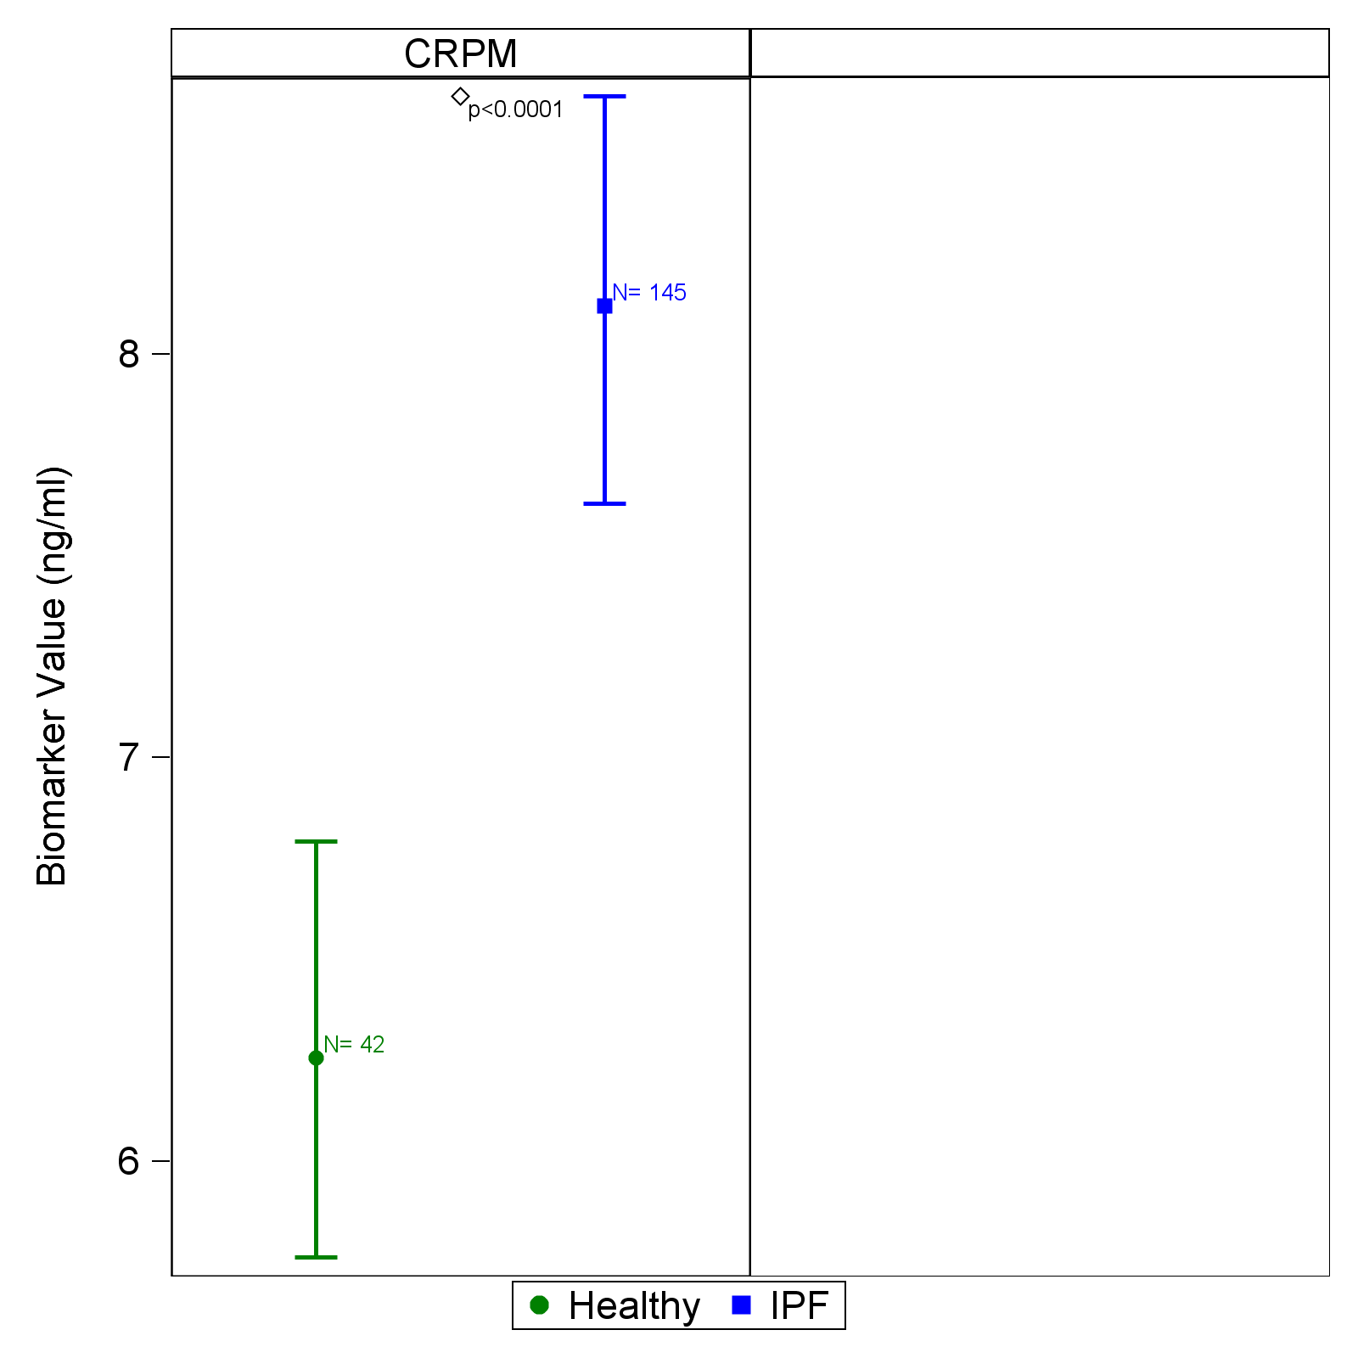

Figure S1. Baseline comparison of collagen degradation neoepitope (BGM, C1M, C3M, C6M and CRPM) concentrations in healthy controls (n=50) and participants with idiopathic pulmonary fibrosis (n=145). Plots represent mean and 95% CI (error bars) adjusted for gender.

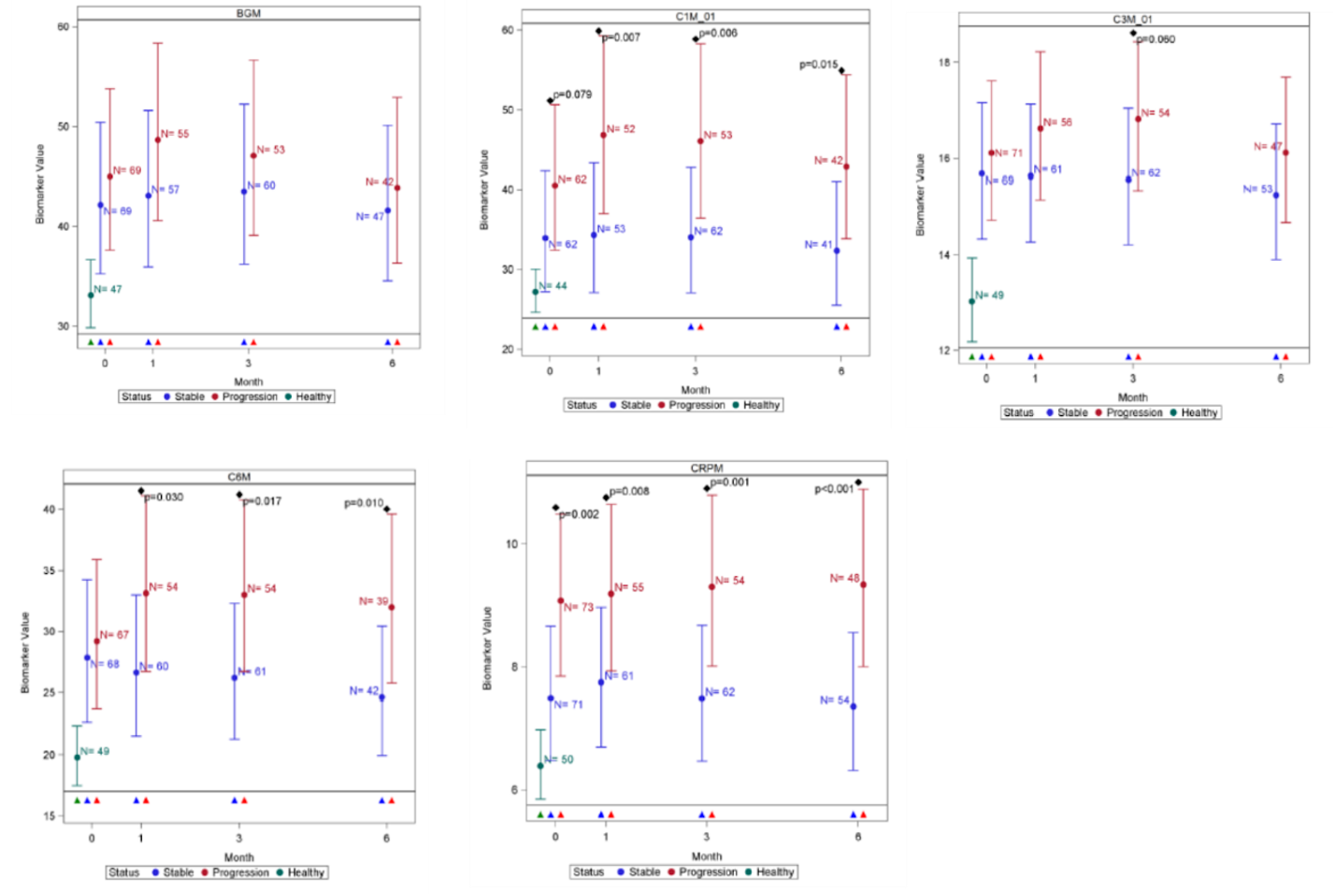

Figure S2. Comparison of neoepitope concentrations in healthy controls (green) and participants with stable (blue) and progressive (red) idiopathic pulmonary fibrosis at baseline and subsequently at 1-, 3- and 6-months.Plots represent mean and 95% CI (error bars) adjusted for age, sex, site and smoking status. Disease progression was defined as all-cause mortality or ≧10% decline in forced vital capacity at 12 months. The number of evaluable samples available for analysis at each time point are provided in the graph. P values are provided where significant (p<0.05) differences were observed between stable and progressive disease at a particular time point.

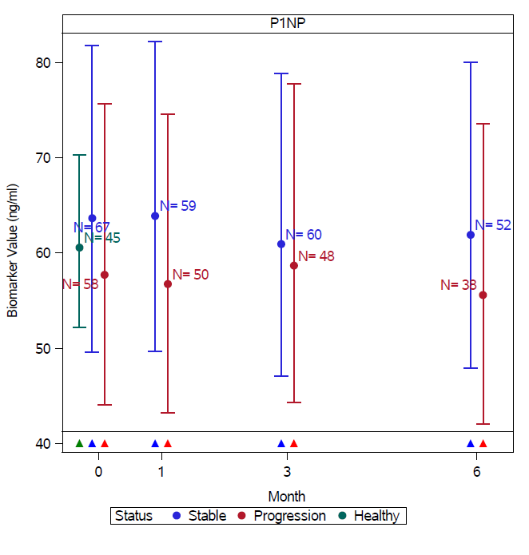
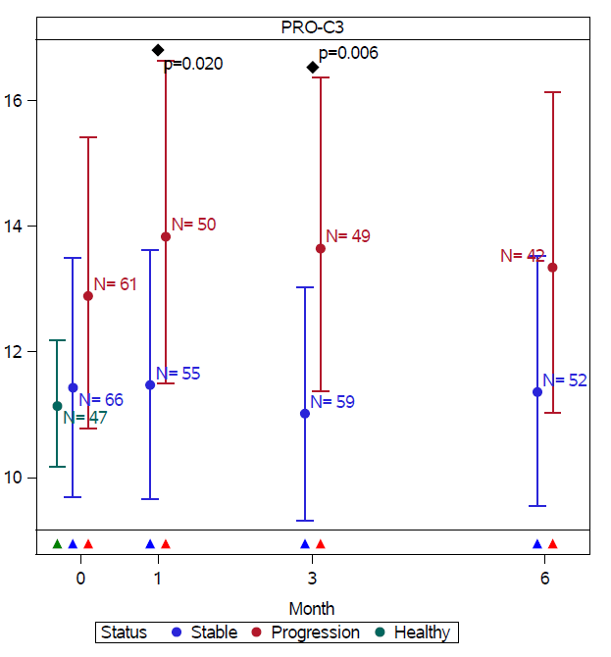
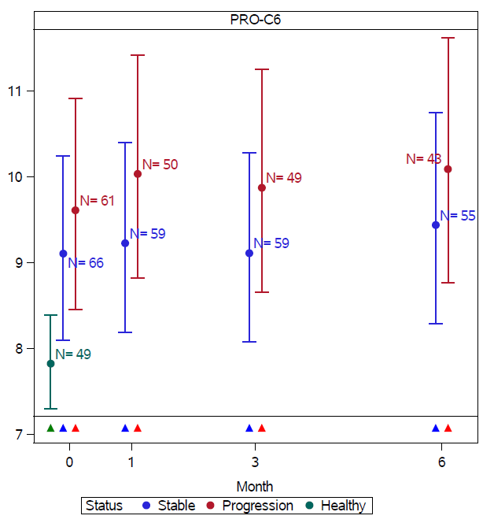
F

Figure S3. Comparison of synthesis neoepitope concentrations adjusted for baseline FVC and DLco %predicted in healthy controls (green) and participants with stable (blue) and progressive (red) idiopathic pulmonary fibrosis at baseline and subsequently at 1-, 3- and 6-months.Plots represent mean and 95% CI (error bars) adjusted for age, sex, site and smoking status. Disease progression was defined as all-cause mortality or ≧10% decline in forced vital capacity at 12 months. The number of evaluable samples available for analysis at each time point are provided in the graph. P values are provided where significant (p<0.05) differences were observed between stable and progressive disease at a particular time point.
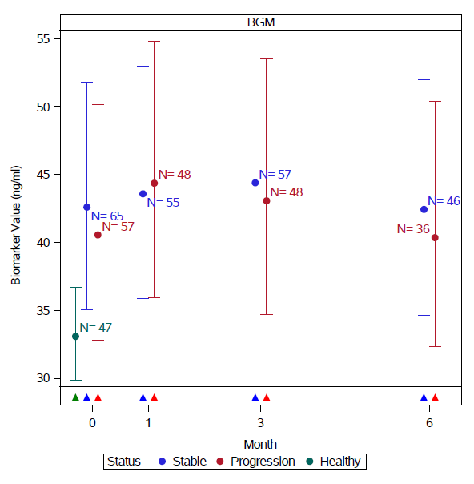
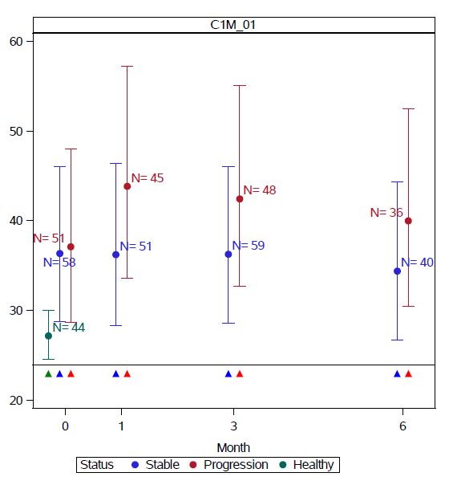
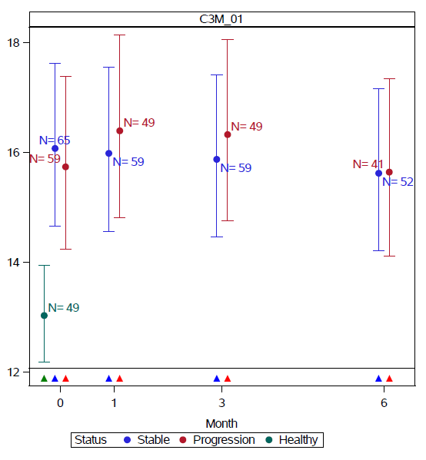
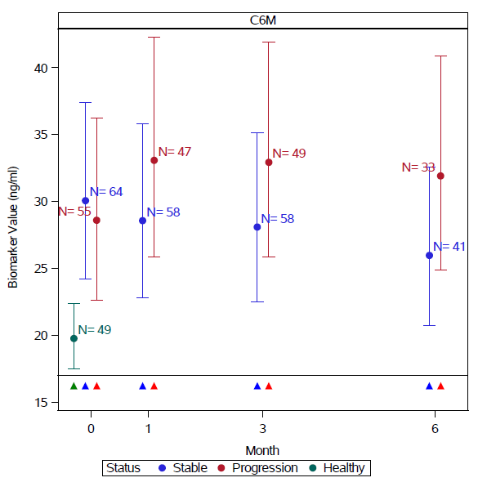
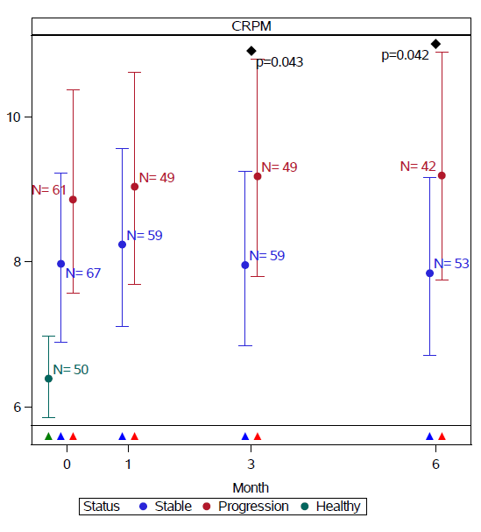

Figure S4: Comparison of degradation neoepitope concentrations adjusted for baseline FVC and DLco %predicted in healthy controls (green) and participants with stable (blue) and progressive (red) idiopathic pulmonary fibrosis at baseline and subsequently at 1-, 3- and 6-months.Plots represent mean and 95% CI (error bars) adjusted for age, sex, site and smoking status. Disease progression was defined as all-cause mortality or ≧10% decline in forced vital capacity at 12 months. The number of evaluable samples available for analysis at each time point are provided in the graph. P values are provided where significant (p<0.05) differences were observed between stable and progressive disease at a particular time point.

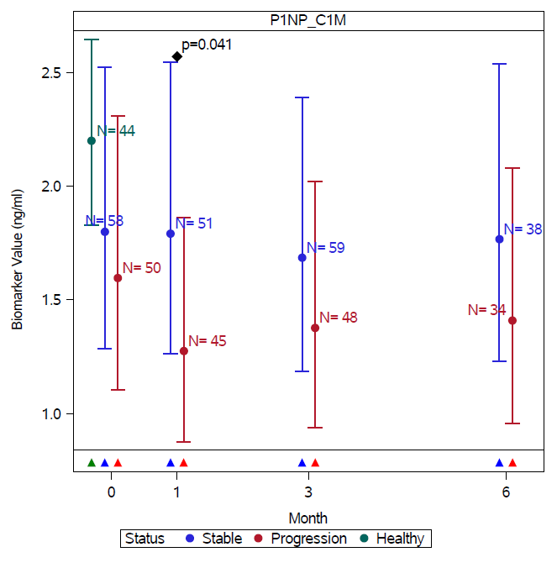
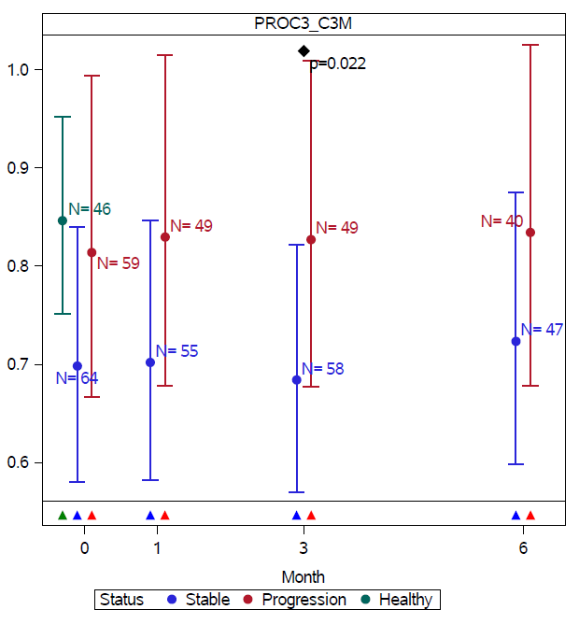
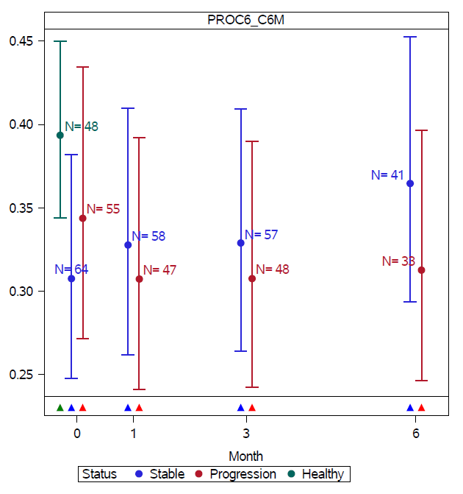

Figure S5. Comparison of neoepitope concentrations adjusted for baseline FVC and DLco %predicted in healthy controls (green) and participants with stable (blue) and progressive (red) idiopathic pulmonary fibrosis at baseline and subsequently at 1-, 3- and 6-months.Plots represent mean and 95% CI (error bars) adjusted for age, sex, site and smoking status. Disease progression was defined as all-cause mortality or ≧10% decline in forced vital capacity at 12 months. The number of evaluable samples available for analysis at each time point are provided in the graph. P values are provided where significant (p<0.05) differences were observed between stable and progressive disease at a particular time point

