Figure S1. Scatterplot (panel A) and Bland Altman plot (panel B) demonstrating good agreement between pulmonary and critical care reviewers (ICC 0.93, CI 0.91-0.95).

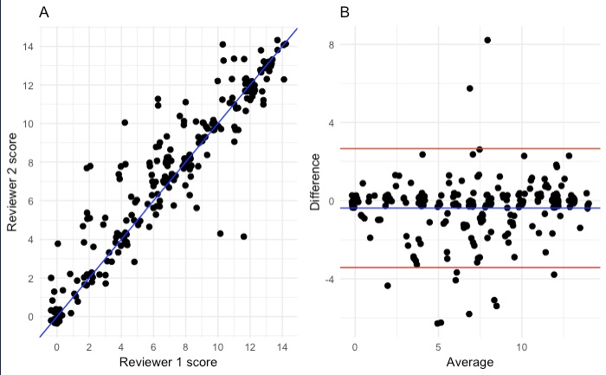

Figure S2. Overall mortality stratified by chest radiograph score quartile for the entire cohort (panel A) and excluding subjects with Acute Respiratory Distress Syndrome (ARDS) (panel B).
A
B
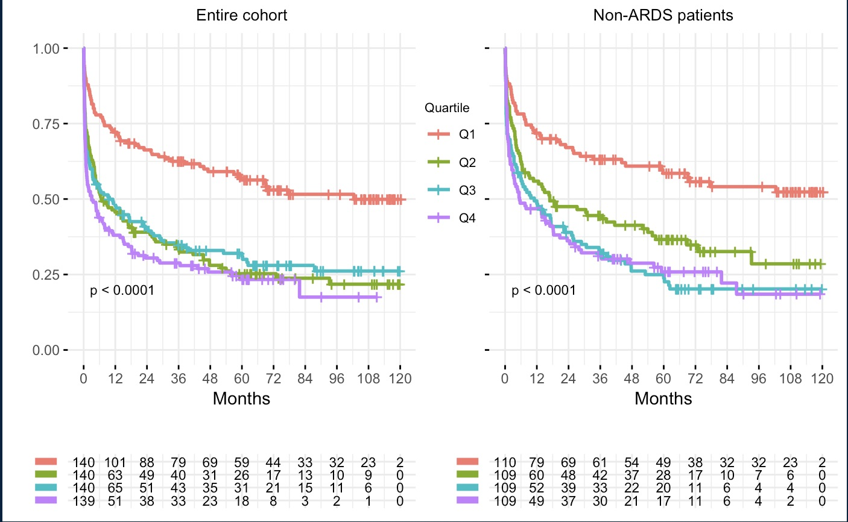

Figure S3. Association between chest radiograph total score and biomarkers of critical illness and lung weights on autopsy.
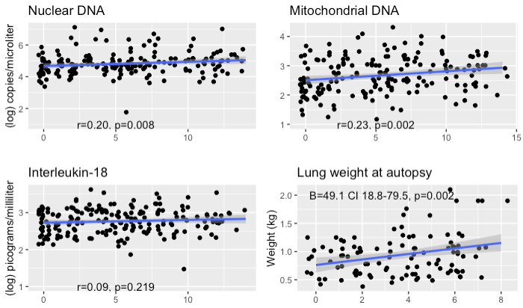
Table S1. 60-day mortality by chest radiograph score quartile. P-values have been adjusted with the
Bonferroni correction for multiple testing.
Entire cohort (n = 560)
Quartile | Odds Ratio  (Confidence Interval) | Adjusted  p-value | Odds Ratio  (Confidence Interval) | Adjusted  p-value | Odds Ratio  (Confidence Interval) | Adjusted  p-value | Odds Ratio  (Confidence Interval) | Adjusted  p-value
1 | reference |  | 0.36 (0.19-0.68) | 0.011 | 0.32 (0.16-0.59) | 0.003 | 0.22 (0.11-0.41) | <0.001
2 | 2.78 (1.48-5.39) | 0.011 | reference |  | 0.88 (0.51-1.51) | >0.999 | 0.61 (0.36-1.03) | 0.407
3 | 3.16 (1.69-6.10) | 0.003 | 1.14 (0.66-1.95) | >0.999 | reference |  | 0.70 (0.41-1.17) | >0.999
4 | 4.55 (2.45-8.72) | <0.001 | 1.63 (0.97-2.78) | 0.407 | 1.44 (0.86-2.43) | >0.999 | reference
Excluding Acute Respiratory Distress Syndrome patients (n = 437)
1 | reference |  | 0.57 (0.26-1.22) | 0.940 | 0.35 (0.17-0.71) | 0.028 | 0.25 (0.12-0.50) | 0.001
2 | 1.74 (0.82-3.82) | 0.940 | reference |  | 0.61 (0.32-1.16) | 0.824 | 0.43 (0.22-0.81) | 0.063
3 | 2.84 (1.40-6.00) | 0.028 | 1.63 (0.86-3.14) | 0.824 | reference |  | 0.70 (0.38-1.27) | >0.999
4 | 4.07 (2.00-8.66) | 0.001 | 2.34 (1.23-4.53) | 0.063 | 1.43 (0.79-2.63) | >0.999 | reference

Table S2. In-hospital mortality by chest radiograph score quartile. P-values have been adjusted with the
Bonferroni correction for multiple testing.
Entire cohort (n = 560)
Quartile | Odds Ratio  (Confidence Interval) | Adjusted  p-value | Odds Ratio  (Confidence Interval) | Adjusted  p-value | Odds Ratio  (Confidence Interval) | Adjusted  p-value | Odds Ratio  (Confidence Interval) | Adjusted  p-value
1 | reference |  | 0.38 (0.19-0.74) | 0.032 | 0.30 (0.14-0.54) | 0.001 | 0.27 (0.13-0.52) | 0.001
2 | 2.66 (1.36-5.40) | 0.032 | reference |  | 0.74 (0.43-1.30) | >0.999 | 0.71 (0.41-1.23) | >0.999
3 | 3.57 (1.85-7.19) | 0.001 | 1.34 (0.77-2.35) | >0.999 | reference |  | 0.96 (0.56-1.64) | >0.999
4 | 3.72 (1.93-7.45) | 0.001 | 1.40 (0.81-2.43) | >0.999 | 1.04 (0.61-1.77) | >0.999 | reference
Excluding Acute Respiratory Distress Syndrome patients (n = 437)
1 | reference |  | 0.66 (0.29-1.47) | >0.999 | 0.35 (0.16-0.73) | 0.039 | 0.42 (0.19-0.90) | 0.168
2 | 1.53 (0.68-3.50) | >0.999 | reference |  | 0.54 (0.27-1.06) | 0.458 | 0.64 (0.32-1.29) | >0.999
3 | 2.83 (1.36-6.16) | 0.039 | 1.86 (0.94-3.73) | 0.458 | reference |  | 1.19 (0.63-2.26) | >0.999
4 | 2.37 (1.11-5.25) | 0.168 | 1.56 (0.77-3.17) | >0.999 | 0.84 (0.44-1.58) | >0.999 | reference

Table S3. Overall mortality by chest radiograph score quartile. P-values have been adjusted with the
Bonferroni correction for multiple testing.
Entire cohort (n = 560)
Quartile | Hazard Ratio  (Confidence Interval) | Adjusted  p-value | Hazard Ratio  (Confidence Interval) | Adjusted  p-value | Hazard Ratio  (Confidence Interval) | Adjusted  p-value | Hazard Ratio  (Confidence Interval) | Adjusted  p-value
1 | reference |  | 0.49 (0.35-0.67) | <0.001 | 0.51 (0.37-0.70) | <0.001 | 0.46 (0.33-0.63) | <0.001
2 | 2.06 (1.49-2.84) | <0.001 | reference |  | 1.05 (0.79-1.40) | >0.999 | 0.94 (0.71-1.25) | >0.999
3 | 1.97 (1.42-2.72) | <0.001 | 0.95 (0.72-1.27) | >0.999 | reference |  | 0.90 (0.68-1.19) | >0.999
4 | 2.19 (1.59-3.01) | <0.001 | 1.06 (0.80-1.40) | >0.999 | 1.11 (0.84-1.47) | >0.999 | reference
Excluding Acute Respiratory Distress Syndrome patients (n = 437)
1 | reference |  | 0.56 (0.38-0.81) | 0.015 | 0.43 (0.30-0.62) | <0.001 | 0.40 (0.27-0.58) | <0.001
2 | 1.80 (1.23-2.64) | 0.015 | reference |  | 0.79 (0.56-1.08) | 0.800 | 0.72 (0.51-1.00) | 0.315
3 | 2.31 (1.60-3.33) | <0.001 | 1.28 (0.93-1.78) | 0.800 | reference |  | 0.92 (0.67-1.27) | >0.999
4 | 2.51 (1.72-3.65) | <0.001 | 1.39 (1.00-1.94) | 0.315 | 1.08 (0.79-1.49) | >0.999 | reference

Table S4. In-hospital, 60-day, and overall
mortality for patients with Acute Respiratory Distress Syndrome.
 |  | Odds Ratio (Confidence Interval) | p-value
In-hospital mortality |  | 1.08 (0.95-1.23) | 0.227
60-day mortality |  | 1.07 (0.94-1.22) | 0.308
 |  | Hazard Ratio (Confidence Interval) | p-value
Overall mortality |  | 0.99 (0.93-1.06) | 0.840
 | Quartile 1 | reference
 | Quartile 2 | 0.90 (0.48-1.71) | 0.750
 | Quartile 3 | 0.93 (0.49-1.75) | 0.814
 | Quartile 4 | 0.89 (0.47-1.67) | 0.710

Table S5. Duration of stay in the intensive care unit by chest radiograph score quartile. P-values have been adjusted with the Bonferroni correction for multiple testing.
Quartile | Rate Ratio  (Confidence Interval) | Adjusted  p-value | Rate Ratio  (Confidence Interval) | Adjusted  p-value | Rate Ratio  (Confidence Interval) | Adjusted  p-value | Rate Ratio  (Confidence Interval) | Adjusted  p-value
1 | reference |  | 0.72 (0.60-0.85) | 0.001 | 0.56 (0.47-0.66) | <0.001 | 0.52 (0.44-0.62) | <0.001
2 | 1.40 (1.17-1.66) | 0.001 | reference |  | 0.78 (0.66-0.92) | 0.019 | 0.73 (0.62-0.86) | 0.001
3 | 1.79 (1.50-2.13) | <0.001 | 1.28 (1.09-1.51) | 0.019 | reference |  | 0.93 (0.79-1.09) | >0.999
4 | 1.92 (1.62-2.29) | <0.001 | 1.38 (1.17-1.62) | 0.001 | 1.08 (0.92-1.26) | >0.999 | reference

Table S6. Duration of mechanical ventilation for intubated patients (n = 286) by chest radiograph score quartile. P-values have been adjusted with the Bonferroni correction for multiple testing.
Quartile | Rate Ratio  (Confidence Interval) | Adjusted  p-value | Rate Ratio  (Confidence Interval) | Adjusted  p-value | Rate Ratio  (Confidence Interval) | Adjusted  p-value | Rate Ratio  (Confidence Interval) | Adjusted  p-value
1 | reference |  | 0.98 (0.70-1.38) | >0.999 | 0.65 (0.47-0.90) | 0.043 | 0.64 (0.47-0.88) | 0.025
2 | 1.02 (0.73-1.43) | >0.999 | reference |  | 0.66 (0.50-0.87) | 0.016 | 0.65 (0.50-0.85) | 0.008
3 | 1.54 (1.11-2.14) | 0.043 | 1.51 (1.15-1.99) | 0.016 | reference |  | 0.98 (0.77-1.26) | >0.999
4 | 1.57 (1.14-2.14) | 0.025 | 1.54 (1.18-2.00) | 0.008 | 1.02 (0.79-1.30) | >0.999 | reference

