ONLINE SUPPLEMENTARY MATERIAL

ACCOMPANYING MANUSCRIPT TITLE:
BMI is associated with FEV₁ decline in chronic obstructive pulmonary disease: a meta-analysis of clinical trials

AUTHORS:
Yilan Sun, Stephen Milne, Jen Erh Jaw, Chen Xi Yang, Feng Xu, Xuan Li, Ma'en Obeidat, Don D. Sin

CORRESPONDING AUTHOR:
Don D. Sin, MD
Room 548, Burrard Building, St. Paul’s Hospital, Vancouver, BC, Canada, V6Z 1Y6
Email: don.sin@hli.ubc.ca
Voice: 1-604-806-8395
FAX: 1-604-806-9274

CONTENTS:
Table S1 | Quality appraisal of studies in systematic review
Figure S1 | Funnel plots and Egger’s test for publication bias for meta-analyses of annualized rate of FEV₁ decline by body mass index (BMI) category
Figure S2 | Meta-analyses of annualized rate of FEV₁ decline by body mass index (BMI) category, following sensitivity analysis
Figure S3 | Funnel plots and Egger’s test for publication bias for meta-analyses of annualized rate of FEV₁ decline by body mass index (BMI) category, following sensitivity analysis
Figure S4 | Meta-regression of annualized rate of FEV₁ decline by body mass index (BMI), following sensitivity analysis
References

Author (year of publication) | Random sequence generation | Allocation concealment | Blinding of participants and personnel | Blinding of outcome assessment | Incomplete outcome data | Selective reporting | Other bias
Celli (2008)¹ | Low risk | Low risk | Low risk | Low risk | Low risk | Low risk | Low risk
Calverley (2018)² | Low risk | Low risk | Low risk | Low risk | Low risk | Low risk | Low risk
Tashkin (2008)³ | Low risk | Low risk | Low risk | Low risk | Low risk | Low risk | Low risk
Anzueto (2015)⁴ | Low risk | Low risk | Low risk | Low risk | Low risk | Low risk | Low risk
Tkacova (2016)⁵ | Low risk | Low risk | High risk | Low risk | Low risk | Low risk | Low risk
Table S1

Quality appraisal of studies in systematic review. Risk of bias categorized using Cochrane Collaboration tool [12]

Figure S1
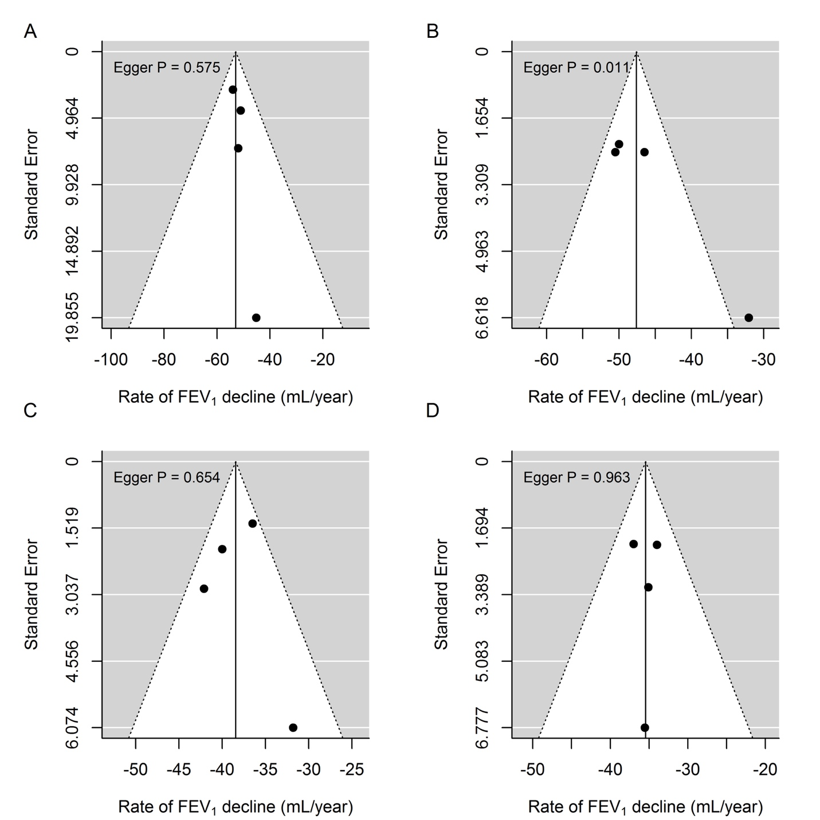

Funnel plots and Egger’s test for publication bias for meta-analyses of annualized rate of FEV₁ decline by body mass index (BMI) category. (A-D), categories BMI-I to BMI-IV, respectively. See main text for description of BMI categories. FEV₁, forced expiratory volume in 1 s.

Figure S2
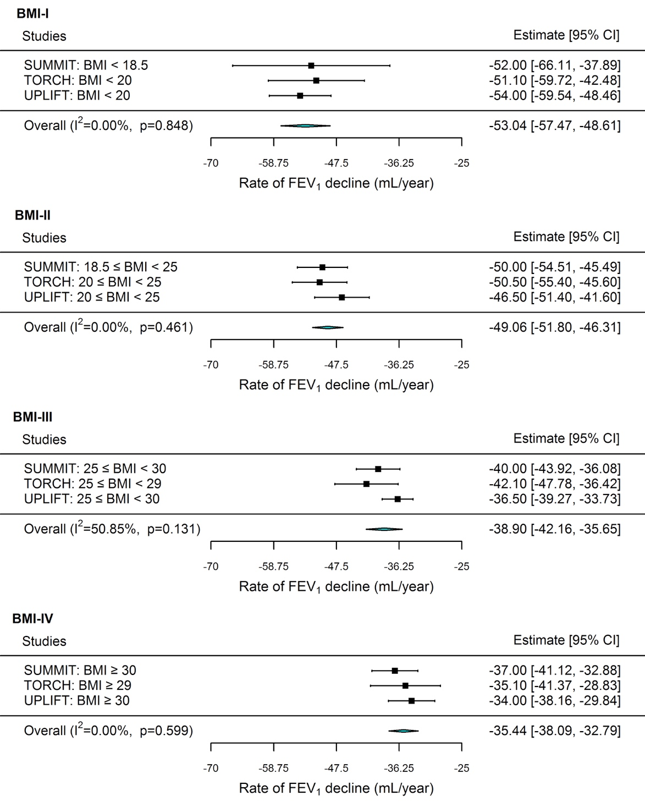
Meta-analyses of annualized rate of FEV₁ decline by body mass index (BMI) category, following sensitivity analysis. For this sensitivity analysis, data from TIOSPIR (Anzueto et al⁴) was removed from the main meta-analysis due to evidence of publication bias. Individual meta-analyses presented for each BMI category from lowest (BMI-I) to highest (BMI-IV). Data from randomized controlled trials: SUMMIT, Calverley et al;² TORCH, Celli et al;¹ UPFLIFT; Tashkin et al.³ FEV₁, forced expiratory volume in 1 s; CI, confidence interval; I², heterogeneity statistic; p, significance from Cochran’s Q test of heterogeneity.

Figure S3
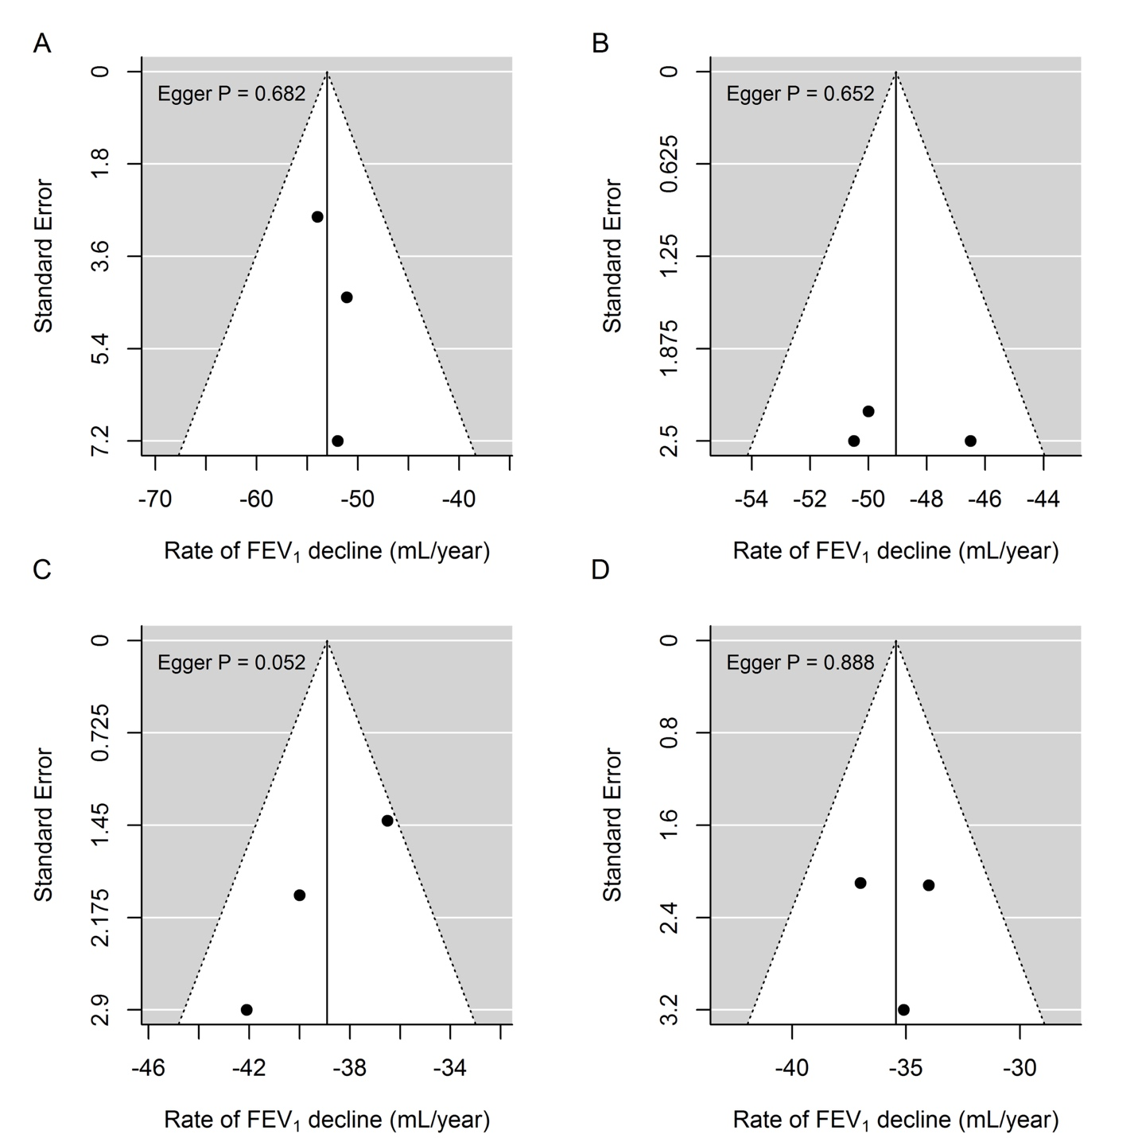
Funnel plots and Egger’s test for publication bias for meta-analyses of annualized rate of FEV₁ decline by body mass index (BMI) category, following sensitivity analysis. For this sensitivity analysis, data from TIOSPIR (Anzueto et al⁴) was removed from the main meta-analysis due to evidence of publication bias. (A-D), categories BMI-I to BMI-IV, respectively. See main text for description of BMI categories. FEV₁, forced expiratory volume in 1 s.

Figure S4

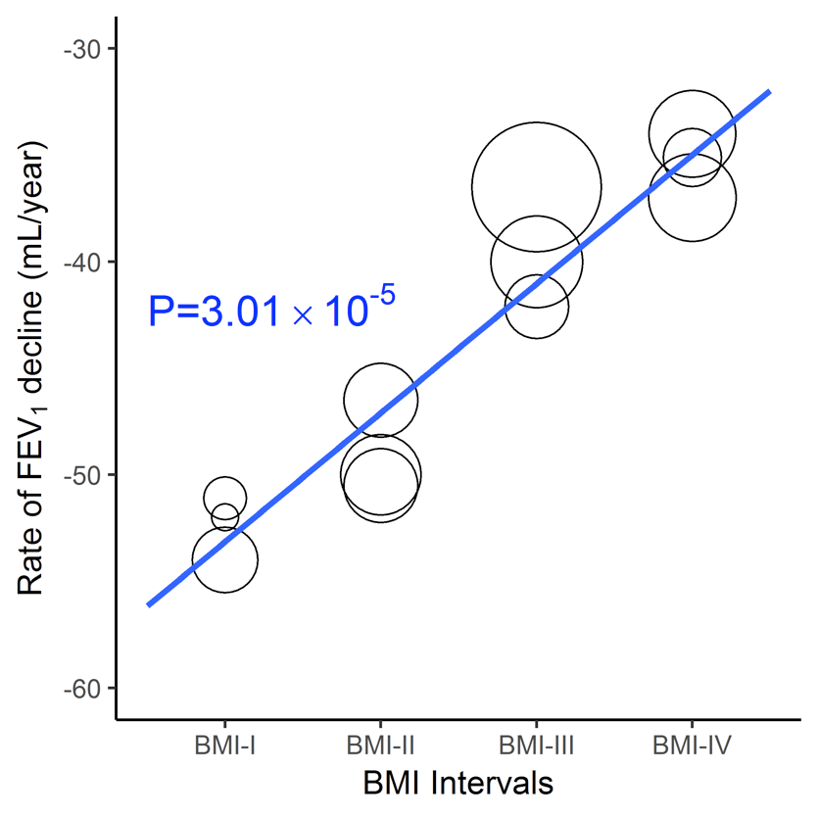
Meta-regression of annualized rate of FEV₁ decline by body mass index (BMI), following sensitivity analysis. For this sensitivity analysis, data from TIOSPIR (Anzueto et al⁴) was removed from the main meta-analysis due to evidence of publication bias. Inverse variance weighting (IVW) model with BMI as a continuous variable from BMI-I (lowest) to BMI-IV (highest). See main text from description of BMI categories. Size of circles represents relative weighting of estimates. FEV₁, forced expiratory volume in 1 s; p, significance of linear trend
References
1. Celli BR, Thomas NE, Anderson JA, et al. Effect of pharmacotherapy on rate of decline of lung function in chronic obstructive pulmonary disease: results from the TORCH study. Am J Respir Crit Care Med. 2008;178(4):332-338.
2. Calverley PMA, Anderson JA, Brook RD, et al. Fluticasone Furoate, Vilanterol, and Lung Function Decline in Patients with Moderate Chronic Obstructive Pulmonary Disease and Heightened Cardiovascular Risk. Am J Respir Crit Care Med. 2018;197(1):47-55.
3. Tashkin DP, Celli B, Senn S, et al. A 4-year trial of tiotropium in chronic obstructive pulmonary disease. N Engl J Med. 2008;359(15):1543-1554.
4. Anzueto A, Wise R, Calverley P, et al. The Tiotropium Safety and Performance in Respimat(R) (TIOSPIR(R)) Trial: Spirometry Outcomes. Respir Res. 2015;16:107.
5. Tkacova R, Dai DLY, Vonk JM, et al. Airway hyperresponsiveness in chronic obstructive pulmonary disease: A marker of asthma-chronic obstructive pulmonary disease overlap syndrome? J Allergy Clin Immunol. 2016;138(6):1571-1579 e1510.

