Supplementary Material
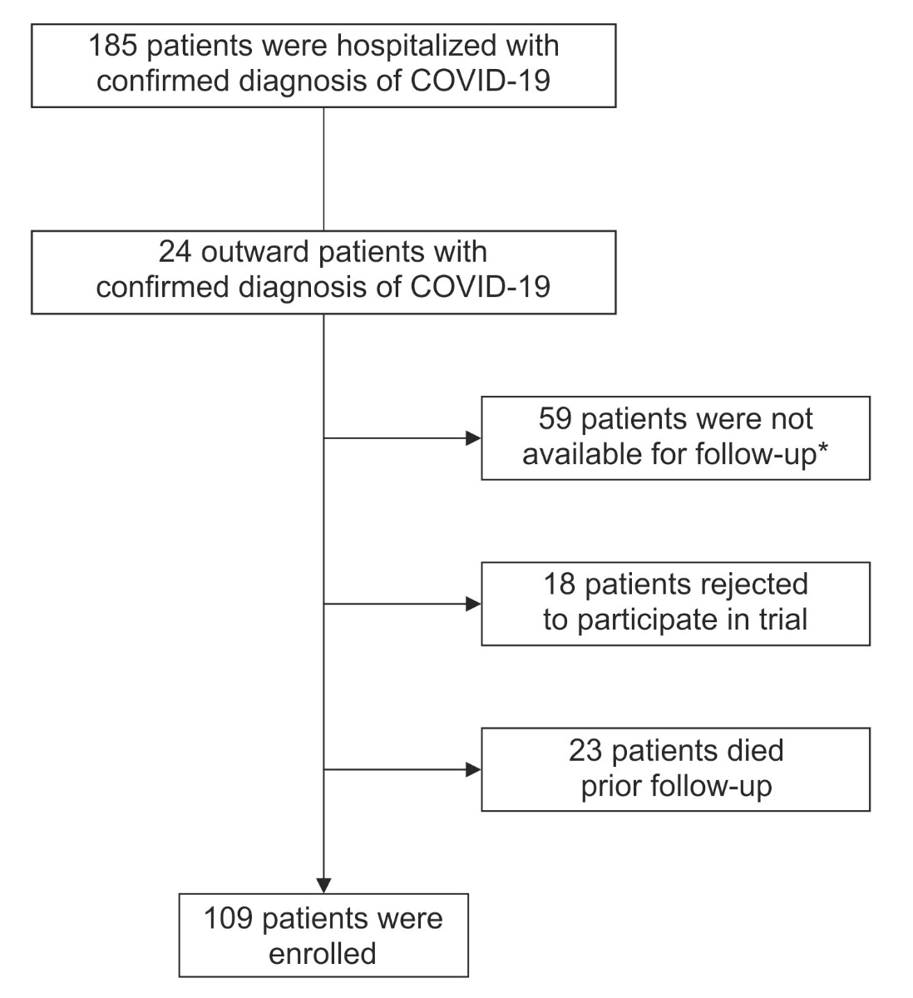
Figure S1: Enrolment of CovILD study participants
*non-available patients could not attend the study centre in Innsbruck because they left the country after hospital discharge or resided too far away from the study centre to attend regular follow-ups.

Table S1 List of primers and probes for RT-PCR analysis of PBMC mRNA expression patterns
TaqMan | forward primer | reverse primer |  | probe
β-TUBULIN | TCCTTCAACACCTTCTTCAGTGAGACG | GGTGCCAGTGCGAACTTCATCA |  | ATGTGCCCCGGGCAGTGTTTGTAGACTTG
DMT1 | GTGGTCAGCGTGGCTTATCTG | CCACAGTCCAGGAAGGACATG |  | TGTTCTACTTGGGTTGGCAATGTTTGATTGC
FPN1 | TGACCAGGGCGGGAGA | GAGGTCAGGTAGTCGGCCAA |  | CACAACCGCCAGAGAGGATGCTGTG
HAMP | TTTCCCACAACAGACGGGAC | AGCTGGCCCTGGCTCC |  | CAGAGCTGCAACCCCAGGACAGAGC
H-FERRITIN | AGAAAACTCAGCGACTGCCAG | TAGTTTTGGCGCACTTGCC |  | ACCGCTGACCGCCCCGCT
TFR1 | TCCCAGCAGTTTCTTTCTGTTTT | CTCAATCAGTTCCTTATAGGTGTCCA |  | CGAGGACACAGATTATCCTTATTTGGGTACCACC
SYBR-Green | forward primer |  | reverse primer
IL6 | CCACTCACCTCTTCAGAACG |  | CATCTTTGGAAGGTTCAGGTTG
IL10 | GGGAGAACCTGAAGACCCTCA |  | TGCTCTTGTTTTCACAGGGAAG
LCN2 | GGCTTCACAGAGGATACCATTGT |  | AGCCCTGGGGAGTCCTATTG
TNF | GGTGCTTGTTCCTCAGCCTC |  | CAGGCAGAAGAGCGTGGTG

