Additional File 1
Figure 1. Bland-Altmann analysis was performed to identify inter-observer variability in capillary density (loops/mm) measurements in the study cohort.

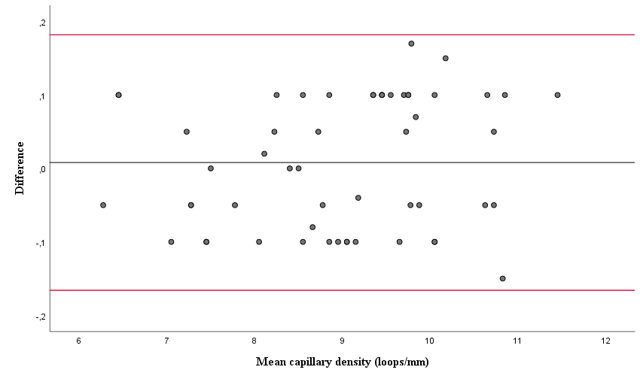

Reference line represents the mean difference in measurements between investigator 1 and 2, while the upper and lower red lines represent the 95% confidence intervals (CIs) (mean difference: 0.008 loops/mean; standard deviation: 0.09; 95% CIs: -0.16,0.18; p= 0.51).

Figure 2. Bland-Altmann analysis was used to identify inter-observer variability in loop diameter (μm) measurements in the study cohort.

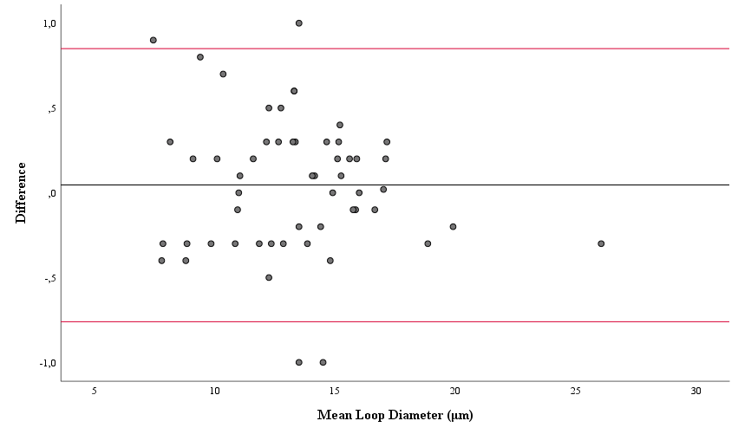

Reference line represents the mean difference in measurements between investigator 1 and 2, while the upper and lower red lines represent the 95% confidence intervals (CIs) (mean difference: 0.046μm; standard deviation: 0.41; 95% CIs: -0.76,0.85; p= 0.41).

Figure 3. Bland-Altmann analysis was performed to identify inter-observer variability in measuring the number of shape abnormalities per linear mm in the study cohort.

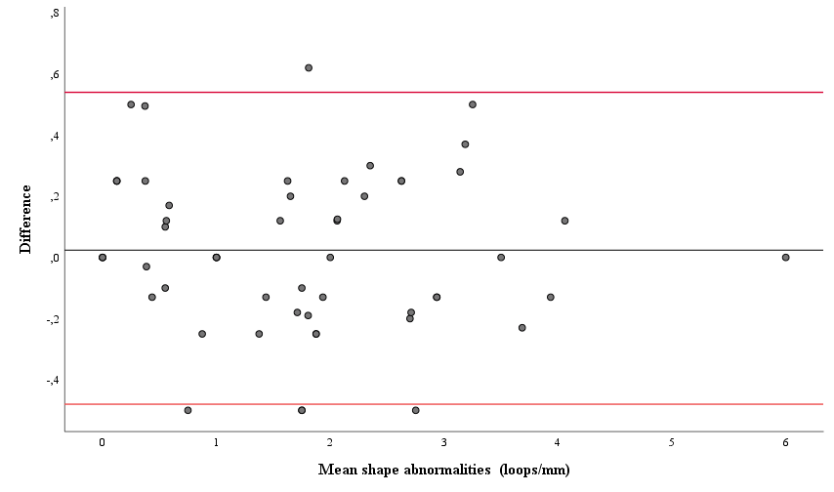

Reference line represents the mean difference in measurements between investigator 1 and 2, while the upper and lower red lines represent the 95% confidence intervals (CIs) (mean difference: 0.024 loops/mean; standard deviation: 0.26; 95% CIs: -0.48,0.54; p= 0.48).

Table. Correlations among capillaroscopic parameters and demographic, laboratory, functional, echocardiographic and heamodynamic markers of cardiac function in patients with precapillary PH.
 | IPAH |  | CTEPH
 | Capillary Density (loops/mm) |  | Capillary Density (loops/mm) |  | Shape Abnormalities (loops/mm)
 | Coefficient (r) | P-Value* | Coefficient (r) | P-Value* | Coefficient (r) | P-Value*
Age, years | 0.4 | 0.19 | 0.36 | 0.19 | -0.07 | 0.81
BMI, kg/m² | -0.35 | 0.26 | -0.03 | 0.9 | -0.05 | 0.84
SpO2% | 0.05 | 0.87 | -0.58 | 0.04 | 0.02 | 0.94
6-MWD, m | 0.18 | 0.60 | -0.38 | 0.24 | -0.003 | 0.99
Log₁₀ (NT-proBNP) | -0.26 | 0.4 | 0.15 | 0.62 | -0.06 | 0.86
GFR, ml/min | -0.37 | 0.22 | -0.07 | 0.78 | 0.07 | 0.81
mPAP, mmHg | -0.45 | 0.13 | 0.33 | 0.24 | 0.05 | 0.86
CI, L/min/m² | -0.12 | 0.7 | 0.05 | 0.86 | 0.05 | 0.85
PVR, WU | -0.18 | 0.55 | 0.35 | 0.24 | 0.05 | 0.87
TAPSE, mm | 0.15 | 0.62 | 0.36 | 0.2 | 0.38 | 0.17
RV MPI | -0.33 | 0.34 | -0.69 | 0.02 | -0.68 | 0.02
PH: pulmonary hypertension; IPAH: idiopathic pulmonary arterial hypertension; CTEPH: chronic thromboembolic pulmonary hypertension; BMI: body mass index; 6-MWD: 6-minute walk distance; bpm: beats per minute; GFR: glomerular filtration rate; Log₁₀ (NT-proBNP): common logarithm of N-terminal pro-brain natriuretic peptide; MPI: myocardial performance index; RV: right ventricle; SpO2% arterial oxygen saturation %, TAPSE: tricuspid annular plane systolic excursion, mPAP: mean pulmonary arterial pressure, CI: cardiac index, PVR: pulmonary vascular resistance
*A p-value <0.05 (bold) is considered statistically significant.

