Supplemental Figure 3. Rate of decline in forced vital capacity (FVC) (mL/year) over 52 weeks in subjects with a UIP-like fibrotic pattern on HRCT (A) or other fibrotic patterns on HRCT (B) in the primary analysis, in an analysis excluding subjects who took ≥1 restricted or prohibited therapy, and in an analysis excluding FVC measurements taken after initiation of restricted or prohibited therapy. HRCT = high-resolution computed tomography; UIP = usual interstitial pneumonia.

A Subjects with a UIP-like fibrotic pattern on HRCT
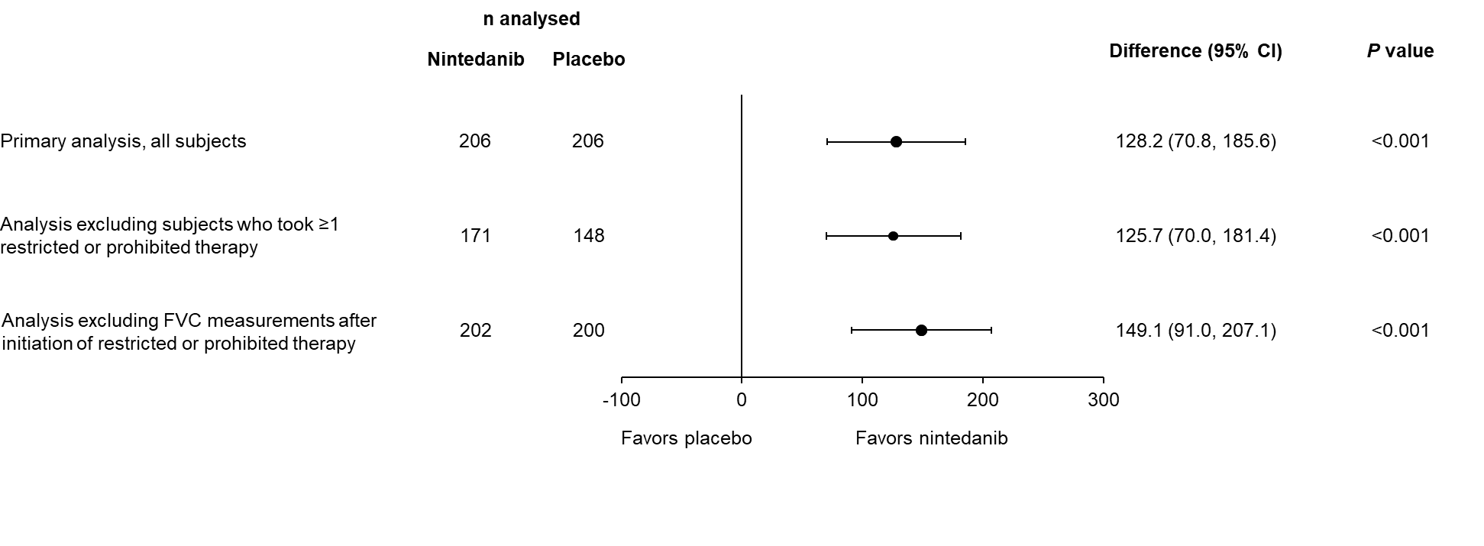

B Subjects with other fibrotic patterns on HRCT
