Additional File for:
Mepolizumab improves clinical outcomes in patients with severe asthma and comorbid conditions
Peter G. Gibson, Charlene M. Prazma, Geoffrey L. Chupp, Eric S. Bradford, Mark Forshag, Stephen A. Mallett, Steve W. Yancey, Steven G. Smith, Elisabeth H. Bel

Table of Contents
Additional Table 1 2
Additional Figure 1 3
Additional Figure 2 4
Additional Figure 3 5
Additional Figure 4 6

Additional Table 1. Key inclusion criteria for the four pivotal mepolizumab studies.
 | DREAM | MENSA | SIRIUS | MUSCA
Key inclusion criteria
Age group | ≥12 years | ≥12 years | ≥12 years | ≥12 years
Exacerbation history | ≥2 exacerbations requiring corticosteroid treatment in previous 12 months | ≥2 exacerbations requiring corticosteroid treatment in previous year | Not required | ≥2 exacerbations requiring corticosteroid treatment in previous year
Sputum eosinophil count | Historical or baseline 3%ª | Not required | Not required | Not required
Peripheral blood eosinophil count | Historical count (12 months) ≥300 cells/µL | Historical count (12 months) ≥300 cells/µL OR baseline count ≥150 cells/µL | Historical count (12 months) ≥300 cells/µL OR baseline count ≥150 cells/µL | Historical count (12 months) ≥300 cells/µL OR baseline count ≥150 cells/µL
Baseline treatments^{b} | High-dose ICS ± OCS + controller in previous 12 months | High-dose ICS ± OCS in previous 12 months + controller for ≥3 successive months in previous 12 months | High-dose ICS + OCS for ≥6 months + controller for ≥3 successive months in previous 12 months | High-dose ICS ± OCS in previous 12 months + controller for ≥3 successive months in previous 12 months
Lung function | Pre-bronchodilator FEV₁ <80% predicted OR peak flow diurnal variability of >20% on ≥3 days during run-in | Pre-bronchodilator FEV₁ <80% predicted | Pre-bronchodilator FEV₁ <80% predicted | Pre-bronchodilator FEV₁ <80% predicted
ªEosinophilic inflammation was defined by one of several criteria, of which sputum eosinophil and peripheral blood cell count were two possibilities. Patients were required to meet one of these criteria to be included in the study; ^{b}controller medication: LABA, LTRA, or theophylline.
FEV₁, forced expiratory volume in 1 second; ICS, inhaled corticosteroid; LABA, long-acting β₂-agonist; LTRA, leukotriene receptor antagonists; OCS, oral corticosteroid.

Additional Figure 1. Rate of clinically significant exacerbations by OCS-dependence comorbidity category.
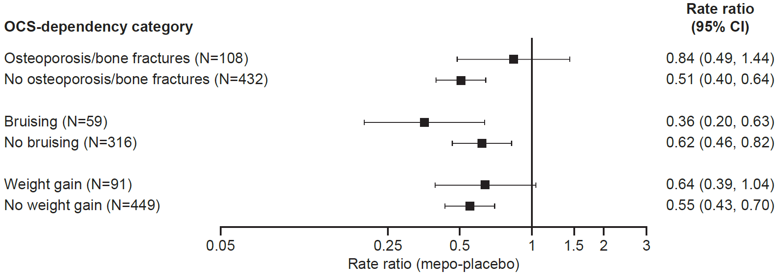
The rate of clinically significant exacerbations was analyzed using a negative binomial generalized linear model with a log-link function, including log of time on treatment as an offset variable. Horizontal bars indicate 95% confidence intervals for the mepolizumab/placebo rate ratio. Adrenal-related, psychopathologies, and eye-related analyses not performed due to insufficient number of patients. CI, confidence interval; OCS, oral corticosteroid.

Additional Figure 2. Change from baseline in ACQ-5 score at Week 24 by OCS-dependence comorbidity category.
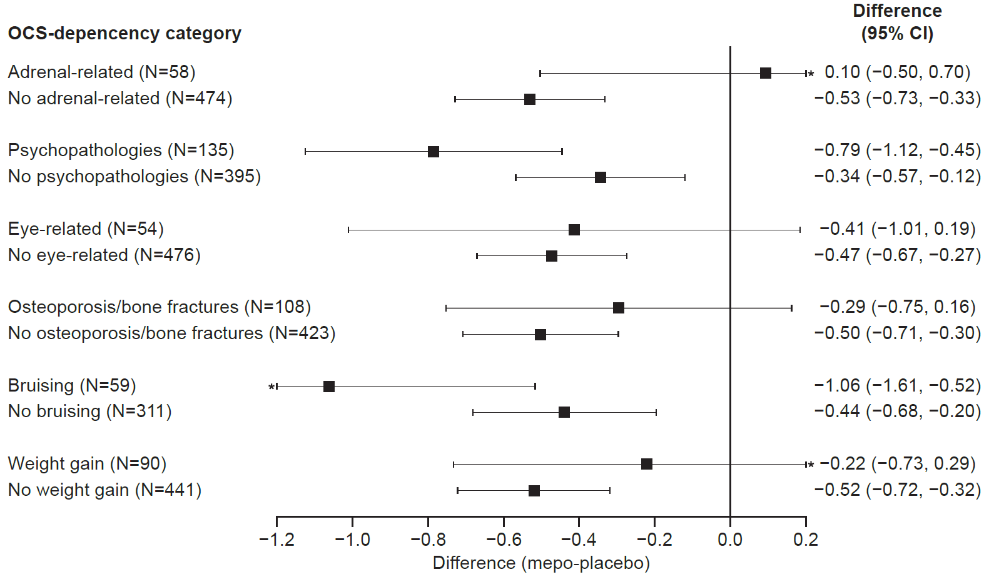
Change from baseline in ACQ-5 score was analyzed using a MMRM analysis. Horizontal bars indicate 95% confidence intervals for the treatment difference between mepolizumab and placebo. *Denotes lower/upper confidence interval extends beyond the range of the x axis. ACQ, Asthma Control Questionnaire; CI, confidence interval; MMRM, mixed model repeated measures;
OCS, oral corticosteroid.

Additional Figure 3. Change from baseline in SGRQ total score at study end by OCS-dependence comorbidity category.
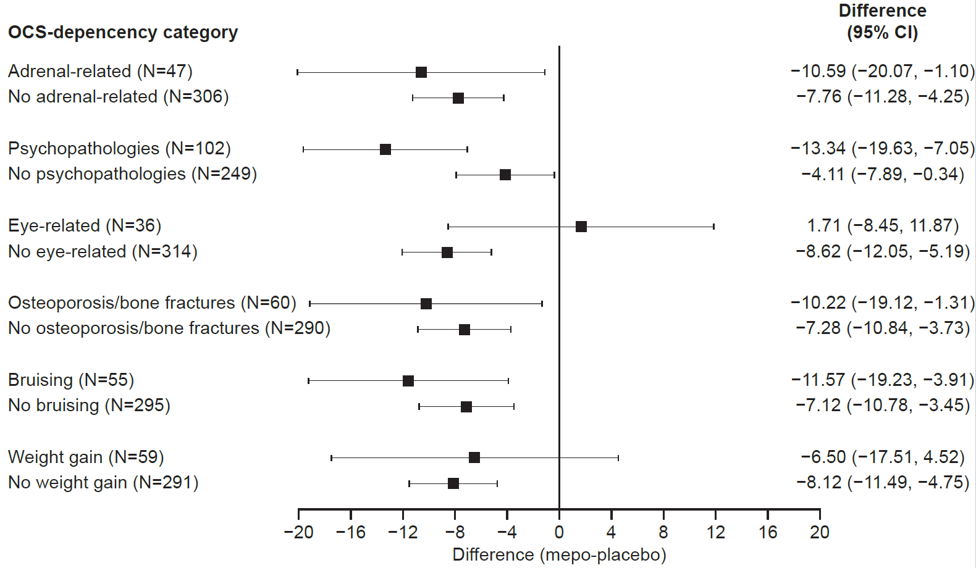
Change from baseline in SGRQ total score was analyzed using analysis of covariance. Horizontal bars indicate 95% confidence intervals for the treatment difference between mepolizumab and placebo. CI, confidence interval; OCS, oral corticosteroid; SGRQ, St George’s Respiratory Questionnaire.

Additional Figure 4. Change from baseline in pre-bronchodilator FEV₁ (mL) at Week 24 by OCS-dependence comorbidity category.
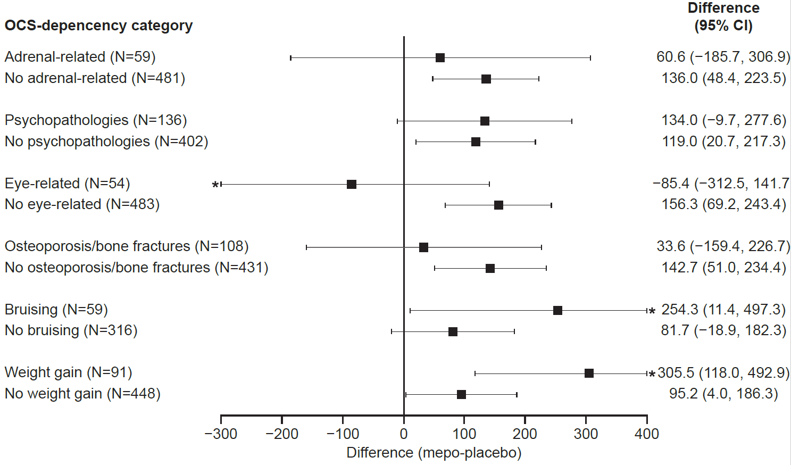
Change from baseline in pre-bronchodilator FEV₁ was analyzed using a MMRM analysis. Horizontal bars indicate 95% confidence intervals for the treatment difference between mepolizumab and placebo. *Denotes lower/upper confidence interval extends beyond the range of the x axis. CI, confidence interval; FEV₁, forced expiratory volume in 1 second; MMRM, mixed model repeated measures; OCS, oral corticosteroid.

