Supplementary files

Air pollution and hospitalisation of patients with idiopathic pulmonary fibrosis in Beijing: a time-series study
Lirong Liang^{1,#}, Yutong Cai^{2,3#,*}, Baolei Lyu⁴, Di Zhang¹, Shuilian Chu¹, Hang Jing¹, Kazem Rahimi^{2,3}, Zhaohui Tong^{1,5*}
¹ Department of Clinical Epidemiology & Tobacco Dependence Treatment Research, Beijing Institute of Respiratory Medicine, Beijing Chaoyang Hospital, Capital Medical University, Beijing, China
²Centre for Environmental Health and Sustainability, Department of Health Sciences, Univeristy of Leicester, Leicester, UK
³ Nuffield Department of Women’s & Reproductive Health, University of Oxford, Oxford, UK
⁴ Huayun Sounding Meteorology Technology Corporation, Beijing, China
⁵ Department of Respiratory and Critical Care Medicine, Beijing Institute of Respiratory Medicine, Beijing Chaoyang Hospital, Capital Medical University, Beijing, China
# equally contributing
*Correspondence to:
Professor Dr Zhaohui Tong, Department of Respiratory and Critical Care Medicine, Beijing Institute of Respiratory Medicine, Beijing Chaoyang Hospital, Capital Medical University, Beijing 100020, China. Email: tongzhaohuicy@sina.com

Figure E1: Air quality monitoring stations across Beijing
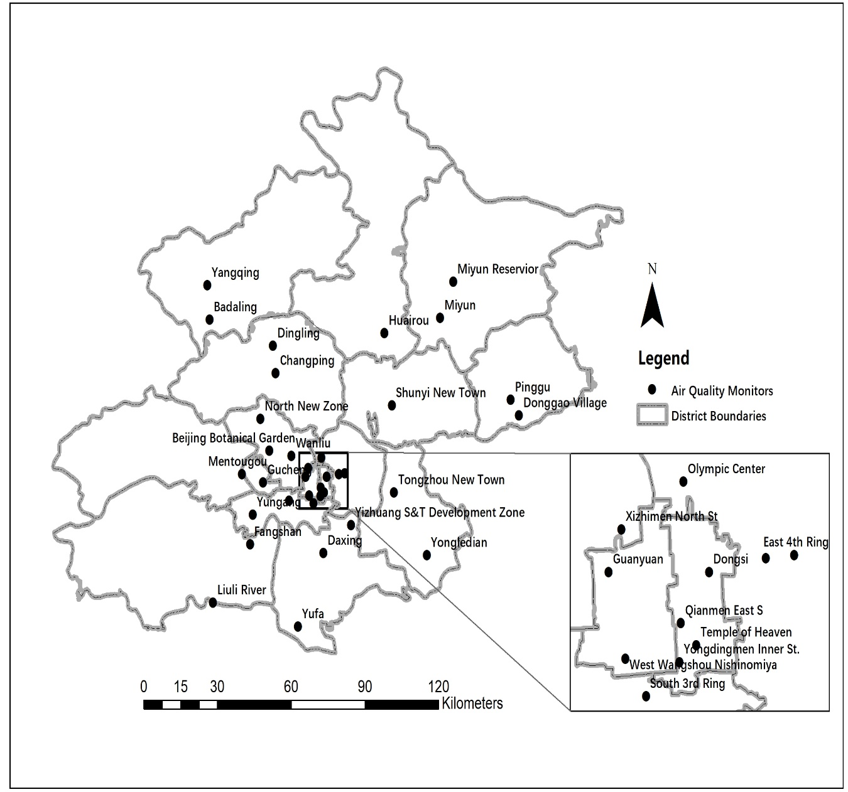

Table E1 Spearman correlation between air pollutants during 2013-2017

 | PM₁₀ | PM_{2.5} | NO₂ | SO₂ | O₃
PM₁₀ | -
PM_{2.5} | 0.93 | - | 0.777 | 0.546 | -0.143
NO₂ | 0.73 | 0.777 | - | 0.638 | -0.386
SO₂ | 0.49 | 0.546 | 0.638 | - | -0.289
O₃ | -0.10 | -0.143 | -0.386 | -0.289 | -

Table E2 Associations between PM_{2.5} and PM₁₀ (per IQR increase) and IPF hospitalisation in Beijing at different lags during 2013-2017.

 | PM₁₀ |  |  | PM_{2.5}
lag | RR | 95%CI |  | RR | 95%CI
lag0 | 1.042 | 1.019 | 1.064 | 1.049 | 1.024 | 1.074
lag1 | 1.005 | 0.984 | 1.027 | 1.008 | 0.986 | 1.030
lag2 | 0.998 | 0.978 | 1.019 | 0.998 | 0.977 | 1.019
lag3 | 0.994 | 0.973 | 1.014 | 0.991 | 0.971 | 1.012
lag4 | 1.001 | 0.981 | 1.022 | 0.995 | 0.975 | 1.016
 | RR | 95%CI |  | RR | 95%CI
lag0-1 | 1.027 | 1.005 | 1.050 | 1.031 | 1.007 | 1.056
lag0-2 | 1.019 | 0.997 | 1.042 | 1.021 | 0.998 | 1.044
lag0-3 | 1.012 | 0.991 | 1.034 | 1.013 | 0.990 | 1.036
lag0-4 | 1.011 | 0.989 | 1.033 | 1.009 | 0.987 | 1.032
lag0-30 | 1.021 | 0.994 | 1.049 | 0.994 | 0.962 | 1.027

IQR for PM_{2.5} and PM₁₀ during 2013-2017 was 72 and 86 μg/m³ respectively.

Table E3 Associations between PM_{2.5} (per IQR increase of 83 μg/m³) and IPF hospitalisation in Beijing at different lags during 2008-2012.

 | lag | RR | 95%CI
PM_{2.5} | lag0 | 1.062 | 1.025 | 1.101
PM_{2.5} | lag1 | 1.035 | 1.002 | 1.070
PM_{2.5} | lag2 | 1.031 | 0.999 | 1.065
PM_{2.5} | lag3 | 1.020 | 0.988 | 1.054
PM_{2.5} | lag4 | 0.988 | 0.956 | 1.020
PM_{2.5}
PM_{2.5} | lag0-1 | 1.054 | 1.020 | 1.090
PM_{2.5} | lag0-2 | 1.056 | 1.021 | 1.093
PM_{2.5} | lag0-3 | 1.052 | 1.018 | 1.087
PM_{2.5} | lag0-4 | 1.041 | 1.007 | 1.076

Figure E2 Comparisons of associations between PM_{2.5} and IPF hospitalization for periods 2008-2012 and 2013-2017.

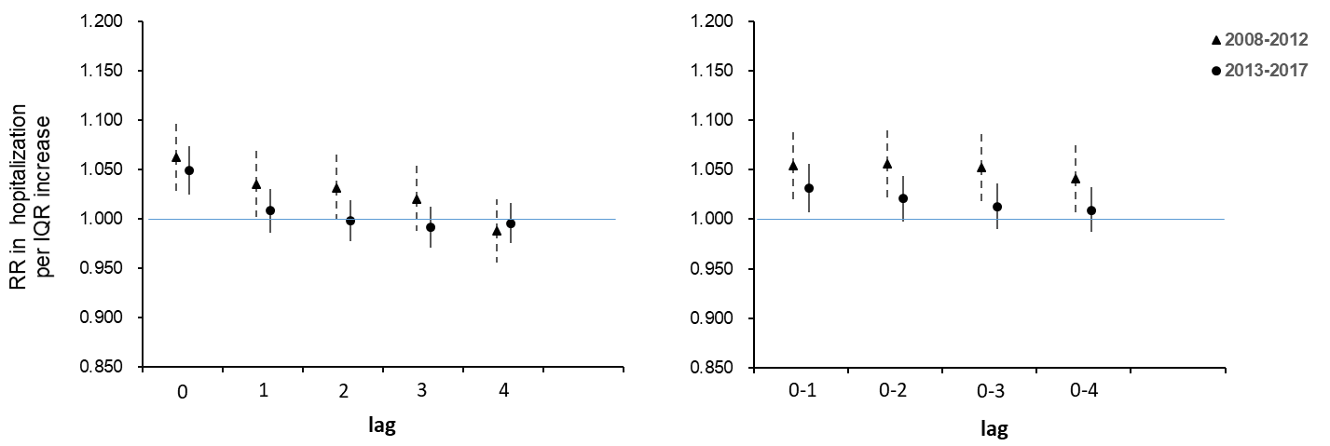

Table E4 Associations between gaseous pollutants (per IQR increase) and IPF hospitalisation in Beijing at different lags during 2013-2017.

 | lag | RR | 95%CI
NO2 | 0 | 1.029 | 0.999 | 1.060
no2_lag1 | 1 | 0.998 | 0.971 | 1.025
no2_lag2 | 2 | 0.983 | 0.958 | 1.009
no2_lag3 | 3 | 0.990 | 0.965 | 1.016
no2_lag4 | 4 | 0.990 | 0.965 | 1.015
SO2 | 0 | 1.023 | 1.002 | 1.045
so2_lag1 | 1 | 1.007 | 0.988 | 1.026
so2_lag2 | 2 | 1.015 | 0.995 | 1.034
so2_lag3 | 3 | 1.017 | 0.997 | 1.037
so2_lag4 | 4 | 1.012 | 0.992 | 1.032
O3 | 0 | 1.045 | 1.000 | 1.092
O3_lag1 | 1 | 1.056 | 1.014 | 1.100
O3_lag2 | 2 | 1.057 | 1.017 | 1.098
O3_lag3 | 3 | 1.037 | 0.998 | 1.077
O3_lag4 | 4 | 1.007 | 0.970 | 1.046
NO2 |  | RR | 95%CI
no2_lag0-1 | 0-1 | 1.014 | 0.986 | 1.044
no2_lag0-2 | 0-2 | 1.002 | 0.974 | 1.030
no2_lag0-3 | 0-3 | 0.998 | 0.969 | 1.027
no2_lag0-4 | 0-4 | 0.994 | 0.965 | 1.024
no2_lag0-30 | 0-30 | 1.029 | 0.999 | 1.060
SO2
so2_lag0-1 | 0-1 | 1.019 | 0.996 | 1.043
so2_lag0-2 | 0-2 | 1.023 | 0.998 | 1.048
so2_lag0-3 | 0-3 | 1.028 | 1.002 | 1.056
so2_lag0-4 | 0-4 | 1.031 | 1.002 | 1.061
so2_lag0-30 | 0-30 | 1.060 | 1.025 | 1.097
O3
O3_lag0-1 | 0-1 | 1.071 | 1.019 | 1.126
O3_lag0-2 | 0-2 | 1.091 | 1.034 | 1.151
O3_lag0-3 | 0-3 | 1.099 | 1.038 | 1.164
O3_lag0-4 | 0-4 | 1.093 | 1.028 | 1.162
O3_lag0-30 | 0-30 | 1.047 | 0.941 | 1.165

Table E5 Associations between ozone (per IQR increase) and IPF hospitalisation in Beijing at different lags during 2013-2017: by season

 | RR | 95%CI
O₃_warm | 1.035 | 0.977 | 1.097
O₃_warm_lag1 | 1.032 | 0.979 | 1.089
O₃_warm_lag2 | 1.039 | 0.989 | 1.092
O₃_warm_lag3 | 1.026 | 0.977 | 1.077
O₃_warm_lag4 | 0.991 | 0.944 | 1.039
O₃_cold | 1.037 | 0.972 | 1.107
O₃_cold_lag1 | 1.087 | 1.027 | 1.151
O₃_cold_lag2 | 1.086 | 1.030 | 1.144
O₃_cold_lag3 | 1.044 | 0.993 | 1.097
O₃_cold_lag4 | 1.030 | 0.979 | 1.083
O₃_warm_lag0-1 | 1.040 | 0.983 | 1.100
O₃_warm_lag0-2 | 1.048 | 0.993 | 1.106
O₃_warm_lag0-3 | 1.050 | 0.994 | 1.109
O₃_warm_lag0-4 | 1.038 | 0.984 | 1.096
O₃_cold_lag0-1 | 1.089 | 1.017 | 1.166
O₃_cold_lag0-2 | 1.124 | 1.046 | 1.207
O₃_cold_lag0-3 | 1.123 | 1.043 | 1.209
O₃_cold_lag0-4 | 1.118 | 1.037 | 1.205

Table E6 Results of the sensitivity analyses

 | PM_{2.5} RR (95%CI)
 |  | Lag0 | Lag1 | Lag2 | Lag3 | Lag4 | Lag5 | Lag0-1 | Lag0-2 | Lag0-3 | Lag0-4
1 | 2013-2017 | 1.039  (1.015,1.063) | 1.003  (0.982,1.025) | 0.994  (0.974,1.014) | 0.988  (0.968,1.008) | 0.991  (0.971,1.011) | 1.001  (0.982,1.022) | 1.023  (1.000,1.046) | 1.013  (0.991,1.035) | 1.006  (0.984,1.027) | 1.002  (0.981,1.023)
2 | 2013-2017 | 1.047  (1.008,1.088) | 0.990  (0.967,1.014) | 0.989  (0.969,1.010) | 0.986  (0.966,1.006) | 0.990  (0.970,1.010) | 1.001  (0.981,1.021) | 1.008  (0.976,1.040) | 0.997  (0.970,1.024) | 0.991  (0.967,1.016) | 0.989  (0.966,1.012)
3 | 2013-2017 | 1.048  (1.023,1.074) | 1.007  (0.985,1.030) | 0.997  (0.976,1.018) | 0.991  (0.970,1.012) | 0.994  (0.974,1.016) | 1.005  (0.985,1.026) | 1.031  (1.007,1.056) | 1.020  (0.997,1.044) | 1.012  (0.989,1.036) | 1.008  (0.985,1.032)
4 | 2013-2017 | 1.030  (1.008,1.052) | 1.016  (0.994,1.039) | 1.011  (0.989,1.034) | 1.004  (0.982,1.026) | 1.006  (0.984,1.028) | 1.012  (0.991,1.033) | 1.028  (1.005,1.051) | 1.027  (1.004,1.051) | 1.025  (1.001,1.050) | 1.025  (1.000,1.051)
5 | 2013-2017 | 1.020  (0.998,1.041) | 1.006  (0.985,1.029) | 1.002  (0.980,1.024) | 0.995  (0.974,1.017) | 0.999  (0.977,1.020) | 1.014  (0.993,1.036) | 1.015  (0.993,1.037) | 1.012  (0.990,1.035) | 1.009  (0.986,1.031) | 1.007  (0.985,1.030)
- = remove ‘calendar time’
- = replace ‘calendar time’ with an interaction term of exposure-by-season
- = increase the degrees of freedom of temperature and humidity to six
- = model moving averages for lag0–4 of temperature and humidity instead of concurrent day (lag0)
- = model moving averages for lag0–15 of temperature and humidity instead of concurrent day (lag0)

 | RR (95%CI)
 |  | Lag0 | Lag1 | Lag2 | Lag3 | Lag4 | Lag5 | Lag0-1 | Lag0-2 | Lag0-3 | Lag0-4
1 | NO₂ | 1.021  (0.992,1.050) | 0.994  (0.969,1.020) | 0.980  (0.956,1.005) | 0.987  (0.962,1.012) | 0.986  (0.961,1.011) | 0.988  (0.964,1.012) | 1.008  (0.981,1.035) | 0.996  (0.970,1.023) | 0.992  (0.965,1.020) | 0.988  (0.961,1.016)
1 | SO₂ | 1.011  (0.994,1.029) | 1.001  (0.985,1.018) | 1.007  (0.990,1.024) | 1.009  (0.992,1.026) | 1.005  (0.988,1.022) | 1.001  (0.985,1.019) | 1.008  (0.989,1.027) | 1.009  (0.989,1.029) | 1.011  (0.990,1.032) | 1.011  (0.989,1.034)
1 | O₃_warm | 1.050  (0.994,1.109) | 1.044  (0.992,1.098) | 1.046  (0.998,1.098) | 1.034  (0.986,1.084) | 1.000  (0.955,1.048) | 1.013  (0.968,1.061) | 1.054  (1.000,1.111) | 1.058  (1.007,1.113) | 1.060  (1.008,1.115) | 1.050  (0.999,1.103)
1 | O₃_cold | 1.021  (0.964,1.083) | 1.068  (1.012,1.126) | 1.069  (1.018,1.124) | 1.034  (0.987,1.085) | 1.019  (0.971,1.068) | 1.048  (0.997,1.102) | 1.059  (0.997,1.125) | 1.084  (1.018,1.155) | 1.084  (1.016,1.157) | 1.077  (1.008,1.151)
2 | NO₂ | 1.025  (0.975,1.078) | 0.984  (0.956,1.012) | 0.977  (0.953,1.002) | 0.985  (0.961,1.010) | 0.985  (0.961,1.010) | 0.987  (0.963,1.012) | 0.991  (0.954,1.030) | 0.980  (0.948,1.012) | 0.978  (0.948,1.009) | 0.976  (0.946,1.006)
2 | SO₂ | 1.042  (0.994,1.092) | 0.994  (0.973,1.016) | 1.004  (0.985,1.023) | 1.007  (0.988,1.025) | 1.003  (0.985,1.021) | 0.999  (0.980,1.017) | 1.003  (0.967,1.041) | 1.006  (0.975,1.038) | 1.010  (0.979,1.041) | 1.009  (0.978,1.041)
3 | NO₂ | 1.026  (0.996,1.058) | 0.996  (0.970,1.024) | 0.982  (0.957,1.008) | 0.990  (0.965,1.016) | 0.989  (0.964,1.015) | 0.991  (0.966,1.017) | 1.012  (0.984,1.042) | 1.000  (0.971,1.029) | 0.996  (0.966,1.026) | 0.992  (0.962,1.022)
3 | SO₂ | 1.025  (1.003,1.047) | 1.009  (0.990,1.029) | 1.017  (0.998,1.037) | 1.020  (1.000,1.040) | 1.014  (0.994,1.034) | 1.010  (0.990,1.031) | 1.022  (0.998,1.046) | 1.027  (1.001,1.053) | 1.033  (1.005,1.062) | 1.037  (1.007,1.068)
3 | O₃_warm | 1.039  (0.980,1.101) | 1.032  (0.978,1.089) | 1.040  (0.989,1.094) | 1.028  (0.979,1.079) | 0.993  (0.946,1.042) | 1.004  (0.958,1.053) | 1.042  (0.985,1.103) | 1.050  (0.994,1.109) | 1.053  (0.996,1.113) | 1.041  (0.986,1.099)
3 | O₃_cold | 1.038  (0.973,1.108) | 1.093  (1.031,1.158) | 1.088  (1.032,1.147) | 1.044  (0.992,1.097) | 1.029  (0.979,1.083) | 1.068  (1.012,1.126) | 1.093  (1.021,1.171) | 1.128  (1.049,1.213) | 1.127  (1.046,1.214) | 1.120  (1.038,1.209)
4 | NO₂ | 1.010  (0.984,1.037) | 0.999  (0.973,1.026) | 0.989  (0.963,1.017) | 0.997  (0.970,1.025) | 0.995  (0.968,1.022) | 0.994  (0.969,1.020) | 1.006  (0.980,1.032) | 1.000  (0.973,1.028) | 0.999  (0.969,1.029) | 0.997  (0.966,1.029)
4 | SO₂ | 1.014  (0.994,1.035) | 1.008  (0.989,1.028) | 1.019  (0.999,1.039) | 1.021  (1.001,1.041) | 1.015  (0.996,1.035) | 1.010  (0.991,1.030) | 1.015  (0.991,1.039) | 1.022  (0.997,1.048) | 1.030  (1.002,1.059) | 1.035  (1.004,1.066)
4 | O₃_warm | 1.027  (0.975,1.082) | 1.035  (0.980,1.093) | 1.057  (1.001,1.116) | 1.051  (0.997,1.109) | 1.013  (0.962,1.067) | 1.024  (0.974,1.076) | 1.036  (0.982,1.093) | 1.055  (0.998,1.115) | 1.071  (1.009,1.137) | 1.071  (1.007,1.138)
4 | O₃_cold | 1.002  (0.945,1.063) | 1.053  (0.990,1.120) | 1.065  (1.000,1.133) | 1.017  (0.957,1.080) | 0.998  (0.942,1.058) | 1.047  (0.988,1.108) | 1.036  (0.968,1.109) | 1.075  (0.991,1.167) | 1.087  (0.989,1.195) | 1.082  (0.976,1.200)
5 | NO₂ | 1.002  (0.976,1.028) | 0.993  (0.968,1.020) | 0.985  (0.959,1.011) | 0.990  (0.964,1.017) | 0.986  (0.960,1.013) | 0.994  (0.969,1.021) | 0.997  (0.972,1.023) | 0.991  (0.965,1.018) | 0.988  (0.960,1.017) | 0.984  (0.954,1.014)
5 | SO₂ | 1.008  (0.987,1.030) | 1.005  (0.984,1.026) | 1.016  (0.995,1.037) | 1.016  (0.995,1.037) | 1.007  (0.987,1.028) | 1.009  (0.988,1.030) | 1.009  (0.984,1.034) | 1.016  (0.989,1.044) | 1.023  (0.993,1.055) | 1.026  (0.993,1.060)
5 | O₃_warm | 1.037  (0.987,1.090) | 1.039  (0.988,1.093) | 1.054  (1.002,1.108) | 1.047  (0.997,1.100) | 1.016  (0.967,1.067) | 1.032  (0.982,1.084) | 1.043  (0.993,1.096) | 1.055  (1.004,1.108) | 1.065  (1.011,1.121) | 1.062  (1.008,1.118)
5 | O₃_cold | 1.014  (0.958,1.074) | 1.055  (0.993,1.120) | 1.065  (1.001,1.133) | 1.015  (0.955,1.079) | 0.993  (0.936,1.054) | 1.035  (0.972,1.102) | 1.045  (0.979,1.116) | 1.081  (1.000,1.169) | 1.091  (0.996,1.195) | 1.086  (0.982,1.201)
- = remove ‘calendar time’
- = replace ‘calendar time’ with an interaction term of exposure-by-season
- = increase the degrees of freedom of temperature and humidity to six
- = model moving averages for lag0–4 of temperature and humidity instead of concurrent day (lag0)
- = model moving averages for lag0–15 of temperature and humidity instead of concurrent day (lag0)

Table E7 Results of two-pollutant models

PM_{2.5}+SO₂ | Lag0 | Lag1 | Lag2 | Lag3 | Lag4
 | 1.048 (1.018, 1.079) | 1.005 (0.978, 1.032) | 0.984 (0.960, 1.009) | 0.975 (0.951, 1.000) | 0.985 (0.961, 1.009)
 | Lag0-1 | Lag0-2 | Lag0-3 | Lag0-4
 | 1.029 (1.001, 1.059) | 1.013 (0.985, 1.041) | 1.000 (0.974, 1.027) | 0.996 (0.971, 1.023)
PM_{2.5} + O₃ | Lag0 | Lag1 | Lag2 | Lag3 | Lag4
 | 1.047 (1.021, 1.073) | 1.008 (0.986, 1.031) | 1.000 (0.979, 1.021) | 0.994 (0.974, 1.015) | 0.995 (0.974, 1.016)
 | Lag0-1 | Lag0-2 | Lag0-3 | Lag0-4
 | 1.028 (1.004, 1.053) | 1.021 (0.997, 1.045) | 1.015 (0.992, 1.039) | 1.012 (0.989, 1.035)
NO₂+SO₂ | Lag0 | Lag1 | Lag2 | Lag3 | Lag4
 | 1.015 (0.978, 1.052) | 0.986 (0.952, 1.020) | 0.953 (0.922, 0.985) | 0.964 (0.933, 0.996) | 0.970 (0.939, 1.001)
 | Lag0-1 | Lag0-2 | Lag0-3 | Lag0-4
 | 1.000 (0.965, 1.036) | 0.979 (0.945, 1.014) | 0.972 (0.938, 1.007) | 0.968 (0.934, 1.003)
NO₂+O₃ | Lag0 | Lag1 | Lag2 | Lag3 | Lag4
 | 1.032 (1.002, 1.062) | 1.001 (0.975, 1.027) | 0.991 (0.966, 1.017) | 0.997 (0.972, 1.022) | 0.992 (0.967, 1.017)
 | Lag0-1 | Lag0-2 | Lag0-3 | Lag0-4
 | 1.017 (0.988, 1.046) | 1.008 (0.980, 1.037) | 1.007 (0.978, 1.037) | 1.004 (0.974, 1.035)
SO₂+PM_{2.5} | Lag0 | Lag1 | Lag2 | Lag3 | Lag4
 | 1.000 (0.975, 1.026) | 1.004 (0.981, 1.028) | 1.023 (1.000, 1.046) | 1.030 (1.006, 1.054) | 1.020 (0.997, 1.043)
 | Lag0-1 | Lag0-2 | Lag0-3 | Lag0-4
 | 1.003 (0.976, 1.032) | 1.016 (0.986, 1.046) | 1.028 (0.996, 1.061) | 1.034 (1.000, 1.069)
SO₂+NO₂ | Lag0 | Lag1 | Lag2 | Lag3 | Lag4
 | 1.017 (0.992, 1.044) | 1.013 (0.989, 1.038) | 1.037 (1.012, 1.063) | 1.034 (1.009, 1.060) | 1.026 (1.002, 1.051)
 | Lag0-1 | Lag0-2 | Lag0-3 | Lag0-4
 | 1.019 (0.990, 1.049) | 1.034 (1.003, 1.066) | 1.044 (1.011, 1.078) | 1.049 (1.014, 1.085)
SO₂+O₃ | Lag0 | Lag1 | Lag2 | Lag3 | Lag4
 | 1.024 (1.004, 1.044) | 1.007 (0.989, 1.025) | 1.017 (0.999, 1.036) | 1.018 (0.999, 1.037) | 1.013 (0.994, 1.033)
 | Lag0-1 | Lag0-2 | Lag0-3 | Lag0-4
 | 1.019 (0.996, 1.043) | 1.024 (0.999, 1.049) | 1.028 (1.002, 1.056) | 1.032 (1.002, 1.061)

Figure E3 Exposure-response curves between air pollution exposure and IPF hospitalization at lag0

