Journal: Respiratory Research – BioMed Central

Title: Endotracheal Tube Microbiome in Hospitalized Patients Defined Largely by Hospital Environment

Authors: Erika Alejandra Cifuentes¹, María Alejandra Sierra^{1,2}, Andrés Felipe Yepes³, Ana Margarita Baldión³, José Antonio Rojas⁴, Carlos Arturo Álvarez-Moreno⁴, Juan Manuel Anzola¹, María Mercedes Zambrano¹, Mónica G Huertas^{1,5*}
*Corresponding autor: mogahuertas@gmail.com, monica.huertas01@uptc.edu.co

Additional files 1

Supplementary Figures

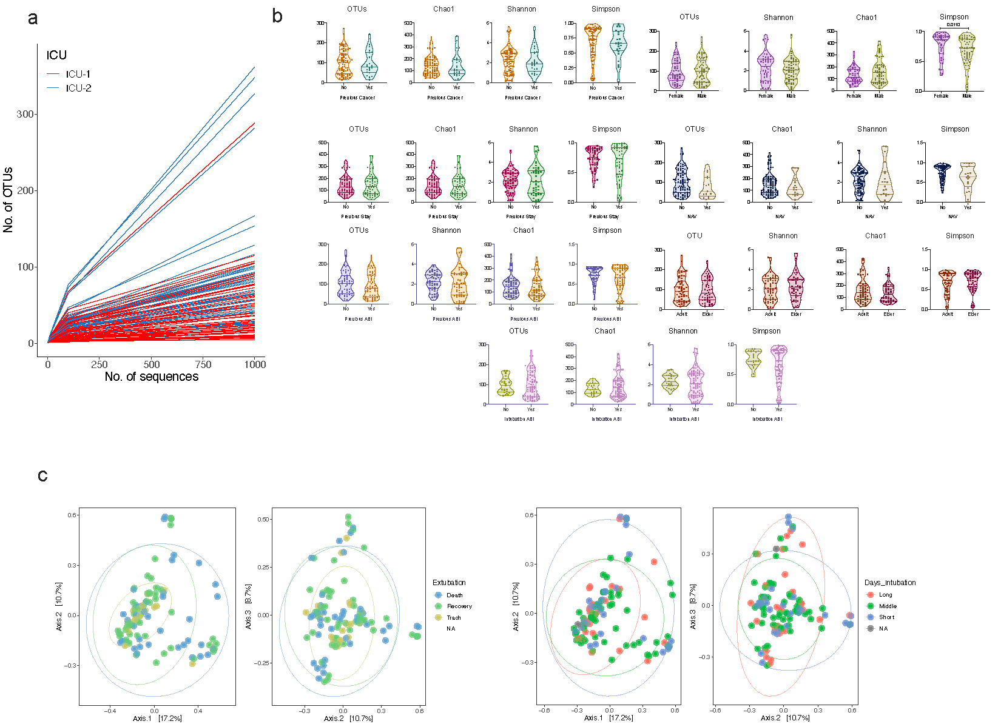
d
Figure S1. (a) Rarefaction curves showing saturation for most samples from ICU-1 and ICU-2. (b) Alpha diversity indexes for the clinical characteristics collected. No statistical differences were observed according to Welch t-test, p>0.05. Principal coordinate analysis for extubation reason (death, recovery or tracheostomy) (c) and days of intubation (long >16 days, middle 6-15 days, and short 0-5 days) (d) do not display differences.

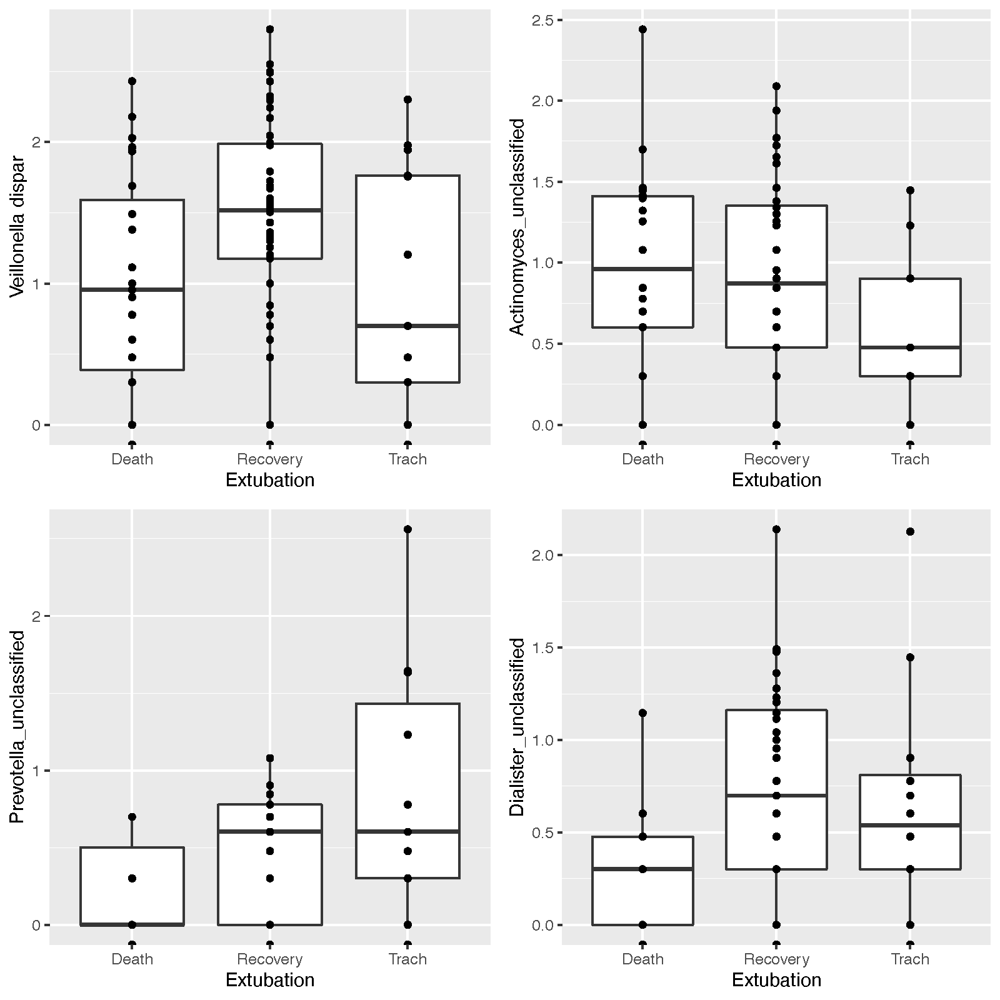

Figure S2. Effects of extubation reason on bacterial differential abundances. 4 OTUs showed significant differences when comparing patients who died, recovered or had a tracheostomy. All the differences were significant according to the expected P value of Welch’s t-test and the expected P value of the Wilcoxon rank test.

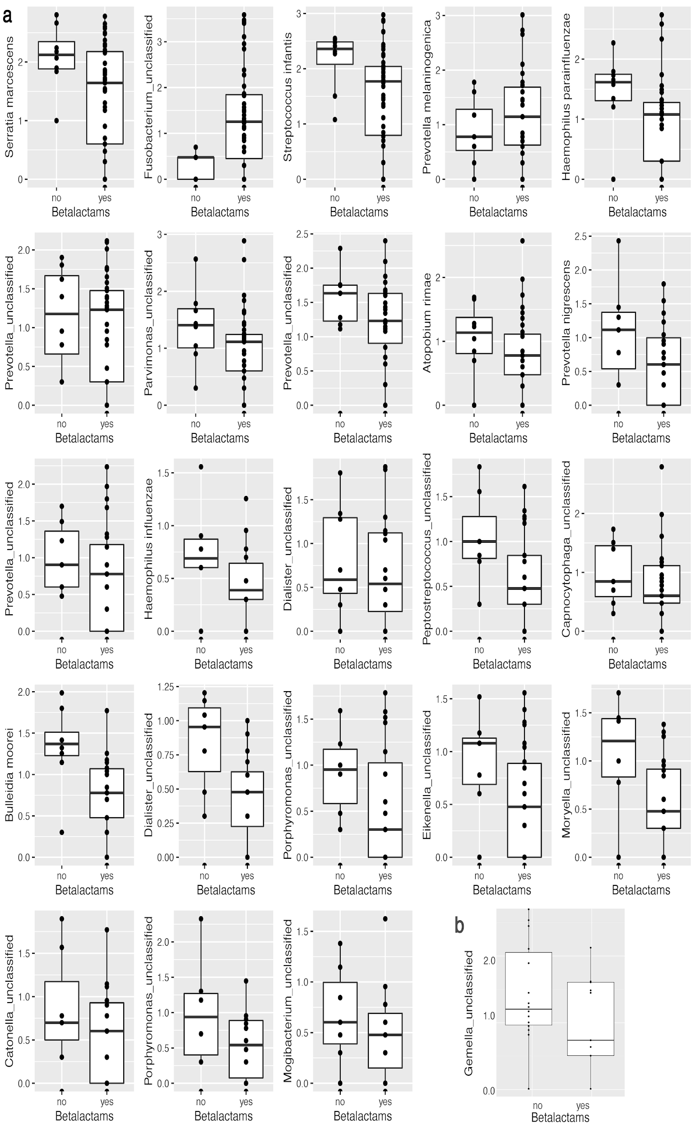

Figure S3. Effect of beta-lactam use on OTU abundance. Significant differences in OTU abundance based on beta-lactam use in (a) ICU-1 and ICU -2 (b). All the differences were significant according to the expected P value of Welch’s t-test and the expected P value of the Wilcoxon rank test.

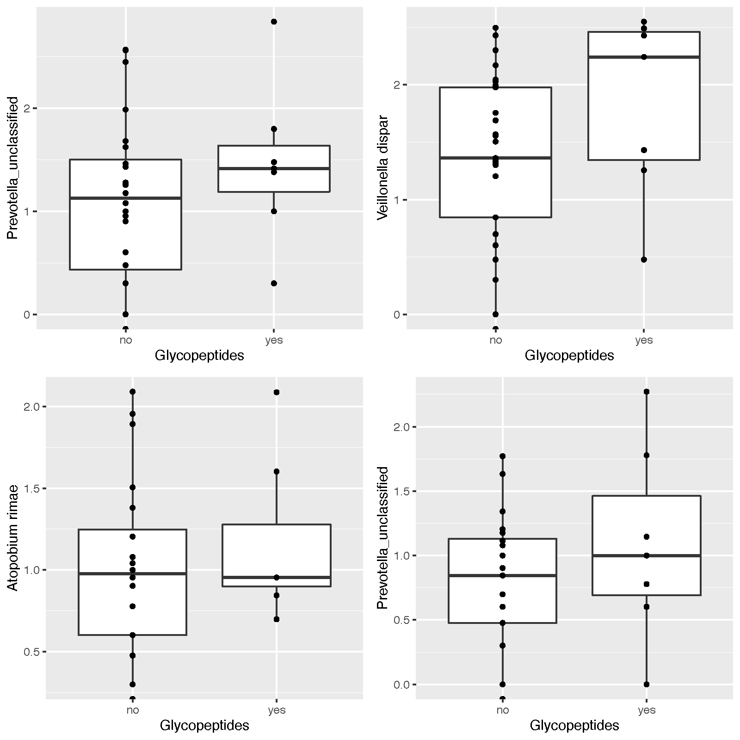
Figure S4. Effect of glycopeptide use on OTU abundance. The use of glycopeptides resulted in significantly different abundances of 4 OTUs in ICU-2 . All the differences were significant according to the expected P value of Welch’s t-test and the expected P value of the Wilcoxon rank test.

