Additional figure legends
Figure S1. Tumor mutation burden estimates were highly correlated between (A) tumor tissue and sputum supernatant, (B) tumor tissue and plasma, and (C) sputum supernatant and plasma. Shown on each plot are the corresponding Pearson correlation coefficients and p-value.
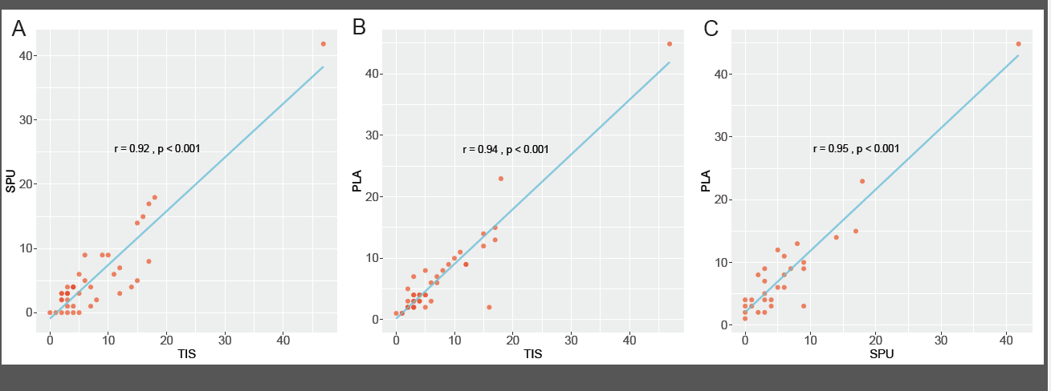
Figure S2. A worked example of how to use the nomogram to predict the probability achieving more sensitive genome profiling with sputum supernatant (SPU) than with plasma (PLA). For a 60-year-old female smoker with EGFR-positive, ALK-wild-type centrally located lung tumor that has violated the trachea, The points for each risk factor add up to 219 (blue, dashed lines). A vertical line (red, solid) is then drawn from 219 on the “Total points” line down (third to the last) to the last line to predict likelihood of SPU outperforming PLA in sensitivity (77%).
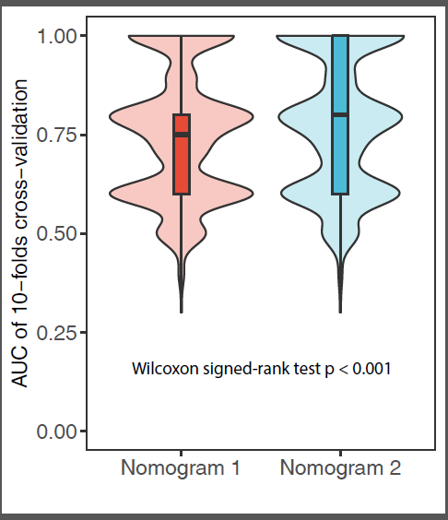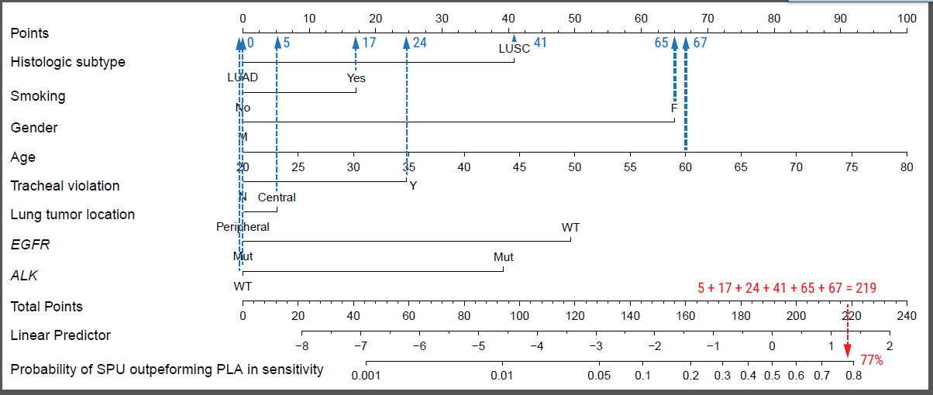
Figure S3. Areas under curve (AUCs) resulting from discrimination power evaluation of Nomograms 1 and 2 with 10-fold cross-validation, revealing significantly higher AUCs for Nomogram 2.

Additional tables
Table S1. Mutation detection rates using sputum supernatant in different patient populations.
 |  | SPU |  | PLA |  | p  (SPU vs. PLA)
Clinicohistologic feature |  | % (n) | p | % (n) | p | p  (SPU vs. PLA)
Sex | Female | 56.2 (9/16) | 0.37 | 56.2 (9/16) | 0.22 | 1.00
Sex | Male | 70.4 (38/54) |  | 74.1 (40/54)
Histologic subtype | LUAD | 60.7 (34/56) | 0.03 | 66.1 (37/56) | 0.20 | 0.82
Histologic subtype | LUSC | 93.3 (14/15) |  | 86.7 (13/15)
Smoking | Smoker | 78.8 (26/33) | 0.08 | 72.7 (24/33) | 0.80 | 0.55
Smoking | Non-smoker | 57.9 (22/38) |  | 68.4 (26/38)
Location of lung tumor | Central | 79.5 (31/39) | 0.03 | 61.5 (24/39) | 0.05 | 0.10
Location of lung tumor | Peripheral | 53.6 (15/28) |  | 85.7 (24/28)
Stage | III | 68.2 (15/22) | 1.00 | 72.7 (16/22) | 1.00 | 1.00
Stage | IV | 68.8 (33/48) |  | 70.8 (34/48)
Sputum type | Induced | 61.5 (8/13) | 0.74 | 61.5 (8/13) | 0.51 | 1.00
Sputum type | Non-induced | 69.0 (40/58) |  | 72.4 (42/58)
M stage | M0 | 73.7 (14/19) | 0.77 | 68.4 (13/19) | 1.00 | 1.00
M stage | M1 | 68.8 (33/48) |  | 70.8 (34/48)
Nodal metastasis | Yes | 67.6 (46/68) | 1.00 | 72.1 (49/68) | 0.49 | 0.61
Nodal metastasis | No | 100 (2/2) |  | 50.0(1/2)
Brain metastasis | Yes | 83.3 (10/12) | 0.32 | 66.7 (8/12) | 0.73 | 0.61
Brain metastasis | No | 65.5 (38/58) |  | 72.4 (42/58)
Pleural metastasis | Yes | 66.7 (18/27) | 0.80 | 74.1 (20/27) | 0.79 | 0.84
Pleural metastasis | No | 69.8 (30/43) |  | 69.8 (30/43)
Bone metastasis | Yes | 69.6 (16/23) | 1.00 | 78.3 (18/23) | 0.42 | 0.83
Bone metastasis | No | 68.1 (32/47) |  | 68.1 (32/47)
Tracheal violation | Yes | 78.3 (18/23) | 0.28 | 69.6 (16/23) | 0.78 | 0.67
Tracheal violation | No | 63.6 (28/44) |  | 72.7 (32/44)
Blood vessel invasion | Yes | 66.7 (8/12) | 1.00 | 58.3 (7/12) | 0.29 | 0.78
Blood vessel invasion | No | 69.6 (39/56) |  | 75 (42/56)
Pleurisy | Yes | 52.6 (10/19) | 0.08 | 73.7 (14/19) | 1.00 | 0.48
Pleurisy | No | 77.1 (37/48) |  | 72.9 (35/48)

All p values were from Fisher’s exact test. LUAD, lung adenocarcinoma. LUSC, lung squamous cell carcinoma. PLA, plasma. SPU, sputum supernatant. TIS, tumor biopsy.

Table S2. Overall concordance rates resulting of mutation matching between tissue-sputum or tissue-plasma in the entire cohort or selected patient subgroups.
Patients | Concordance rate, n (%) |  | p
Patients | SPU-TIS | PLA-TIS | p
Entire cohort | 48 (67.6) | 52 (73.2) | 0.58
Location of lung tumor
Central (n = 39) | 30 (76.9) | 26 (66.7) | 0.45
Peripherally (n = 28) | 16 (57.1) | 24 (85.7) | 0.04
Smoking history
Smokers (n = 33) | 25 (75.8) | 24 (72.7) | 1.00
Non-smokers (n = 38) | 23 (60.5) | 28 (73.7) | 0.33
Histologic subtype
LUAD (n = 56) | 34 (60.7) | 40 (71.4) | 0.32
LUSC (n = 15) | 14 (93.3) | 12 (80.0) | 0.60

All p values were from Fisher’s exact test. Concordance rate was defined as the fraction of the total number of true positive patients (carrying at least one alteration that was detected from both matched samples) and true negative patients (no mutation detected from either sample) relative to the entire cohort or indicated subgroup. LUAD, lung adenocarcinoma. LUSC, lung squamous cell carcinoma. PLA, plasma. SPU, sputum supernatant. TIS, tumor biopsy.

