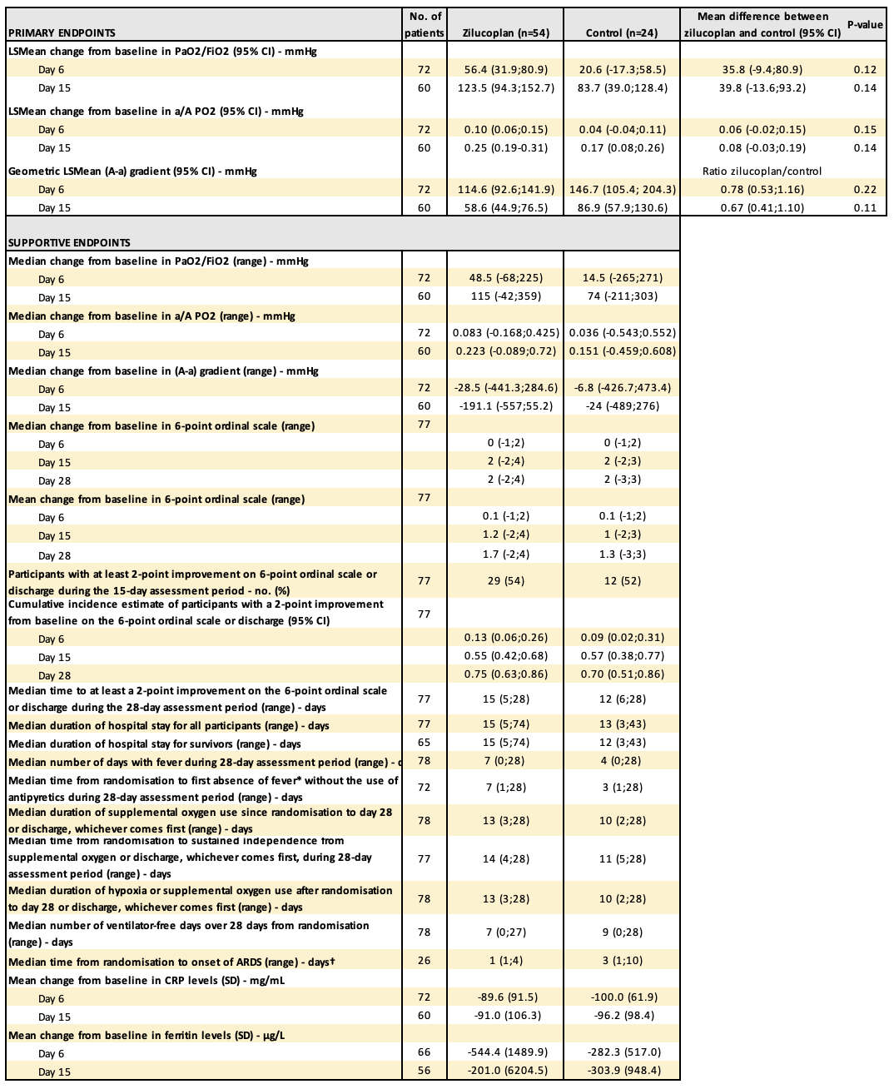
Table S1: Primary and supportive endpoints in the full analysis data set.
LSMean, least square mean; PaO₂, arterial partial pressure of oxygen; FiO₂, fraction of inspired oxygen; PaO₂, partial pressure of arterial oxygen; ARDS, acute respiratory distress syndrome; CRP, C-reactive protein; CI, confidence interval; SD, standard deviation.
*Based on the highest temperature in 24 hours.

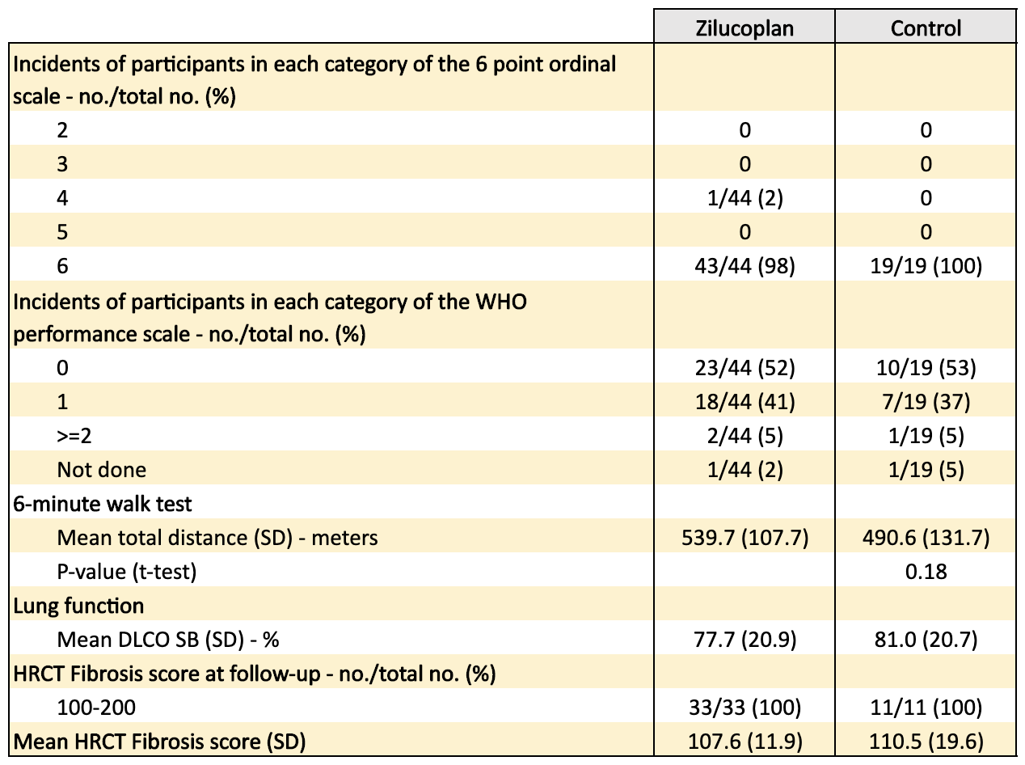
Table S2: Follow-up endpoints.
SD, standard deviation; DLCO, diffusing capacity of lung for carbon monoxide; HRCT, high-resolution computed tomography; WHO, world health organisation.
6-point ordinal scale: 2 on invasive mechanical ventilation; 3 on non-invasive ventilation or high flow oxygen devices; 4 hospitalized, requiring supplemental oxygen; 5 hospitalized, not requiring supplemental oxygen, 6 not hospitalized.

